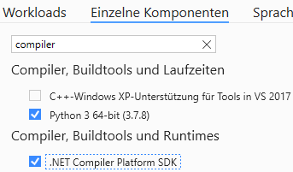
https://docs.microsoft.com/en-us/visualstudio/releases/2019/release-notes#16.10.0

There is now debugger support for Source Generators. You will first need to install the .NET Compiler Platform SDK component from the Visual Studio Installer. You will then need to add the <IsRoslynComponent>true</IsRoslynComponent> property to your your project file. Next, enable the 'Roslyn Component' debugger option in the Project Properties Debug page and select the appropriate target project. Next, press F5 on the generator project which will start the CSC.exe/VBC.exe that builds the target project allowing you to debug the generator code.

