4/30/2021 – Cdurham – WRITE UP OF PROGESS for PCASER Tool

Updates:

Updated GUI Layout.

Made changes to GUI layout.

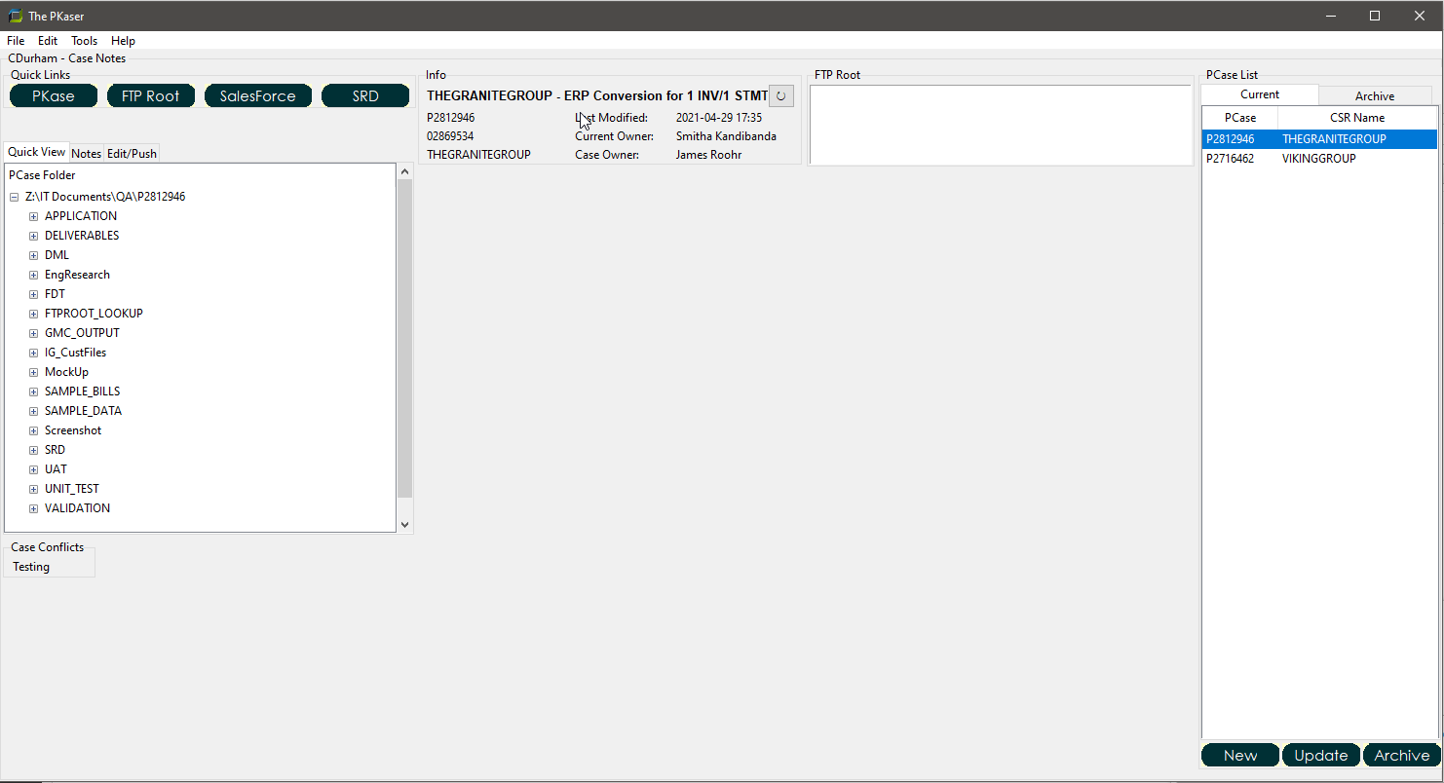

Fixes:

Resolved Archive and UnArchive issue by creating an unarchive option under the file menu.

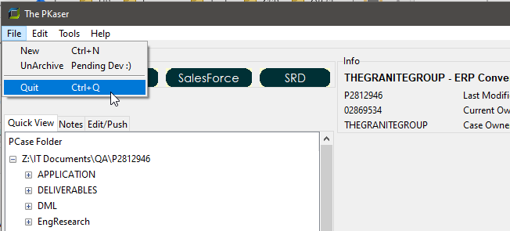

In Progress:

Created Real Estate for Code Conflicts Tool. Researching best way to display output of conflicts based on CSRNAME.

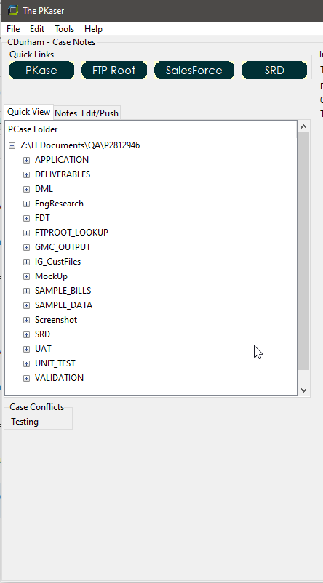

Goals:

Finalize output for Code Conflict Results.

Expedite roll out by implementing the PCase List in with Quick View. A user code then minimize the window to sit on the side of their own workflow, and update as need until the note taking feature is coded up and tested.