Pulse: an AI-assisted CRM for WooCommerce
Small online stores know their products better than their customers. Order data sits inside WooCommerce, and customer communication is usually manual. Pulse turns every order event into an organized customer record and a ready-to-review message.
- Customer data management: every order creates or updates a shopper profile with order count, lifetime value, last purchase and an automatic segment (New, Loyal, VIP, At-Risk).
- Order tracking: each status change (processing, on-hold, completed, refunded) is stored as an event, so every order has a timeline.
- Communication workflows: a status change triggers a message draft written by AI from the customer’s history. The draft appears in an approval queue where an agent edits it and clicks send. The AI is instructed to use only facts from the data and never invent tracking numbers, dates or discounts.
Tech stack: WooCommerce webhooks (HMAC-verified) and REST API, Node.js and Express, MySQL, React with Vite and Tailwind, the Anthropic API for drafts, and Resend for email.
Current status. I’d write this part exactly as it is true. For example: “The integration is built against WooCommerce’s webhook and REST formats and tested end to end with signed simulated webhooks. A local WooCommerce store (LocalWP) is set up for live testing.” Only change that to “tested with a live store” once you’ve received at least 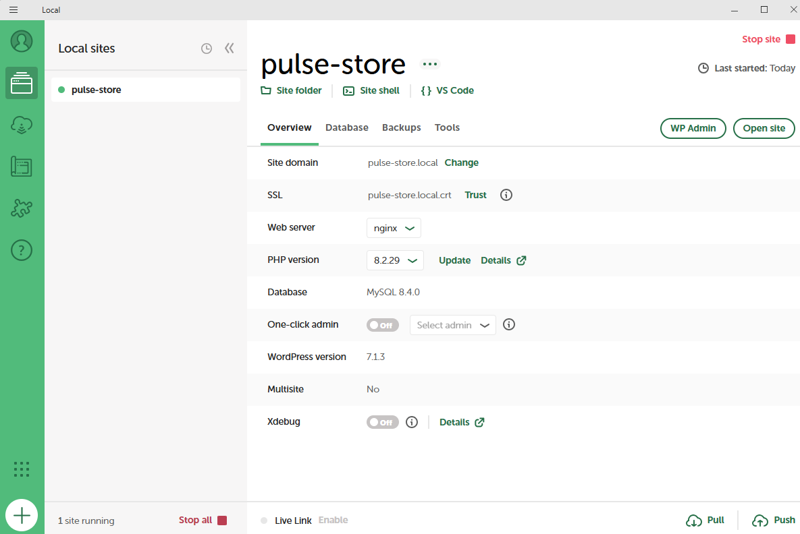one real order from it.
