Distributed Multi-Model Analytics for E-commerce Data
AUCA Big Data Analytics — Final Project Technical Report
Student | Christian MANZI SHEMA · Student ID 101382
Course / brief | Big Data Analytics, AUCA — project brief dated 28 Oct 2026
Technologies | MongoDB 7.0 · HBase 2.1 (Thrift) · Apache Spark 4.0.5 (PySpark) · Python 3.13 · Docker
Date | 9 November 2026 (submission due 11 Nov 2026, 11:59 am)

1. Introduction and objectives
This project builds a working analytics system in which MongoDB, HBase and Apache Spark each do the job they are best at, and then answers business questions that need all three together. It runs end-to-end on one Windows laptop: MongoDB and HBase in Docker, Spark in local mode on 8 cores. All numbers come from one reproducible run on 9 Nov 2026.
Part (weight) | What was built | Evidence
1. Data modeling (25%) | MongoDB document model: 5 collections, 9 indexes, 5 aggregation pipelines. HBase wide-column model: 2 tables, 7 query patterns | Notebooks 01–02; hbase_shell_commands.txt
2. Spark processing (30%) | Cleaning to partitioned Parquet; recommendation indicators; cohort analysis; 11 Spark SQL queries, 2 over live MongoDB + HBase data | Notebooks 03–04; spark_sql_queries.sql
3. Integration (25%) | Customer Lifetime Value and funnel conversion, each combining all three systems | Notebook 05
4. Visualization (20%) | 8 static charts and auto-generated findings | Notebook 06; outputs/figures

2. Dataset and data-quality findings
The course generator was run at medium scale: 10% of the brief's session and transaction volume (401 MB of JSON). The full 2 million sessions need 15+ GB of RAM just to generate, because the script keeps every session in one Python list; the analysis code is identical at any scale. Only two changes were made to the generator: a SCALE setting, and writing each file in one call (much faster on Windows).
Entity | Records | Size | Notes
Users | 10,000 | 1.8 MB | registered 2026-02-12 to 2026-08-11
Products / categories | 5,000 / 25 | 1.6 MB | 234 inactive, 163 out of stock; 3–5 subcategories per category
Transactions | 50,000 | 21.9 MB | 2026-08-11 to 2026-11-09 (91 days)
Sessions | 200,000 | 376 MB | 1,998,578 page views, in 2 files
Profiling the data before designing schemas found four facts that shaped every later decision:
- The conversion_status flag is unreliable: 15,515 of 40,609 "converted" sessions (38%) have no transaction. Real purchases are always taken from transactions.
- Half of all orders have no session (24,906 of 50,000), so the funnel can only use session-linked orders.
- Products have no subcategory_id (the brief's sample shows one), so margin is estimated per category.
- Users have no age, so segmentation uses purchase frequency, RFM, registration cohort and country instead.
No duplicate IDs, null keys or arithmetic errors were found: subtotal − discount = total holds for all 50,000 orders.

3. System architecture
MongoDB and HBase form the storage layer, each holding the data its model suits. Spark is the processing layer: it cleans the raw files, runs batch and SQL analytics, and joins live data from both stores for the integrated queries.
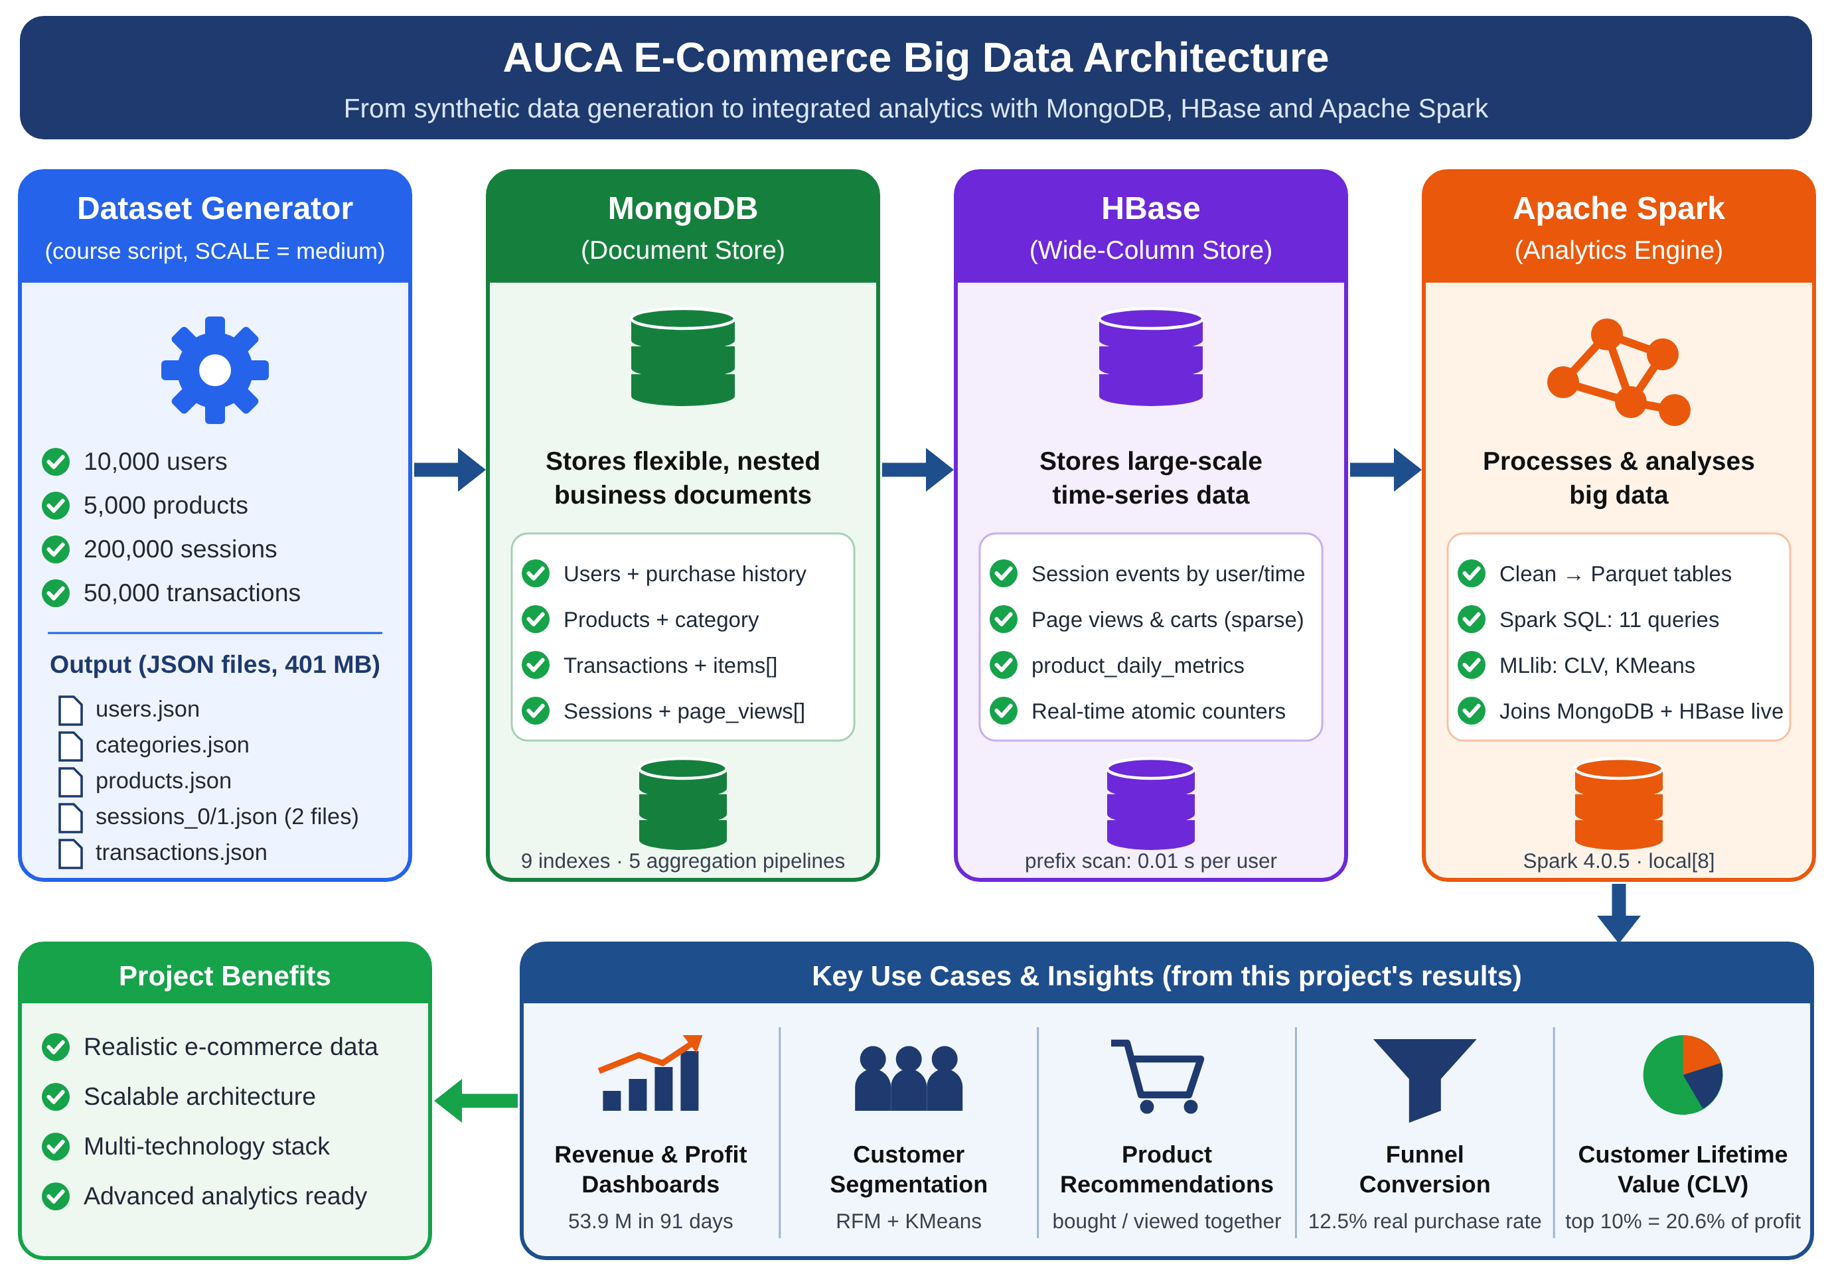
Figure A. System architecture (also delivered as docs/architecture.svg).

4. Data modeling decisions (Part 1)
Each store holds the data whose access pattern it serves best: MongoDB the rich, nested business entities queried in many different ways; HBase the high-volume, append-only session stream that is read by user and time.
Data | Store | Access pattern that decided it
Products + category; users + purchase summary | MongoDB | Read-heavy; filtered and segmented on many fields
Transactions + line items | MongoDB | Ad-hoc revenue analytics with $unwind, $group, $lookup, $bucket
Sessions (complete journeys) | MongoDB | Analyse a whole journey in one document (the brief's example query)
Session event stream | HBase user_sessions | "All sessions of user X, newest first" at any volume; sparse, variable columns
Product metrics per day | HBase product_daily_metrics | "Trend of product X over a date range"; atomic counters for streaming
Sessions are stored in both systems on purpose: MongoDB answers flexible journey questions; HBase serves the per-user lookup that must stay fast at billions of rows.

4.1 MongoDB document model
- Embed what is read together and bounded: a transaction's items[] and a session's page_views[].
- Denormalise small, stable attributes: each product embeds {category_id, name, avg_margin} and each line item carries its category_id, so revenue by category needs no $lookup.
- Replace dynamic keys with arrays: cart_contents: {"prod_00123": {…}} cannot be indexed, so it becomes cart_items: [{product_id, quantity, price}].
- Store real dates (datetime, not strings) so range queries and date operators use indexes.
- Pre-compute summaries in the database: two $group + $merge pipelines write purchase_summary and preferences.top_categories into each user, so segmentation reads 10,000 documents instead of joining 50,000 orders.
Indexes follow the query patterns (9 in total, e.g. transactions(user_id, timestamp), multikey items.product_id). One customer's orders read 4 documents in 3 ms with the index versus 50,000 documents in 27 ms with a forced collection scan. Loading used batches of 5,000 with ordered=False; 200,000 sessions loaded in 24 s.
Aggregation pipeline (2 required, 5 built) | Brief category | Key technique | Result
Top-selling products | Popularity | $unwind, $group, $lookup after $limit | #1: 102 units, 46 buyers
Most-viewed products | Popularity | $unwind viewed_products | top: 193 sessions
Revenue and profit by category × month | Revenue | discount allocated pro rata; $dateToString | top category 2.60 M
Customers by purchase frequency | Segmentation | $bucket on purchase_summary | 50% placed 4–6 orders
Daily revenue; conversion by device × referrer | Revenue / behaviour | conditional $sum | ~20–21% in every group

4.2 HBase wide-column model
In HBase the row key is the schema. user_sessions uses user_id # reverse_timestamp # session_id with reverse_timestamp = 9,999,999,999,999 − epoch_ms (13 digits). User first keeps a user's sessions adjacent (one prefix scan); the reversed time sorts newest first, so "last 5 sessions" is a scan with limit=5 and no sort; the session suffix keeps keys unique. Families: meta (duration, referrer, status), device, geo, pv (one column per page view: sparse, variable count) and cart (the product ID is the column name — natural in HBase, an anti-pattern in MongoDB). All families use VERSIONS=1 and row Bloom filters; the shell script pre-splits the table into 5 regions. product_daily_metrics uses product_id # yyyymmdd with views, cart adds, purchases, units and revenue, kept current with atomic counter_inc.
Query (200,000 sessions loaded at ~1,540 rows/s) | Access path | Time
All sessions of one user / last 5 sessions | prefix scan (+ limit) | 0.01 s
A user's sessions in a 14-day window; one product's 81-day trend | range scan on computed start/stop keys | 0.02 s
Rebuild one full journey | point get | 0.08 s
Key lookup vs full-table scan (100 users) | 14.5 ms per user vs 4.84 s per scan | ~333× cheaper
The trade-off is explicit: a new question such as "sessions by referrer" needs a full scan in HBase, so such questions go to Spark or to a second table keyed for them.

5. Spark processing pipelines (Part 2)

5.1 Batch pipeline
- NDJSON conversion — the generator writes giant JSON arrays that Spark cannot split; one record per line lets Spark read in parallel.
- Explicit schemas — no inference pass, and no silent type changes.
- Clean and validate — drop null keys and duplicates, parse timestamps, standardise text, explicit defaults (UNKNOWN country, 0 stock); rule violations (total = subtotal − discount, subtotal = Σ items, duration > 0) are flagged, not deleted. A reconciled is_purchased flag from real transactions replaces conversion_status.
- Enrich — price history, category margin (broadcast join), each line item's share of the order discount and estimated gross profit; funnel flags, cart value, hour and weekday per session.
- Flatten and write Parquet — 1,998,578 page-view rows and 208,004 cart rows; sessions, page views and carts partitioned by session_date.

5.2 Product recommendation indicators
Support, confidence and lift are computed for every product pair with a basket self-join (a.product_id < b.product_id). "Bought X also bought Y" (50,000 orders) kept 351 pairs seen ≥ 2 times; "viewed together" (171,920 sessions) kept 2,130 pairs seen ≥ 3 times, turned into a top-5 recommendation table per product with a window function. A null-model check refilled the same baskets with random products: it produced 1,652 pairs with median lift 28.3, against 2,130 and 24.7 for the real data. The same order of magnitude means the generator has no built-in product affinity — the pipeline is correct, but there are no real relationships to find.

5.3 Cohort analysis
Users are grouped by registration month (Feb–Aug 2026) and their spending measured in three equal 30-day periods, so every cohort has the same exposure. About 80% of every cohort buys in every period, spending 1,688–1,879 per user (period average 1,765 → 1,826). There is no cohort effect.

5.4 Spark SQL analytics
# | Question | SQL techniques | Key result
A1 | Top 3 products per category | CTE + RANK() OVER (PARTITION BY …) | 75 rows
A2 | Daily revenue trend | AVG … ROWS 6 PRECEDING, LAG(…,7) | stable near 600 k/day
A3 | RFM scoring | NTILE(5) × 3, CASE | 2,165 Champions (avg 7,865); 2,391 At risk (3,083)
A4 | Funnel by device | conditional aggregation | real 12.5% vs platform flag 20.3%
A5–A6 | Category conversion; views vs sales | 3 CTEs joined; LEFT JOIN + COALESCE | view-to-cart ~30%; r = 0.70
A7–A9 | Weekday × hour; payment × status; countries | joins, PIVOT | apple_pay/crypto only "completed"
B1 | Does engagement (HBase) predict spend (MongoDB)? | cross-system join + NTILE(3) | high vs low: 5,885 vs 4,933 (+19%)
B2 | Loyal buyers who stopped visiting | cross-system join + DATEDIFF | re-engagement list
B1 and B2 run on data loaded live from MongoDB (PyMongo) and HBase (Thrift scan of the meta family only) by src/federation.py; the notebook prints MongoDB (LIVE) + HBase (LIVE). If a store is down it falls back to Parquet and labels the result "SIMULATED". All 11 queries are in outputs/spark_sql_queries.sql.
Optimisations, measured: Parquet answered a sessions-per-device query in 1.06 s vs 3.84 s for NDJSON (3.6× faster); partitioning by date made a one-week query read only 7 folders (PartitionFilters); small dimensions are broadcast (BroadcastHashJoin, no shuffle of the large side); 16 shuffle partitions + adaptive execution instead of 200; reused DataFrames are cached.

6. Integrated analytics workflows (Part 3)
Two integrated queries were built (one required). Both read MongoDB and HBase live and use Spark for the joins and computation neither store can do alone.

6.1 Query A — Customer Lifetime Value
Business question: which customers will be worth the most over the next 12 months, and does browsing engagement add anything beyond past spend? Workflow: (1) MongoDB returns user profiles with the pre-computed purchase_summary (0.9 s); (2) HBase returns per-user sessions, duration and page views from a scan of the small meta family (9.6 s); (3) Spark joins both with line-item gross profit; (4) Spark scores 12-month CLV; (5) MLlib validates the signal on a time split; (6) MLlib KMeans segments customers.
CLV_{12m} = (gross profit observed ÷ months observed) × Σ_{t=0..11} r^{t} / (1+d)^{t}, r = 0.90, d = 1% → multiplier 6.88
- Projected 12-month profit is 30.9 M; the top 10% of customers hold 20.6% of it, the top 30% hold 49%.
- KMeans chose k = 2 (silhouette 0.456 vs 0.391 for k = 3): Engaged big spenders are 41% of customers but 61% of projected profit (6.9 orders, 8,041 spend on average).
- Honest validation: linear regression and a 100-tree random forest beat the run-rate baseline (RMSE 1,655 vs 2,054) but R² ≈ 0, with flat feature importances. Engagement carries no extra signal about next month's spend in this synthetic data; on real data, this same test decides whether to trust an engagement-based CLV.

6.2 Query B — Funnel conversion
Business question: how many sessions view, add to cart, reach checkout and really buy; where is the biggest loss; and how much money is at stake? Workflow: journeys come from the session data (HBase pv/cart families; the all-user funnel is a full-scan aggregation, so it runs in Spark); purchases come from MongoDB transactions.distinct("session_id"). Spark's purchased-session set equals MongoDB's exactly (25,094 = 25,094). Each funnel stage requires the one before.
- 12.5% of sessions end in an order; the biggest loss is cart → checkout (72,134 sessions, 44.6% step conversion).
- The platform flag reports 40,609 conversions against 25,094 real orders: it over-reports by 62%.
- Money at stake: 72.0 M in abandoned carts and 12.3 M in failed checkouts (flagged converted, no order — likely stock-outs), against 20.0 M actually purchased.
- Device and referrer rates span only 12.1–12.8%; with ~40,000 sessions per group this is noise.
Performance: HBase reads only the light meta family and MongoDB serves a pre-aggregated summary, so the expensive joins happen once, in Spark; extracted DataFrames are cached because MLlib iterates over them.

7. Visualizations and business insights (Part 4)
Four visualizations answer the four questions the brief names: sales performance, customer segmentation, product performance and the conversion funnel. All are static Matplotlib/Seaborn charts (200 dpi) drawn from the result tables of notebooks 03–05 by notebooks/06_visualization_and_insights.ipynb and src/report_figures.py.

Figure 1 — Sales performance over time and by category
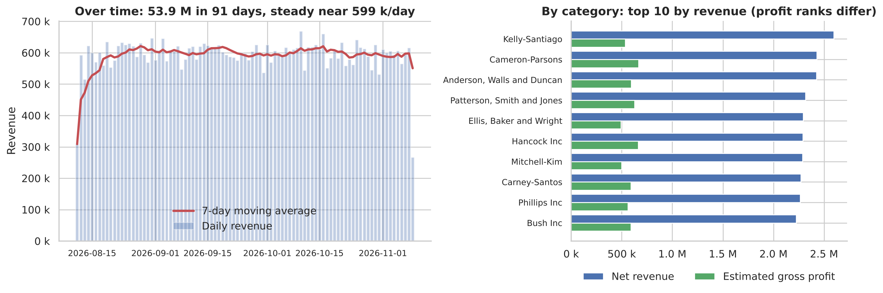
Figure 1. Left: daily revenue and 7-day moving average (first and last days are partial). Right: top-10 categories, net revenue vs estimated gross profit.
Sales are steady, and category profit ≠ revenue. Revenue totals 53.9 M over 91 days at about 599 k/day, with only 5% day-to-day variation and no weekly or monthly seasonality. Kelly-Santiago leads revenue (2.60 M), but Rodriguez-Graham earns the most estimated profit (748 k) because margins range from 18% to 36%. Insight: promotions and shelf space should follow profit, not revenue.

Figure 2 — Customer segmentation and average spending
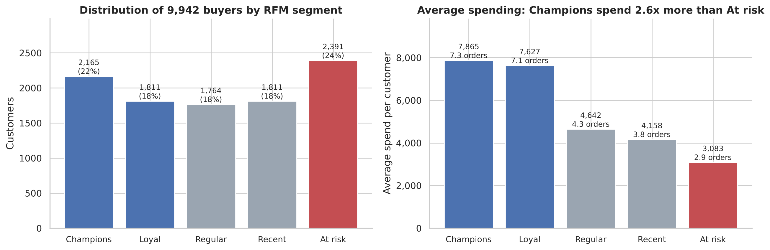
Figure 2. Distribution of the 9,942 buyers by RFM segment (left) and each segment's average spending and orders (right). The data has no age field, so RFM segments replace the brief's age groups.
Spending differs 2.6× between segments. Champions (2,165 customers, 22%) spend 7,865 on average over 7.3 orders; the largest group, At risk (2,391, 24%), spends only 3,083 over 2.9 orders. Champions and Loyal together are 40% of buyers but 57% of all revenue. Insight: protect Champions and Loyal with retention offers, and win back At-risk customers before they lapse.

Figure 3 — Product performance: top-selling vs most-viewed
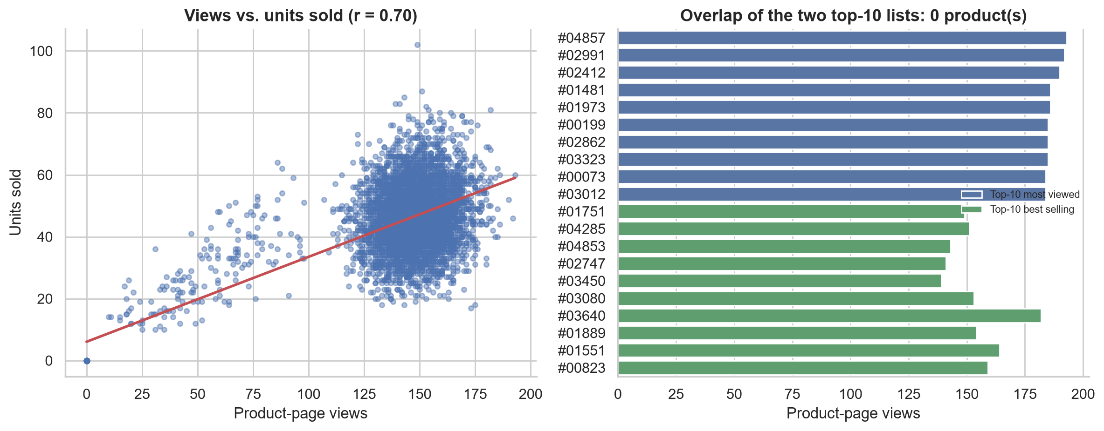
Figure 3. Product-page views vs units sold for all 5,000 products (left) and the top-10 most-viewed vs top-10 best-selling products (right).
Popular pages are not the best sellers. Views and sales are correlated (r = 0.70), yet none of the 10 most-viewed products is among the 10 best-sellers; the median is 0.32 units sold per view. Insight: high-view, low-sale products are candidates for a price or product-page review.

Figure 4 — Conversion funnel stages
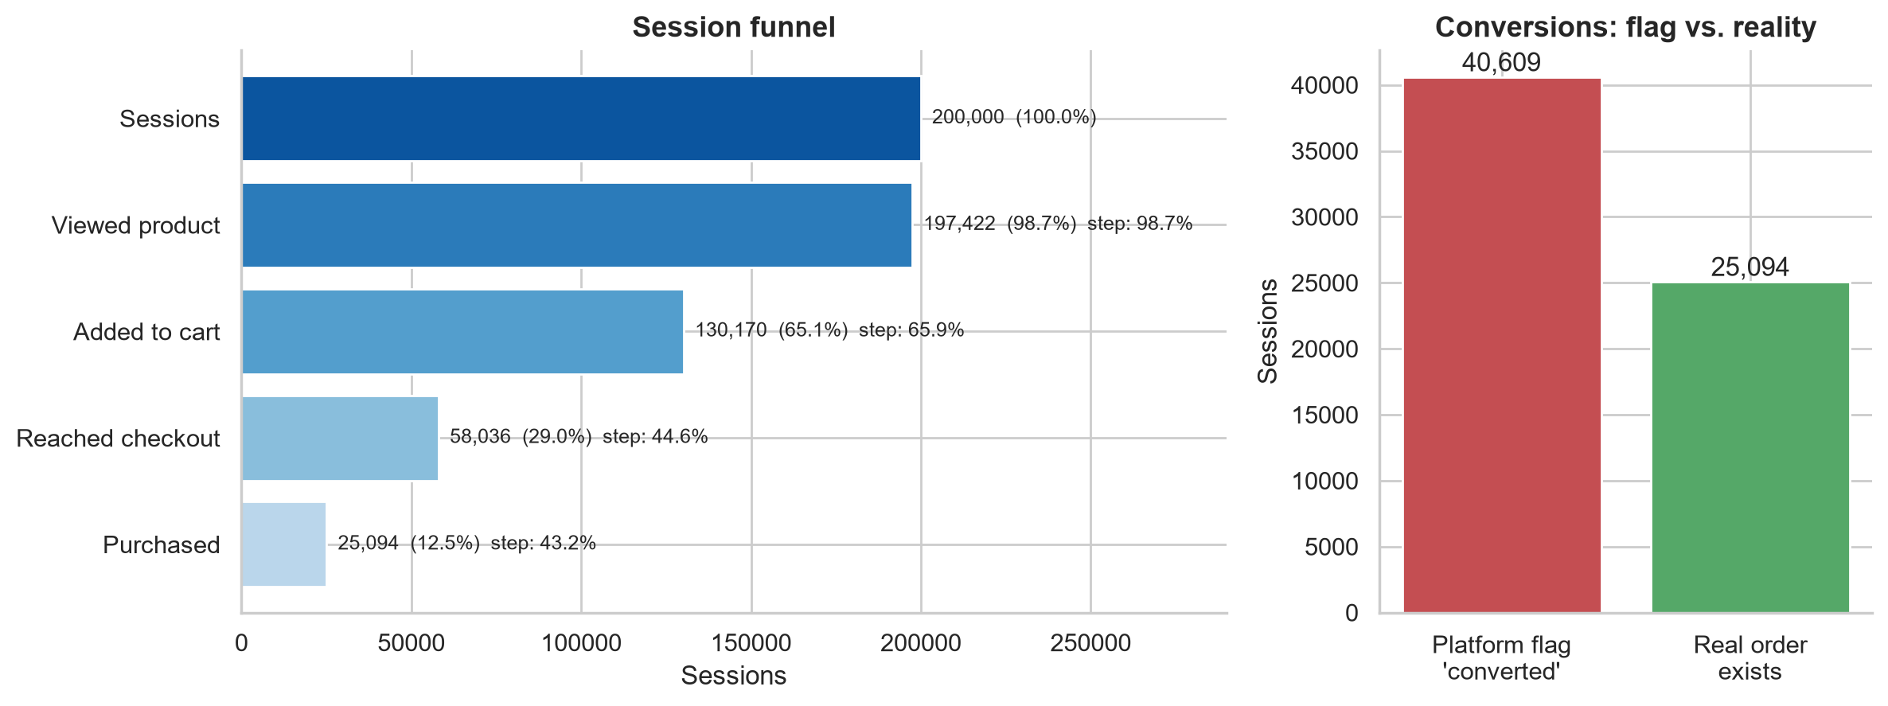
Figure 4. Strict session funnel — each stage requires the previous one (left) — and the platform's 'converted' flag vs sessions with a real order (right).
Only 12.5% of sessions end in an order, and the biggest leak is cart → checkout (72,134 sessions lost; step conversion 44.6%). The platform's own flag reports 40,609 conversions against 25,094 real orders, over-stating conversion by 62%, and 12.3 M of cart value sits in checkouts that never became orders. Insight: report conversion from real orders, and fix stock availability at checkout first.

Recommendations
- Measure conversion from real orders, never the platform flag (62% over-reporting).
- Fix stock availability at checkout: 12.3 M of cart value was lost after customers had decided to buy.
- Retain Champions and Loyal customers (40% of buyers, 57% of revenue) and win back the 2,391 "At risk" customers.
- Review price and pages of high-view, low-sale products; manage categories on profit, not revenue.

8. Scalability, limitations and future work
Component | Scales by | Watch-out at 10× volume
MongoDB | Sharding (transactions on hashed user_id; sessions on {user_id, start_time}); per-shard aggregation | Cross-shard $lookup is costly — hence denormalised categories
HBase | Regions split by key range across region servers; per-user scans stay in milliseconds at any size | Sequential IDs concentrate writes: pre-split (done) or salt hash(user_id) % N
Spark | More executors; partitions follow the Parquet files; same code | Pair self-joins grow with basket size: cap or sample baskets
Ingestion | Parallel loaders; HBase bulk-load from HFiles; official Spark connectors | Generator must stream records (2 M in one list needs 15+ GB)
Streaming: the demonstrated HBase counter_inc on product_daily_metrics is the write path for a Spark Structured Streaming job reading page-view events from Kafka, so batch and stream share one table.
Limitations. (1) Synthetic, independently random data: the null-model affinity result, flat cohorts, R² ≈ 0 and even channels are properties of the data, not method failures, and are not findings about real customers. (2) No subcategory_id or age. (3) 10% of the brief's volume, a configuration choice for an 8 GB laptop. (4) 91 days cannot show churn, so CLV rests on a stated 90% retention assumption; a sensitivity check at 80% and 95% is advised. (5) Single-node timings show relative, not cluster, cost. (6) Half the orders have no session.
Future work. Replace the Python bridges with the mongo-spark and hbase-spark connectors; add the Structured Streaming job; train collaborative filtering (Spark ALS) on richer data, keeping the null-model check; fit a churn model on a longer history.

9. Conclusion and technology selection
Analytical task | Technology | Reason
Revenue, popularity, frequency segments | MongoDB aggregation | Nested items[], indexed $unwind/$group/$bucket, no ETL
A customer's latest sessions; a product's daily trend; live counters | HBase | Row-key design → prefix/range scans in 0.01–0.02 s; atomic increments
Cleaning 2 M page views, pair mining, cohorts, SQL reporting | Spark / Spark SQL | Full-data passes, self-joins, window functions, PIVOT in parallel
CLV and funnel across all stores | Spark + MongoDB + HBase | Only Spark can join both stores and run MLlib on the result
The three technologies proved complementary rather than interchangeable. The analysis also checked itself: it reconciled an unreliable conversion flag against real orders, tested product affinities against a random baseline, and validated the CLV signal on a time split. Where the synthetic data could not support a conclusion, the report says so.
Reproducibility. Repository: github.com/Chrisma111/AUCA-Big-Data-Analytics-_101382. Run docker compose up -d, install requirements.txt (Python 3.10–3.13, Java 17), then notebooks 00 → 06 in order (about 20 minutes in total). Supporting files: hbase/hbase_shell_commands.txt, outputs/spark_sql_queries.sql, outputs/key_findings.md, outputs/tables/*.csv, docs/*.xlsx.

