|  |  |
| --- | --- |
| **ACTIVITY:** | *Barangay Yook General Assembly First Semester 2025* |
| **DATE:** | *March 23, 2025* |
| **VENUE:** | *Yook Covered Court* |
| **NO. OF  PARTICIPANTS:** | *Barangay Officials and Residents, including one DILG Intern* |
|  | |
| **REPORT SUMMARY** | |
|  | |
| **I. OBJECTIVES OF THE ACTIVITY:** | |
| *The Barangay Assembly aimed:*   * *To discuss about the State of Barangay Address (SOBA)* * *To discuss about the accomplishments of each Barangay Kagawad/Comittee* * *To discuss about the issues and concerns of each residents of the Barangay* | |
|  | |
| **II. HIGHLIGHTS OF THE ACTIVITY:** | |
| ***Call to Order***   * *The assembly started at 1:28 PM with a prayer and the singing of the Pambansang Awit.*   ***Opening Remarks***   * *Given by Punong Barangay Clemencia Villavicencio. She introduced the topics to be discussed, including barangay issues and concerns.*   ***State of the Barangay Address (SOBA)***   * *Delivered by Punong Barangay* * *Discussed the current status of the barangay and necessary improvements.* * *Reported some of the past events by the barangay:* * *Last month’s medical mission* * *LTO seminar* * *Yook National High School (YNHS) participation in Street Dancing Competition* * *Engr. Daryl Famadico expressed gratitude for assistance with the road project in Madricacawan* * *Appreciation for plumbers who repaired water lines in Siluan, Yook.* * *Barangay resolution passed to improve the water system*   ***Accomplishment Reports:***   * *Kagawad Rejie Castillo:* * *Assisted plumbers in fixing water issues.* * *Water system in Sitio Layas is nearing completion, pending water pump installation.* * *Kagawad Guillermo Mataac:* * *Assigned to Sitio Balikot, which has 1,000 households* * *Updates on road project in Madricacawan with the assistance of Engr. Famadico.* * *Kagawad Teddie Reanzares:* * *Encouraged youth participation in future assemblies* * *Reported improvements in Proper 1 area.* * *175 elementary students receiving educational assistance.* * *Kagawad Hilda Edora:* * *Health and VOWC initiatives* * *Barangay Yook won “Best in Breastfeeding Corner” in Buenavista among 17 barangays* * *Distributed milk and medicine to children* * *Noted a decrease in reports of domestic violence* * *Few messages from Councilor Edgar Perlas* * *Kagawad Sherwin* * *Educational cooperative matters* * *Advised parents to limit children’s gadget usage* * *Kagawad Sergio Macaburas* * *Disaster preparedness initiatives* * *Encouraged proper care for plants, animals, and fishing equipment.* * *Advocated for waste segregation* * *Participated in Fire Prevention Month activities at YNHS* * *Kagawad Peejay Castillo* * *Peace and order updates* * *Barangay is more peaceful with fewer incidents* * *Barangay won overall championship in the region* * *SK Chairman John Lennon* * *No transactions for 2025 yet* * *Budget was prepared on October 2, 2024* * *Actively participates in barangay sessions and meetings* * *Barangay Treasurer’s Report by Treasurer Edraline Privado* * *Presented barangay expenses, including electricity, internet, travel to Albay, honoraria, and certification clearances.*   ***Open Forum***   * *Some of the residents requested to replace the main water line with alarger one to improve water supply.* | |
|  | |
| **III. OUTPUT/S OF THE ACTIVITY:** | |
| * ***Barangay Accomplishment Reports*** *– Updates from each Kagawad regarding their respective responsibilities (e.g., water system repairs, educational assistance, disaster preparedness, health programs, peace and order).* * ***State of the Barangay Address (SOBA)*** *– Summary of the barangay’s current status, past initiatives, and future plans.* * ***Barangay Treasurer’s Financial Report*** *– Breakdown of expenses such as utilities, honoraria, and other barangay expenditures.* * ***Community Concerns and Resolutions*** *– Issues raised in the Open Forum, such as the request to improve the main water line.* * ***Acknowledgments and Recognitions*** *– Appreciation for individuals and groups who contributed to barangay projects (e.g., road construction, plumbing repairs, health initiatives).* | |
|  | |
| **IV. RECOMMENDATIONS/RELEVANT APPLICATION IN DILG *(if any):*** | |
| ***Recommendations:***   1. ***Strengthen Community Participation*** *– Encourage more residents, especially the youth, to actively participate in barangay assemblies and local governance. This aligns with DILG’s Barangay Assembly Day mandate.* 2. ***Improve Water Infrastructure*** *– Since water supply issues were raised, the barangay should coordinate with the DILG’s Support to the Barangay Development Program (SBDP) or seek assistance from the Local Government Support Fund (LGSF) for funding improvements.* 3. ***Sustainability in Health and Education Programs*** *– Collaborate with DILG’s Seal of Good Local Governance (SGLG) criteria to maintain high standards in health services (e.g., breastfeeding advocacy) and education support (e.g., scholarships, gadget use awareness).* 4. ***Promote Waste Segregation and Environmental Protection*** *– Align with DILG’s Barangay Environmental Compliance Audit (BECA) and seek support for waste management programs.* 5. ***Strengthen Peace and Order Initiatives*** *– Coordinate with the Barangay Peace and Order Committee (BPOC) under the DILG to ensure continuous improvement in crime prevention and community safety.*   ***Relevant Application in DILG:***   * *The discussions on water system improvements, disaster preparedness, and health initiatives support the* ***SGLG*** *requirements for good barangay governance.* * *Peace and order updates contribute to the* ***Barangay Peacekeeping Action Teams (BPATs)*** *initiative under DILG’s Peace and Order Program.* | |
|  | |
| **V. REQUESTED ACTIONS *(if any):*** | |
| * ***Water System Improvement*** *– Request DILG funding and coordinate with local agencies to upgrade the main water line.* * ***Youth Engagement*** *– Encourage SK programs for youth participation and request leadership training support from DILG.* * ***Disaster Preparedness*** *– Seek LDRRMF resources for training and equipment, and organize emergency drills.* * ***Health & Social Services*** *– Request DOH and DILG support for maternal health programs and strengthen the VAWC Desk.* * ***Peace & Order*** *– Train Barangay Tanods and BPATs with MPOC assistance and seek anti-drug campaign support.* * ***Environmental Protection*** *– Request BECA support for waste management and coordinate with MENRO for garbage collection improvements.* | |

**VI. Attachments *(check as applicable)*:**

|  |  |
| --- | --- |
| Photos | Program of activities |
| Powerpoint/lecture materials | Certificate of attendance/participation/completion |
| Brochures | Others (specify) _____________________________________ |
| Workshop/Activity Materials | _____________________________________ |
| *Pre and Post Test Analysis for Provision of*  *Technical Assistance Procedure– Category A,*  *if applicable* |  |

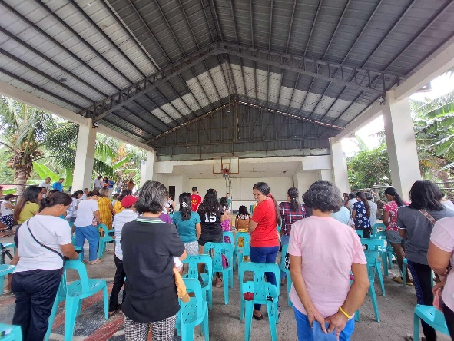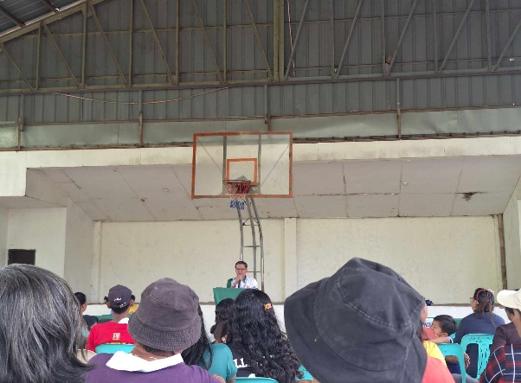

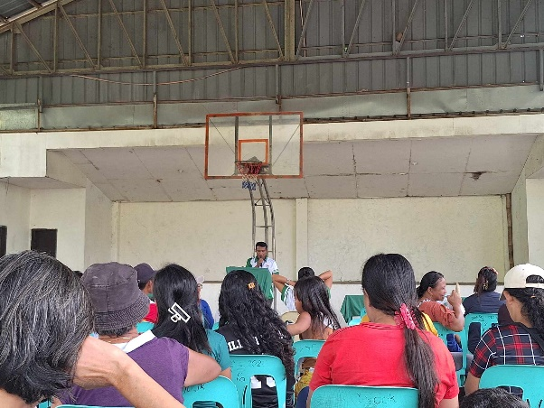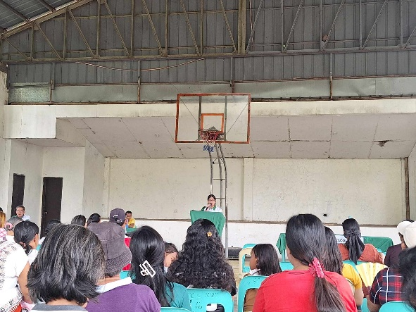

Prepared by: Noted by:

________________________________________ _______________________________________________

MARY AGUSTHINE R. RAMIREZ, Intern DARYL A. BUENAVENTURA