

GHETTOBASA

System Documentation



Dessylynn inc.

Functions

System has the following functions:

* Register users.
* Approval of user registrations.
* View user’s info.
* Create a job.
* Retrieve all jobs.
* Bid for a job.
* Receive job biddings.
* Confirm a bid and nullify the other bids on the job.
* Re-open job posts in events of unforeseen circumstances.
* Rate a user based on job performance and satisfaction.
* Review a user.
* View or generate system reports.

User Portals

The system consists of two user portals:

1. Admin Dashboard
2. User Dashboard
3. Admin Dashboard facilitates the following:
   1. User authentications.
   2. System statistics on dashboard.
   3. Admin user management.
   4. Approve user registrations.
   5. View reports.
   6. View job history.
   7. View user info.
4. User Dashboard facilitates the following:
   1. User authentication.
   2. Create jobs.
   3. View jobs.
   4. Bid for a job.
   5. View job bids.
   6. Rate a user.
   7. Review a user.

Database design

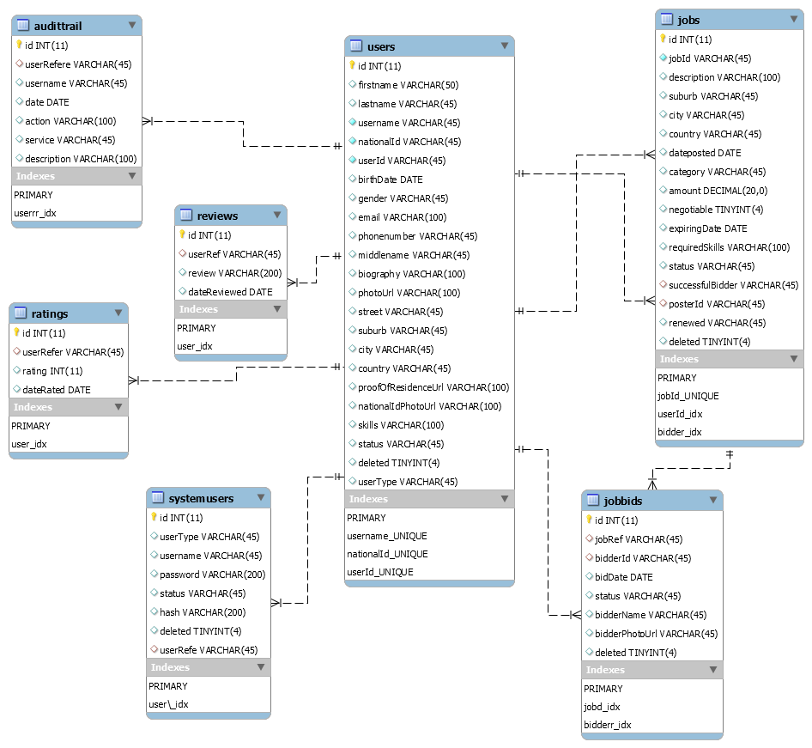

System Tools

The system was made by the following technology stack:

* .NET core framework
* MySQL database engine
* Angular Framework
* Bootstrap
* jQuery