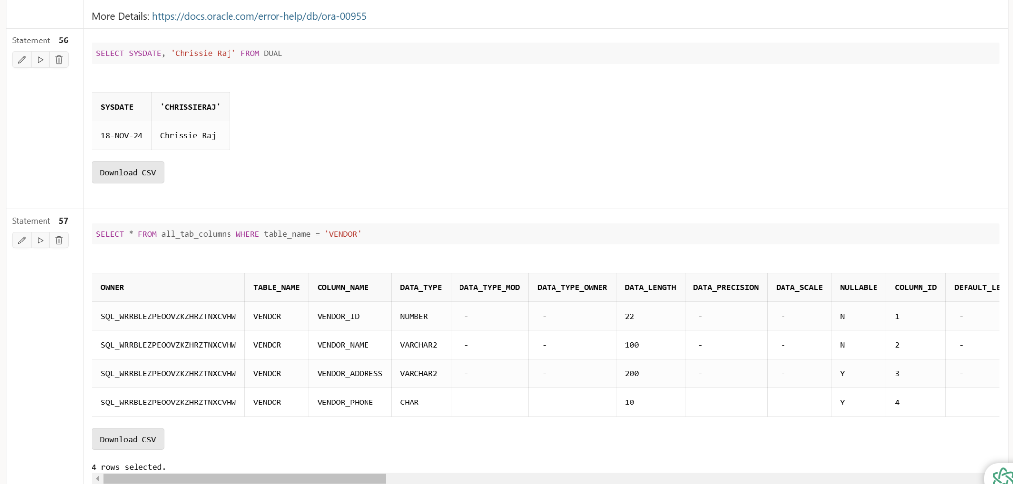

Displays the current date (18-NOV-24) and the user's name (Chrissie Raj) using the SYSDATE function to personalize query results.

Shows the structure of the VENDOR table, including the columns VENDOR_ID, VENDOR_NAME, VENDOR_ADDRESS, and VENDOR_PHONE, along with their data types, lengths, and constraints (e.g., NOT NULL for VENDOR_NAME and UNIQUE for VENDOR_PHONE).

ERD:

### **1. VENDOR Table**

* **Attributes:**
  + vendor_id: Primary Key (PK).
  + vendor_name: VARCHAR2(100), NOT NULL.
  + vendor_address: VARCHAR2(200).
  + vendor_phone: CHAR(10), UNIQUE.
* **Constraints:**
  + Correct use of PK on vendor_id.
  + Proper application of NOT NULL and UNIQUE constraints on vendor_name and vendor_phone.

### **2. PRODUCT Table**

* **Attributes:**
  + product_id: Primary Key (PK).
  + prod_desc: VARCHAR2(255), UNIQUE.
  + prod_price: NUMBER(10, 2), NOT NULL.
* **Constraints:**
  + Correct use of PK on product_id.
  + Proper application of UNIQUE on prod_desc.
  + Correct implementation of NOT NULL on prod_price.

### **3. VENDOR_PRODUCT (Bridge Table)**

* **Attributes:**
  + vendor_id: Foreign Key (FK), referencing VENDOR.vendor_id.
  + product_id: Foreign Key (FK), referencing PRODUCT.product_id.
  + Composite Primary Key (PK) on (vendor_id, product_id).
* **Relationships:**
  + Many-to-Many relationship between VENDOR and PRODUCT is accurately represented using the bridge table vendor_product.
  + Correct use of FK constraints to link the primary keys from VENDOR and PRODUCT.

