Assignment 1

Christos Zotos

Cognitive Computing

ITC 3154 A1

Proff. Grigoriadis

24/10/2026

Task 1 and 2:
I downloaded the data set that was given in the blackboard assignment and loaded it inside a folder in Vs Code. I then printed df.head(20). Below is a screenshot of the first 20 lines/rows and their 12 columns. I also removed extra spaces from the column names with df.columns = df.columns.str.strip for better readability. 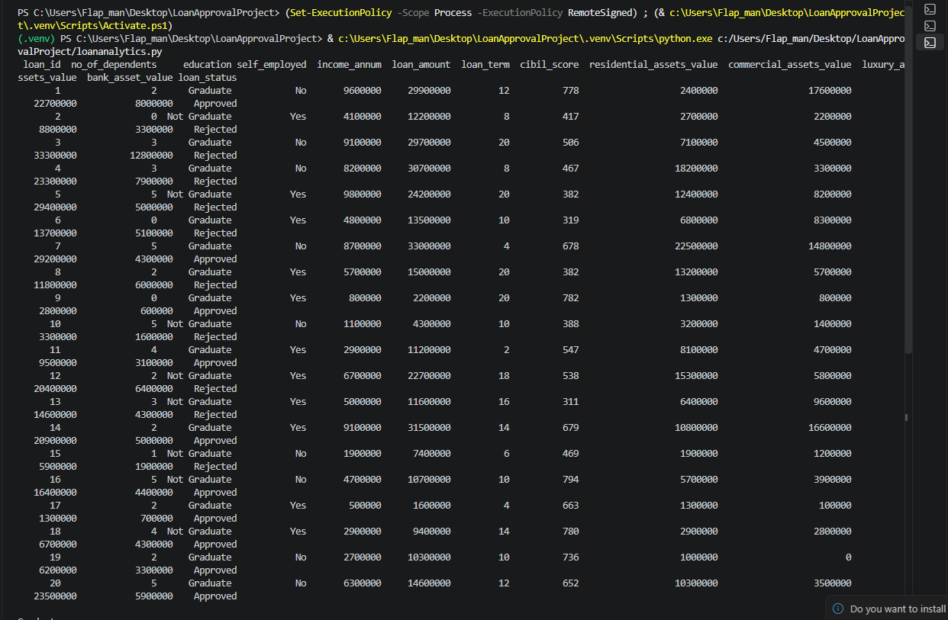

Task 3:
Below is the table where I asses each column based on what it represents.
Feature | Important | In-between | Not-important | Reason
loan_id |  |  | ✔ | It doesn’t tell us anything about the applicants finances
no_of_dependents |  | ✔ |  | Having to support more people can create financial strain
education |  | ✔ |  | While better educated people tend to make more money, that’s not certain
self_employed |  | ✔ |  | Being self-employed affects a steady income stream.
income_annum | ✔ |  |  | Someone’s income shows if he has enough money to repay a loan
loan_amount | ✔ |  |  | Is very important as it basically showcases how much money someone will be to pay back
loan_term |  | ✔ |  | the period of time is how long a person has to pay the loan
cibil_score | ✔ |  |  | Important, someone’s credit score gives him trust for future loans
residential_assets_value |  | ✔ |  | Assets like this can be inherited and don’t show how much money someone makes
commercial_assets_value |  | ✔ |  | A business doesn’t mean that a person can make enough money to pay back a loan
luxury_assets_value |  | ✔ |  | Luxury assets can be taken as repayment fir a loan
bank_asset_value | ✔ |  |  | Someone’s assets give assurance that repayment is possible

Task 4: Heat map
I converted the loan Status labels together into a new numerical column with Approved being 1 and Rejected equal to 0. This allowed the outcome to be also included in the correlation matrix. I then selected numerical columns and excluded load id because it was an identifier. I calculated corrmatrix = numnerical_data.corr() and passed corrmatrix into a sns.heatmap (green white).
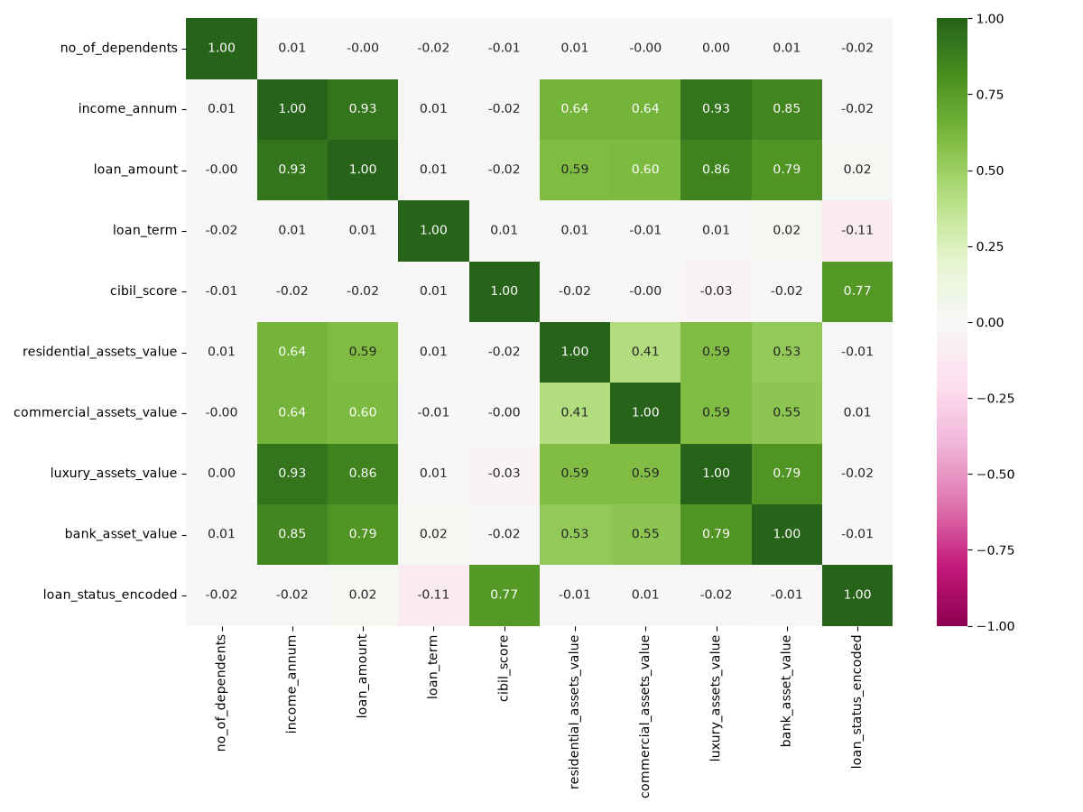

Task 5:
Cibil_score has the strongest relationship with loan approval, with a correlation of 0.77. Meaning that applicants that possess higher credit scores tend to get approved more often. While loan_term has a negative correlation of −0.11. The other numerical features have correlations close to zero, showing minimal individual relationship with approval of the loans.
I selected education and compared their loan outcomes (approved/rejected) for graduates and non-graduates.
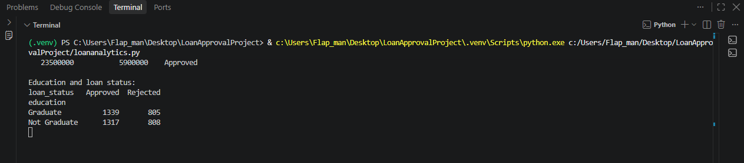
Based on the results the differences in the approval/rejection ratio is very minimal between them, showcasing that education only lightly manipulates a loan approval decision.

