Untitled
Table of contents

1 中文
library(ggplot2)
ggplot()+
geom_text(aes(1,3,label="开题"))
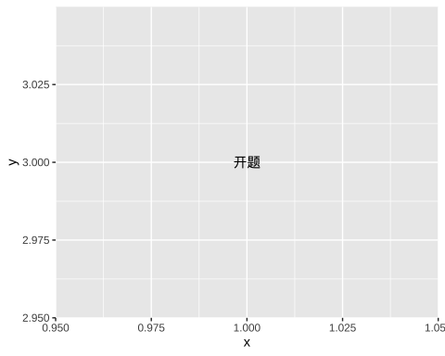
ggplot(diamonds,aes(x=price))+
geom_histogram()+
labs(x="切工",y="频数",title = "测试")
`stat_bin()` using `bins = 30`. Pick better value with `binwidth`.
