Tester: Yujia Yang

IS 2545 - DELIVERABLE 5: Performance Testing Conway's Game of Life

**Summary:**

When I run the program and looked at CPU time shown in VisualVM, I found that toString() method, convertToInt() method and runContinuous() method took up most running time, so there may be some inefficient code in these three method. After understanding the whole program, I noticed that all of these three method used loops that are not useful. Such as in the toString() method, it runs 10000 times to add text of the cell to a string variable and then get the first letter of that string which is the same as text of the cell. As a result, there is no need to do all of these things, and we can just use text of the cell instead. The same thing happens when we get the number of neighbors of a cell. The variable numNeighbors we get has already been an integer, so there is no need to convert it to integer with such a complex method. In runContinuous() method, before calling backup() method, there is a paragraph of code which takes lots of time. Since backup() and calculateNextIteration() function do not accept any parameter, those iterations are obvious useless. According to these redundancies, I made some modification and improved the running speed of the program. From the CPU time shows in VisualVM after modification, we can easily find that these three method do not take as much time as before.

I did junit test on the first two method, but manual test on the third one. That is because the first two function both have return value, so that it is easy to test their correctness by using assertEquals() method, while runContinuous() function is a void one and manual test would be much easier applied on it.

**Code located at: https://github.com/ChristalYujiaYang/GameOfLife**

**Screenshot:**

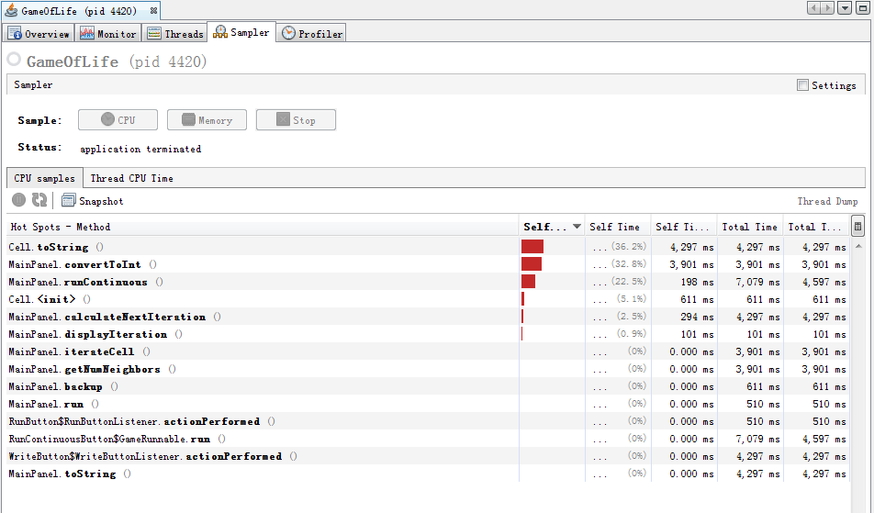

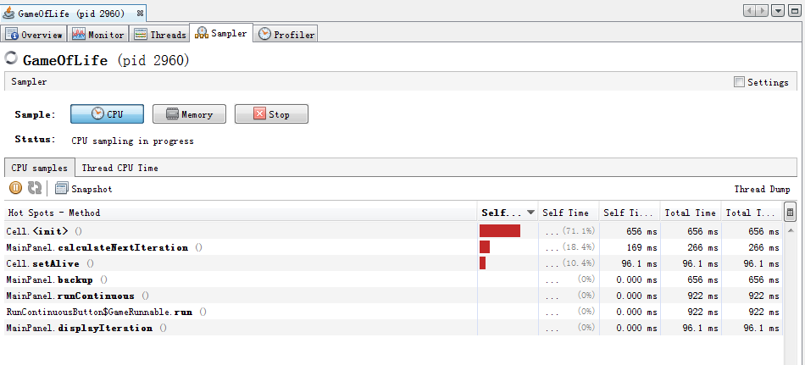

**Extra points: +3 bonus**

