Scarecrow

Sound-Based Bird Deterrent System for Pokkali Crops

1. Introduction

A Block Innovation Cluster is a local group within a specific block, or administrative region in Kerala, formed to foster innovation and entrepreneurship by addressing local challenges and creating solutions collaboratively. Led by organizations like the Kerala Development and Innovation Strategic Council (K-DISC), these clusters connect stakeholders from industry, academia, and local communities to promote a robust innovation ecosystem, develop innovative action plans, and support young talent and MSMEs.

This project was received as part of the Block Innovation Cluster meeting held from 11/08/25 to 13/08/25, where the Vypin Block Panchayath put forward three problems statements, out of which our current problem statement was selected from.

As part of our research and investigation, the team conducted two site visits, allowing for proper interaction and study of the area available for implementation of our project, and for proper understanding of the issues that are present there.

After thorough research and theory-based study, we have come to the conclusion that the use of a sound system-based bird deterrent system would be most efficient, both cost and sustainability wise.

The test model involves a sound system that issues distress calls that put off the different type of birds currently attacking the field at randomized intervals, preventing the birds from getting accustomed to these distress calls.

We expect this model to make a considerable impact, reducing between 50 to 70% of the damages caused by the birds to these crops.

2. Problem Statement
Pokkali farming, a traditional and eco-friendly cultivation system in Kerala, combines paddy farming during monsoon with prawn farming in the post-harvest season. This system has been practiced for centuries and is recognized for its resilience against salinity and climate challenges. However, in recent years, crop loss due to bird intrusion has emerged as one of the major threats to Pokkali farmers.
Field visits conducted by our team on August 23 and September 1 revealed that farmers face consistent problems caused by different types of birds, including:
- Attakili (Egret): While searching for fish and insects, they disturb seedlings and uproot tender plants.
- Erranda (Whistling Duck): These arrive in large flocks during dawn and dusk, grazing directly on the seedlings and causing large-scale damage.
- Neelakkozhi (Purple Moorhen): The most destructive species this year, as they not only feed on the Pokkali seedlings but also build nests within the fields. Their floating nests rise with the water level, meaning the birds remain in the fields for extended periods. This results in continuous damage to the crop, unlike other birds that come and go.
Currently, farmers depend on manual scaring, scarecrows, reflective tapes, and noise-making methods to control birds. Some also use nets or chemical repellents. However, these approaches are ineffective in the long term:
- Scarecrows and tapes lose effectiveness as birds adapt quickly.
- Nets are costly and difficult to maintain in water-logged Pokkali fields.
- Manual guarding is labor-intensive and impractical for long durations.
- No existing system provides automated, 24×7 monitoring and deterrence.
Due to these limitations, farmers report significant yield reduction every season, especially during the early growth stage of paddy. The 2025 season has been particularly challenging, as farmers observed that Neelakkozhi populations increased sharply, nesting directly inside fields and damaging crops continuously.
Hence, there is a clear gap in existing protection strategies. Farmers require a sustainable, cost-effective, and automated crop protection system that can:
- Detect bird intrusions reliably, both day and night.
- Repel birds without harming them or the ecosystem.
- Operate with minimal farmer intervention and low running cost.
Such a system would not only protect Pokkali fields from severe yield loss but also preserve the cultural and ecological heritage of Pokkali farming.

3. Findings from Site Visits (Pokkali Farming – Crop Protection Focus)
Site Visits Conducted
1st Visit: August 23, 2025
Team guided by: Prof. Anusree Radhakrishnan and Prof. Nitha C Pankajakshan
Local support: President and Vice President of Vypin Block Panchayath
2nd Visit: September 1, 2025
Participants: Project student team (Dheeraj Shaiju , Ashwin D Sreenivas , Adwaith Shameer , Christeena Geego , Benhur P Benny , Ikramul Haque , Sivakami Matheth)
Local support: Ashokan, experienced farmer who provided detailed insights during field interaction
Introduction
As part of our academic project, we conducted two site visits to Pokkali fields to understand the problems faced by farmers and identify suitable solutions. Pokkali farming is unique because it follows a traditional rotation system – paddy cultivation during monsoon and prawn farming during the post-harvest season. However, in recent years, bird intrusion has become a major challenge, causing severe crop losses and threatening the sustainability of this heritage farming method.Our visits helped us directly interact with farmers and observe the field conditions. Below we summarize our findings and the key limitations currently faced.
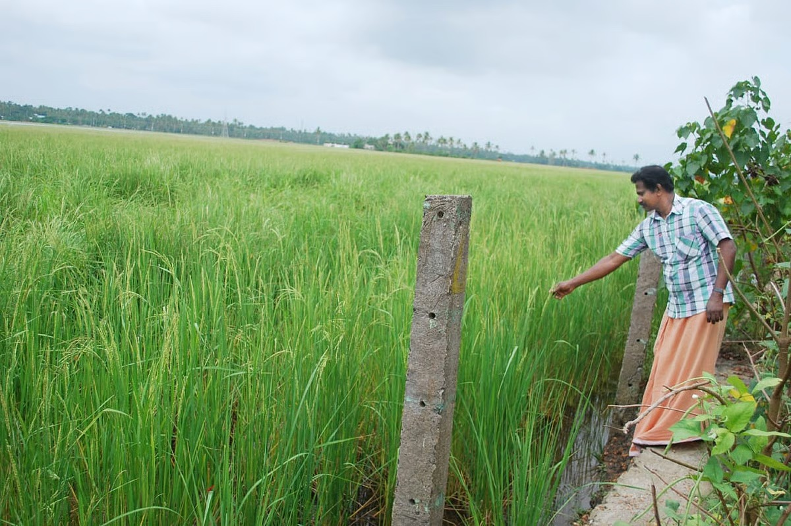
Observations from Farmers
During discussions, farmers mentioned multiple species of birds that attack the fields, each with different behaviors and effects:
(a) Attakili (Egret)
Commonly found in Pokkali fields.Feeds on small fishes, insects, and sometimes damages the paddy seedlings while searching for food.Large flocks disturb the crop growth and seedlings.
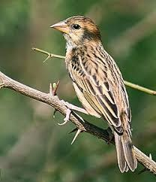
(b) Erranda (Whistling Duck)
Arrives in large flocks during early morning and evening.Floats inside the field and feeds on young seedlings.Very difficult to chase away because they repeatedly return after disturbance.
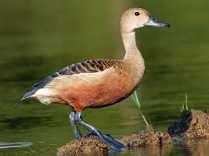
(c) Neelakkozhi (Purple Moorhen) – New & Growing Threat in 2025
Farmers reported that Neelakkozhi has become a serious new problem this year.Unlike other birds that only come for feeding, Neelakkozhi stays inside the fields for long periods. They build nests inside the crop area, which float when water level rises, allowing the birds to remain permanently. These birds feed continuously on seedlings and plants, causing severe crop loss.Even protective nets fail because they can tear or bypass them. This makes Neelakkozhi more destructive compared to egrets, ducks, or moorhens.
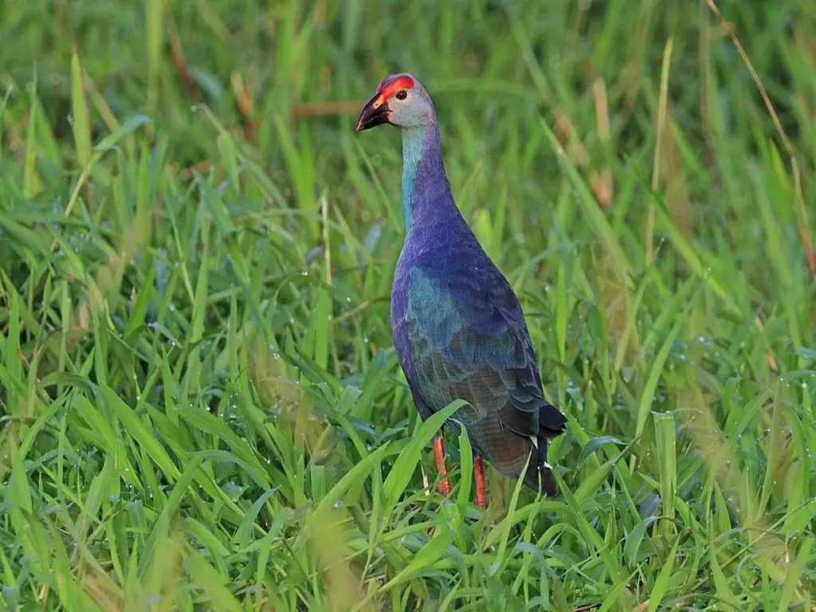
Major Finding (Unique Problem in 2025)
The rise of Neelakkozhi nesting inside Pokkali fields is the most critical observation from this year. Farmers highlighted that this is a new and more destructive challenge compared to earlier years. Since the nests float along with water, these birds remain inside the fields for the whole season, causing continuous crop damage.This situation creates an urgent need for a sustainable, automated crop protection system that can reduce farmer effort and protect Pokkali cultivation effectively.

4. Existing methods
Bird intrusion in Pokkali fields is not a new problem. Farmers have been using different traditional and modern approaches to protect crops. During our field visits, we observed and collected details of several existing methods that are commonly practiced. These can be broadly classified into manual, visual, acoustic, and physical barrier methods.
Manual Scaring
Traditionally, farmers or hired workers stay near the field during peak hours (early morning and evening) and drive away birds by shouting, clapping, or throwing stones. Sometimes children are employed for this purpose.
Advantage: Low-cost, immediate response.
Limitation: Requires continuous human presence, very labor-intensive, and impractical for large fields. Birds also return once the farmer leaves.

Scarecrows
Scarecrows made of sticks, old clothes, and plastic bags are erected in fields to create the illusion of a human presence. Farmers sometimes move them occasionally to increase effectiveness.
Advantage: Very cheap and easy to set up.
Limitation: Birds quickly adapt and stop fearing static scarecrows. Within a few days, species like egrets and whistling ducks completely ignore them.
Reflective Objects
Some farmers use shiny tapes, old CDs, or aluminum foils tied on strings across the field. The moving reflections in sunlight disturb the birds initially.
Advantage: Low-cost, uses waste materials.
Limitation: Works only in bright sunlight; during cloudy or rainy days (common in Pokkali season), effectiveness is very low. Birds also get habituated over time.
Noise-Making Devices
Farmers sometimes hang tins, bottles, or small drums in fields. When the wind blows, they produce disturbing sounds that scare birds temporarily. In some places, firecrackers are also used during peak bird activity.
Advantage: Immediate deterrence, simple to implement.
Limitation: Short-term only; birds quickly adapt to repeated predictable sounds. Firecrackers are not environmentally friendly and are costly for daily use.
Netting
Nets are used to cover nurseries or small patches of fields to protect seedlings.
Advantage: Physically blocks birds from reaching the crop.
Limitation: Very expensive and impractical for large Pokkali fields (which are water-logged). Nets also hinder farmer movement and prawn farming later.
Chemical Repellents
In some places, chemical sprays are used to repel birds. However, most Pokkali farmers avoid them because Pokkali is an organic and heritage farming system, where chemical use is discouraged.
Advantage: Can reduce bird feeding temporarily.
Limitation: Environmental concerns, possible contamination of water, impact on prawns, and goes against the organic branding of Pokkali rice.
Overall Limitations
Most existing methods are manual or temporary.
Birds, especially Erranda (whistling ducks) and Neelakkozhi (purple moorhen), are persistent and adaptive; they return even after scaring.
Methods like scarecrows and reflective tapes become ineffective within a week.
Netting and chemicals are either too costly or unsuitable for Pokkali’s ecological nature.
No method provides automated, 24×7, rain-proof protection.
Thus, while farmers continue to use these traditional approaches, the losses remain high, and there is an urgent need for a sustainable technological solution that integrates detection and deterrence in a smart, automated way.
Limitations of Current Bird-Scaring Practices
- Manual effort needed:-Farmers shout, clap, or wave sticks/cloth manually. Not practical all day; tiring and time-consuming.
- Scarecrows :-(dummies, sticks, cloth, bottles)Birds quickly learn they are not dangerous → effect fades in 2–3 days. Cannot adapt to different bird species.
- Tins/bottles:- That rattle with wind only work when wind blows; no sound during calm weather. Sound is monotonous, birds get habituated fast.
- Firecrackers :-Disturbs entire area (including humans, pets, fish).Not sustainable; costly and unsafe for frequent use.
- Nets over crops:-Expensive to cover large areas like 1 acre. Difficult to install/remove; may interfere with prawns after Pokkali harvest.

4. Objective
To design and test a sound-based deterrent unit that allows research on its effectiveness and provides a foundation for a scalable, permanent solution.

5. Scope
The scope of this project focuses on testing the feasibility and effectiveness of a sound-based bird deterrent system in Pokkali farming fields within the Vypin Block Panchayath region.
Study Area:
The pilot study will be conducted in selected Pokkali fields under the Vypin Block Panchayath, which represents a typical ecosystem where bird interference causes significant crop damage.
Pilot Scale:
The intervention will be implemented over an approximate area of 300–600 m² of farmland, which provides a manageable yet realistic scale for testing. This scale ensures that the results can be studied clearly while keeping costs and logistics practical.
Testing Duration:
The project will be carried out in two phases for comparative analysis:
Week 1 – Intervention Phase: The deterrent unit (horn speaker + Arduino-based system) will be installed and made operational to observe its effectiveness in repelling bird flocks, especially whistling ducks and other major pests identified during the site visits.
Week 2 – Control Phase: The deterrent unit will be removed, and the same field will be observed without any intervention. This will provide a baseline for measuring the natural extent of bird activity and damage.
Evaluation Method:
Data from both phases will be compared in terms of:
Number and type of birds entering the field
Visible crop damage (qualitative observations and farmer feedback)
Differences in activity patterns with and without the system
The scope is limited to short-term pilot testing, with the intention of providing a foundation for scaling the solution to larger areas and integrating it with additional deterrent mechanisms (such as water spraying or laser-based methods) in future phases.

6. Working Plan
The proposed project will be implemented as a minimal, functional prototype designed to test bird deterrence in Pokkali farming. The plan of execution includes the following steps:
Control Unit – Arduino-Based Automation
An Arduino microcontroller will be programmed to randomly trigger pre-recorded bird-deterrent sounds at variable intervals.
A DFPlayer Mini (or similar module) will be used to play MP3 files stored on an SD card.
The randomness in playback will ensure that birds do not adapt to repeated, predictable sounds.
Sound System – PA or High-Capacity Speakers
A horn-type PA speaker (10W–20W) connected to a small amplifier will broadcast the sounds over the farmland.
Placement of the speaker will be optimized to cover maximum field area, with provisions for adding additional units in the future for scalability.
Power Source – Solar Panel with Backup Battery
A 12V solar panel system with a rechargeable battery will provide sustainable power for continuous operation.
During the pilot phase (1–2 weeks), if solar installation is not feasible, a borrowed/recharged 12V battery may be used as an interim solution.
Protection Mechanisms – Weatherproofing & Safety
All electronics will be enclosed in a weatherproof casing (plastic box with sealing).
Surge protection (fuse or simple regulator circuit) will be included to safeguard the system against power fluctuations or short-circuits.
Wiring & Assembly – Secure Field Deployment
Proper wiring with conduit pipes or insulation tape will be used to protect against water damage and accidental disconnections.
The entire system will be mounted on a pole or a raised platform within the field, ensuring both coverage and safety from flooding.
Field Testing and Observation
The system will be operated continuously during early morning and evening hours, which are peak bird-feeding times.
Farmers and project members will record observations of bird presence, behavior, and crop damage.
Comparative data will be collected during periods with and without the system to evaluate effectiveness.

7. Expected Outcome
Based on supporting research and theoretical models, the system is expected to achieve at least 70% reduction in bird attacks during the active test period. Actual effectiveness will be validated through collected field data.

8. Risk Assessment
1. Hearing Concerns: High-volume sounds may affect humans or animals nearby.
2. Weather Damage: Rain or storms could harm electronics.
3. Habituation: Birds might adapt to the sounds over time, reducing effectiveness.
Mitigation includes volume control, waterproof enclosures, and varying sound patterns.

9. Future Plan & Impact
If successful, the project will be scaled to cover larger cultivation areas, offering farmers a cost-effective, sustainable, and eco-friendly alternative to chemical deterrents or manual guarding. Long-term adoption can significantly reduce crop protection expenses and improve yields.

10. Cost Estimation
Item | Estimated Cost (INR)
Solar panel | 2200
Battery | 3000
Charge controller | 800
Arduino board | 500
MP3 module | 600
Speaker | 1,700
Amplifier | 600
Wiring and connectors | 600
Welding and fabrication | 1,500
Protective case | 1,500
Procurement and Miscellaneous | 2,000
Total | 15,000

TEAM GUIDE:

Dr. Gilesh M P
Prof. Anusree Radhakrishnan
Prof. Nitha C Pankajakshan

TEAM MEMBERS:
Dheeraj Shaiju – Project Coordinator
Adwaith Shameer
Christeena Geego
Ashwin D Sreenivas
Sivakami Matheth
Adwaith KV
Glenys Gladson
Benhur P Benny
Ikramul Haque

