**UA Vendo Smart:**

**University of Antique Vending Machine Test Booklet using Internet of Things (IoT) Technology**

**CHAPTER 1**

**Introduction**

* 1. **BACKGROUND OF THE STUDY**

In the University of Antique one of the common ways for the students to take an exam is to buy a test booklet, for many students it is a hassle when buying it in one local source, it causes a bottleneck situation where the distribution is slow, time consuming, crowded, noisy and students from farther departments are getting tired when buying and returning the test booklets from their classroom.

This paper introduces an IoT-enabled vending

machine designed specifically for the distribution of test booklets,

addressing common challenges faced by educational institutions and students. By leveraging the Internet of Things (IoT) technology, this vending machine aims to create a more efficient, fast, and user-friendly solution for students and

administrators alike. Equipped with interfaces and payment options,

the machine allows students to access their materials quickly and efficiently.

Additionally, the integration of IoT technology enables real-time monitoring of inventory levels, ensuring that the necessary test booklets are always

available when needed.

* 1. **OBJECTIVE OF THE STUDY**

This study has the following objectives:

1. To develop a device and assess the primary bottlenecks that affect the distribution of test booklets in educational institutions.
2. Implement a vending machine provided with Internet of Things functionality which would overcome these bottlenecks and increase distribution effectiveness.
3. To set up the vending machine to specific locations to lessen bottlenecks, more efficient distribution, and less time to travel long distances to get to the local source.
   1. **SCOPE AND LIMITATION OF THE STUDY**

This study’s scope considers the design and usage of an IoT based vending machine for test booklets aimed at school or university educational establishments. While it seeks to analyze the specific features of the construction and functioning of the vending machine, we do not seek to analyze in detail the specifics of the IoT hardware and software. It should be noted that one of the limitations of this study is the possible opposition coming from the educational institutions due to the budgetary constraints or the requirement of training of the personnel for accommodating the new technology into the system. However, the fear of the expense at the start, the maintenance and the assistance in the technical side of things may prevent some of the institutions to invest into this technology. Further studies should be directed towards the provision of solutions to such problems as well as offering the additional options that would improve functionality of the vending machine further.

* 1. **SIGNIFICANCE OF THE STUDY**

The importance of this research is that it has the capability to change the entire process of distribution of test booklets to learners quite positively in educational organizations. The introduction of an IoT equipped vending machine has the following objectives of the study:

1. Increase resource efficiency in distribution systems by mechanization and labor saving.
2. Minimize the workload of the staff by making sure that activities such as the preparation and distribution for test booklets are completely removed.
3. Assist learners gain the required materials in the most efficient and effective manner possible therefore enhancing their learning experience.
4. Cultivate a new trend in handling of resources in education environments in a way that is consistent with the increase use of technology in education as a whole.
   1. **DEFINITION OF TERMS**

**Internet of Things**: A network of interconnected devices that communicate and share data with each other via the internet.

**Vending Machine**: A machine that provides items such as snacks, drinks, or in this case, test booklets, upon payment or authentication.

**Test Booklet**: A printed document containing examination questions or assessments provided to students in an educational setting.

**Educational Institutions:** Organizations dedicated to education, such as schools, colleges, and universities.

**CHAPTER II**

**REVIEW OF RELATED LITERATURE**

* 1. **SYNTHESIS OF RELATED LITERATURE**

Educational institutions have always had difficulties in distributing test booklets which usually lead to inefficiency and aggravation. In the University of Antique there’s a lot of challenges when the students are claiming their test booklets especially the students of the department of CEA, CCS and CBS when claiming their booklet for the exam, they have to go down the hill and return to their classroom exhausted. The conventional procedures that are employed are often manual which takes a lot of time, has a likelihood of human errors, and how logistics issues. However, this is not the case today as new technologies have begun to emerge pushing old ways of doing things to the periphery.

**2.2 SYNTHESIS**

IoT Technology and Its Applications

Various fields have benefitted from the advancement of the Internet of Things (IoT) and education is not left behind. Equipped with sensors, microcontrollers and connectivity, IoT devices are capable of collecting data and transmitting it allowing for monitoring and control purposes. In the case of distributing test booklets, IoT technology can be harnessed to automate operations, boost the efficiency of processes and students’ satisfaction.

Vending Machines and Their Evolution

Vending machines have now become associated with more than just dispensing snack and beverage items. Well, in recent times, high technology has contributed to the growth of sophisticated vending machines able to sell items such as books, documents, and even medicines. Such machines have low cost limitations and often say contain touch screens, radio frequency id readers, and biometric authentications.

* 1. **CONCEPT OF THE STUDY**

This system seeks to address the challenges faced in a manual distribution processes, such as inefficiencies of sources, logistical problems, location and the potential for human error. Students will take less time buying their test booklets and can take the exam smoothly. By integrating Internet of Things (IoT) technologies like sensors, microcontrollers, and cloud connectivity the project aims to explore how automation can reshape the way test booklets are provided to students.

Additionally, the use of IoT allows educational institutions to track usage patterns, manage inventory remotely, and enhance overall operational efficiency—leading to a smoother and more reliable system for distributing test materials.

**CHAPTER III**

* 1. **CONCEPTUAL FRAMEWORK**

Challenges in the Distribution of Test Booklets the Traditional Way

There are a number of weaknesses that block the effective distribution of test booklets in the traditional way:

1. Preparation, payment, and distribution are tedious processes: Preparing, receiving payment, and distributing test booklets can take a long time, specifically in peak periods.
2. Distribution of test booklets. Allocation of the booklets to the different users correctly can also be disrupted due to loss of the booklets.
3. Test distribution: The process of getting test booklets to various locations is a hassle and lacks sufficient logistics support.
4. Securing the test materials: It is also important to ensure that any unauthorized access is not possible for the examination materials.

Test Booklet Distribution System Improvement

The proposed test distribution system has combined two machine’s capabilities and addresses plenty of challenges faced in the process of conventional test booklet distribution.

The conceptual framework presents seven central components and their interrelations:

**IoT Device:**

The system comes complete with some microcontroller (esp32) which is regarded as the master of the system as it organizes most of the various components in the system.

**Sensors:**

These detect stock levels, inventory and user presence and payment options.

**Actuators:**

Control various aspects of the dispensing mechanism including the money receiving and other mechanical aspects of the system.

**Connectivity:**

For communication connecting with the cloud and radial with other devices.

**Cloud Platform:**

Data storage and processing:

Keeps records of stock quantities, the activity of users, and the performance of the system.

**Real-time monitoring:**

Monitors amounts of inventories and conditions of the system.

**Remote management:**

Gives the administrators the ability to supervise and manage the vending machine as long as they are not there.

**RFID reader:**

Maps users and how they interacted with the machine.

**Payment System:**

Provides integration with payment transaction systems, highly protected against fraud.

**Physical security measures**:

Restricts access to the machine and the contents of this machine from anyone unauthorized.

* 1. **CHART**

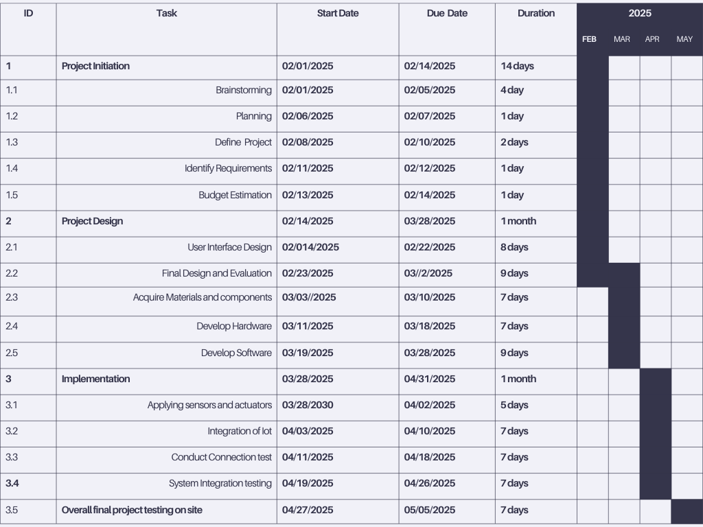

BUDGETARY REQUIREMENTS FOR THE IOT-ENABLED VENDING MACHINE

1. Hardware Components

Vending Machine (Base Unit) ₱ 1,000 ~ 2,000

Sensors and Actuators ₱ 500 ~ 2,000

Microcontrollers (Arduino, ESP 32 etc.) ₱ 500 ~ 1,000

Power Supply ₱ 100 ~ 500

Hardware ₱ 3,000 ~ 5,000

Subtotal ₱ 5,100 ~ 10,500

1. Software Development

Iot Application/site Subscription ₱ 200 ~ 500

Software Licenses and API Costs ₱ 1,000 ~ 2,000

Subtotal (Software) ₱ 1,200 ~ 2,500

1. Connectivity

Wires ₱ 100 ~ 300

Wi-Fi Setup and Maintenance ₱ 2,000 ~ 5,000

Subtotal (Connectivity) ₱ 2,100 ~ 5,300

1. Installation and Testing

Installation Costs ₱ 400 ~ 500

Labor ₱ 500 ~ 700

Testing and Calibration ₱ 1,000 ~ 2,000

Subtotal (Installation) ₱ 1,900 ~ 3,200

**Total Estimated Costs Initial Setup Cost** ₱ **10, 300 ~ 21,500**

**Organizational Structure**

1**. Project Leader**

- Oversees the entire project, ensuring that it stays on schedule and within budget.

- Responsible for coordinating between different teams (research, design, implementation, etc.).

- Manages reporting and communication with stakeholders.

2. **Researcher**

- Conducts preliminary research, identifies the main challenges in test booklet distribution.

- Helps in gathering requirements and exploring existing solutions.

**3.Technical**

- Designs and develops the hardware components

- Responsible for integrating IoT components (ESP32, RFID, sensors).

- Ensures the overall functionality of the system.

**4. Programmer**

- Designs and develops the software for the vending machine, including user interface, payment system, and IoT integration.

- Implements cloud platform integration.

**5. Designer**

- Develops an intuitive user interface for the vending machine to ensure it is easy to use for students and administrators.

* 1. **REFERENCES**

1. Gubbi, J., Buyya, R., Marusic, S., & Palaniswami, M. (2013). - Internet of Things (IoT): A vision, architectural elements, and future directions. Future Generation Computer Systems, 29(7), 1645-1660.
2. Rouse, M. (2021). - What is the Internet of Things (IoT)? TechTarget. [https://www.techtarget.com](<https://www.techtarget.com>)
3. Rhee, J. (2019). - The Evolution of Vending Machines: From Snacks to Smart Machines. Journal of Advanced Technology, 10(2), 22-34.
4. Singh, D., & Kaur, A. (2020). - IoT-Based Systems and Applications in Education. Springer.
5. Sundararajan, V. (2018). - Platform Revolution: How Networked Markets Are Transforming the Economy.

Al-Fuqaha, A., Guizani, M., Mohammadi, M., Aledhari, M., & Ayyash, M. (2015). Internet of Things: A survey on enabling technologies, protocols, and applications. IEEE Communications Surveys & Tutorials, 17(4), 2347**–**2376. https://doi.org/10.1109/comst.2015.2444095