Physics List report

The start of the discussion is the Figure from Jan Mayer his thesis:
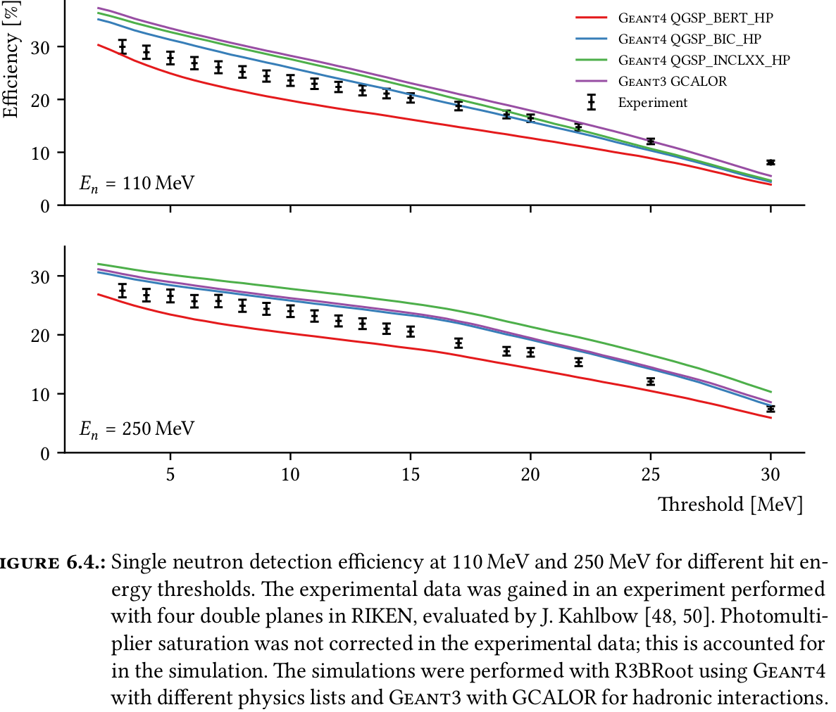
This is a BenchMark of different physics lists w.r.t. experimental data taken with the NeuLAND demonstrator at RIKEN. The NeuLAND demonstrator consists of the first 4 double planes of NeuLAND without the aluminium frame. The detector is located roughly 11 meters behind the target.

The problem is as follows: if we train a DNN with, say simulation data of QSGP_INCLXX_HP, while we get the black datapoints in reality, how trustworthy will the DNN be? Probably less than our DNN verifications.

We investigate this by testing 2 physics lists against each other: QSGP_INCLXX_HP (INCLXX for short) against QSGP_BERT_HP (BERT for short). The black data is in between, so differences between these physics lists are expected to be an upper bound of the error described above.

To see what is causing the difference, we do a very simple simulation (one million events):
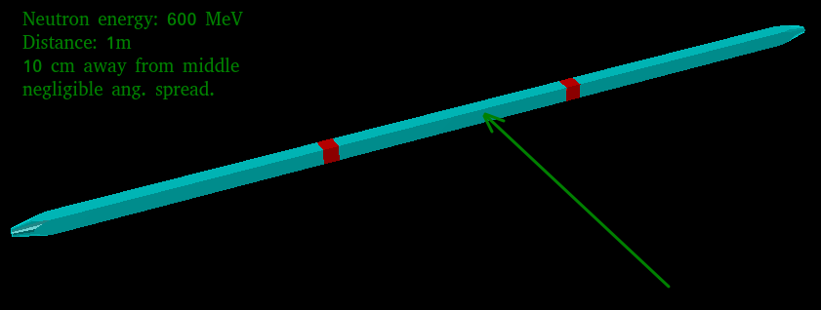
Interaction rates (error are 0.1%):

INCLXX
MC: 8.2%
Detection: 5.5%
97.3% of all detected events contain at least one proton track.

BERT:
MC: 8.2%
Detection: 5.1%
97.8% of all detected events contain at least one proton track.

This difference in detection efficiency translates to the differences in Jan Mayers figure.

To see what is causing this, we investigate deposited energy & scattering angle of the strictly secondary particle tracks only:

INCLXX:
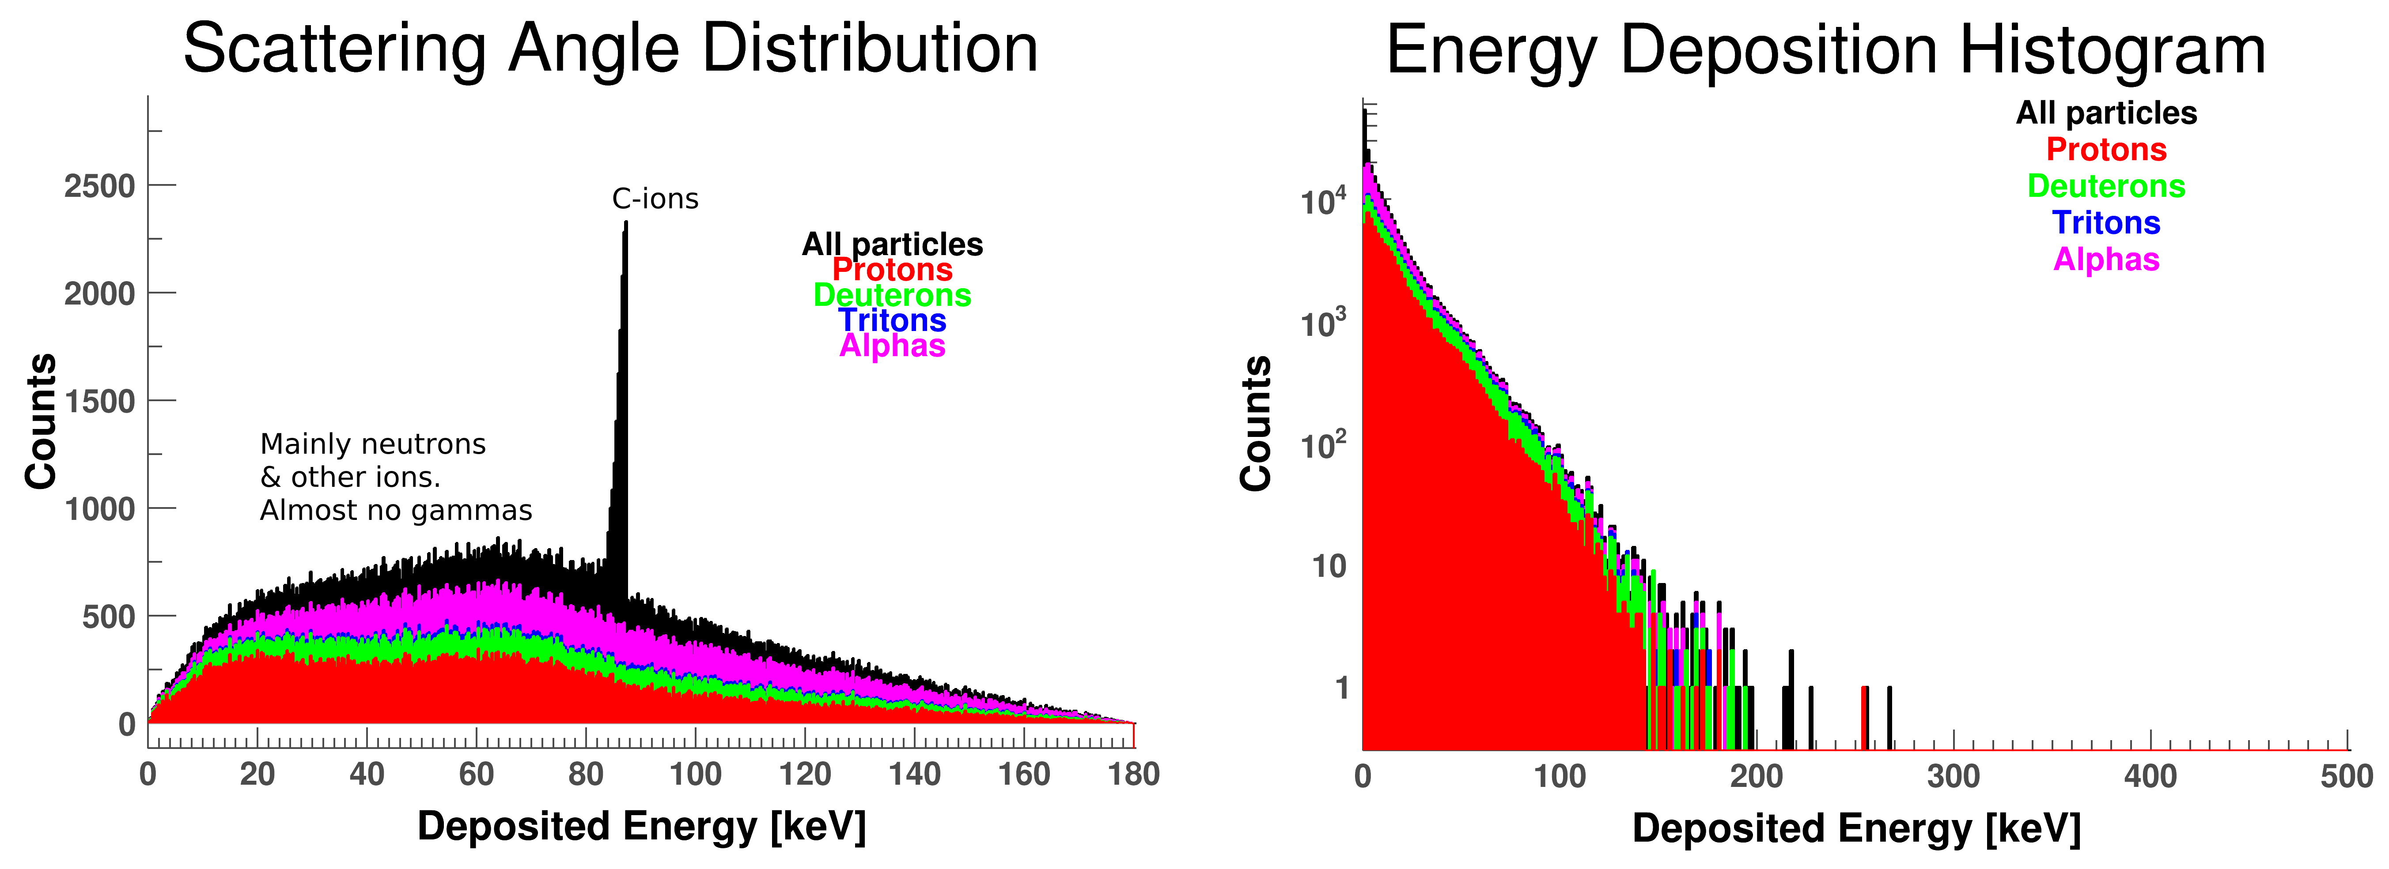

BERT:
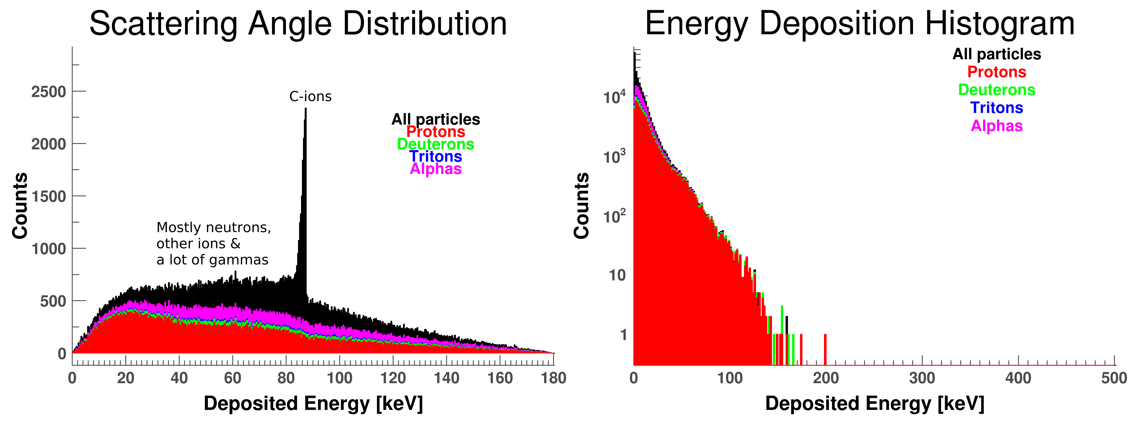
Compare proton energy deposition & scattering angle:
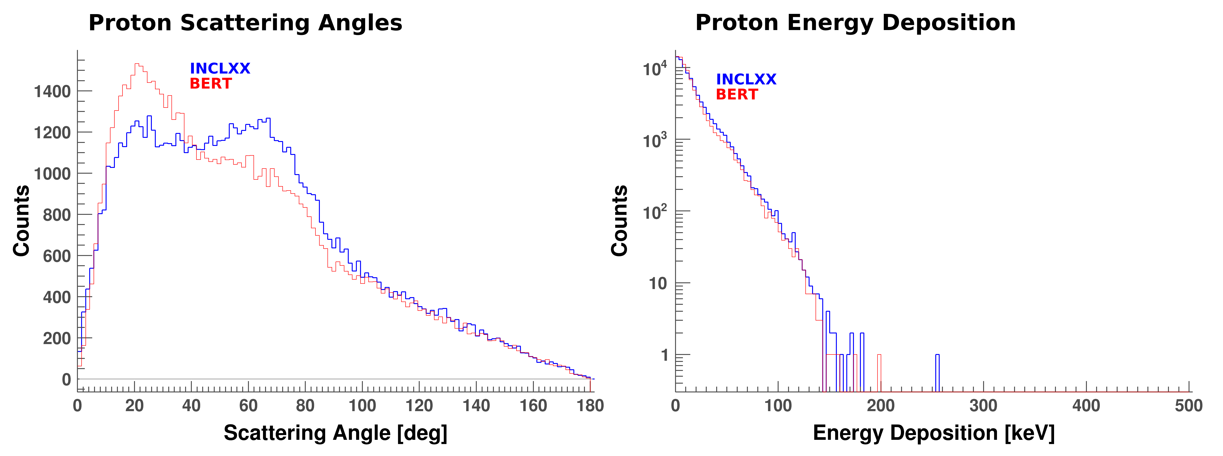
So BERT & INCLXX have same proton energy deposition, although the shower development is clearly different. On top of that, INCLXX also has significant energy deposition from deuterons & alphas (& a bit from tritons). BERT also has some alphas, but they do not deposit much energy!
In order to carry away the energy that BERT cannot deposit through alphas and deuterons (& tritons), BERT produces a lot of gammas, while INCLXX produces almost no gammas. The neutron showers are about the same:

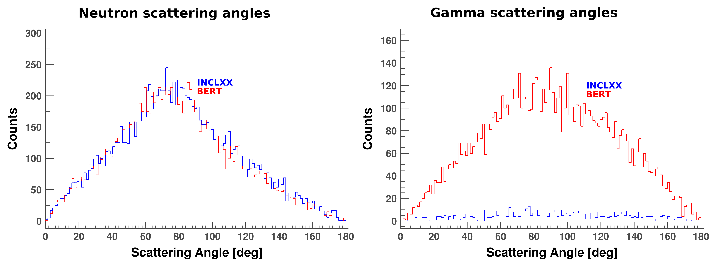

Are the deuterons & alphas (& tritons) really what causes the difference in Jan Mayers plots?
==> Make the same plots as Jan Mayer (not exactly the same, since we do not include the rest of the SAMURAI setup & a different event generator. NB: We use 250 MeV neutrons here.
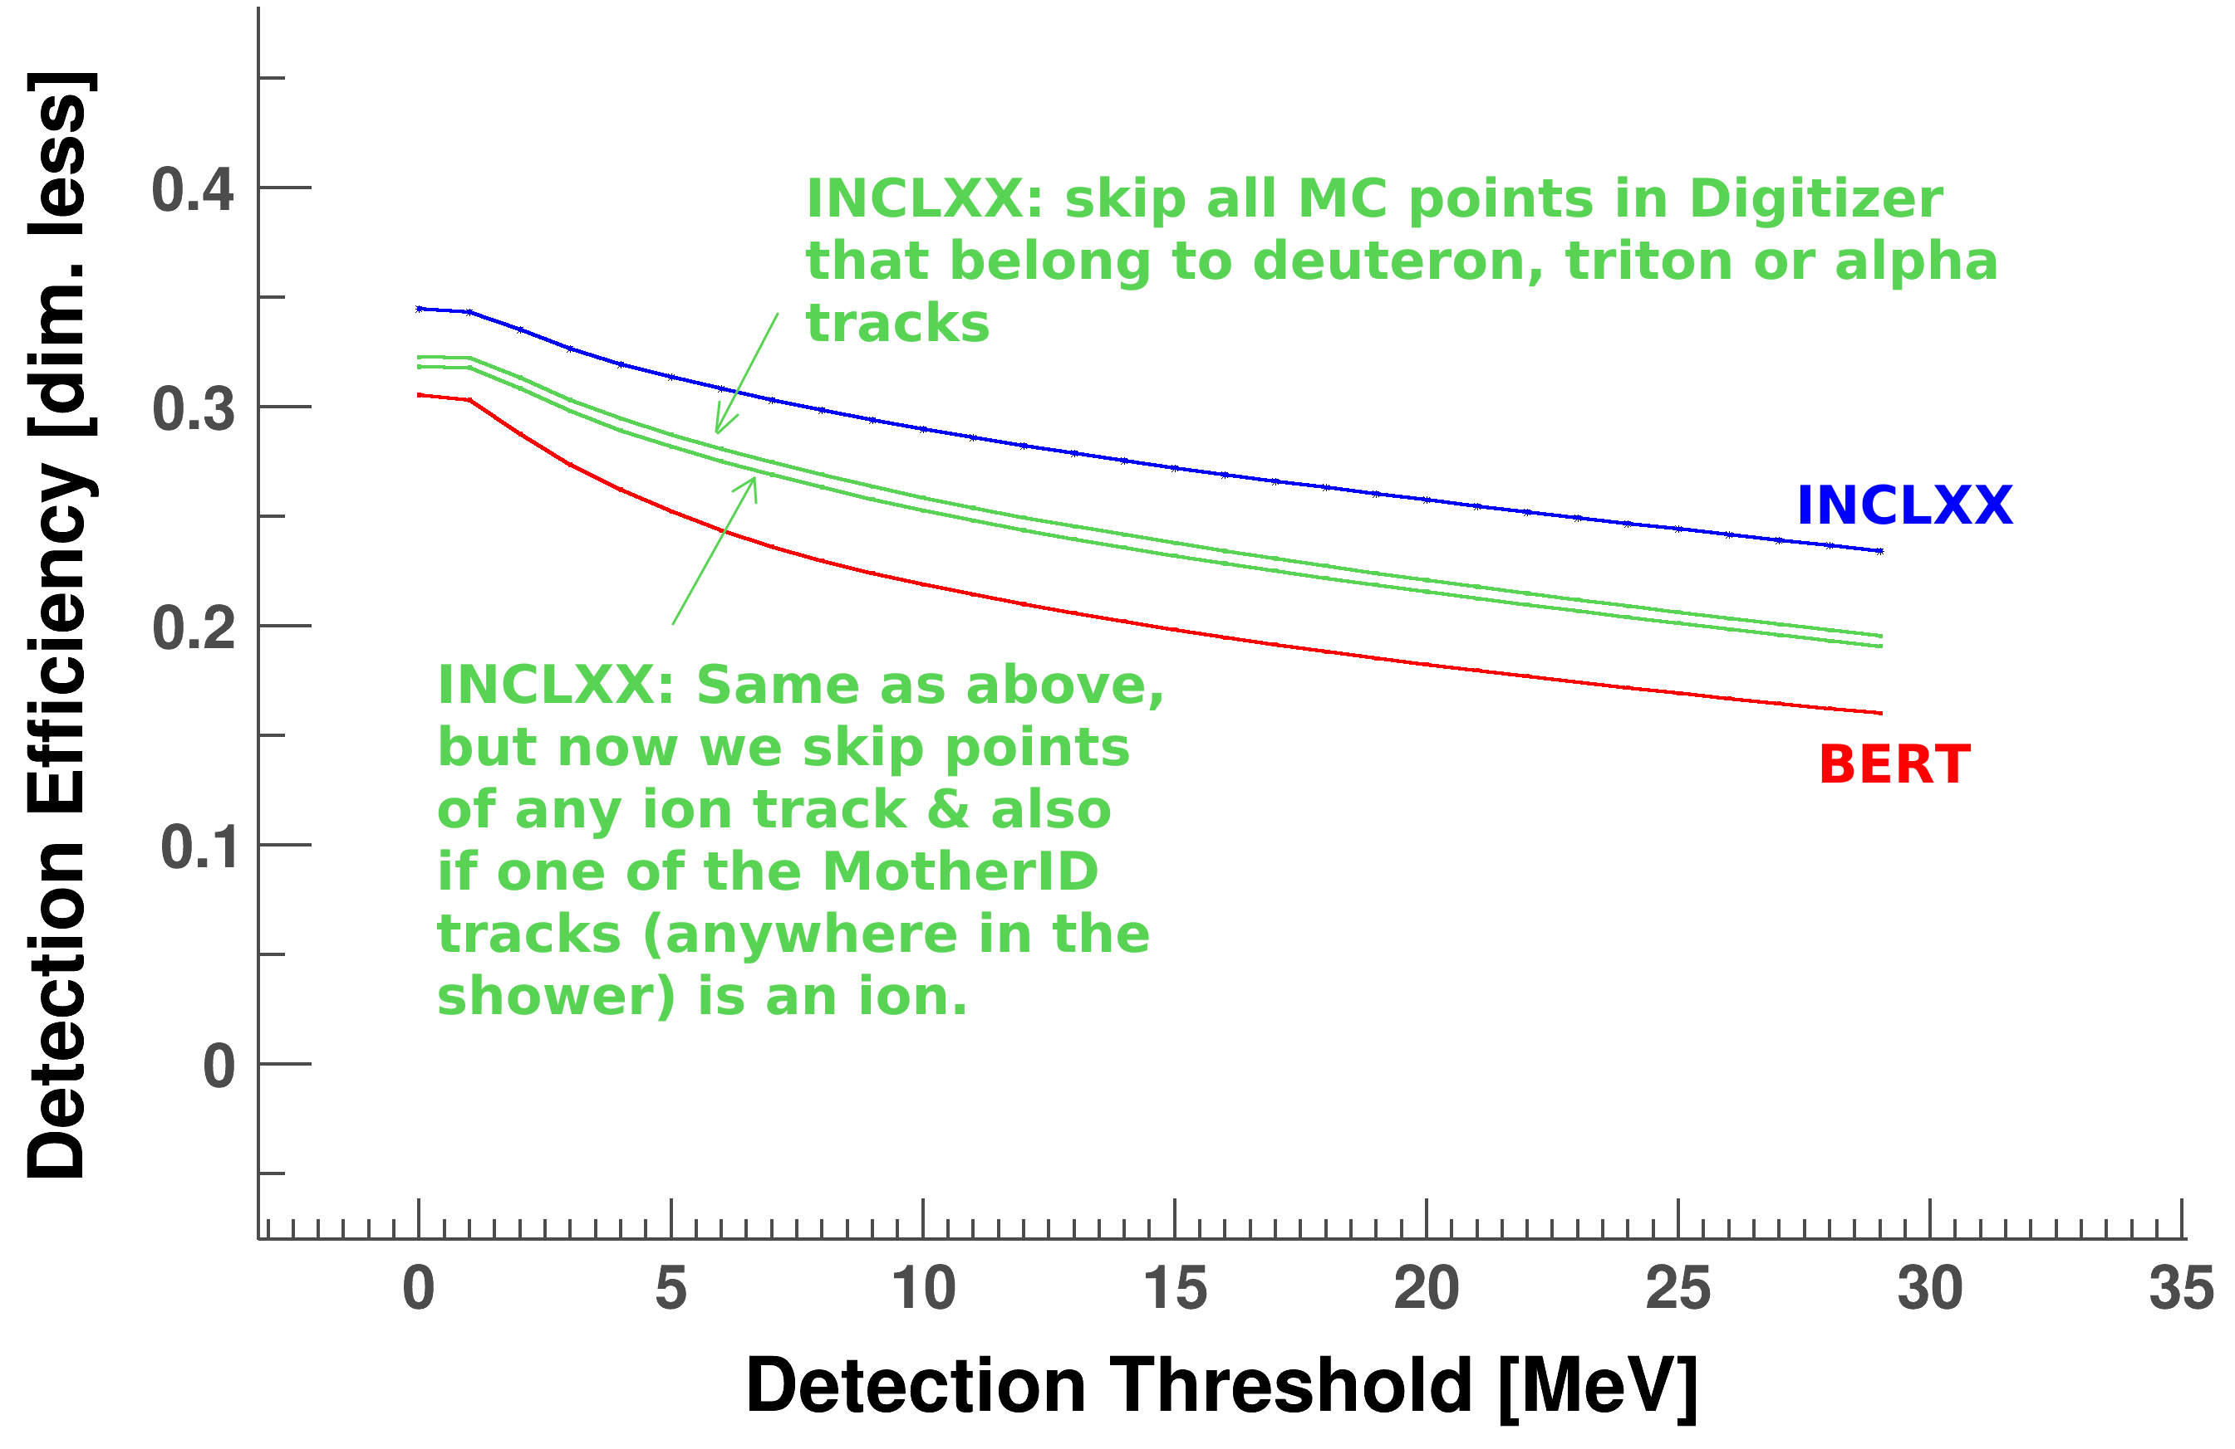
Appearently, there are two effects that raise INCLXX above BERT. 1) is the contribution from ions, which is mainly due to alphas, tritons & deuterons. 2) is the difference in shower development. This has to be the different scattering angles in the proton tracks. We verified that, apart from a few pions, protons & nuclei are the only particle types that deposit energy in the scintillator. Hence, the other difference can only come from the scattering angle difference.

BERT gives a more forward-boosted proton shower than INCLXX. This means that the protons (on average) travel more parallel to the scintillators for INCLXX and, therefore, encounter less dead material (aluminium foil & tape).

To benchmark the shower development, we need access to Julian Kahlbows data directly to make xy-plane plots of the NeuLAND hits (z-axis=energy deposition). For the simulations, we do make these plots:

INCLXX (no eliminations):
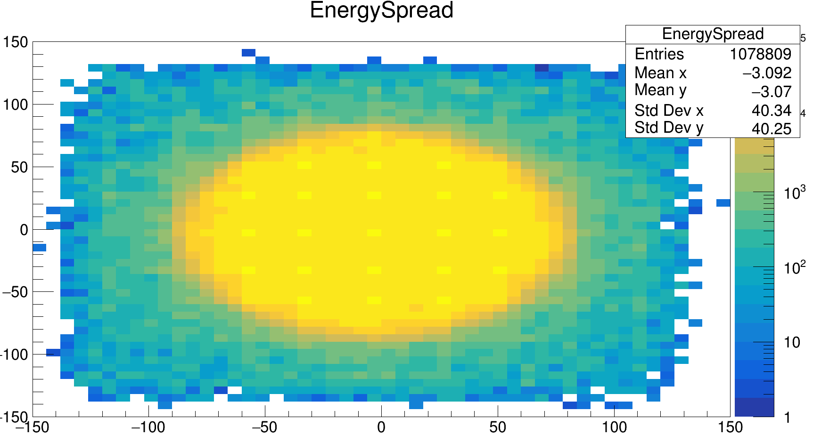
problem is that this beam has 4 deg angular spread, which is too large to reveal any differences in forward boosts. Rerun with 0.05 degrees spread:

INCLXX (no elimination):
max = 129969, set to 2e5:
bins = 10 per bar; randomise by unif. Dist over bar width in perpendicular direction:
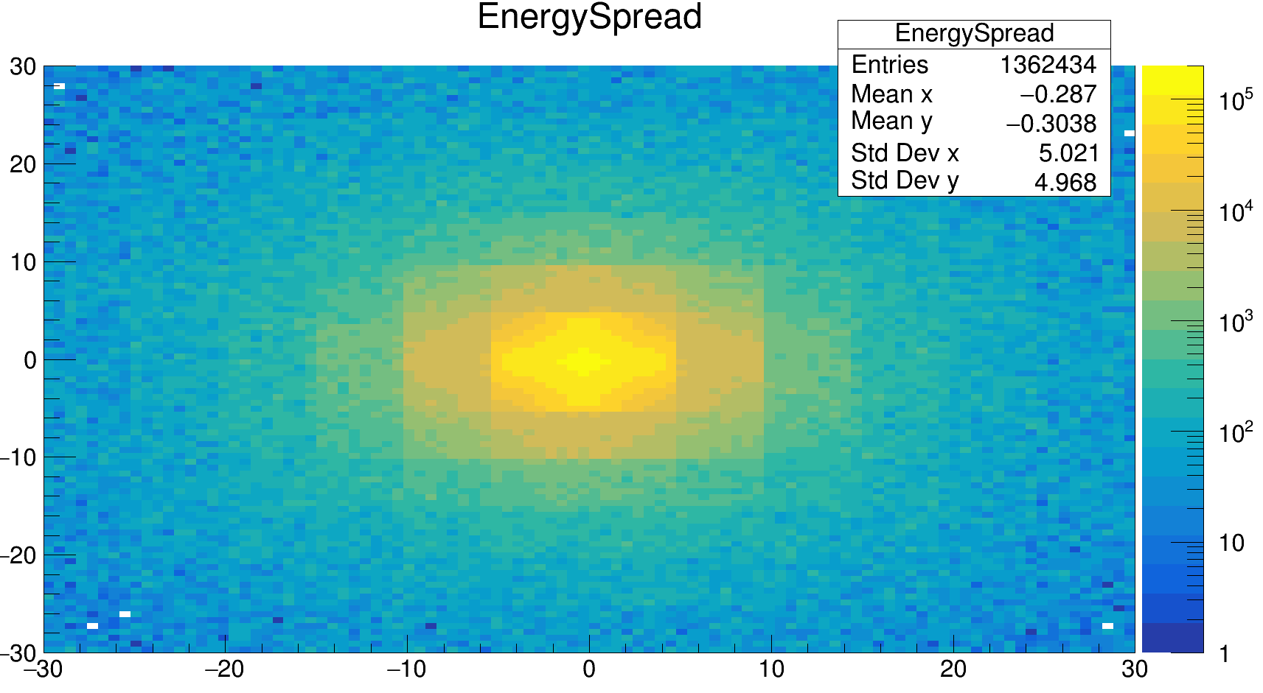

INLCXX with elimination (lower green line)
max = 95219 (set to 2e5):
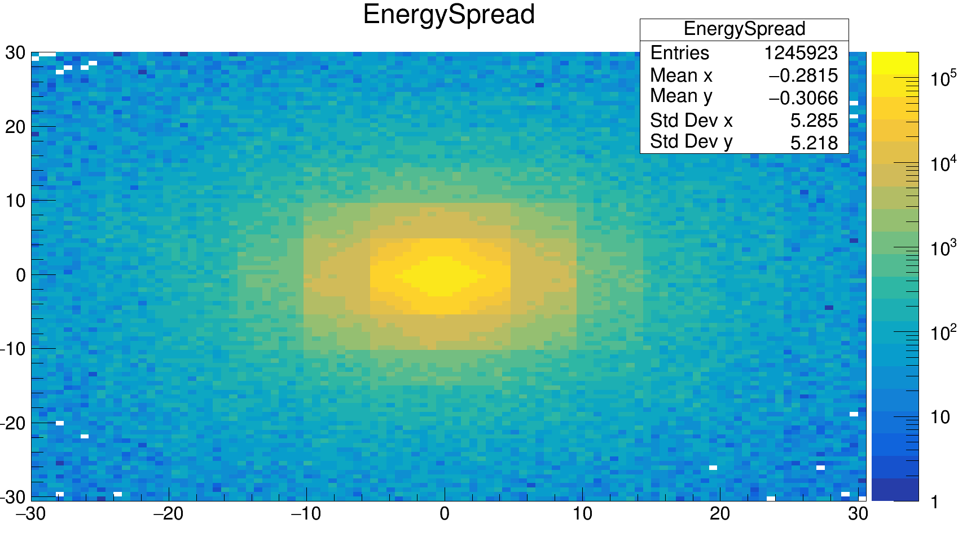
BERT; max = 76770 (no elimination), set to 2e5:
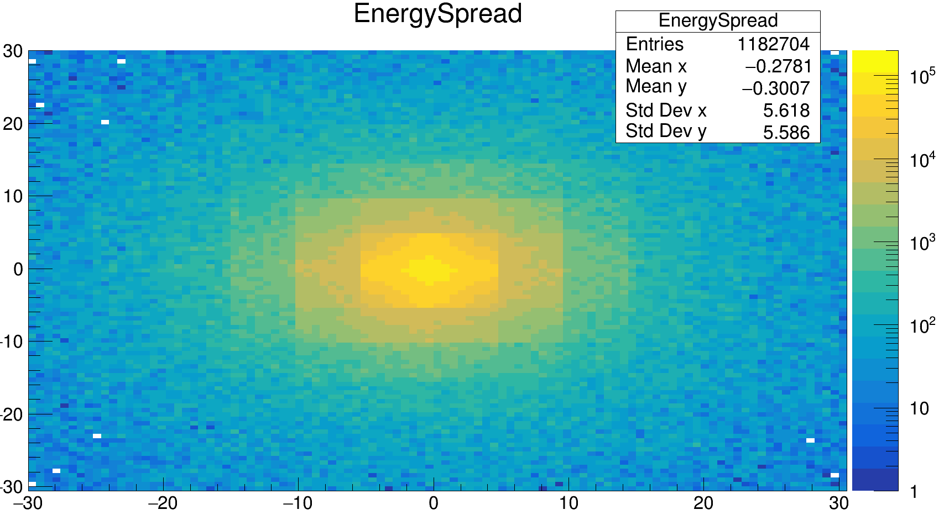
Even after elimination, there isclearly a larger spread wth INCLXX (which can only be from proton tracks). Moreover, with only 4dp, the charged (proton) tracks of BERT, which are forward, may excape the detector easier than through the side with INCLXX. And the aluminium is effective in absorbing proton energy (due to its high density, compared to CH2) and is not active. In z-direction, more aluminium is encountered than in x/y, since the scintillators extend in those directions.

One other important conclusion came up. The shower heads seem to be rather independent of the physics lists. This is understandable, because if there is a shower head, the energy is so large that it is almost always detected. The precise shower development does not make muchb difference. If the threshold is 1 MeV, than it does not mether wehther you have a signal of 3.1 or 3.2 MeV. The physics list difference happen further away in the shower.

Do 600 MeV neutrons, 4 neutrons per event, 14 m to NeuLAND, 4 degerees spread & 30dp.

Erel spectra based on MC data:
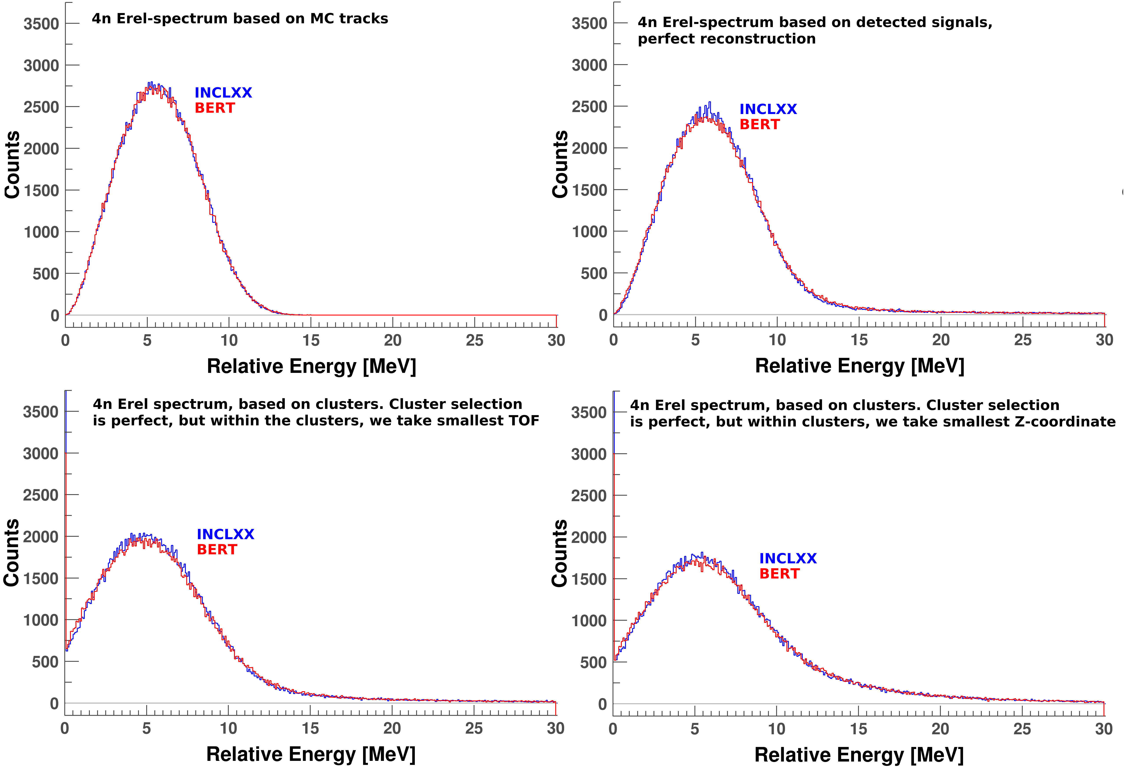
MC: exactly the same (as it should be, since we used the same event generator). It is also clear that using clusters is not very advantageous, since the peak goes down w.r.t. the signal-situation. And within the clusters, one can better use TOF than Z. And the more the peak goes donw (because wrong signals are assigned as primaries), the bigger the physics list difference gets. It remains small, because we remain near the shower head (clusters are picked perfectly). Hence, these plots support our conclusion.

However, it is important to realize that although the shower heads do not contain that much physics list difference, the position of the head does, in the form of detection efficiency. The lower this number, the deeper the head in the detector, and the more the shower is stretched in length. Hence, the detection efficiency is very important for figuring our the correct neighbouring relations between signals for a DNN.

Interaction rates: MC-rate/detection-rate/proton-production rate:

QGSP_INCLXX_HP: 0.0821/0.0535/0.0552
QGSP_BERT_HP: 0.0820/0.0493/0.0504
QGSP_BIC_HP: 0.0817/0.0507/0.0511
QGSP_INCLXX: 0.0824/0.0535/0.0550
FTFP_INCLXX_HP: 0.0821/0.0532/0.0547
QBBC: 0.0819/0.0505/0.0508
ShieldingM: 0.0824/0.0496/0.0510

