Colorado School of Mines
Memo
To: Instructor and TA
From: Christian Prather
Team #: M420
Date: 10-22-20
Re: Lab 3: Closed loop control
Problem Statement:
Robotic control can be simulated perfectly all day however once you enter the real world variables arise that you can not model. It is the designers job to build a platform that can handle such disturbances. On method of doing so is through sensor feedback. This feedback method closes the loop in the robot's logic and tells it to take into consideration what has happened in the past and adjust to meet your goal. In this labs case we have introduced encoders to help give feed back as to actual motor rotation.
Methods:
Sensors:
To offer the highest resolution in the encoders values their placement was set at the motor shaft as any placement at the geared down end of my drive train would of resulted in fewer revolutions per linear distance traveled and this would of limited resolution.
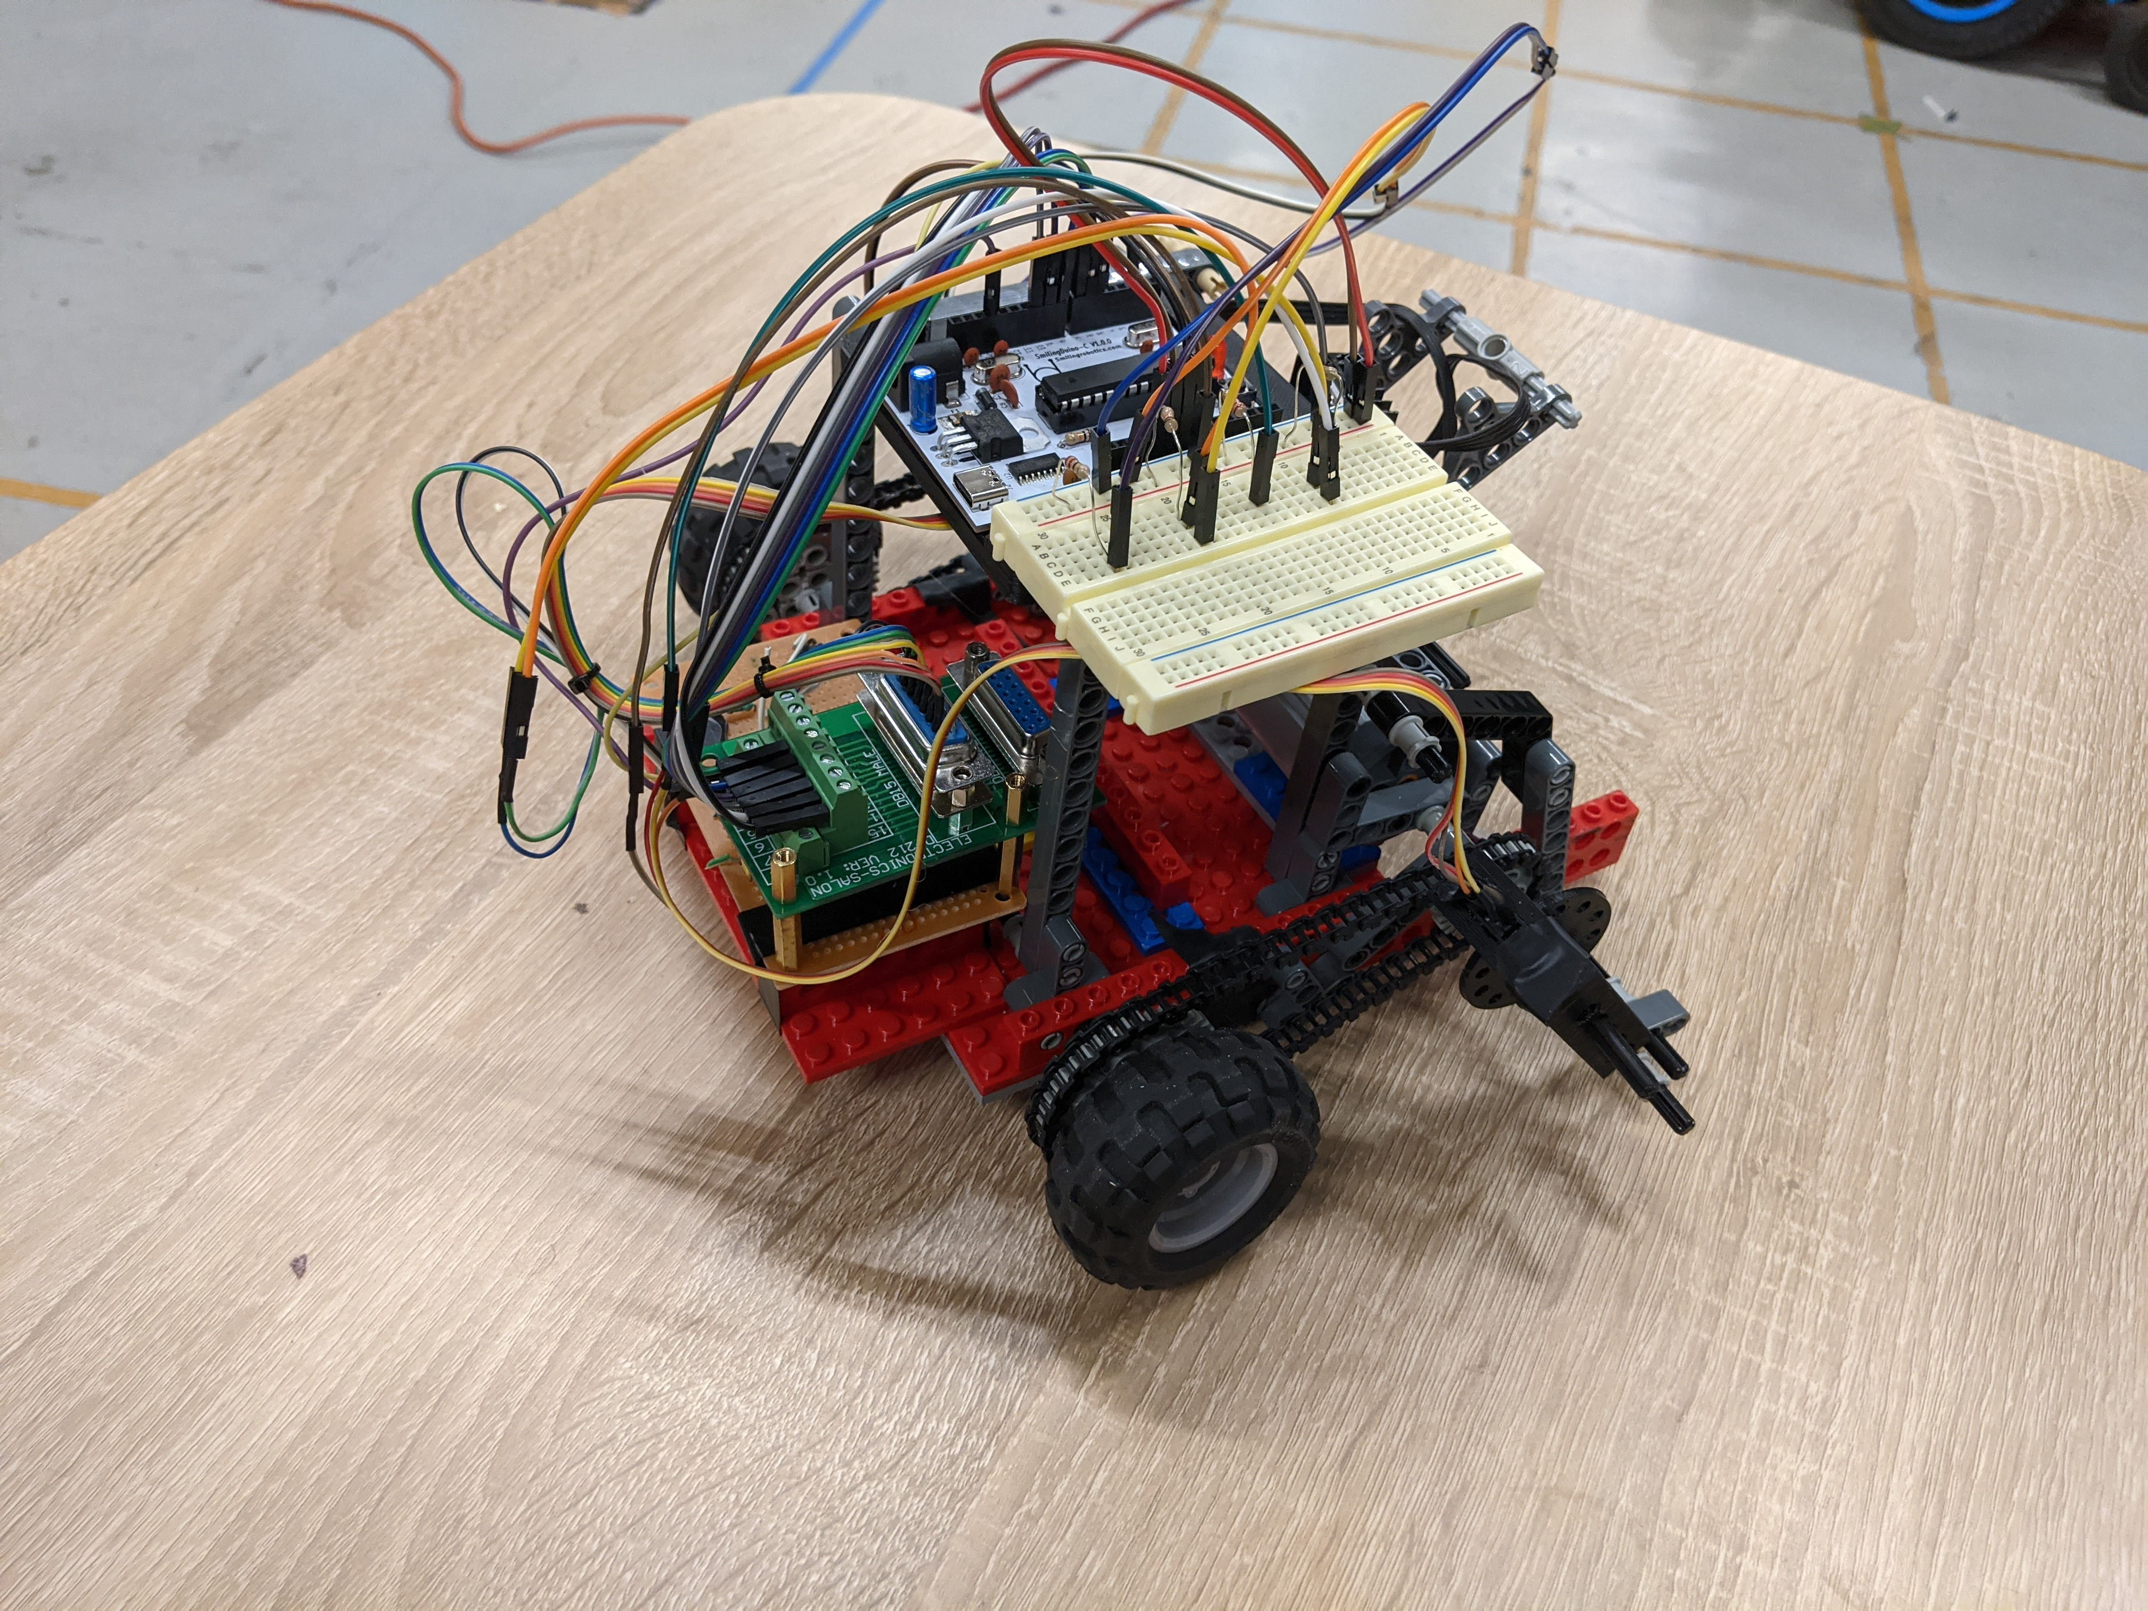
(Fig 1)
Encoder

I decided that rather than dealing with mounting the encoder using a combination of legos I would design and 3D print a small bracket to mount the encoder to my motor wheel. This went through a couple of revision but proved a good choice as my largest area of hindrance is my robots chaise.
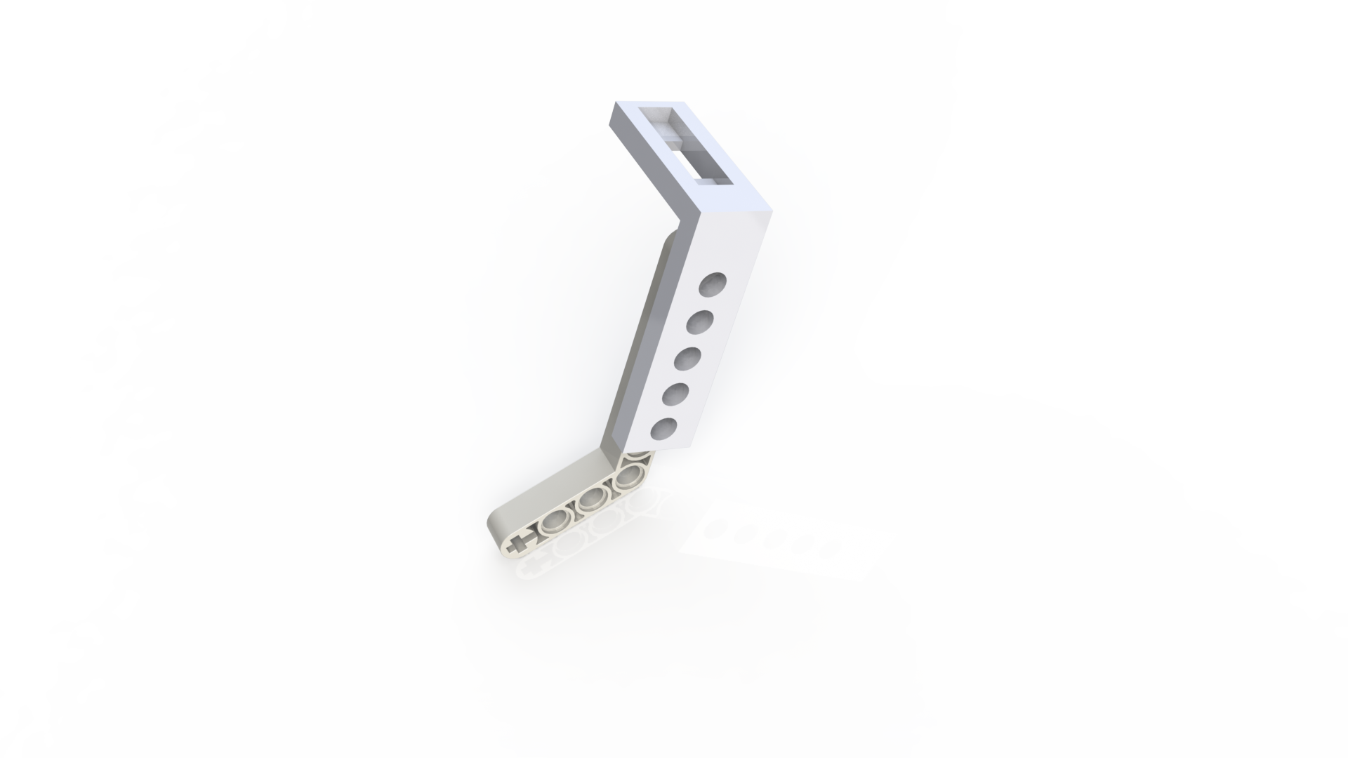
(Fig 2)
I also designed and printed a mount for my Arduino board that allowed for better mounting then I had in last lab and added structural integrity to my bot.
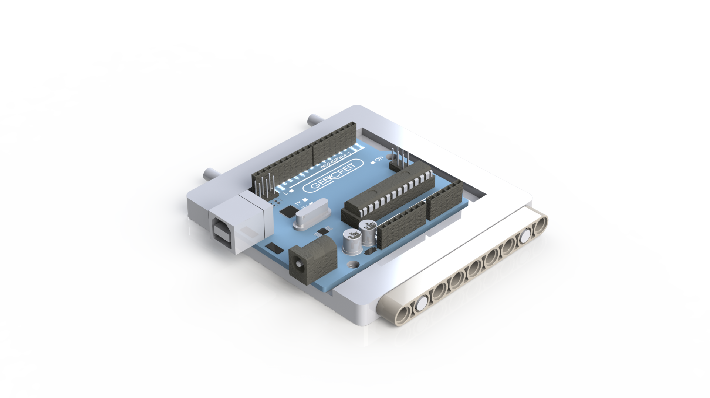
(Fig 3)
Algorithm:
I chose to implemented my own code from scratch for two primary reasons.
1) I wanted the experience as I am very familiar with Arduino programming and wanted to have some more fun with it.
2) As labs progress I do not want to be reliant on another persons code (regardless of how good it is) as incorporating new features will be far easier for myself if I am familiar with the code base.
This also allowed me to break out the code to a higher degree utilizing multiple simple functions as well as a standard PID library offered by Arduino which I have used before. A simple implementation (documented in detail in code) follows the flow of taking in next direction command from a list of (command, distance) pairs, calculating the desired encoder counts given constacnes such as distance/ degrees per rotation and adjusting PWM values of each motor every cycle based on their respective encoder count values (incremented by seperate ISRs) compared to a desired count and fed through their individual PID loops. (As a side note I also made a simple wiring harness as I was sick of how delicate my wiring was with the breadboard and connectors, while this is not a great solution in this lab the goal is to order a simple shield from jlcpcb for next lab. I also replace the standard Arduino Uno board with a custom one I designed as it has a type c USB port which is only important because it offers less resistance when removing it as I was damaging my bot removing the cable so many times).
Results:
I ran my robot through the test maze a surplus of 20 times and had a mix set of results. The primary conclusion that can be scrubbed is that the software was performing very well, when tested on a bench top with the robot immobile or on hardwood floor the bot would move to the same spot almost 100% of the time and the encoder counts would always be with in 2 away from goal as the deceleration curve was performing great. These results did not hold well when maze testing however as this lab seriously highlighted the shortcoming of the chaise design. Its simple dragging pivots in the back seemed to get caught on anything and everything while the wheels would continue spinning, tricking the feedback loop and throwing the bot entirely off. On labs that proved successful my average completion time was 42.16 seconds.
Table 1 shows the results of 3 relatively successful runs
Note: As my chassis proved a large hindrance I allowed mild overlap of robot – wall boundaries in successful runs)
 | Run 1 | Run 2 | Run 3
Time (seconds) | 41 | 40.5 | 45

Conclusions:
There are two major conclusions to be drawn from this lab.

1) A simple encoder based feedback system offers an increase in precision given no major disturbance that are capable of tricking them (motor spinning but robot stationary) but the accuracy of the robots final destination is not guaranteed without better world placement sensors.

2) My chaise needs a redesign to allow a roller in the back as apposed to two dragging pivots, these pivots get caught far too easily and this lab became an order of magnitude harder due to it. My top priority in the following lab will be to adjust for this issue as well as do a better job accounting for collisions. I would like to add a response handler that utilizes bump sensors to adjust in the event of error beyond what can be handled by the encoders.

References

PID library documentation: https://playground.arduino.cc/Code/PIDLibrary/

Appendices:

Fig 1: Encoder placement and robot designed
Fig 2: Encoder mount render
Fig 3: Arduino mount render
Table 1: Times of successful maze runs

