UDP Roundtrip Measurement

Raspberry Pi4 – Pi3

RÖDLACH, VOCK

Inhaltsverzeichnis

Task Description 3

Measurement Setup 3

Result 4

Data 4

Histogramms 4

No Load 50.000 cycles 5

Network Load 50.000 cycles 5

CPU Load 50.000 cycles 6

No Load 500.000 cycles 6

Alternative Setups 7

Source code 7

# Task Description

1. Implement a C language module (or other language of choice)
2. Implement one socket for transmission of the ping message between two nodes
3. An echo function shall transmit every received package back to the sender

Furthermore:

1. Determine the following values for each measurement
   1. min round-trip time
   2. mean round-trip time
   3. max round-trip time
2. Determine histogram for each measurement
3. Measure the following setups
   1. 50.000 cycles normal operation
   2. 50.000 cycles high network load
   3. 50.000 cycles high cpu load
   4. 500.000 cycles normal operation

# Measurement Setup

The Setup consists of the two nodes (pi4 & pi3), a laptop computer and a network switch. The laptop acts as a DHCP-Server and controls the nodes via a Secure Shell (SSH) interface.

The Master node sends a UDP Package filled with a unique message ID, the timestamp of the beginning of the measurement and a REQ message. The Slave node receives the package changes the REQ message to ACK and returns the package to the master.

Upon receiving back, the package the master checks the message ID and the timestamp calculates the roundtrip time and saves it. After all measurements are finished, the results are written to a .csv logfile.

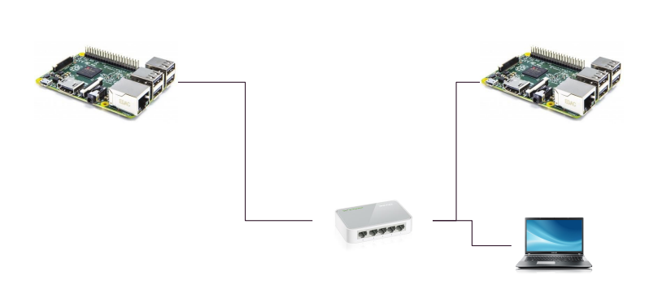

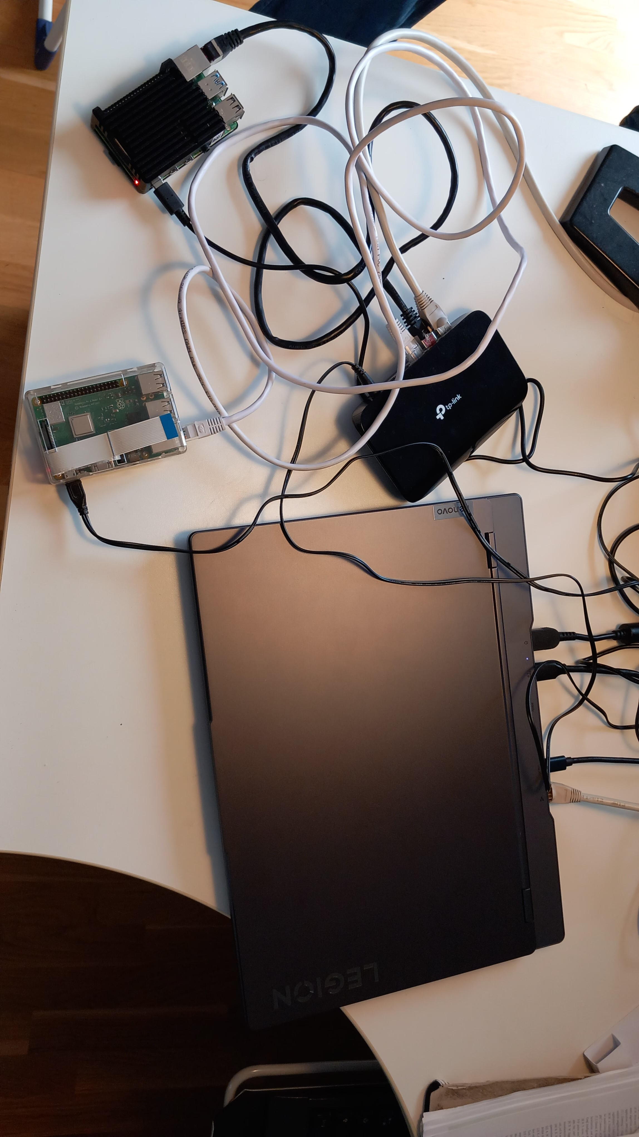

# Result

## Data

|  |  |  |  |  |
| --- | --- | --- | --- | --- |
| **Measuremt pi4 - pi3** | | | | |
|  |  |  |  |  |
| No. of cycles |  | MIN (µs) | MAX (µs) | MEAN (µs) |
| 50.000 |  |  |  |  |
|  | no load | 170.167 | 334.259 | 279.420 |
|  | high network load | 146.871 | 327.127 | 277.232 |
|  | high cpu load | 159.939 | 1009.887 | 246.036 |
| 500.000 |  |  |  |  |
|  | no load | 166.843 | 321.531 | 288.021 |

## Histogramms

The histograms are generated from the .csv logfile via a simple python script. The values on the Y-axis are plotted exponentially to be able to show all data points in the diagram.

### No Load 50.000 cycles

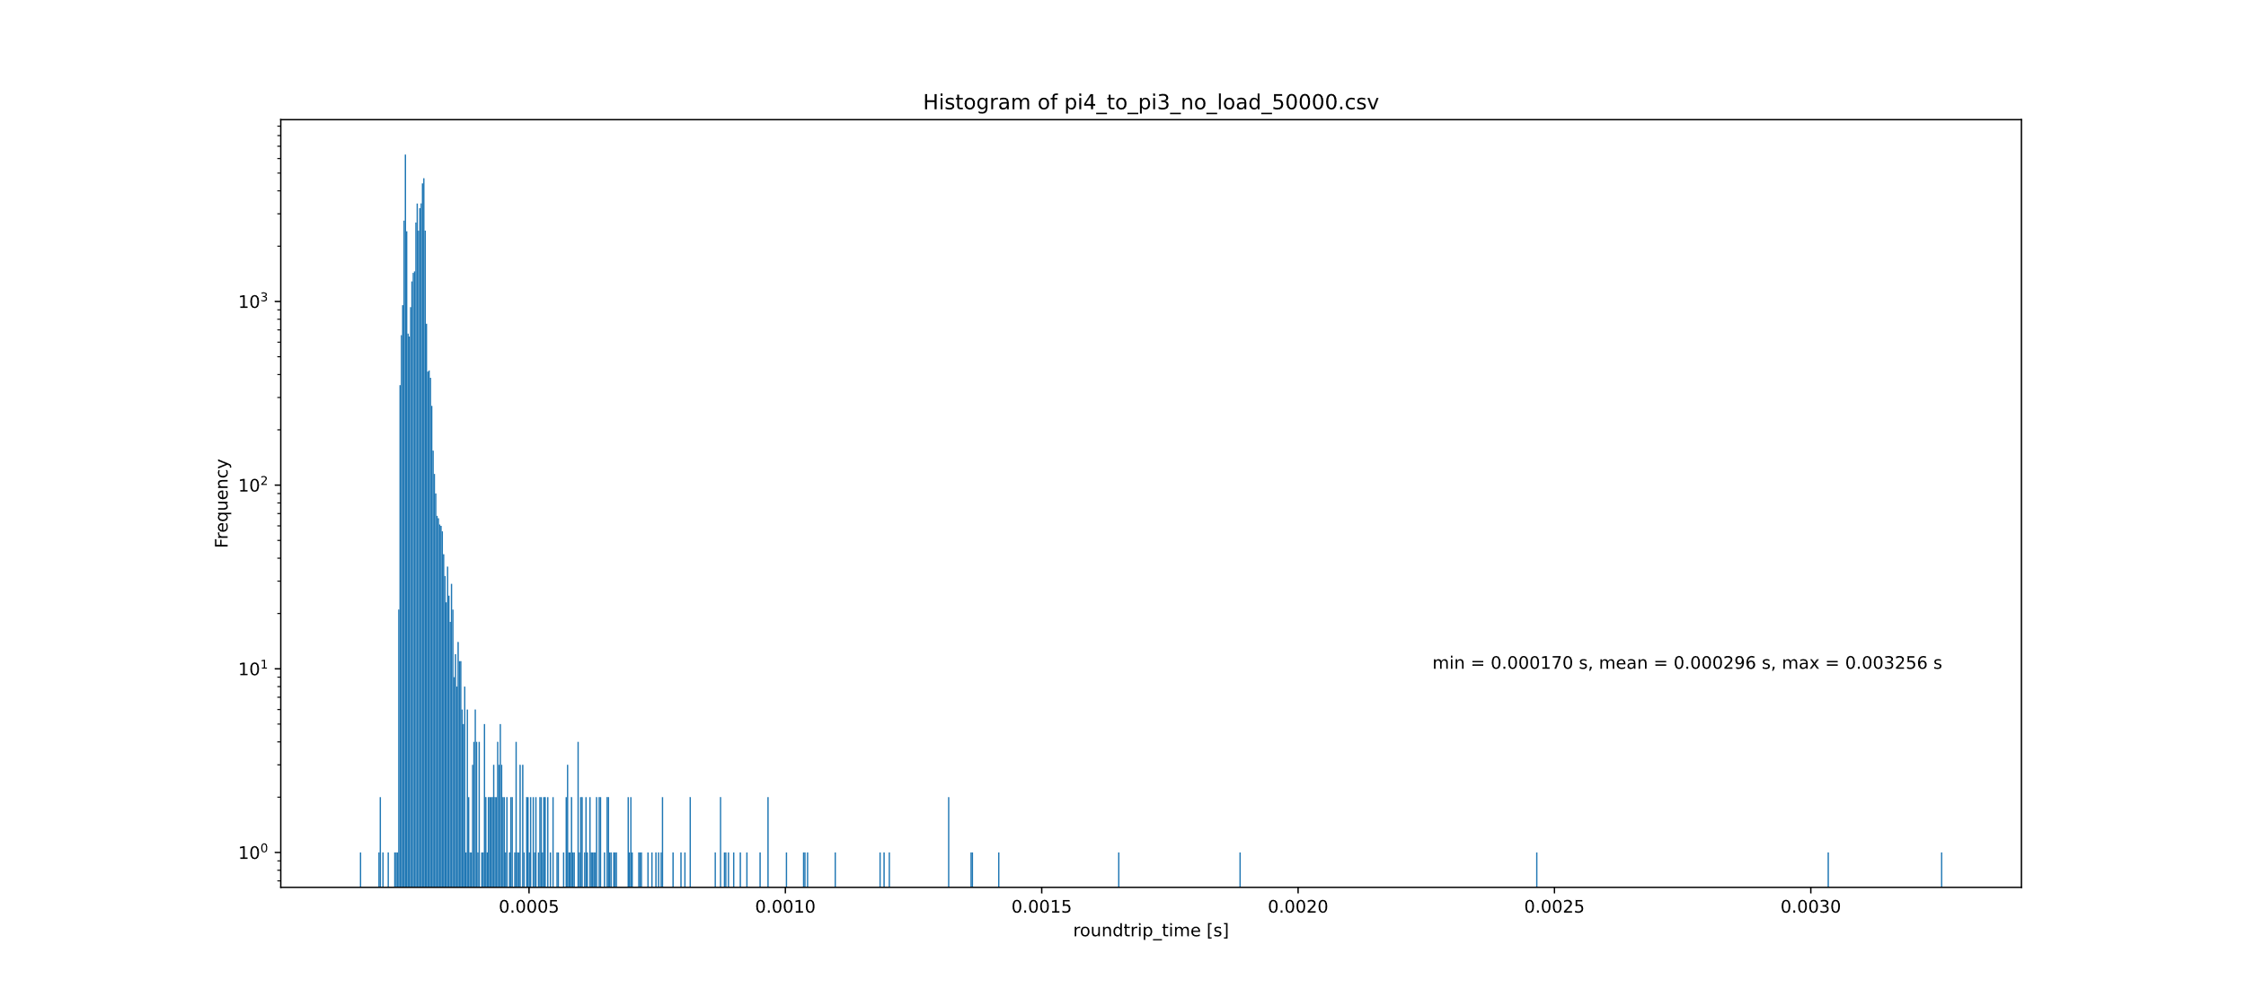

### Network Load 50.000 cycles

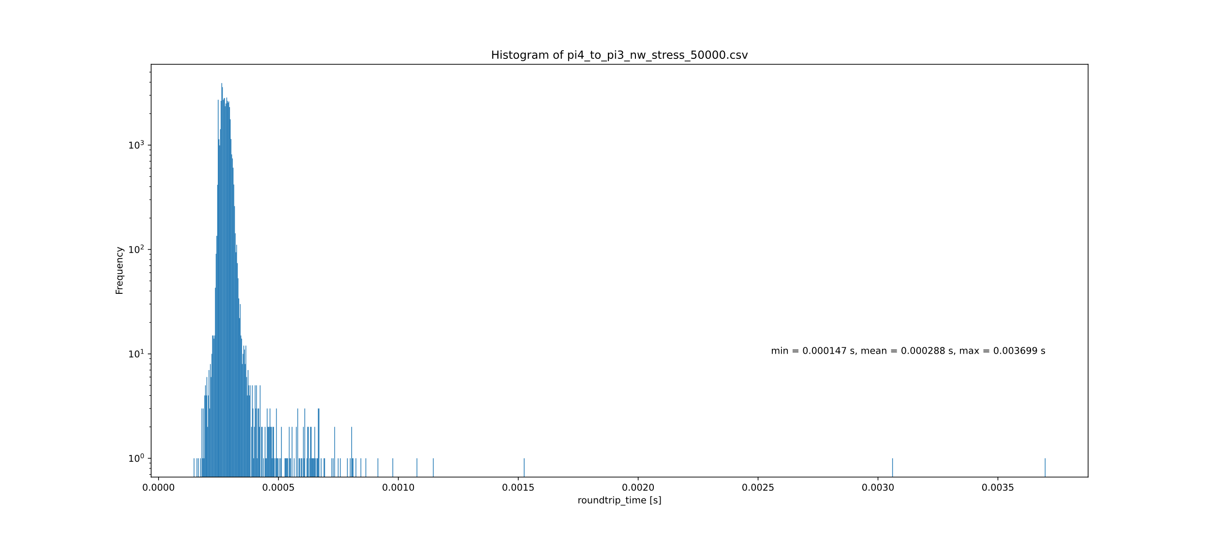

### CPU Load 50.000 cycles

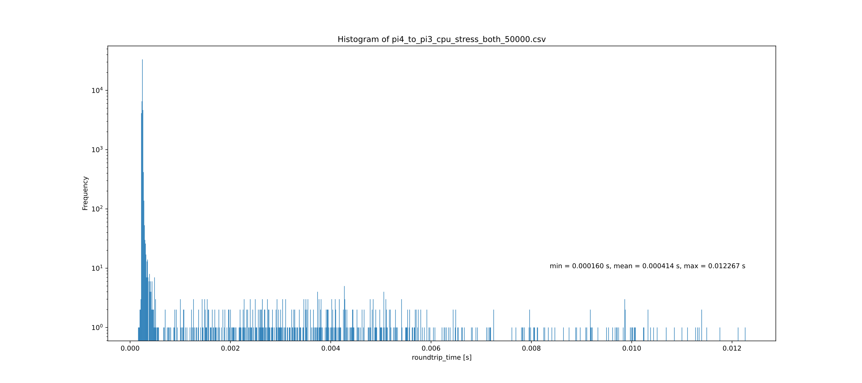

### No Load 500.000 cycles

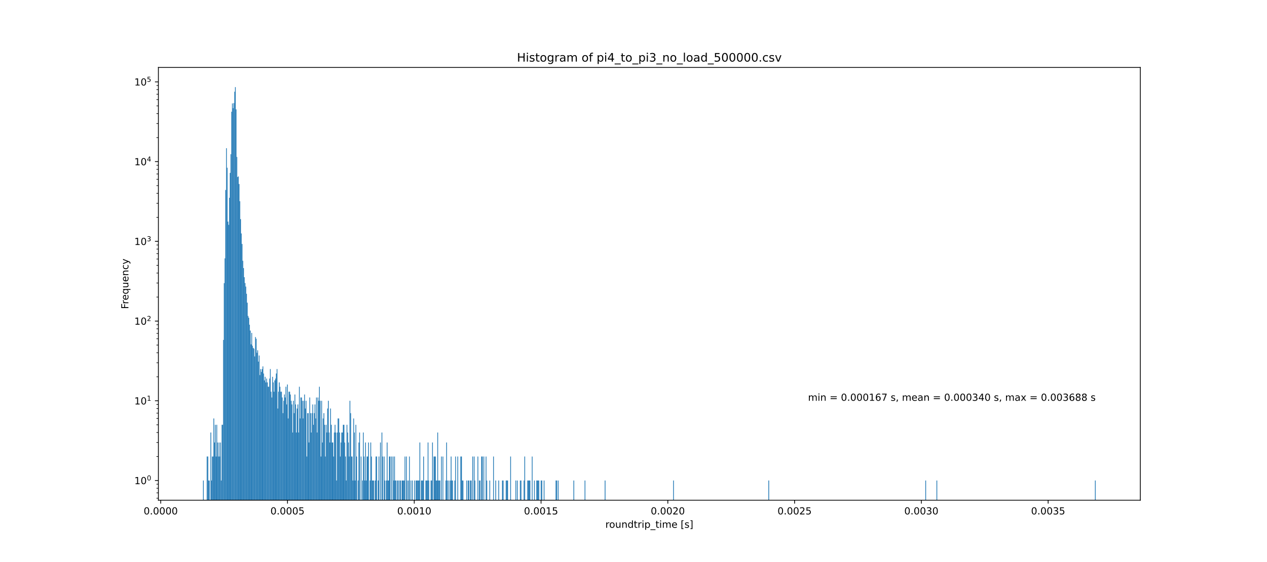

# Alternative Setups

Building upon the Pi4-pi3 measurement, additional experiments were conducted involving the interaction between a laptop and both Raspberry Pi 4 and Raspberry Pi 3. The resulting data will now be compared.

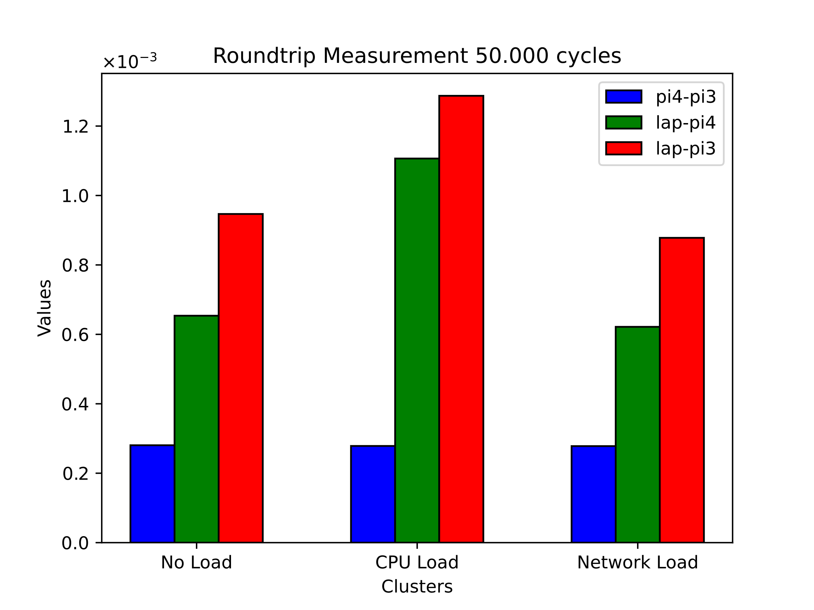

# Source code

The Source code for the roundtrip measurement and the histogram generation as well as all measurement data and diagramms can be found on the following public Git-repository.

<https://github.com/Christian-Roedlach/DES.git>