CS 155 COMPUTER SCIENCE I Summer, 2024
Assignment #21
15 Points

Write a function called getSides that will ask the user to enter 3 sides of a triangle and return those as reference parameters. The function should validate so that each side is greater than zero.

Write another function that will accept 3 sides of a triangle as value parameters and compute and return the triangle's area. Use the formula displayed below to perform the computation.

Check to see if the triangle is valid (that is, the smallest two sides add up to a value that exceeds the largest side). If the triangle is invalid, your function should return -1 as the area.

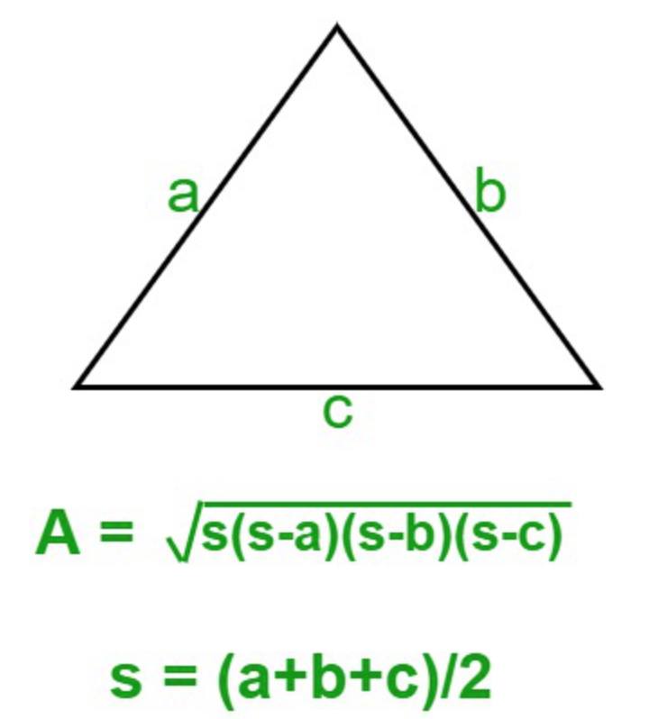

NOTE: This example above uses single letters to represent values. You should never do this when writing computer programs. By the way, A stands for the triangles’ area, and s stands for the triangles semiperimeter.

Write a main program that will allow the user to enter as many triangles as he wishes. The user should be prompted after each triangle to see if he would like to continue.

In addition to sending output to the screen, send the triangle sides and area to a data file named "triangles.txt". For triangles that return -1 as the area, you should output “Invalid triangle”. Format all output (screen and file) to use exactly 4 decimal places.

SUBMIT: C++ source code.

