Design Document – Lake Side University Scholarship Calculator
Name: Christian Tampus
Course: CS155-I01
Assignment: #15 Scholarship Program
Due Date: 6/30/2024
Program Requirements
This program will ask the user how many applicants to process and validate the number of applicants so that only a value in the range of 1 to 6 is accepted. It will continue to ask the user for input until a valid number of applicants is entered. For each applicant the program will ask the user to enter their full name, high school grade point average (GPA) and ACT score. The program will compute the score with a given formula and display it using exactly 2 decimal places. Last it will output the student’s name and the type of scholarship they earned (Leo Scholarship, Una Scholarship, no scholarship).
Program Inputs
- Applicants (Integer)
- Applicant Name (String)
- Applicant GPA (Double)
- Applicant ACT (Integer)
Program Outputs
- Score (Double, w/2 decimal places)
- Applicant Name (String)
- Scholarship (String)
Test Plan
Case #1:
Applicant Score: 95.01
Applicant Name: Christian Tampus
Applicant Scholarship Earned: Leo Scholarship
Case #2:
Applicant Score: 85.01
Applicant Name: John Doe
Applicant Scholarship Earned: Una Scholarship
Case #3:
Applicant Score: 84.99
Applicant Name: Jane Doe
Applicant Scholarship Earned: No Scholarship
Algorithm
- Do Input: Applicants (Integer) While Applicants Is Less Than 0 Or Greater Than 6
- For The Number Of Applicants
  - Input: Applicant Name (Get Full Name Even With Spaces)
  - Do Input: GPA (Double) While GPA Is Less Than 0 Or Greater Than 4
  - Do Input: ACT (Integer) While ACT Is Less Than 1 Or Greater Than 36
  - Score = 16 + (15 * GPA) + (1.8 * ACT)
  - Output: Score (w/2 Decimals)
  - Output: Applicant Name
  - If Score Is Greater Than Or Equal To 95
    - Scholarship = “Leo Scholarship”
  - Else If Score Is Greater Than Or Equal To 85
    - Scholarship = “Una Scholarship”
  - Else
    - Scholarship = “No Scholarship”
  - Output: Scholarship

Flowchart
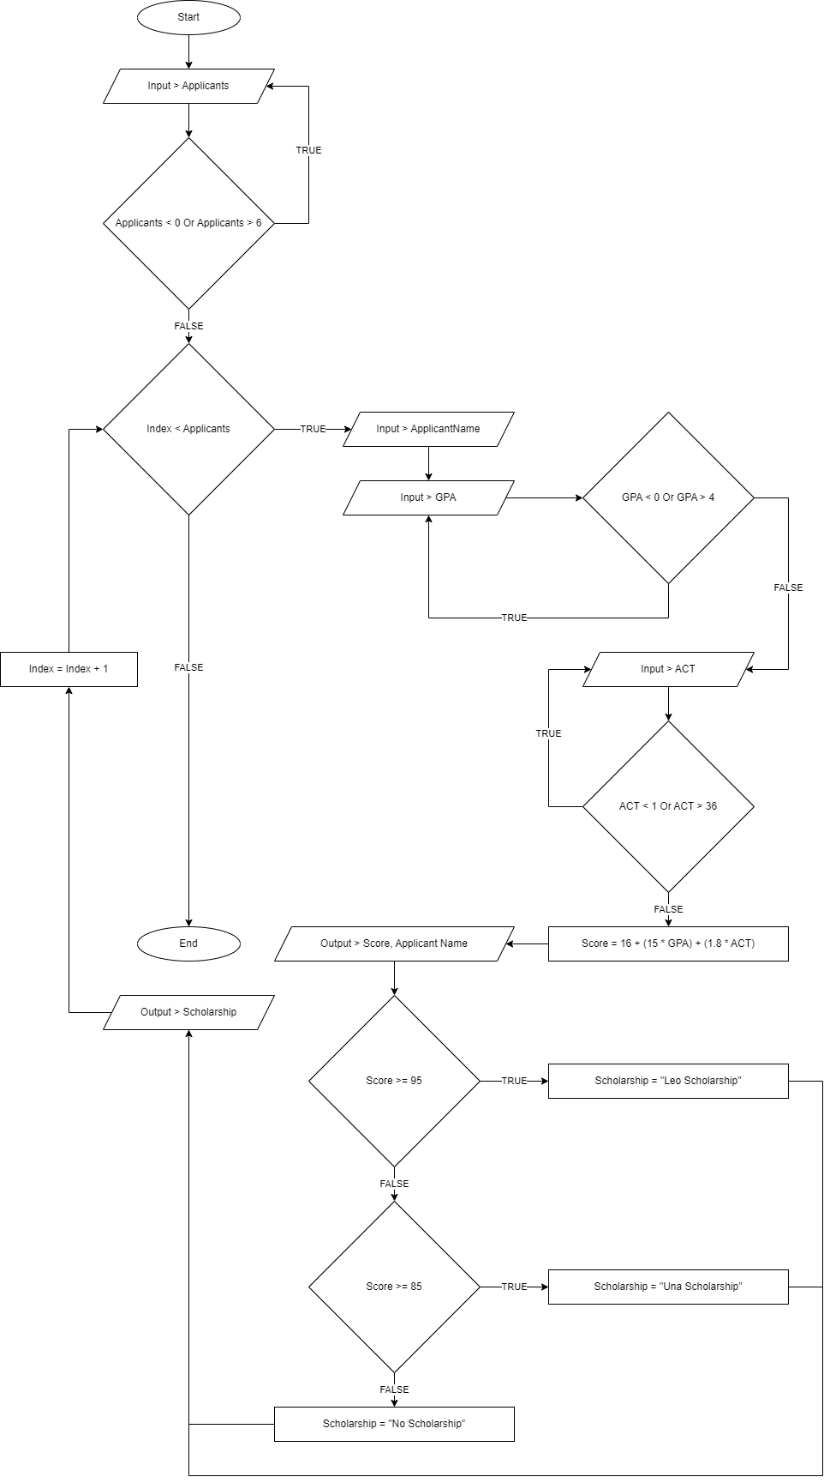

Data Pictures
