Load debug scripts:

https://wonderfulco.sharepoint.com/?debug=true&noredir=true&debugManifestsFile=https://localhost:4321/temp/manifests.js

gulp build

gulp serve

Updates for March 4th release

Travel

Information: https://wonderfulco.sharepoint.com/sites/Travel

Concur: https://launcher.myapps.microsoft.com/api/signin/435b89aa-9532-4c22-9195-49876218038e?tenantId=57fe7bb5-e382-4498-88fe-5c50d256f735

{

name: "Travel",

url: "https://wonderfulco.sharepoint.com/sites/Travel",

dataInterception: "off",

elements: [{ url: "https://wonderfulco.sharepoint.com/sites/Travel", name: "Information", dataInterception: "off" }, { url: "https://launcher.myapps.microsoft.com/api/signin/435b89aa-9532-4c22-9195-49876218038e?tenantId=57fe7bb5-e382-4498-88fe-5c50d256f735", name: "Concur", dataInterception: "off" }]

},

Smart Recruiters: https://www.smartrecruiters.com/app/employee-portal/

new node called "Careers"

* Run ***gulp bundle --ship*** to bundle the solution in vs code terminal or node command prompt.
* Run ***gulp package-solution --ship*** to package the solution in vs code terminal or node command prompt.
* Open the project in File Explorer and the user will find .sppkg file by navigating to SharePoint 🡪 solutions 🡪 wonderful-menu.sppkg
* <https://www.c-sharpcorner.com/article/spfx-commands-cheat-sheet/>

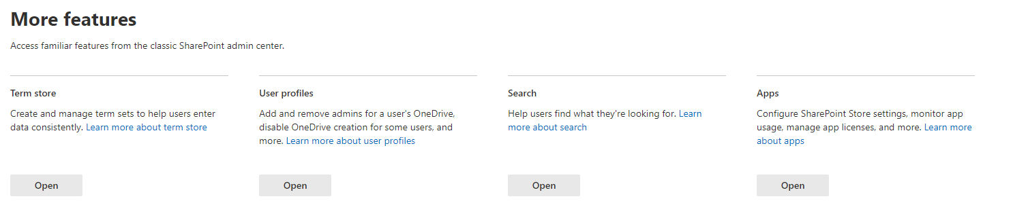

Under Apps / Classic Experience: <https://wonderfulco.sharepoint.com/sites/apps/AppCatalog/Forms/AllItems.aspx>

Drag solution and **uncheck deploy to all sites (this deploys to existing banner sites)  
Deploy**