Assignment 1: Improving a Movie-Review Classifier

1. Objective
Take the neural network from class that classifies IMDB movie reviews as positive or
negative, and test whether targeted changes improve its accuracy on reviews it has never
seen.
2. Approach
- Data: 25,000 labeled reviews for training, 25,000 for final testing. Each review
was converted to a 10,000-feature binary vector (one feature per vocabulary word).
- Fixed protocol: every configuration trained for 20 epochs, batch size 512, with
the first 10,000 training reviews held out as a validation set used to judge each change
during training.
- One change at a time across seven configurations: (1) three hidden layers
instead of two; (2) 64 units per layer instead of 16; (3) MSE loss instead of
cross-entropy; (4) tanh activation instead of ReLU; (5) dropout and L2 regularization.
3. Findings
Configuration | Validation acc. (final) | Validation acc. (best) | Test acc.
Baseline: 2 layers × 16 units (ReLU) | 0.8669 | 0.8868 | 0.8560
Three hidden layers | 0.8714 | 0.8867 | 0.8571
64 units per layer | 0.8729 | 0.8902 | 0.8601
MSE loss | 0.8742 | 0.8872 | 0.8620
Tanh activation | 0.8665 | 0.8883 | 0.8540
Dropout 0.5 | 0.8805 | 0.8892 | 0.8736
L2 regularization (0.001) | 0.8716 | 0.8918 | 0.8619
- Depth: three hidden layers matched the two-layer baseline on both validation
(0.8867 vs. 0.8868) and test data (0.8571 vs. 0.8560) — the extra layer added nothing.
- Width: 64 units per layer gave no meaningful gain (test 0.8601 vs. 0.8560).
- MSE loss: the model trained without issue, but test accuracy (0.8620) did not beat
the standard setup.
- Tanh: no improvement over ReLU (test 0.8540 vs. 0.8560).
- Regularization worked: dropout (0.5) produced the best test accuracy (0.8736) and
the best final validation accuracy (0.8805). L2 reached the highest single-epoch
validation accuracy (0.8918).

Caveat: one run per configuration; differences under about 0.005 are within
noise. MSE loss values sit on a different scale from cross-entropy values, so only
accuracy is compared across loss functions.

4. Visual summary
Accuracy by configuration — dropout leads on unseen reviews:
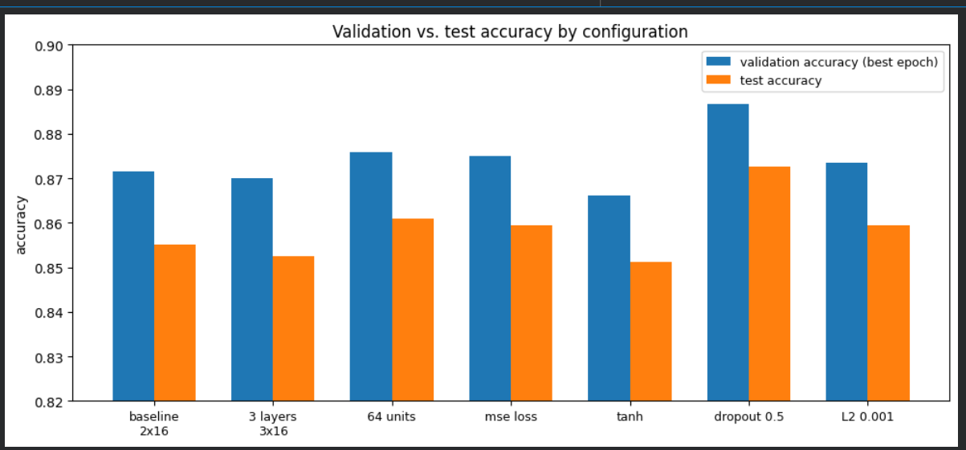

Validation accuracy across the 20 training epochs — dropout pulls ahead and stays there:
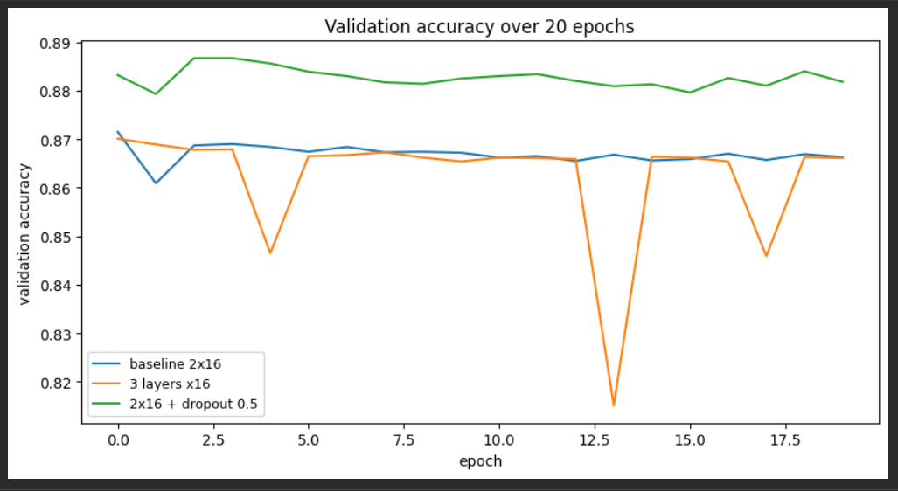
Overfitting check — training accuracy keeps climbing while validation plateaus:
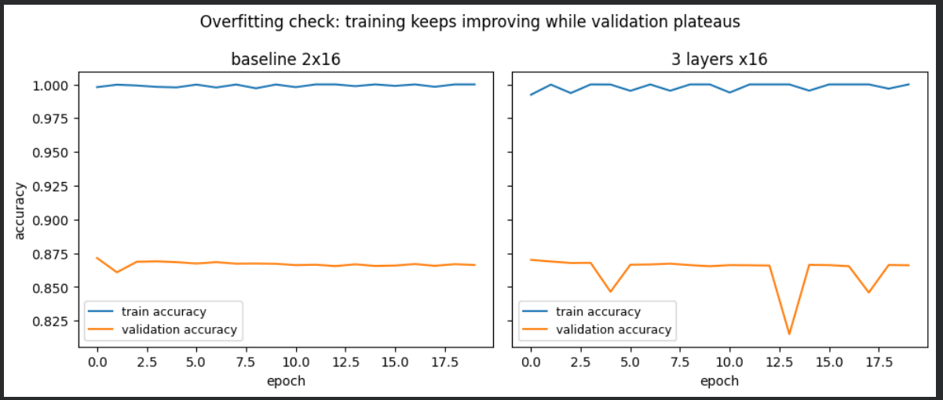
5. Conclusions
- Extra capacity — deeper or wider networks — did not help. The baseline was already
large enough for this task; bigger models overfit the training data.
- The loss function and activation choices mattered less than expected; the class
defaults (cross-entropy, ReLU) held up.
- Regularization was the only change that reliably improved accuracy on unseen reviews.

6. Recommendation
Adopt the dropout (0.5) configuration: highest accuracy on unseen reviews
(0.8736) and the most stable validation performance. L2 regularization is a close
second and worth keeping as a fallback.

