**NARRATIVE REPORT:**

**IT Caravan and Baguio Tour**

**Title:**

$$Ascent to Innovation$$

$$Where Technology Meets Tomorrow$$

**Location:**

Baguio, Teacher’s Camp

**Submitted by:**

Roderick E. Ogatcho

BSIT 31001

IM

**Date:**

November 4-6, 2024

**Introduction:**

On November 4-6, 2024, I had the privilege of joining the IT Caravan and Baguio Tour titled "Ascent to Innovation Where Technology Meets Tomorrow." This three-day journey was organized as part of our academic development, blending educational insights with an exploration of Baguio City's renowned attractions. The event aimed to expose participants to the latest advancements in technology while fostering camaraderie and personal growth. It began with a day of touring iconic landmarks in Baguio, immersing us in the city’s cultural and natural beauty. The following two days were dedicated to an engaging seminar that delved into transformative topics, including Generative AI, the Metaverse, Quantum Computing, and Edge Computing. This narrative report captures the essence of my experience during the tour, reflecting on the sights, knowledge gained, and personal insights from this enriching journey.

**Day 1: Exploration and Discovery**

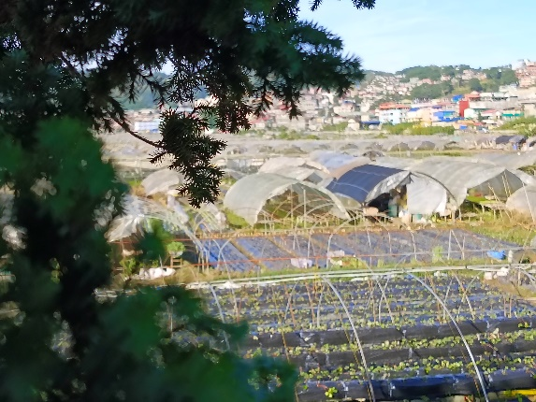

Figure 1. The Strawberry Farm

The first day of our trip was dedicated to sightseeing. Our initial stop was the Strawberry Farm, where I enjoyed exploring the fields and sampling various strawberry-inspired treats. It was a delightful start, setting the tone for the day.

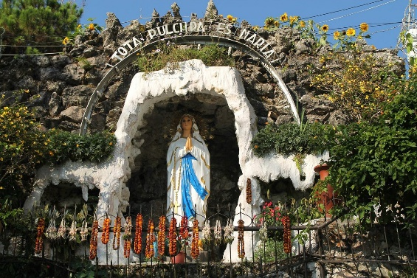

Figure 2. Grotto

Next, we visited the **Our Lady of Lourdes Grotto**, a site known for its serene ambiance and its iconic 200+ steps. While some of my classmates climbed to the top, I and my friend opted out, succumbing to sleepiness. However, the sight of the stairs and the energy of my peers were impressive.

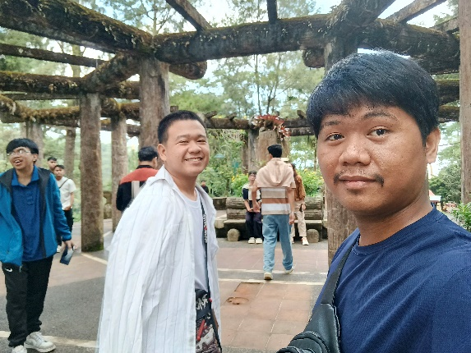

Figure 3. Across the Mansion

The **Mansion** was our next destination. Surrounded by lush greenery, this historical site allowed us to take memorable photos and enjoy the tranquil surroundings. Afterward, we stopped at the **Good Shepherd Convent**, where famous Baguio delicacies are sold. Unfortunately, I stayed on the bus, still battling sleepiness.

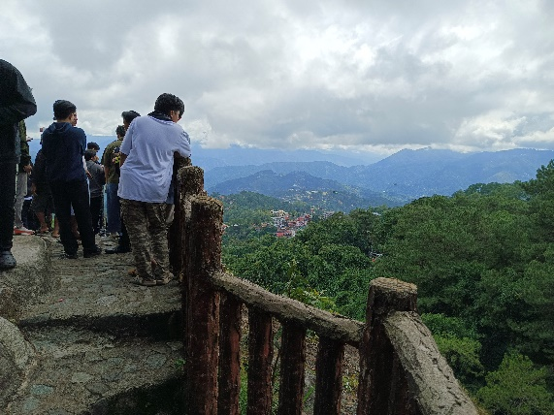

Figure 4. Mines View Park

One of the highlights for me was the **Mines View Park**, with its breathtaking panoramic views. I felt a sense of awe looking out over the landscapes, and it remains a vivid memory of the trip. Our final destination for the day was **Burnham Park**, where we spent the most time. However, I couldn’t fully enjoy it due to my exhaustion.

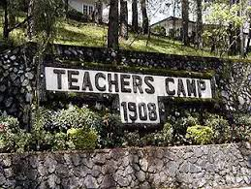

Figure 5. Teacher's Camp

Finally, we arrived at **Baguio Teacher’s Camp**, our home base for the seminar. Teachers Camp in Baguio City offers a variety of accommodations suitable for individuals, families, and large groups attending seminars, workshops, or retreats. It features colonial-style cottages with a rustic charm, complete with bedrooms, living and dining areas, bathrooms, and sometimes kitchen facilities, accommodating 6 to 15 people. The camp also offers conference halls with attached dormitory-style sleeping quarters, perfect for groups needing both meeting spaces and nearby lodging. Facilities include hot and cold showers, dining areas, recreational spaces, and limited Wi-Fi access. After settling into our rooms and having dinner, we had some free time before resting. Despite the strict rules, some batchmates broke the ban on smoking and were caught, providing an unexpected twist to the evening.

**Days 2-3: Academic Engagement**

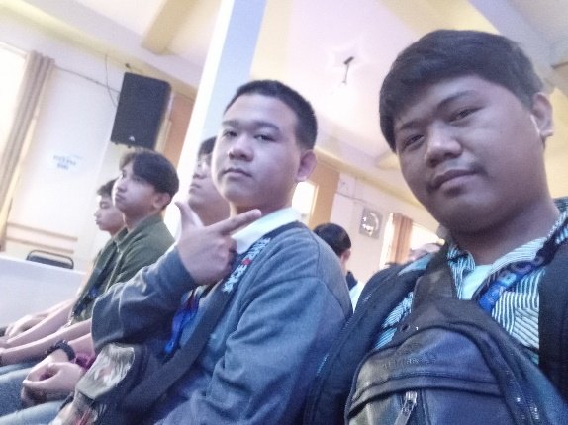

Figure 6. Me and my friends during the seminar

The next two days were focused on the seminar, which explored the theme of technological innovation. The speakers covered four fascinating topics:

1. **Generative AI and it’s Applications:** The 1st part of this topic was discussed by ***Mr. Zen Lee D. Foryasen*** and the 2nd part was from ***Mr. Dann Angelo De Guzman*** about a revolutionary branch of artificial intelligence transforming industries by creating new content. The discussion emphasized its applications, from crafting realistic visuals to enhancing customer service, while also addressing ethical concerns such as misuse and job displacement.
2. **The Metaverse:** This is the topic of ***Ms. Lovely Jenn A. Reformado*** about a virtual shared space with immense potential for education, training, and collaboration. While it holds great promise, challenges like technological limitations and privacy concerns were highlighted.
3. **Quantum Computing:** This topic is discussed by ***Mr. Don Hari C. Malabanan*** about the emerging field leverages quantum mechanics to solve problems beyond the scope of classical computers. The talk delved into its transformative potential across industries while acknowledging the challenges of implementation.
4. **Edge Computing:** The last topic is discussed by ***Mr. Ian M. Erguiza*** A technology bringing processing power closer to data sources, reducing latency for real-time applications. The session emphasized its importance for IoT and 5G networks while addressing issues like security and power consumption.

The seminar expanded my understanding of cutting-edge technologies and their impact on the future. It was inspiring to see how these innovations could shape industries and lives in the coming years.

**Reflection**

Participating in the IT Caravan and Baguio Tour was a mix of leisure and learning, offering a unique blend of experiences. While the sightseeing showed me the beauty and cultural richness of Baguio, the seminar deepened my appreciation for the rapid advancements in technology. This journey reminded me of the importance of staying curious and open to new knowledge. Despite minor struggles like fatigue and the cold weather, I realized the value of stepping out of my comfort zone. It was a moment to bond with classmates, explore new perspectives, and gain insights that will guide my academic and professional journey. Overall, this experience was not just a trip to Baguio but an opportunity to connect with the future of technology and appreciate the world around me.

**Conclusion** The IT Caravan and Baguio Tour was an unforgettable experience that combined education, adventure, and personal growth. Exploring Baguio’s famous landmarks, like the Strawberry Farm, Mines View Park, and Burnham Park, gave us a deeper appreciation for the city’s beauty and cultural heritage. These moments allowed us to bond with our classmates while immersing ourselves in the charm of Baguio. The seminar sessions were equally impactful, covering cutting-edge topics like Generative AI, the Metaverse, Quantum Computing, and Edge Computing. These discussions opened our eyes to the potential of these technologies and their influence on the future, while also addressing the challenges they bring. It was inspiring to learn how innovation is shaping industries and lives worldwide.

This journey taught us the importance of curiosity, stepping out of our comfort zones, and embracing new knowledge. It was a great mix of learning and leisure that left us with valuable lessons, stronger friendships, and cherished memories. Overall, the tour wasn’t just a visit to Baguio but a step forward in our academic and personal growth.