RATU Network Project
Testing Evidence
Supporting Appendix D of the Technical Report — Table 5.1 test results
Prepared by: Christian

Evidence Index
Each figure below corresponds to a numbered test in Table 5.1 of the Technical Report. Screenshots were captured directly from the verified Packet Tracer build (RATU_Full_Network.pkt) after all issues logged in Table 5.2 had been resolved.

Reference — Full Network Topology
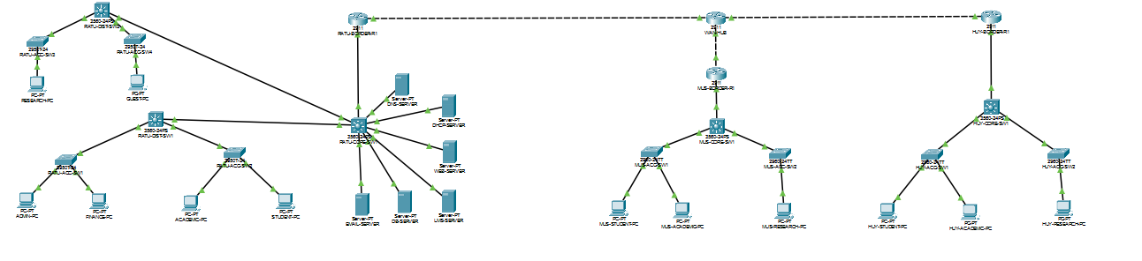
Complete logical topology — Kigali (core, distribution, access, data center), Musanze, and Huye, connected through the shared WAN transit router. Provided for orientation before the individual test evidence below.

T-01 — VLAN Configuration — RATU-CORE-SW1
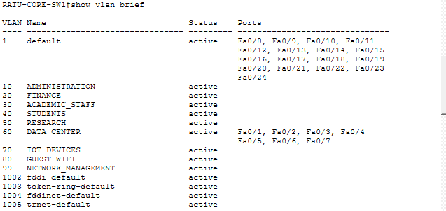
show vlan brief — confirms all 9 VLANs active with ports correctly assigned.

T-01 / T-02 / T-03 / T-04 — Routing Table — RATU-CORE-SW1
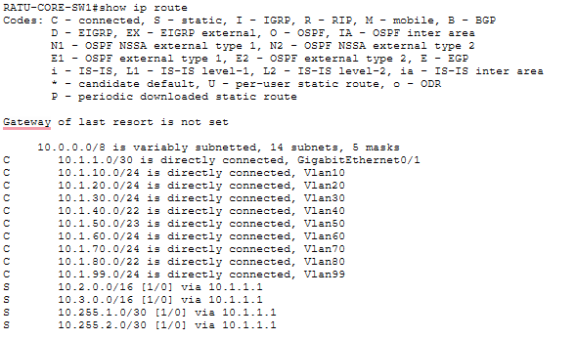
show ip route — all Kigali VLANs and cross-campus routes present.

T-05 — DHCP Bindings — RATU-CORE-SW1
show ip dhcp binding — confirms automatic IP assignment across VLANs.

T-07 / T-08 — Access Control Lists — RATU-CORE-SW1
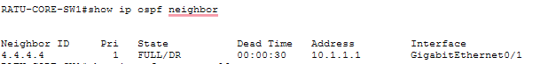
show ip access-lists — STUDENT_RESTRICTIONS and GUEST_RESTRICTIONS active with match counters.

T-09 — OSPF Adjacency — RATU-BORDER-R1
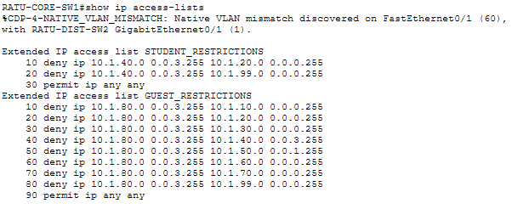
show ip ospf neighbor — FULL/DR state confirmed with the Kigali core switch.

T-10 — GRE Tunnel 0 — RATU-BORDER-R1
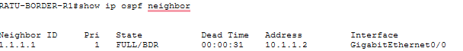
show interfaces tunnel0 — Kigali ↔ Musanze tunnel, up/up.

T-10 — GRE Tunnel 1 — RATU-BORDER-R1
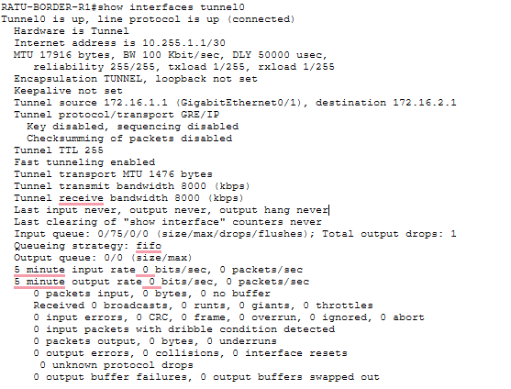
show interfaces tunnel1 — Kigali ↔ Huye tunnel, up/up.

T-02 / T-03 — Inter-Campus Connectivity — ADMIN-PC
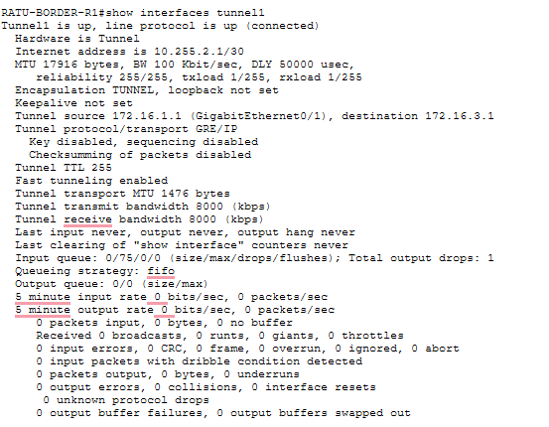
Ping to 10.2.40.1 (Musanze) and 10.3.40.1 (Huye) — both campuses reachable from Kigali.

T-07 — Zero Trust ACL — STUDENT-PC
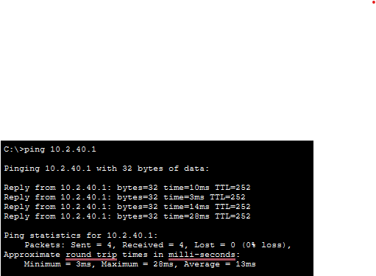
Ping to 10.1.20.1 (Finance) from the Students VLAN — correctly blocked.

T-08 — Zero Trust ACL — GUEST-PC
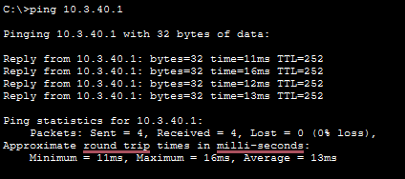
Ping to 10.1.10.1 (Administration) from Guest Wi-Fi — correctly blocked.

T-11 — Port Security — RATU-ACC-SW1
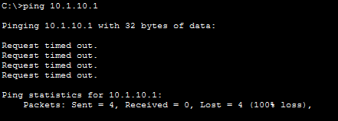
show port-security — sticky MAC learning and restrict mode confirmed on access ports.

Reference — Additional Verification
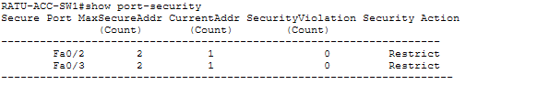
Supporting output captured during final validation.

