## **Computer Specifications:**

* CPU
  + Brand: Intel
  + Model: Intel(R) Core(TM) i5-10400
  + Cores: 6 cores
  + Base Clock: 2.90 GHz
* 32 GBs of DDR4 3600 Memory
* 512 GB SSD
  + Max Sequential Read: 3,000 MBps
  + Max Sequential Write: 2,700 MBps
  + Max Random Read 4k: 110,00 IOPS
  + Max Random Write 4k: 315,00 IOPS

**Integer Benchmark Output:**

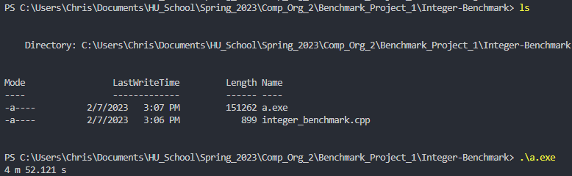

**Floating Point Benchmark Output:**

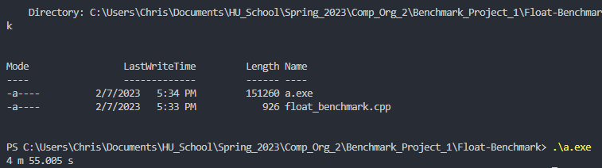

**Memory Benchmark Output:**

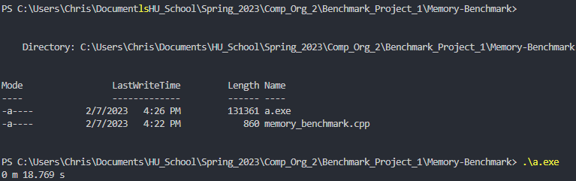

**HardDrive 1 Benchmark Output:**

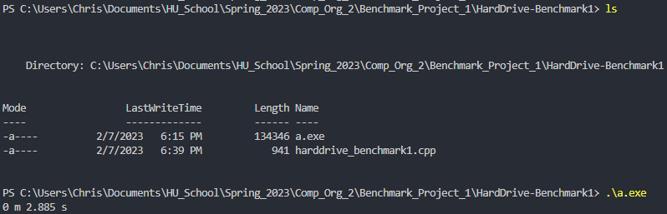

**HardDrive 2 Benchmark Output**

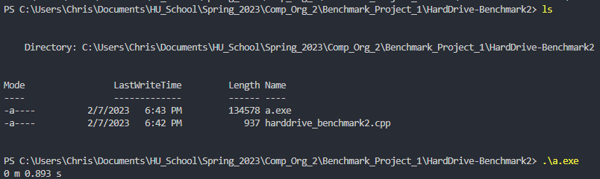

**Data Table:**

|  |  |  |  |  |  |
| --- | --- | --- | --- | --- | --- |
| Integer | Floating Point | Memory | HardDrive 1 | HardDrive 2 | Geometric Mean |
| 4 m 52.121 s | 4 m 55.005 s | 0 m 18.769 s | 0 m 2.885 | 0 m 0.893 s | 0 m 3.594 s |