Christian Alberto Gomez

Homework #1

8/27/2022

Problem 2.

Screenshot from the output program after executed the code.

* The original value that we have in the child process is dummy = 100, but dummy is updated by a value of 150. This happens because, being two different processes, the value of dummy is originally kept in until it is updated depending on the data flow in each process. For example, as you can see, the value of dummy is respected even if the parent has changed its value. Parent is the original process while child is the copy of the original process. Even with this we can understand and see that each process is unique and can have different values even being in the same code and running at the same time.

Problem 3.

Problem 4.

Problem 5.

What the “ps” command does? ps command is used to list the currently running processes and their PIDs along with some other information depends on different options. It reads the process information from the virtual files in **/proc** file-system. /proc contains virtual files, this is the reason it’s referred as a virtual file system.

What the “pstree” command does? Pstree is used to show running processes in a tree (data structure). If a username is specified, all process trees rooted at processes owned by that user are shown. Pstree is used as an alternative to the ps command.

**ps command example:**

**-**If we just enter the command “ps”, we will see:

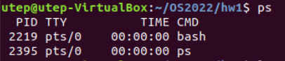

-The output will display some information about the process of the current shell. As you can see, we have PID, TTY, TIME, and CDM. These 4 means the process ID, Terminal Type, time of running for the CPU, and name of the command that lunch the process.

-If we enter “ps -A”

-Here you will have a view of all the running processes at that moment.

**Pstree command example:**

-If we enter “pstree” in our terminal we will see the following tree:

-As you can see, we can check all the running processes as a hierarchy in our CPU. Some processes have a higher precedence than the others. This means that there are processes that are fathers of many processes, making a large or small tree depending of what is running at that moment.

-What if we enter “pstree -p”?

-As you can see, the pstree changes because we are asking to get our pstree with the PID from the processes as an addition. This can help us to identify where is located each process.

**Problem 6:**

After having used the generator.py to get the ex10.c file, try to modify it to get the result of the task. To check this, we first execute the following command:



After executing the command, the terminal will give us a set of numbers that represent the PID of multiple processes that are running at that precise moment. Now, we have to select on PID to get the pstree we want to see.

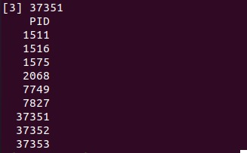

In this case, I chose to see the pstree that is formed within the process with PID 1511. We can enter the ptree with PID 1511 if we run the following command “./p6 & pstree -p 1511”.



Once this command is executed, the corresponding ptree of PID 1511 will be shown. As you can see, we have a ptree with a total of 3 levels of depth. This means that within this pstree we have parents that have childs and these same childs are parents of other childs.

