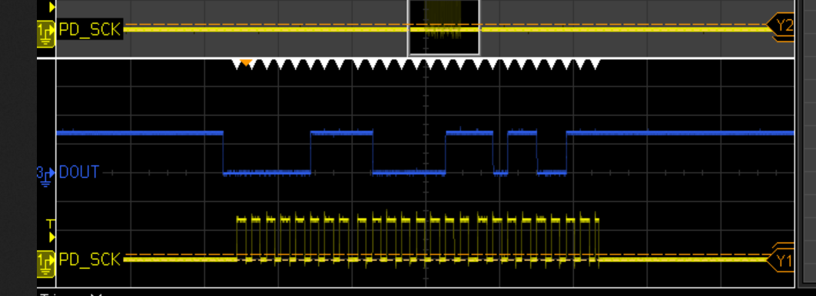

This seems to be a typical signal from the HX711:

DOUT (blue) goes low, saying data is ready, then PD SCK is pulsed to see the data at DOUT

OK, works nicely, made some stupid errors: 1) swapped DOUT and SCK, nevermind

2) installed the RMT TX channel using rmt_driver_install

Which is at odds with having your own interrupt.

For debugging purposes I have reduced the RMT pulse unit to 1 us and use pulses of length 10 ie 10us

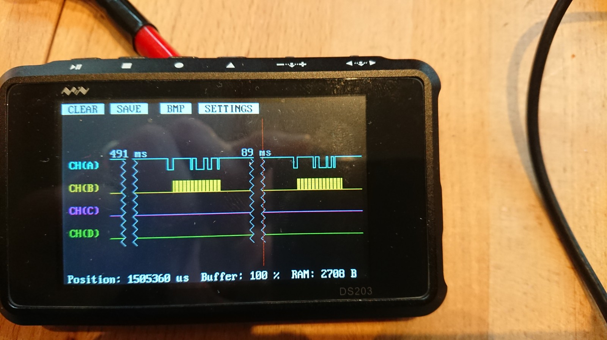

Nice reading every 90ms equals SPS of about 10

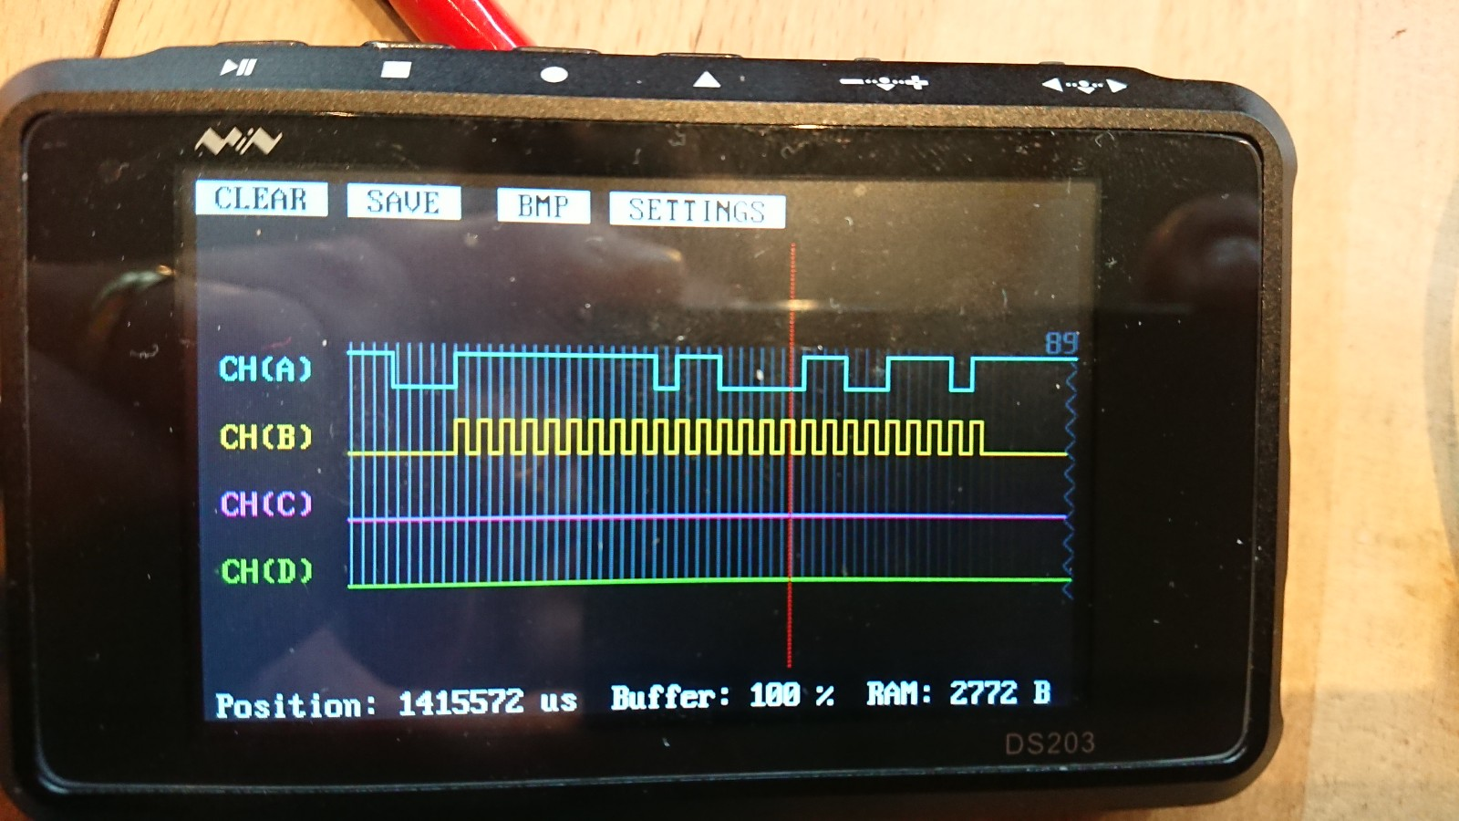

Nice strobe signal (yellow) and nice response (blue) on DOUT

Latency between falling edge of DOUT (data ready) is about 54 us

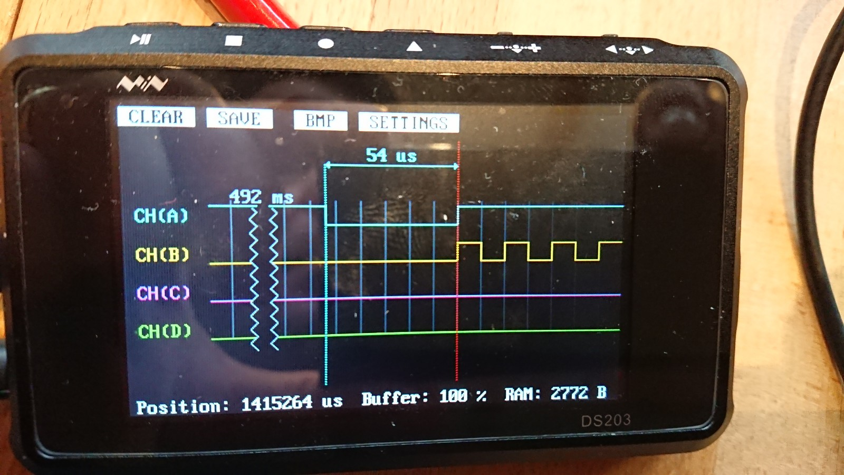

BUT this is using the slow timing for debugging. Let’s see how fast we can go:

Latency is now 14us (note that the scope does not resolve the SCK pulses anymore)

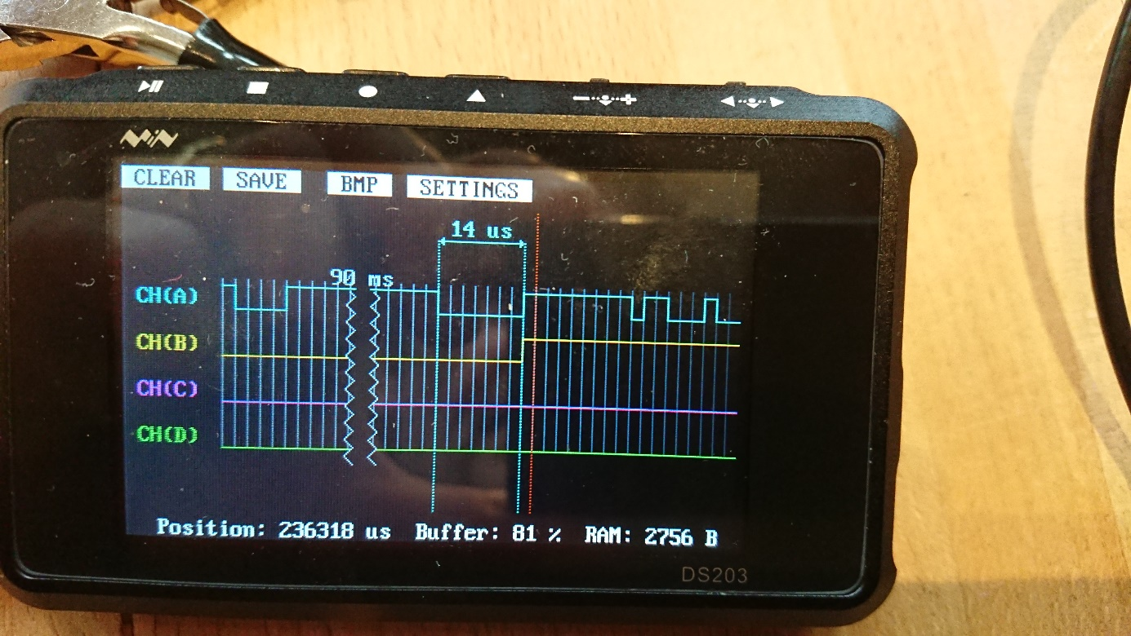

If we get rid of the first 2us „delay pulse“:

    {{{10, 0, 10, 0}}},     // keep L for 2us (because of ISR latency prob not needed)

    {{{10, 1, 10, 0}}},     // H for 1us and L for 1us (line is pulled down)

It looks like this, so effectively we have a 12us delay between falling edge of DOUT and rising edge of first SCK strobe

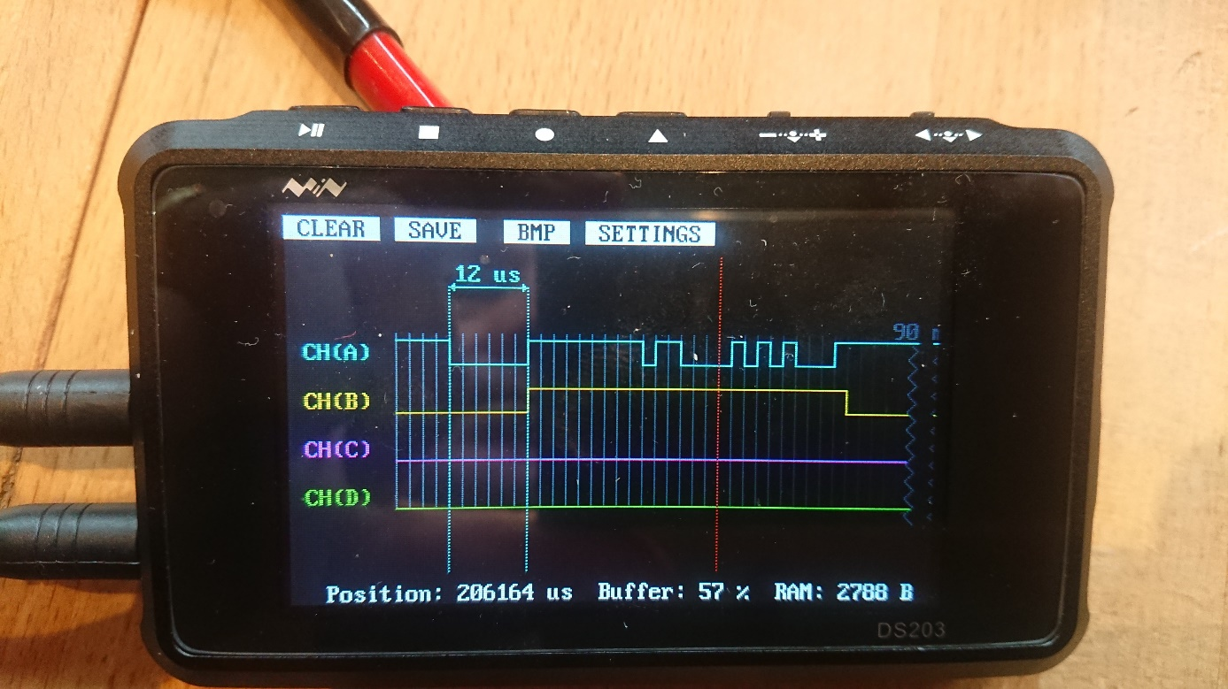

Now we need to decode the pulses. First idea:

Define 24 midpoints in strobe train using the 12us delay then loop through pulses from RMT,

            b1 = (data[i].duration0);

            b2 = (data[i].duration1);

data[0].duration0 is the duration of the first negative pulse

looking at pulse durations for the first (negative pulse) we see:

pulses = [164 264 284 304 324 344 364 403], so nicely on a 2us raster (20 counts = 2us)

so first negative pulse seems to have a minimum at 16.4us

VDD issues

There seems to be an issue regarding Ref voltage for the load cell. The boards are designed for 5V…

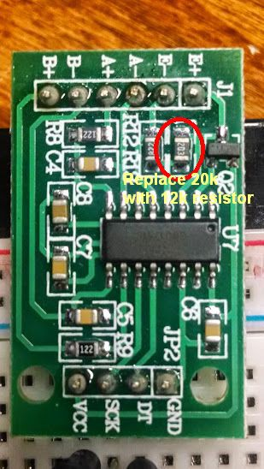

For 3.3V the 20K resistor needs to be about 10-12K. You can put a 22K resistor in parallel which should do the job. Alternatively use 2 voltages for the HX711:

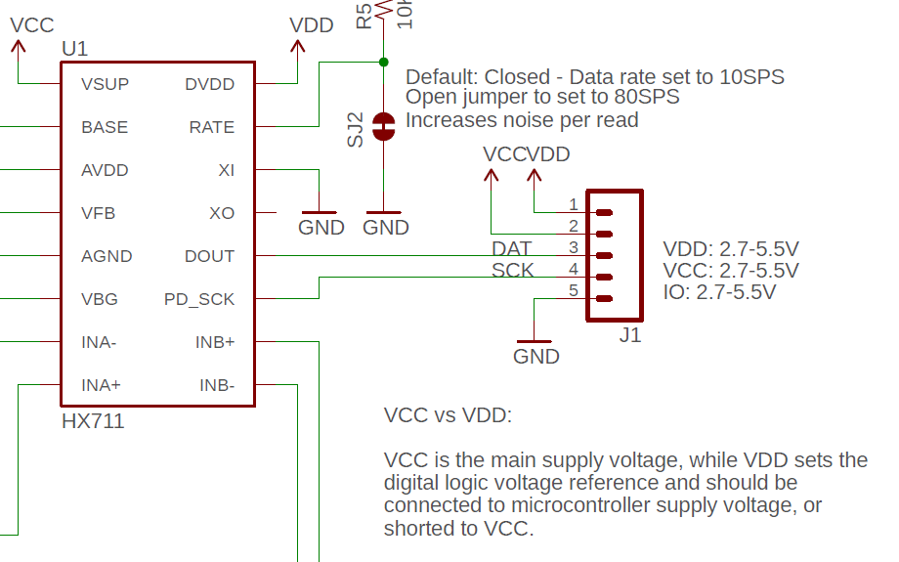

5V for Vcc and 3.3V for Vdd?

Measured voltage for load cell is 2.506V, so not bad!!

Weird behavior tonight:

If I just plot the value in the terminal, the deadtime between DOUT low and start of strobe alternates between 12us and 8us. The latter screws up the timing of this sample !!!

If I print value and last reading, the delay is 16us

Uhhhlala

ALL NEW: abandoned the RMT approach and now everything is read-out in interrupt, works nicely. The scale is accurate to 0.1g which is quite nice!!