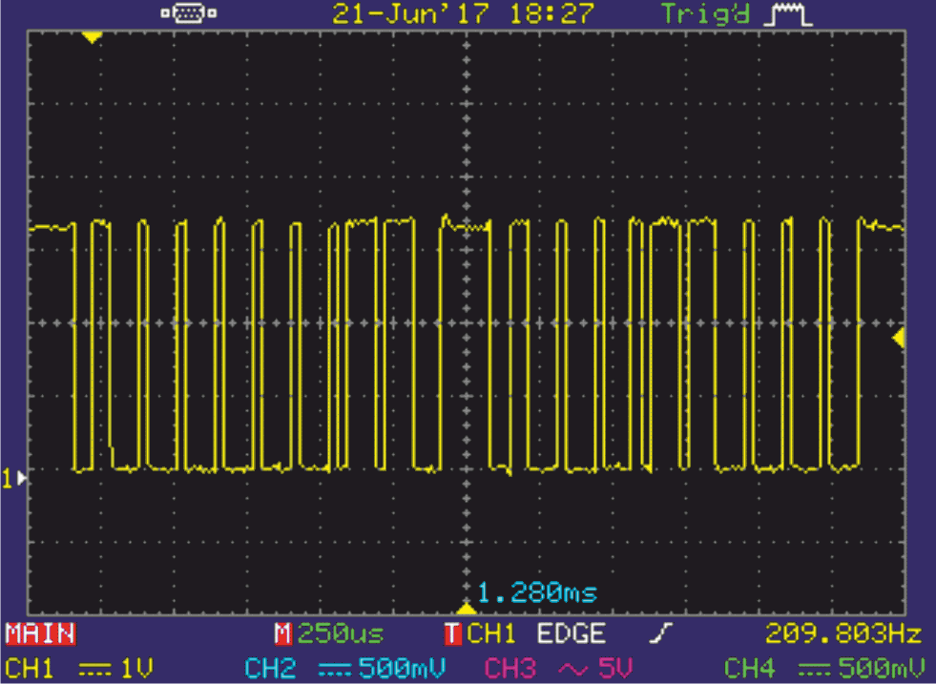

FRom https://sudonull.com/post/69857-Digital-TSic-temperature-sensor-addresses-passwords-appearances-ETF-company-blog

Sending starts with a start bit, then there are insignificant data bits that are always “0”, then there are high data bits - “011”, then a parity bit corresponding to “0 ". The second packet starts after one period (T strobe \* 2) and contains the start bit, the eight least significant data bits “00011000” and the parity bit, respectively equal to “0”.