Thermoino with PWM for CTC feature LUIGI
Contents
The PWM feature 2
How it works 5
How the optocoupler changes the signal 6
Timing update 9
The VAS feature 13
Update 12.4.2023 14

The PWM feature
Setting the following:
cTCBinMs: 10
cTCPos: 7
0 9
1 9
2 9
3 -9
4 -9
5 -9
6 0
Should give 9ms pulses (3 up, 3 down) with 1 ms pauses
This is what EXECCTC produces:
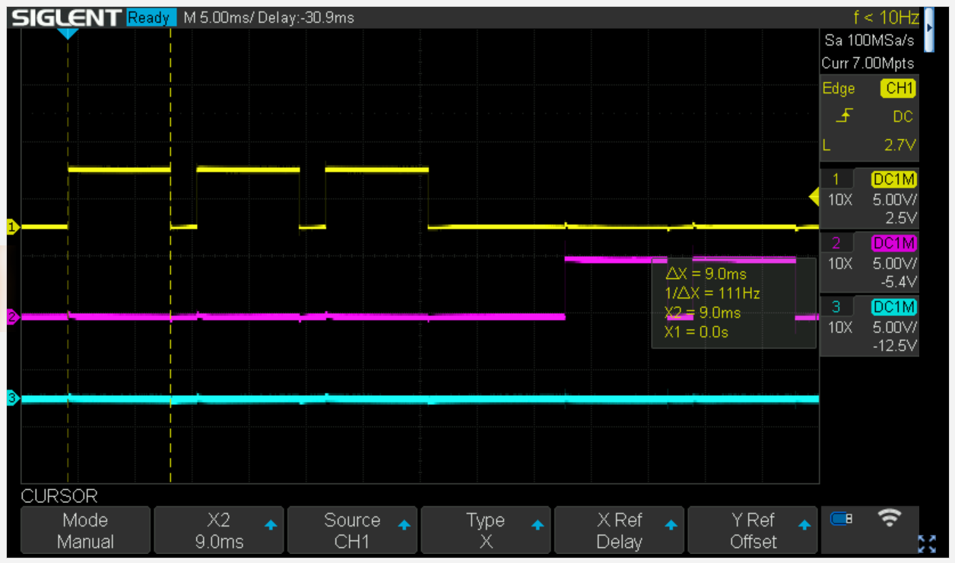
Pulses are 9ms, but time between pulses is >2ms:
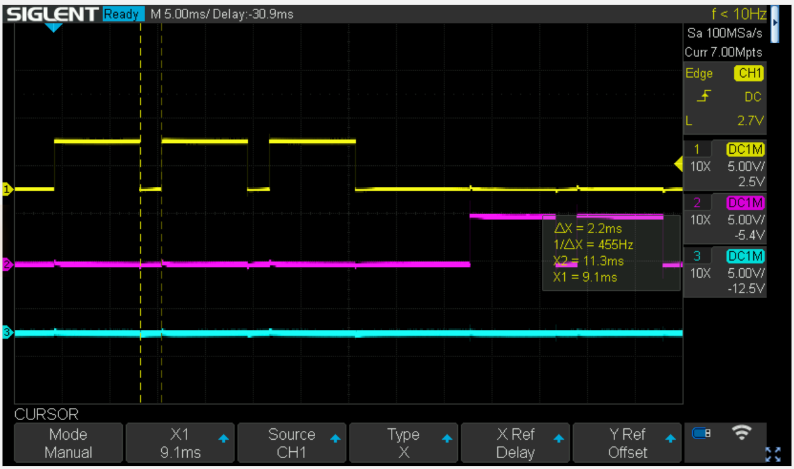
AND the first negative pulse is missing (this changes from run to run and can be worse). It is related to the between-pulse-timing using the loop function. Instead we can use the phase correct PWM feature to generate precise pulse timing for CTC functionality:
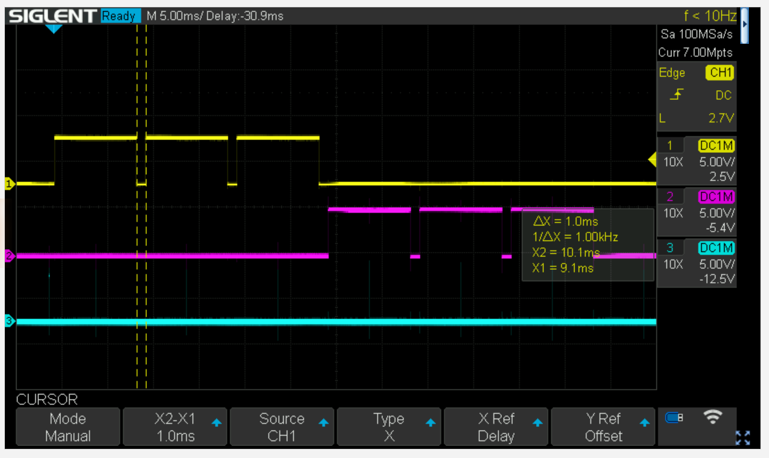
Time between pulses = 1ms, pulse duration = 9ms
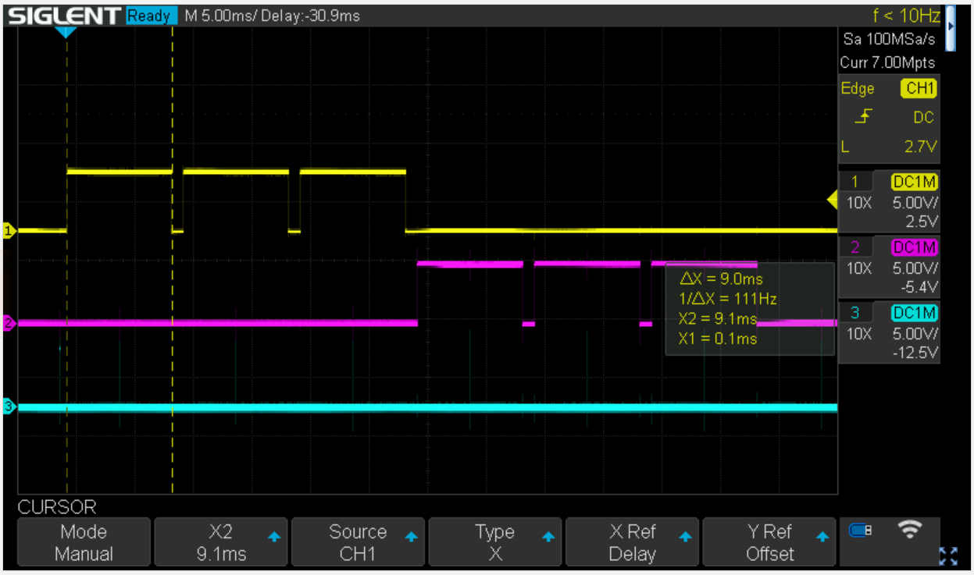

This is implemented for a max cTCBinMs of 500ms, which is a good resolution. 2500 CTC entries are allowed, ie giving a max stimulus duration of 2500*0.5s = 1250s > 20 minutes
Also fixed a bug in EXECCTC: the last pulse was always dropped changed the end of loop statement

Works nicely: sine wave
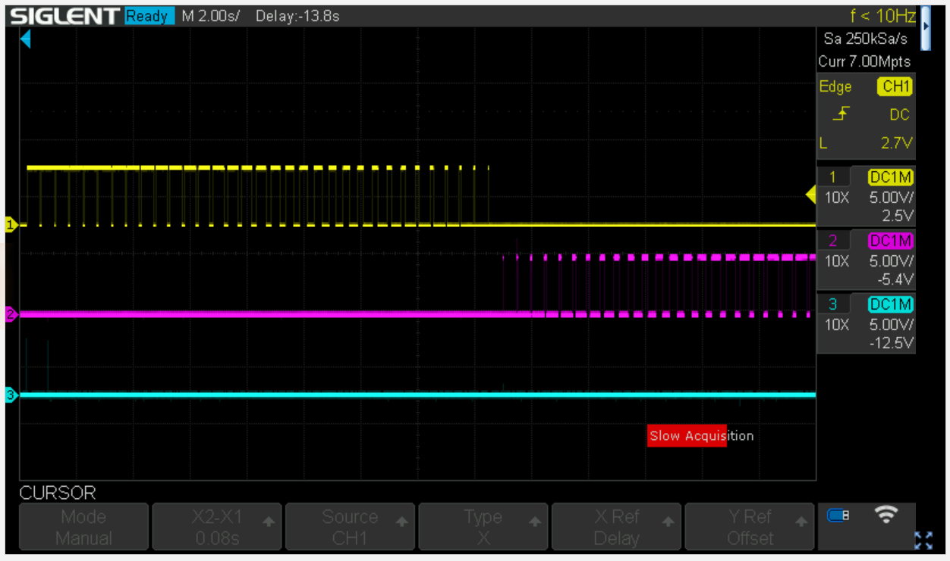

How it works

We are using a 16 bit timer, timer1 in phase correct PWM mode (mode 10).
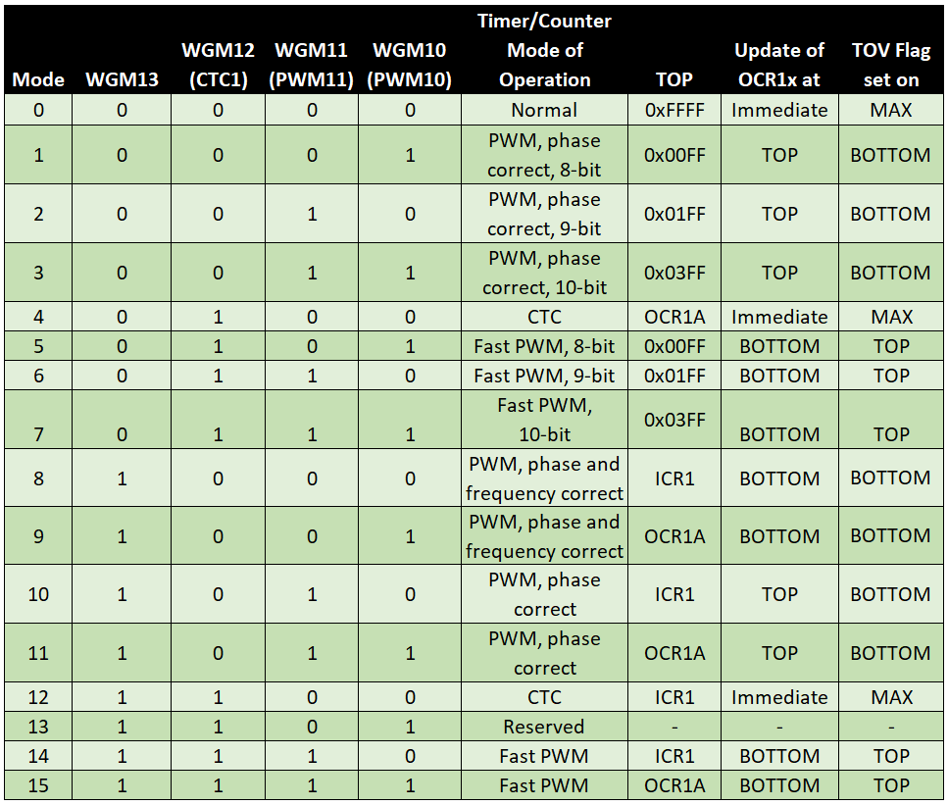
Timing is set by the prescaler:
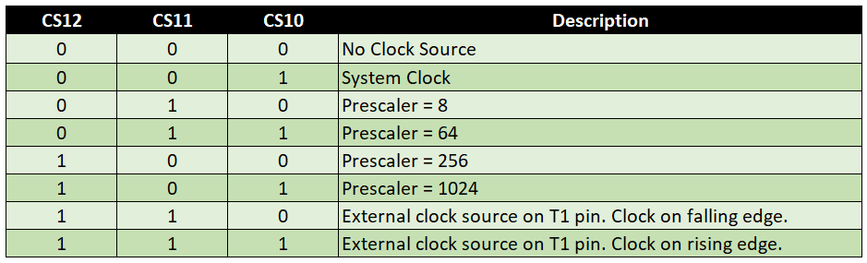
And we are using a prescaler of 64. The Mega2560 runs at 16MHz, prescale by 64 gives a tick per 4us. This is a good divider if we want ms resolution, ie 1ms = 250 ticks.
Phase correct PWM with TOP defined by ICR1 means in one cycle the counter counts from 0 to ICR1 and back again. Now we can define thresholds with OCR1A and OCR1B to generate the pulse. Each pulse is symmetric around a trough.
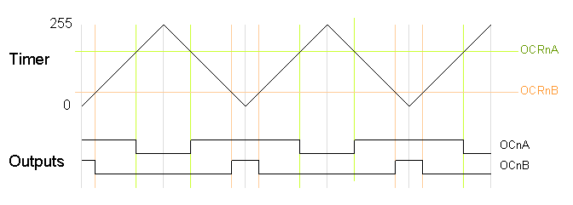
Now how to change pulse width from cycle to cyle? Each time the counter (TCNT1) hits the bottom an interrupt is fired (timer overflow) which we can service using
ISR(TIMER1_OVF_vect)
In this interrupt handler we simply set the new values for OCR1A and OCR1B. Note however, that these only come into effect at the next peak, because OCR1X are double buffered registers.
NB. Given that we also count pulses in the ISR (and terminate the process), the last pulse is cut in half.
Works nicely: part of a sine wave


How the optocoupler changes the signal

The Optocoupler is a quite low speed PC817:
Onset of pulse:
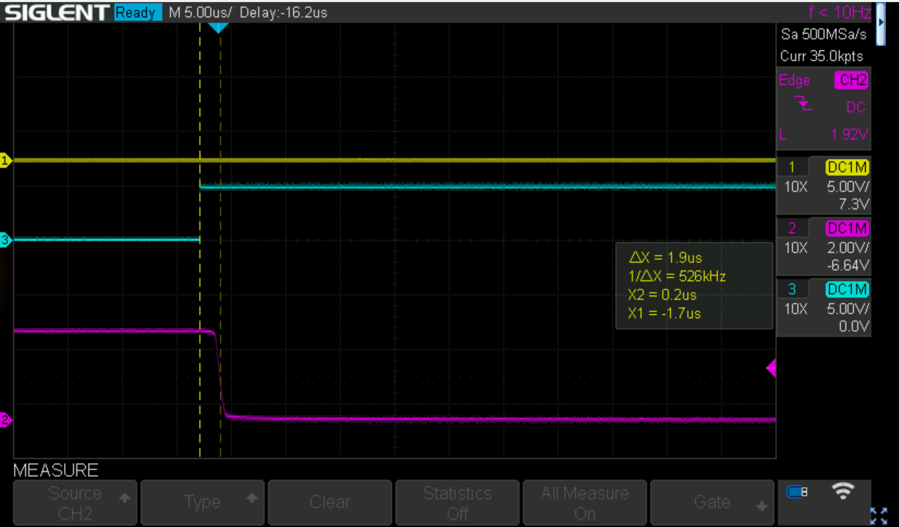
A delay of roughly 2us
How about the offset
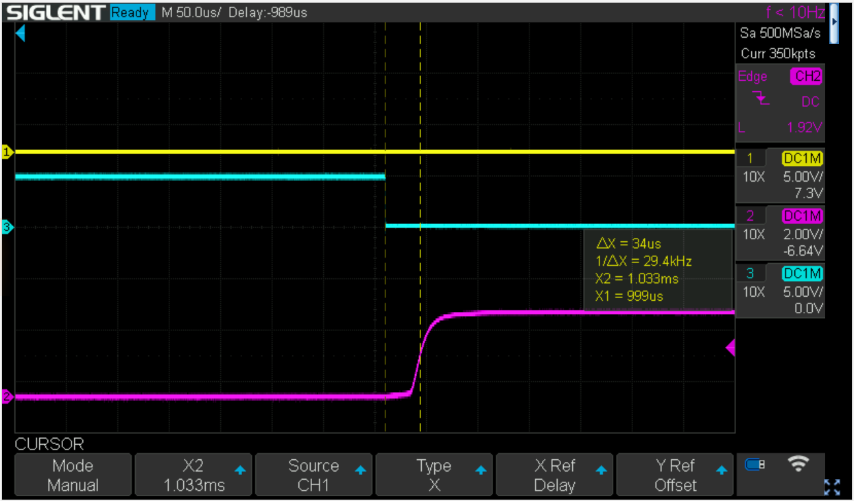
This looks worse with >30us (with a 4R7K pullup), but the slow recovery is related to the large pullup (i.e. slow discharge of capacitance of the photo transistor)
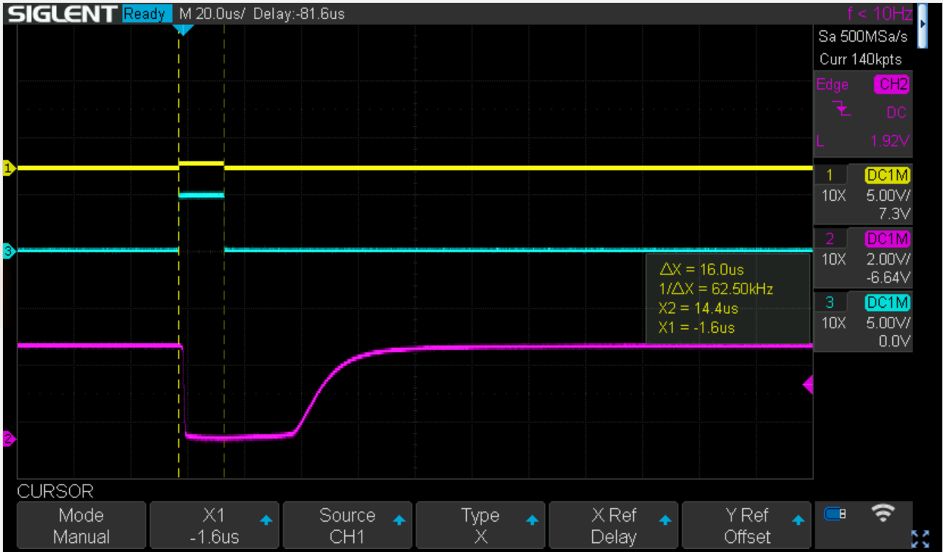
E.g. a 16us pulse gets translated to a 48us pulse with a very badly defined rise. Luckily, we do not operate at that time scale.
Now this gets better if the pullup gets smaller, using 470R get’s us the following
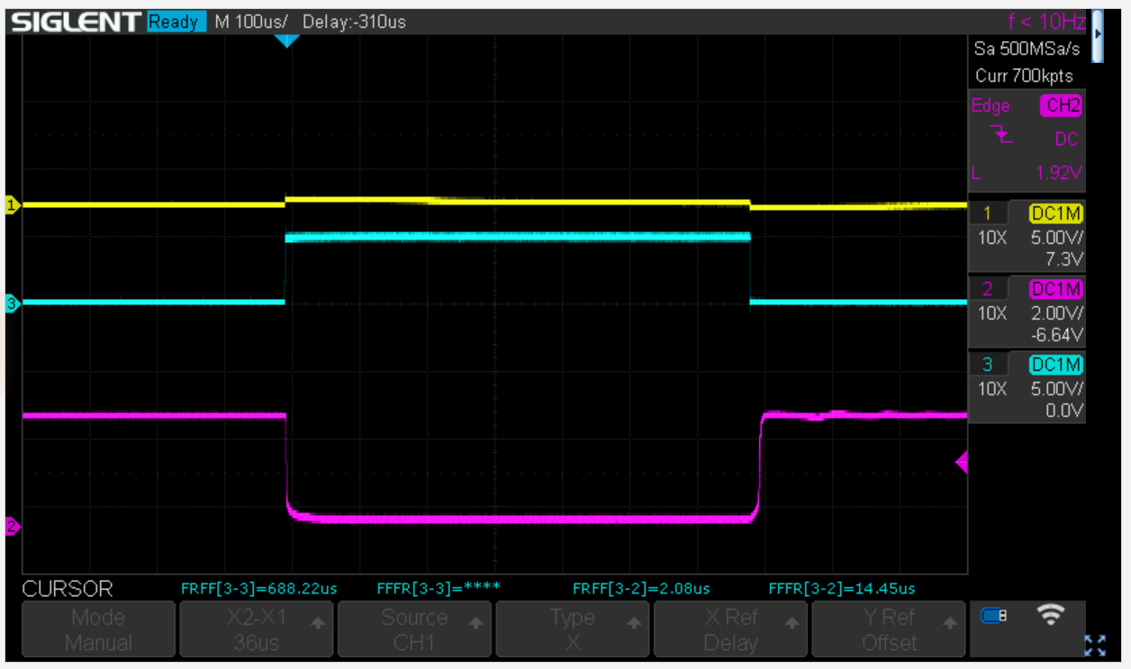
A pretty consistent 2us onset and a 14us offset delay, this is constant at pulses >100us, i.e. in the ms range we are ok and each pulse is roughly 12us too long … We have a timer resolution of 4us, but using count-up/down as in phase correct PWM, the actual resolution is 8us. So we could subtract one tick from every pulse which would bring down the error to 4us, but I guess that is overkill for the thermode…

Timing update
Timed everything in the lab with the thermode attached:
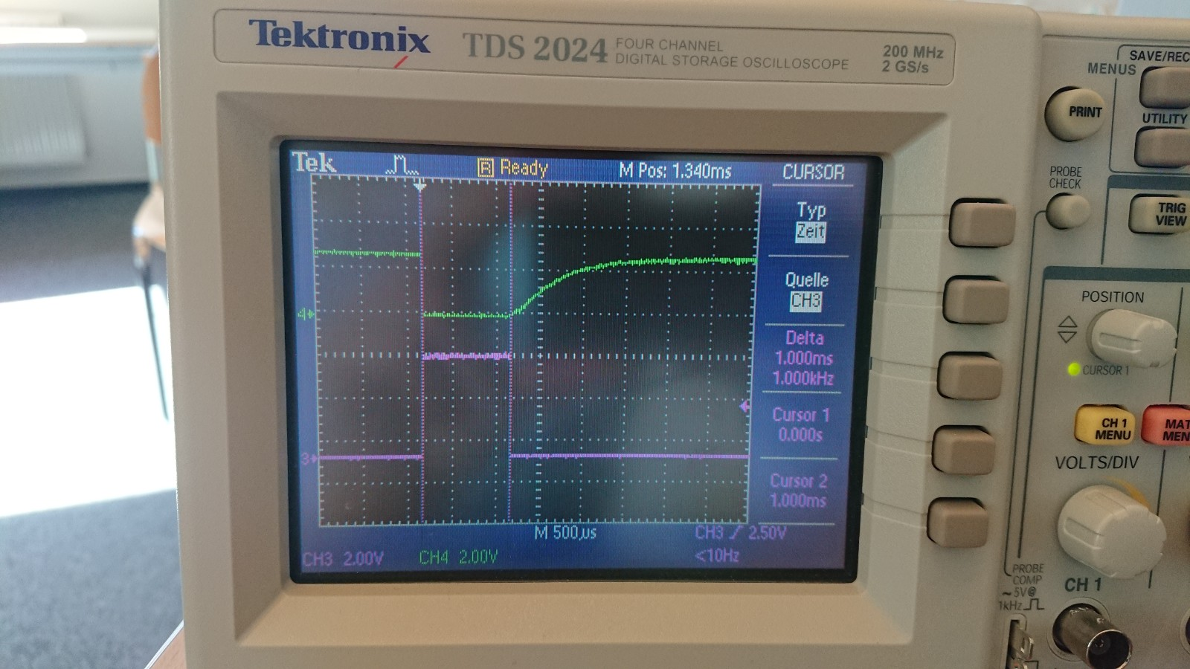
Pretty bad, a pulse of 1ms with heavy bleeding. Back to the drawing board. The idea was to use an optocoupler with an exposed base. This can be connected to GND (100k) to allow to quickly discharge the base capacitance. I had a few CNY 17-3 and looked at it in LTSpice. Based on the time constant, I guessed that the pullup in the thermode is about 220K. Voltage is about 2.7V.
So let’s see a simulation of the old PC817
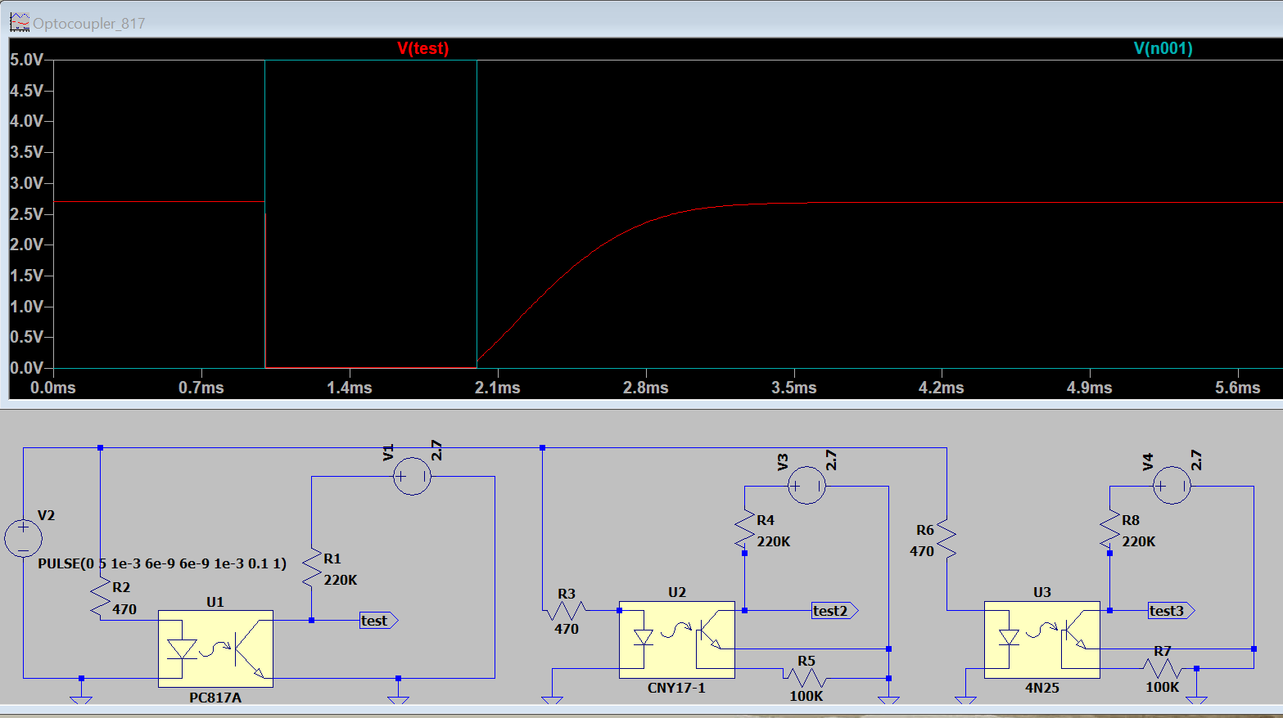
Fits the bill, the red trace is the PC817 output (green-blue Arduino output). Now let’s have a look at the CNY17 circuit with the base grounded:
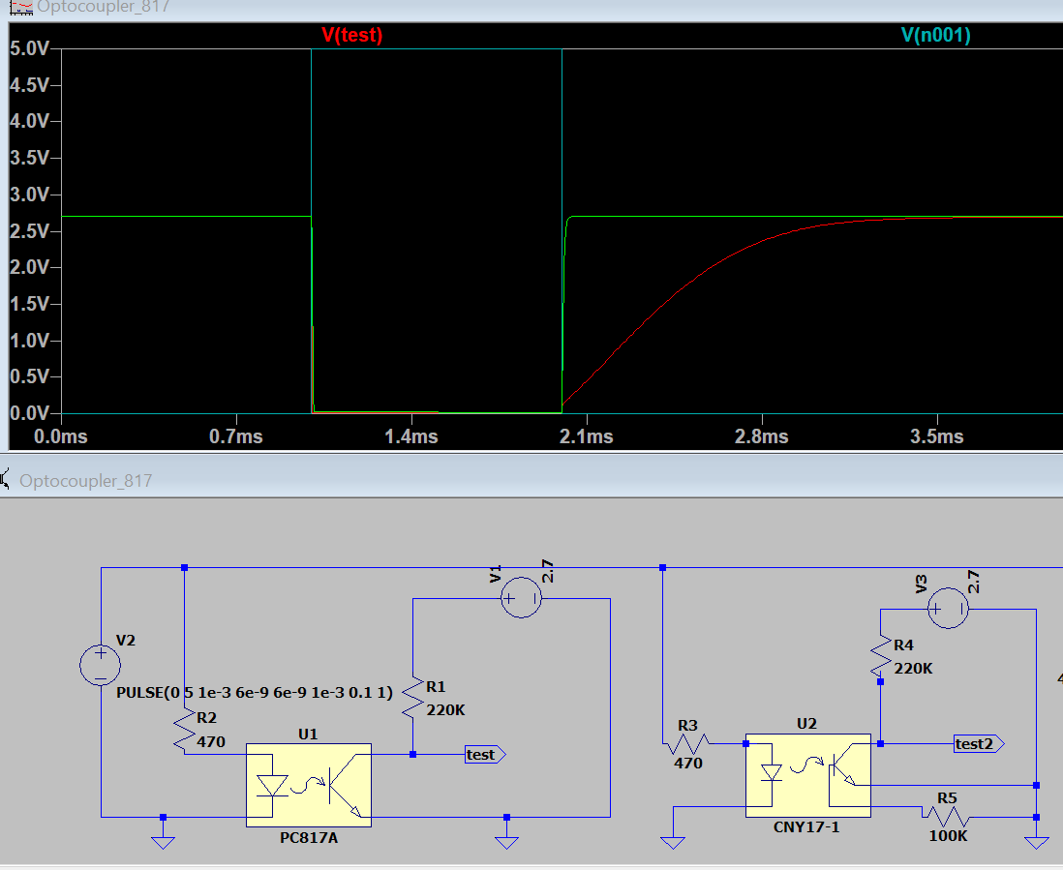
Looks perfect (green trace) at that time scale.
So now the reality check, using the new circuit with a CNY17
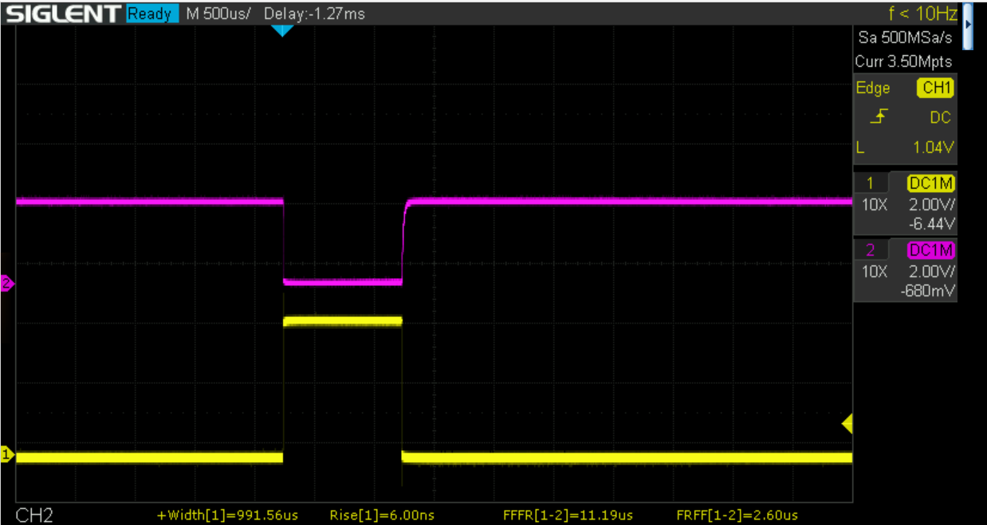
looking good, delay of rising edge is much better and as expected from the LT spice simulation
It is not perfect though. Let’s look at a very brief pulse of 16us with LTspice:
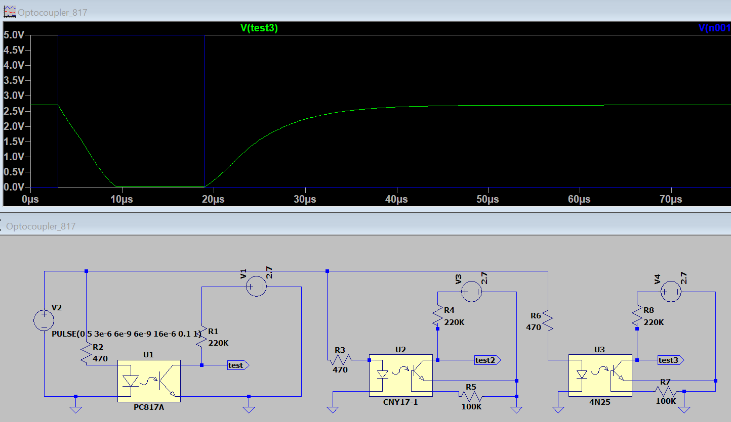
And in reality:
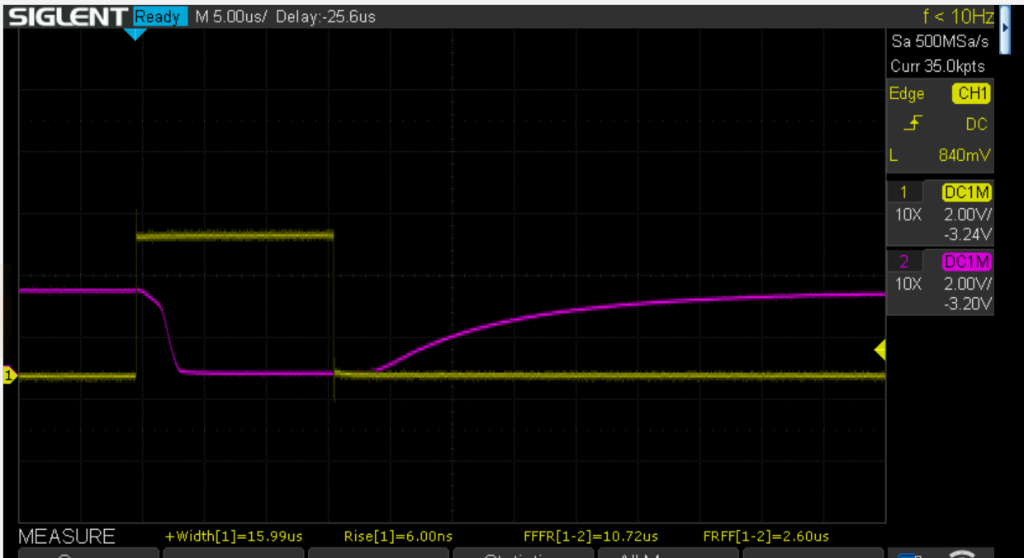
OK, so not suitable for a very high speed interface, but OK for the Thermoino.
Summary: All Thermoinos need an overhaul and get new optocouplers !!
Now a real world example: the following CTC:
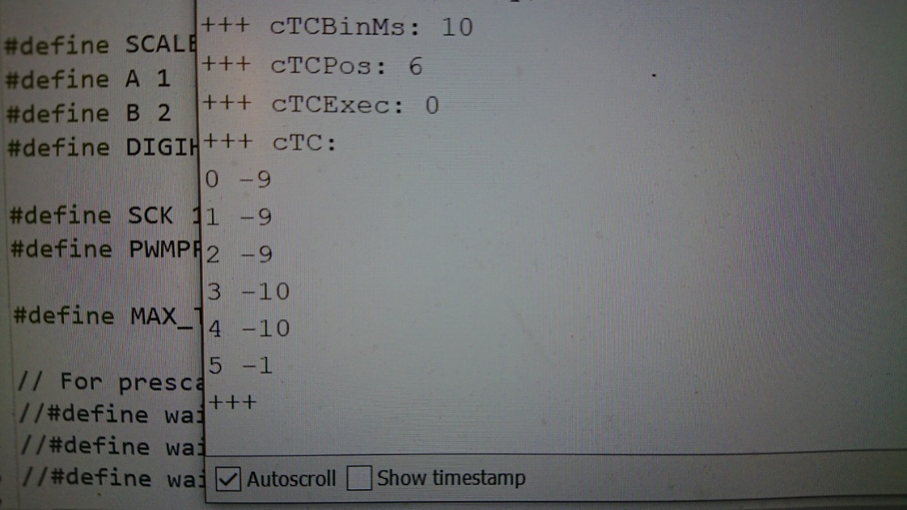
On the old circuit (PC817):
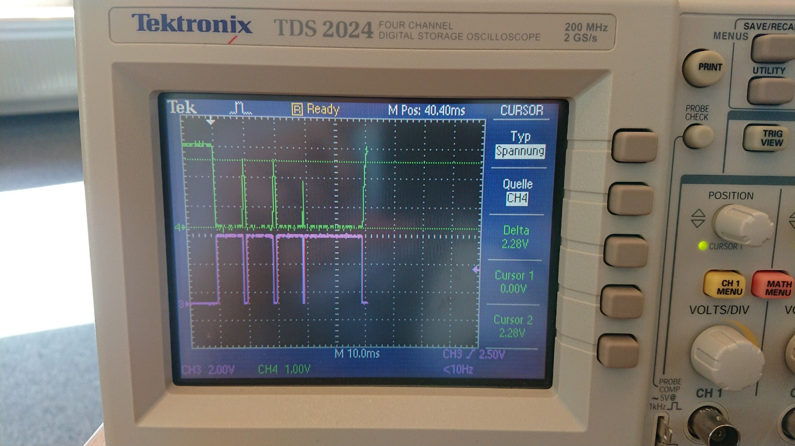
Last pulse not shown.
Now with the new circuit:

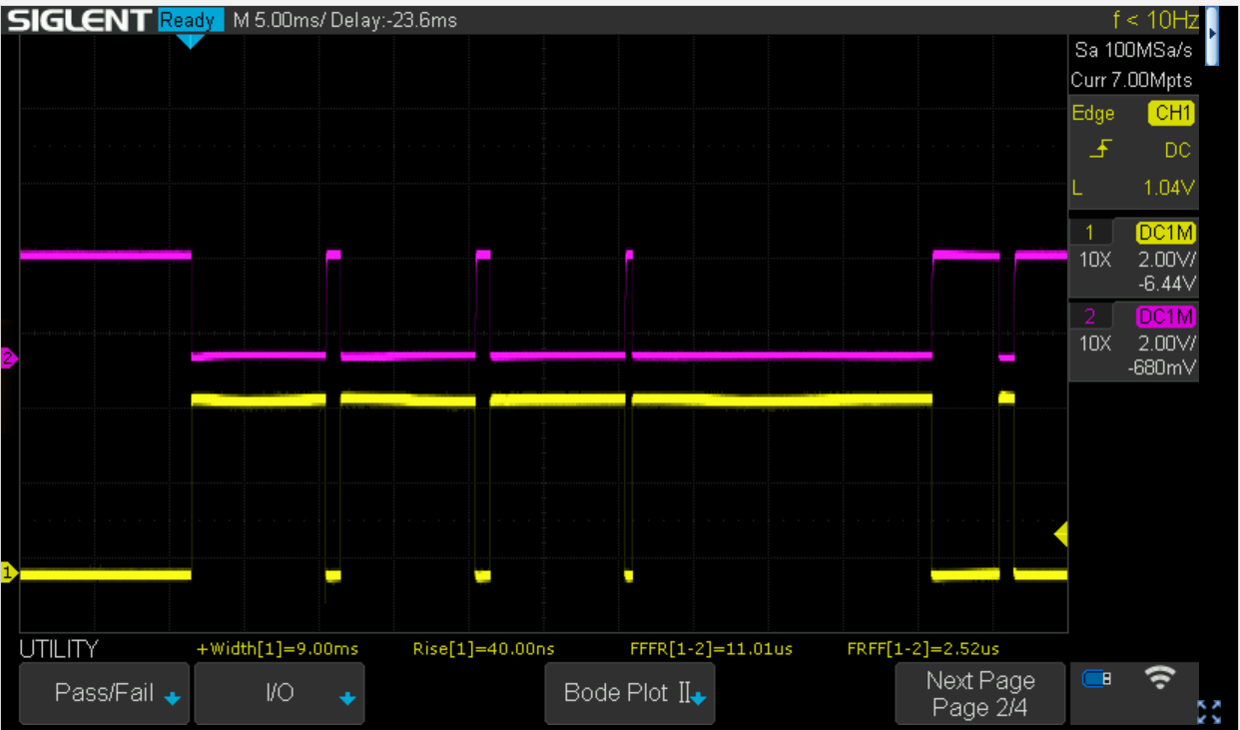
Looks perfect.

The VAS feature
Finally, I have added an experimental VAS feature. The command READVAS returns the time in ms (like GETTIME) since the Thermoino has been powered-up and a reading of the potentiometer (0..1023). This might interfere with EXECCTC, but will not interfere with EXECCTCPWM.
Simply connect a potentiometer (>= 10KOhms) to the following BNCs:
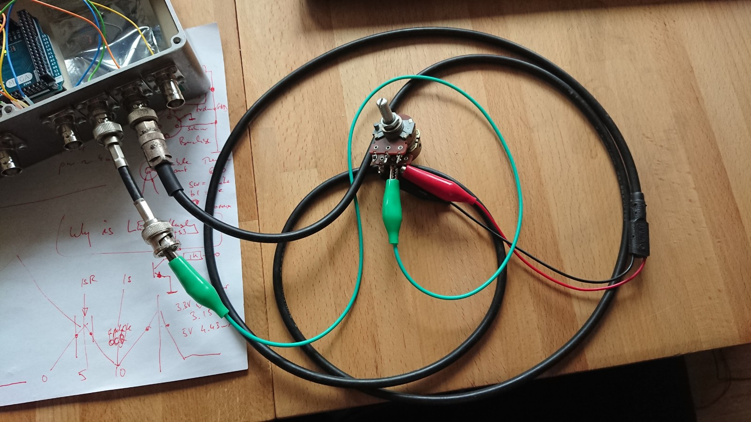
The rightmost has +5V in the middle and GND at the shield (red, black)
The one to the left one (green clip) has the A0 (ADC0) pin in the middle.
This is how it is wired inside LUIGI:
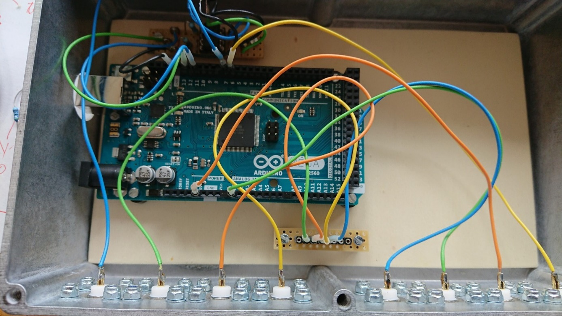

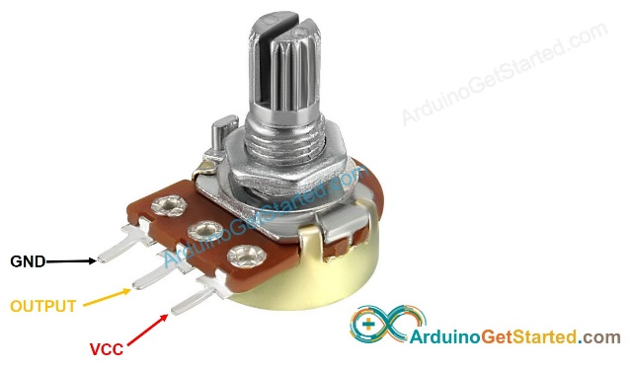
VCC and GND will get connected to the second last BNC. The middle tap of the potentiometer (yellow) gets connected to the third last BNC.
NEVER connect the middle tap of the potentiometer to the second last BNC (this will fry the potentiometer and the Arduino).
The potentiometer needs to be AT LEAST 10K Ohms.

Update 17.4.2023
Shock now on Pin 5 (Timer3)
All I/O now implemented through the fastIO tool as developed by Merlin
MOVE now does precise increments and decrements in 16us steps, i.e. MOVE;16 generates 16µs pulse whereas MOVE;15 does not generate anything
Implemented error codes (negative for error; positive for OK) easy to check
Everything async now, even ramp_temp uses timer and interrupt
Strict checking for ongoing process
Code cleaned up and streamlined
No additional null pulse required for ctc (all done internally)
Shock uses PWM to generate shock train
Better range checking of variables
Commands can be entered in lower case

Update 30.8.2025 (ver 3.5)
Cleaned code and fixed bugs
Has a name stored in EEPROM
Returns status for thermode and digitimer separately allowing for parallel operation
New interface code, more efficient and faster I/O (UseThermoinoPTB)

However, interesting news on the Optocoupler or Medoc interface.
The Pathway has a 2.7V interface and when shorted a current of 15µA flows suggesting an R of 180K
The TSA2 has a 5V interface and when shorted a current of 500µA flows suggesting an R of 12K5
Interestingly the fast optocoupler behaves quite bad on the TSA2
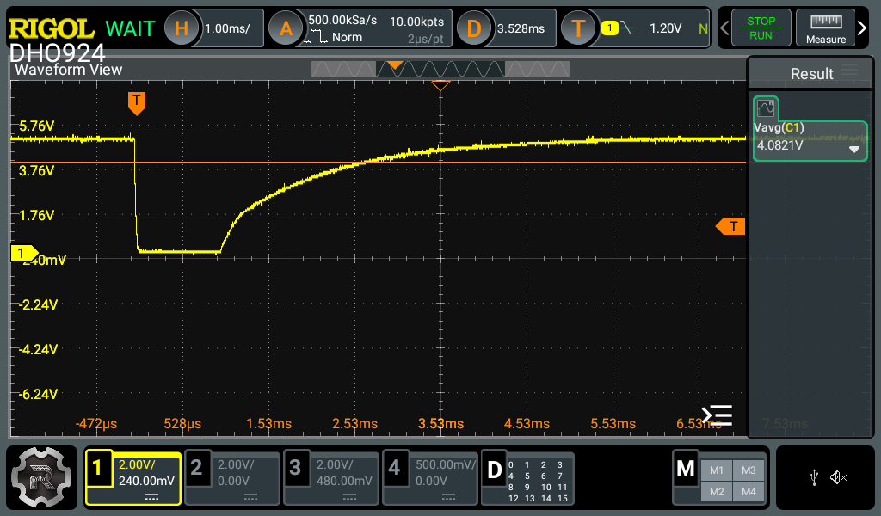
The same on the Pathway
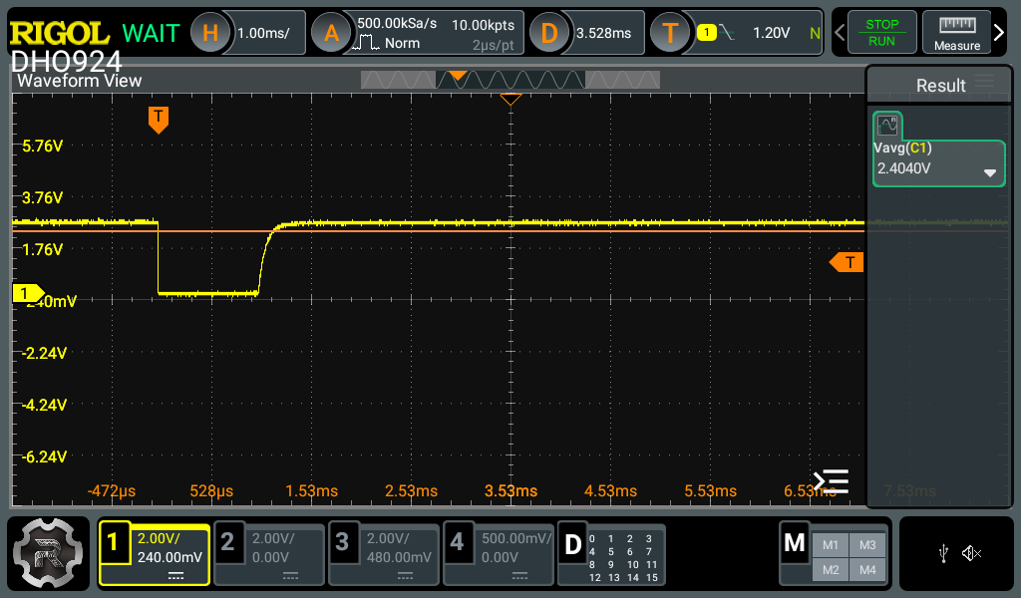
Now let’s see how bad it is using the old Optocouplers
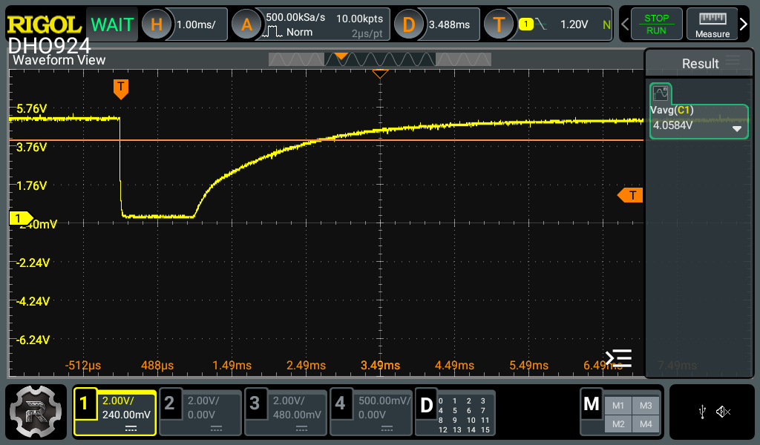
The same !!!
If I simply close and open the contact (short it) the rising part looks like this:
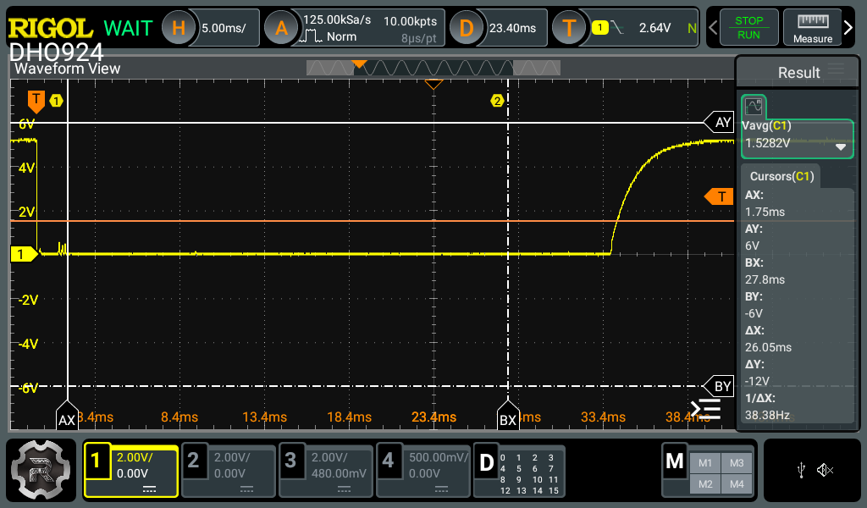
Note 5ms time base, but the timing is essentially the same the signal recovers after about 5ms

