American Football Launcher Design Baseline
Sections 1-4: Stakeholders, CONOPS, Product Design Specification v0.1, Requirements Traceability Matrix and RFLP Decomposition

Phase 1 — Stakeholders, Mission Need and Use Case
This phase defines the reason for the project, the people affected by the design and the high-level use case that should guide concept development.

1.1 Stakeholders
Stakeholder | What they care about
Operator | Safety, ease of loading and simple controls.
Student designer | Demonstrable engineering rigour, clear design decisions and test evidence.
Assessor / future employer | Evidence of CAD, analysis, trade-offs, DFMA, validation and documentation.
Nearby users / bystanders | Guarding, controlled launch direction and safe operating procedure.
Future maintainer | Simple assembly, replaceable parts and clear documentation.

1.2 Mission Need
Manual American football throwing is inconsistent and skill-dependent. The project aims to develop a compact mechanical launcher capable of producing repeatable ball speed, launch angle and spiral spin while remaining safe, manufacturable and suitable for student-level prototyping.

1.3 Use Case Boundary
The prototype is intended for controlled testing and engineering demonstration, not unsupervised public use. The early design should prioritise repeatability, safe operation, standard components, simple manufacture and measurable validation over maximum launch power.

Phase 2 — Concept of Operations
The concept of operations defines how the American football launcher is expected to be used during normal operation and how the system should respond to unsafe or fault conditions. This is included before detailed CAD development so that the design is driven by function, safety and verification rather than by arbitrary geometry.

2.1 CONOPS Narrative
The launcher is intended to be placed on stable ground, adjusted for launch angle and direction, loaded with the football in a repeatable orientation, guarded, spun up to the target operating condition, armed, checked for safety and then released. After launch, the carriage is arrested, the spin module powers down and the system is reset for the next cycle.

2.2 Normal Operating Sequence
- Place launcher on stable ground.
- Set launch angle and direction.
- Open guard or loading access.
- Insert football laces-up into cradle/indexing feature.
- Set ball orientation so it is nose-forward and repeatably indexed.
- Adjust contactor preload onto ball.
- Close guard.
- Spin module accelerates to target RPM.
- Elastic carriage is armed.
- System confirms safe state: guard closed, operator clear and launch path clear.
- Release carriage.
- Ball accelerates forward through the spin/contact module.
- Ball leaves the launcher before the carriage hits the end stop.
- Carriage is arrested by a bumper/brake.
- Spin module powers down.
- System resets.

2.3 Fault and Safety Sequence
Fault | Required response
Guard opened | Motor off; release blocked.
Emergency stop pressed | Motor off; release blocked.
Ball misloaded | No launch; operator re-loads and re-checks orientation.
Overspeed detected | Motor disabled; inspect spin module before further testing.
Carriage not reset | Launch inhibited until carriage is correctly reset and armed.
Excessive vibration | Stop test; inspect rotating assembly, contactors and fixtures.

2.4 Normal and Fault Operating Flow
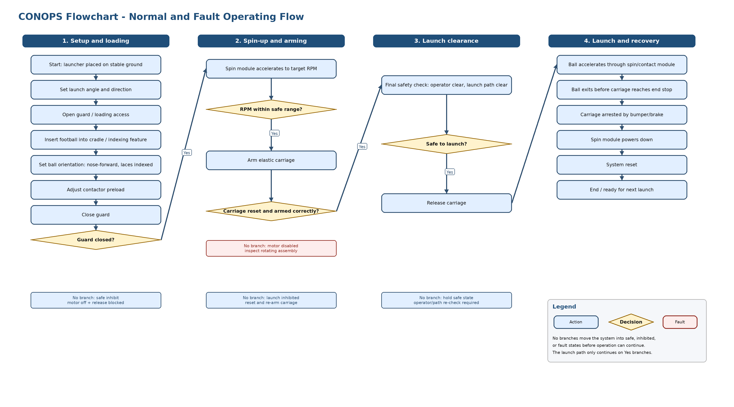
Figure 1. Concept of operations flowchart for the football launcher.
This flowchart shows the full operating sequence from setup to reset. Key safety checks are included before spin-up, arming and launch. Unsafe conditions such as an open guard, overspeed, incorrect carriage reset or unsafe launch path move the system into an inhibited or fault state rather than allowing release.

2.5 System State Diagram
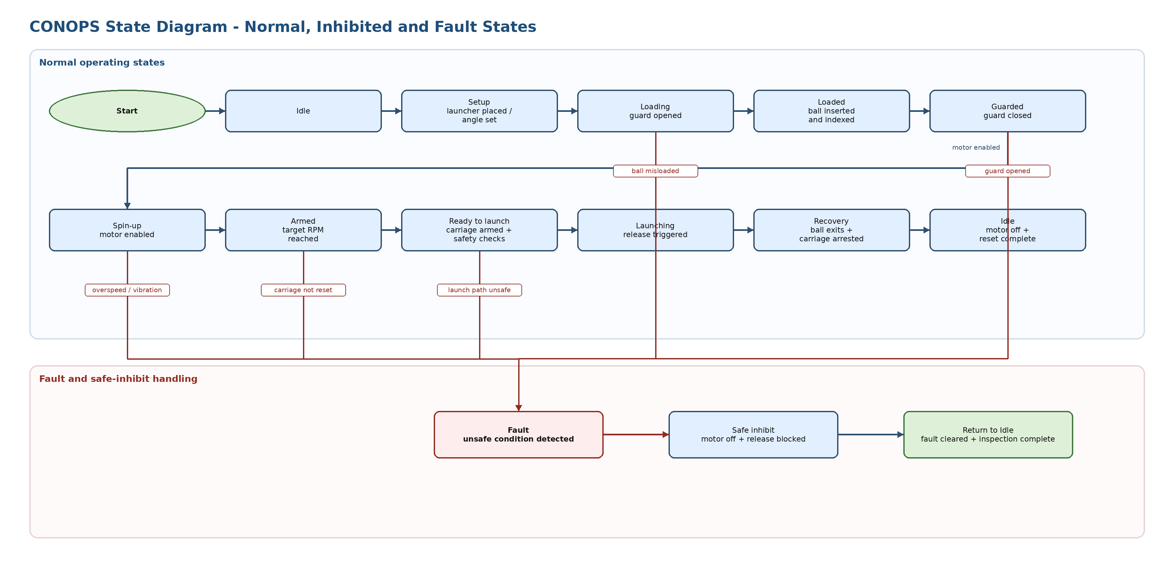
Figure 2. State diagram showing normal, inhibited and fault states.
This diagram represents the launcher as a sequence of operating states rather than individual user actions. It highlights that the system should only enter the launch state after loading, guarding, spin-up, arming and final safety checks have been completed. Any safety-critical fault should move the system into a fault or safe-inhibit state, where motor power is removed and release is blocked until the fault has been cleared.

2.6 Design Implications from the CONOPS
The CONOPS creates several direct design requirements. The launcher requires a repeatable ball indexing feature, an adjustable contactor preload mechanism, a guard around rotating components, a controlled spin-up process, a carriage arming and release system, and a carriage arrest system. It also implies the need for safety interlocks or prototype-equivalent manual checks for guard closure, carriage reset, overspeed, ball loading and launch path clearance.
For the early prototype, some checks may be implemented manually, but they should still be treated as formal safety conditions during testing. The final design should make the transition from Idle to Setup, Loading, Guarded, Spin-up, Armed, Ready to Launch, Launching and Recovery clear to the operator and difficult to bypass accidentally.

2.7 CONOPS V-Model and Verification Approach
The CONOPS V-model links the mission need and stakeholder expectations to the derived requirements, architecture and detailed design decisions that follow. It also shows the matching verification ladder, from inspection and component checks up to subsystem tests, full system verification, acceptance checks and operational validation.
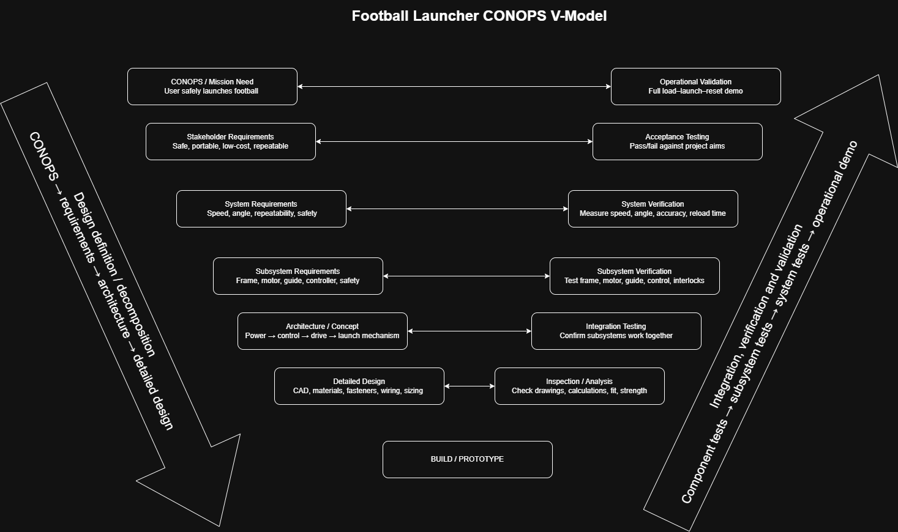

Figure 3. CONOPS V-model linking operational intent, derived design definition and planned verification evidence.
For this launcher, the practical verification strategy is to prove low-level items first by inspection, calculations and component tests, then progressively integrate the frame, drive, controls and release mechanism before running full launch demonstrations. That makes this subsection the bridge between the Phase 2 CONOPS and the measurable PDS requirements in Phase 3, and it sets up the requirement-by-requirement traceability matrix added in Phase 4.

Phase 3 — Product Design Specification v0.1
The Product Design Specification translates the stakeholder needs and CONOPS into measurable requirements. The numerical targets are initial design targets and should be revisited after first-principles calculations, component selection and early prototype tests.
ID | Requirement | Target | Priority | Rationale | Verification / pass-fail rule
REQ-01 | The launcher shall produce a measurable football exit speed. | 10–20 m/s | Must | Main performance requirement; defines whether the launcher actually performs its function. | Measure 5 launches using high-speed video or timed distance. Pass if at least 4/5 launches are within target range.
REQ-02 | The launcher shall achieve a useful throw range. | 10–30 yards | Must | Demonstrates practical throwing capability without making the prototype dangerously powerful. | Field test with marked distance. Pass if ball lands within target range in controlled tests.
REQ-03 | The launcher shall generate spiral spin. | 600–1000 rpm initial target | Must | Spiral stability is central to an American football launcher, not just projectile launching. | Mark ball and use slow-motion video. Pass if rotation can be measured and remains broadly axial.
REQ-04 | The ball shall exit nose-forward. | Nose-forward at release | Must | Poor orientation would make the spin module irrelevant and reduce repeatability. | Side-view video inspection. Pass if nose-forward release occurs in at least 4/5 tests.
REQ-05 | The ball contact system shall use a symmetric contact layout. | 3 contactors approx. 120° apart | Should | Symmetric contact reduces lateral force imbalance and supports controlled spin. | CAD inspection and physical measurement. Pass if angular spacing is within acceptable tolerance, e.g. ±10°.
REQ-06 | The contactor preload shall be adjustable. | Approx. 10–25 N per contactor | Must | Allows tuning for different football stiffness, grip and deformation. | Spring scale/load-cell test. Pass if preload can be adjusted and measured across target range.
REQ-07 | The ball shall leave the launcher before carriage arrest. | Clear exit before bumper/end-stop contact | Must | Prevents the carriage/end stop from disturbing launch or damaging the ball/system. | Slow-motion side-view video. Pass if ball exit occurs before carriage arrest in all safe tests.
REQ-08 | The launch angle shall be adjustable. | 10–45° | Should | Allows testing of range and trajectory without redesigning the frame. | Measure with angle gauge/protractor. Pass if angle can be set and held at selected positions.
REQ-09 | The design shall prevent user contact with rotating parts during operation. | No finger access to spin module when powered | Must | Essential safety requirement. | Physical inspection. Pass if guarded access prevents contact during powered operation.
REQ-10 | The system shall include an emergency stop or equivalent shutdown control. | Motor off and release blocked | Must | Required because the system contains rotating parts and stored elastic energy. | Functional test. Pass if emergency stop disables motor and prevents release.
REQ-11 | The design shall prioritise standard bought-in components. | Bearings, rails, fasteners and motors bought where possible | Should | Reduces manufacturing difficulty and shows good integration of standard parts. | BOM review. Pass if major motion/support elements are standard parts unless justified.
REQ-12 | The design shall be manufacturable with student-accessible methods. | 3D printed parts, simple plates, bought-in rails/shafts | Must | Keeps the prototype realistic for time, budget and workshop access. | Drawing/process review. Pass if each custom part has a defined manufacturing method.
REQ-13 | The launcher shall produce repeatable exit speed. | ±10–15% variation over 5 launches | Must | Repeatability is the real purpose of replacing manual throwing. | Measure 5 launches at same settings. Pass if speed variation remains within chosen tolerance.
REQ-14 | The launcher shall produce repeatable launch direction. | Defined target zone at fixed range | Should | Shows the system is controlled rather than just powerful. | Launch 5 balls at fixed settings. Pass if majority land within a defined test zone.
REQ-15 | The system shall inhibit launch when the guard is open. | No motor/release action with guard open | Must | Converts the safety concept into a testable requirement. | Functional interlock test. Pass if launch cannot occur while guard is open.
REQ-16 | The system shall limit spin-module speed. | Maximum RPM to be defined after motor selection | Must | Prevents overspeed, vibration and rotating-part failure. | Tachometer/ESC setting check. Pass if speed limit is implemented and tested.
REQ-17 | The system shall have a defined maximum stored energy. | To be calculated from elastic/carriage design | Must | Stored elastic energy is a major hazard and drives frame/stop design. | Calculation and inspection. Pass if stored energy is calculated and safety factor/design controls are documented.
REQ-18 | The carriage arrest system shall absorb launch energy without structural damage. | No cracking, detachment or unsafe rebound | Must | End-stop failure is one of the most likely prototype hazards. | Low-energy tests progressing to full-energy tests. Pass if no visible damage or uncontrolled rebound occurs.
REQ-19 | The prototype shall remain stable during launch. | No tipping, sliding or uncontrolled movement | Must | A launcher that moves during firing is unsafe and invalidates accuracy tests. | Video/physical test. Pass if frame remains stable during repeated launches.
REQ-20 | The launcher shall be transportable by one person or two people. | Mass/envelope to be defined after CAD layout | Could | Useful practical constraint but secondary to safety/performance. | Weighing and handling trial. Pass if transport method is practical and safe.
REQ-21 | The prototype shall have a defined power supply and electrical limit. | Voltage/current limit matched to motor and controller | Must | Prevents overloading electronics and makes tests repeatable. | Electrical review. Pass if supply, ESC/controller and motor ratings are documented.
REQ-22 | The design shall include a basic test plan. | Speed, range, spin, preload and safety checks | Must | Converts design claims into evidence. | Test-plan review. Pass if each must-have requirement has a verification method.
REQ-23 | The design shall include a preliminary risk assessment. | Hazards, likelihood, severity and mitigation | Must | Necessary due to rotating parts, stored energy and projectile launch. | Risk-table review. Pass if all major hazards are identified with mitigations.
REQ-24 | The final design package shall include CAD, BOM and drawings. | Assembly CAD, part drawings and BOM | Should | Shows engineering process and makes the project useful as CV evidence. | Documentation review. Pass if another person could understand and rebuild the concept.
REQ-25 | The support legs shall fold into a compact transport configuration while locking rigidly in the deployed configuration. | Folded envelope to be defined after CAD layout; deployed tipping and sliding safety factors ≥ 2.0 at the selected release height. | Should | Foldability improves transportability and product practicality, but the deployed structure must remain stable and locked during launch and carriage arrest. | CAD folded/deployed configuration review, physical lock inspection and repeated launch stability calculation/test. Pass if the deployed support polygon meets the stability target and the folded configuration does not clash with the launcher body, rail, guard or ball path.

3.1 Requirement Grouping
The same requirements are grouped below to make the design work packages easier to plan and verify.

Performance requirements
ID | Requirement
REQ-01 | Launch speed: 10–20 m/s
REQ-02 | Range: 10–30 yards
REQ-03 | Spiral spin: 600–1000 rpm
REQ-04 | Nose-forward release
REQ-13 | Exit speed repeatability
REQ-14 | Direction/range repeatability

Mechanical design requirements
ID | Requirement
REQ-05 | 3 contactors approximately 120° apart
REQ-06 | Adjustable preload
REQ-07 | Ball exits before carriage arrest
REQ-08 | Adjustable launch angle
REQ-17 | Maximum stored energy calculated
REQ-18 | Carriage arrest survives launch loads
REQ-19 | Frame remains stable during launch
REQ-25 | Foldable support legs with rigid deployed locking.

Safety requirements
ID | Requirement
REQ-09 | Rotating parts guarded
REQ-10 | Emergency stop/shutdown
REQ-15 | Guard-open launch inhibit
REQ-16 | Spin-module overspeed limit
REQ-23 | Risk assessment completed

Manufacture and integration requirements
ID | Requirement
REQ-11 | Use standard bought-in components where possible
REQ-12 | Custom parts manufacturable by 3D printing/simple machining
REQ-20 | Prototype transportability
REQ-21 | Defined power supply and electrical limits
REQ-24 | CAD, BOM and drawings completed
REQ-25 | Compact folded transport configuration and practical deployment.

Test and validation requirements
ID | Requirement
REQ-22 | Test plan covering speed, range, spin, preload and safety
REQ-01 to REQ-24 | Each requirement has a verification method

Phase 4 — Requirements Traceability Matrix and RFLP Decomposition
This phase translates the V-model into working engineering traceability. Each Phase 3 requirement is linked back to its CONOPS origin and forward to the intended design response, verification method and evidence that should exist once the prototype has been analysed or tested.

4.1 Requirement Traceability Matrix
The matrix below provides the bridge from operational intent to design action. It should be used to check that every requirement can be justified, implemented, verified and supported by a concrete evidence item.
PDS ID | CONOPS origin | Design response | Verification method | Evidence
REQ-01 | 1.2 Mission need for repeatable launch speed; 2.1/2.2 controlled spin-up and release | Motor, controller and contact geometry sized to deliver target exit speed | Five-shot speed test by high-speed video or timed distance | Shot log, calculation sheet and test video
REQ-02 | 1.2 Useful throwing capability; 2.2 adjustable angle and controlled release | Adjustable launch angle, tuned energy input and stable frame | Field range test at marked distances | Range test sheet and landing map/video
REQ-03 | 1.2 Spiral spin need; 2.2 indexed loading and spin-up | Symmetric spin/contact module with controlled RPM and indexing | Slow-motion video with marked ball to measure RPM and spin axis | Annotated video and RPM estimate sheet
REQ-04 | 2.2 Repeatable indexed orientation before release | Cradle/indexing feature that sets nose-forward orientation | Side-view release video over five launches | Release video and observation log
REQ-05 | 2.6 Need for repeatable ball indexing/contact | Three-contact symmetric geometry around the ball path | CAD inspection and physical angular measurement | CAD screenshot and measurement record
REQ-06 | 2.2 Preload adjustment step; 2.6 adjustable preload implication | Adjustable spring or screw preload mechanism at contactors | Spring-scale or load-cell preload check across range | Preload calibration sheet and photos
REQ-07 | 2.2 Ball exits before carriage arrest; 2.6 need for carriage arrest | Release timing and travel set so the ball clears before bumper engagement | Slow-motion side-view video during launch | Timed video frames and test note
REQ-08 | 2.1/2.2 Setup requires launch-angle adjustment | Angle-setting mechanism with lockable positions and scale | Protractor or angle-gauge check at selected positions | Angle-setting record and photos
REQ-09 | 1.3 Controlled prototype use; 2.3/2.4 guard fault response; 2.6 guard implication | Fixed or hinged guard enclosing rotating parts and nip points | Physical inspection during powered-ready condition | Guard inspection checklist and photos
REQ-10 | 2.3 Safety sequence; 2.4 fault flow to motor-off and release-blocked state | Emergency stop or equivalent shutdown path removing motor power and blocking release | Functional emergency-stop test | Functional test record and demo video
REQ-11 | 1.3 Student prototype and simple manufacture intent | Select standard motors, bearings, rails, fasteners and off-the-shelf hardware | BOM and design review | BOM extract and sourcing notes
REQ-12 | 1.3 Student-level prototyping; 2.6 prototype-equivalent controls | Use 3D-printed or simple machined custom parts with standard interfaces | Drawing and process review | Manufacturing notes, drawings and part list
REQ-13 | 1.2 Repeatability objective; 2.1 reset and controlled sequence | Consistent preload, indexing and drive-speed control at fixed settings | Five-shot exit-speed repeatability test | Speed data table and variation calculation
REQ-14 | 1.2 Repeatable direction; 2.1 stable setup and alignment | Rigid frame, guided launch path and repeatable aim setup | Five-shot landing-dispersion test | Target map, shot plot and video
REQ-15 | 2.3 Guard-open fault; 2.4 inhibited-state logic | Guard interlock or procedural lockout that blocks motor and release | Open-guard interlock functional test | Interlock test sheet and photo/video
REQ-16 | 2.3 Overspeed fault response; 2.6 need for overspeed check | Controller RPM limit, tachometer feedback or fixed speed cap | Tachometer check and controller settings review | RPM log and controller configuration record
REQ-17 | 2.3 Unsafe stored-energy concern; 2.6 carriage and elastic-system implication | Defined spring or elastic energy budget, safety factor and guarded energy path | Stored-energy calculation and design inspection | Calculation sheet and design-review sign-off
REQ-18 | 2.2 Carriage arrest step; 2.6 carriage arrest-system implication | Bumper and end-stop structure sized to absorb carriage energy safely | Progressive low-to-full-energy arrest tests | Test photos/video and post-test inspection record
REQ-19 | 2.1 Stable-ground placement; 2.2 first operating step | Wide base, anchors or feet and mass distribution that resist tipping/sliding | Repeated launch stability test | Launch video and stability checklist
REQ-20 | 1.1 Operator and student stakeholder practicality; 1.3 compact prototype intent | Manage frame size, module packaging and handling points | Weighing and handling trial | Mass record and handling assessment
REQ-21 | 2.1 Controlled spin-up; 2.3 electrical shutdown safety | Defined supply voltage/current, protected controller and rated wiring | Electrical design review against motor/controller ratings | Electrical schematic, ratings sheet and review note
REQ-22 | 2.7 Verification approach; 3.1 test and validation grouping | Test plan covering speed, range, spin, preload and safety checks | Test-plan completeness review | Controlled test plan and requirements checklist
REQ-23 | 2.3 Fault and safety sequence; 2.4 fault states | Preliminary hazard log with mitigations, interlocks and safe procedures | Risk-assessment review | Risk table with mitigations and owner/date
REQ-24 | 2.6 design implications; Phase 3 PDS baseline | Produce assembly CAD, part drawings, BOM and interface details | Design-package documentation review | CAD files, drawing pack and BOM
REQ-25 | 1.1 Operator practicality; 1.3 controlled student prototype boundary; 2.1 stable setup; 2.2 place launcher on stable ground and set launch angle/direction | Folding leg or outrigger base with positive locking in the deployed position, defined support polygon, adjustable or repeatable feet and compact folded envelope | CAD folded/deployed configuration review, support polygon stability calculation, lock inspection and repeated launch stability test | CAD screenshots of folded and deployed states, stability calculation sheet, lock/brace inspection photos and launch stability video

4.2 RFLP Systems Decomposition
The RFLP decomposition makes the systems architecture explicit by separating what the launcher must achieve from how the solution is eventually built. The requirement view is already established by the PDS and traceability matrix. The functional, logical and physical views below convert the CONOPS into a structure that can be used for concept selection, CAD layout and subsystem analysis.
For this project, the RFLP structure is used as a practical design-control tool rather than as a software exercise. Each physical feature should be traceable back to a logical subsystem, a required function and one or more PDS requirements.

4.2.1 Requirement View
Requirement group | Linked PDS IDs | Meaning for the design
Performance | REQ-01, REQ-02, REQ-03, REQ-04, REQ-13, REQ-14 | The launcher must generate useful forward speed, range, spiral spin, nose-forward release and repeatable output.
Mechanical architecture | REQ-05, REQ-06, REQ-07, REQ-08, REQ-17, REQ-18, REQ-19, REQ-25 | The mechanism must provide controlled contact geometry, adjustable preload, clean release timing, stable support and safe carriage arrest.
Safety and controls | REQ-09, REQ-10, REQ-15, REQ-16, REQ-21, REQ-23 | The design must protect the operator from rotating parts, stored energy, overspeed and unsafe launch states.
Manufacture and integration | REQ-11, REQ-12, REQ-20, REQ-24, REQ-25 | The system should use standard components where possible and remain feasible for student-accessible manufacture and documentation.
Verification and validation | REQ-22 and all PDS requirements | Each requirement must have a defined inspection, calculation, bench test or launch test that can produce evidence.

4.2.2 Functional View
The functional view describes what the launcher must do without committing to a final physical solution.
Function | Description
Support launcher | Provide a stable deployed base, maintain the selected launch angle during operation and allow compact folding for transport without compromising deployed stiffness.
Deploy and lock base | Move the support legs between folded and deployed states and positively lock them so the launch reaction and carriage-arrest loads cannot collapse the support structure.
Hold ball | Locate the football before launch so that loading is repeatable.
Index ball | Set a consistent nose-forward and laces-up orientation before launch.
Store launch energy | Store the energy needed to accelerate the ball forward.
Impart forward velocity | Accelerate the ball along the launch path to achieve the target exit speed and range.
Impart spiral spin | Apply controlled tangential contact to create axial ball rotation.
Release ball cleanly | Allow the ball to leave the contact/launch region without tumbling or being disturbed by the carriage.
Arrest carriage | Stop remaining carriage motion safely after the ball has exited.
Guard user | Prevent contact with rotating parts, nip points and stored-energy hazards.
Control operation | Manage spin-up, arming, release inhibit, shutdown and emergency-stop behaviour.
Reset system | Return the launcher to a safe repeatable state after each launch.
Measure performance | Capture speed, spin, range, repeatability and safety evidence during testing.

4.2.3 Logical View
The logical view groups the functions into subsystems that can be designed, analysed and tested separately before integration.
Logical subsystem | Main functions served | Key interfaces
Base/frame | Support launcher, set launch angle, resist launch loads, deploy and lock base | Ground, rail carriage, guard, launch-angle adjustment, folding leg pivots, locking braces/pins, feet
Ball cradle/indexer | Hold ball and index ball orientation | Football, carriage, loading access, operator
Rail carriage | Impart forward velocity and guide ball path | Rails, elastic drive, release latch, cradle, end stop
Elastic drive / launch energy system | Store and release launch energy | Frame, carriage, release latch, guarding
Release latch | Hold the armed carriage and release it when safe | Operator/control input, carriage, safety inhibit
Carriage arrest system | Absorb remaining carriage energy after ball exit | Carriage, frame, bumper/damper, guard
Spin module | Impart spiral spin through controlled contact | Football, contactors, motor/drive, preload adjusters
Motor/drive system | Spin contactors at controlled speed | Power supply, controller, belts/gears/shafts, spin module
Control and safety system | Control operation, inhibit unsafe states and perform shutdown | E-stop, guard switch, motor controller, release inhibit, operator
Guarding | Guard user from rotating and stored-energy hazards | Frame, spin module, loading access, interlock/safety procedure
Measurement system | Measure speed, spin, range and repeatability | Ball, launch path, camera/tachometer, test area

4.2.4 Physical View
The physical view identifies practical implementation options for the logical subsystems. These are not yet final CAD decisions; they form the starting point for concept selection and architecture freeze.
Logical subsystem | Candidate physical implementation | Notes for concept selection
Base/frame | Aluminium extrusion or tube frame with folding legs/outriggers, pinned hinges, diagonal locking braces, adjustable feet, ballast provision or ground-anchor option. Reinforced 3D-printed parts may be used for non-critical brackets, covers and foot pads only. | Must resist pitching, sliding and sideways roll. Folding joints must lock by positive mechanical engagement such as pins, over-centre braces or collars, not by friction alone.
Ball cradle/indexer | 3D-printed cradle or plate-based support with laces-up indexing feature | Must avoid damaging or over-constraining the football.
Rail carriage | Linear guide rail, drawer slide, aluminium extrusion rail or shaft-guided sled | Must move smoothly and release the ball before end-stop contact.
Elastic drive / launch energy system | Latex tubing, bungee cord, extension springs or spring-carriage system | Stored energy must be calculated and guarded.
Release latch | Mechanical pin latch, lever trigger, solenoid-assisted latch or manually released catch | Must not release accidentally and should be compatible with safety inhibit.
Carriage arrest system | Rubber bumper, foam damper, spring stop, friction brake or combined bumper/brake | Must absorb carriage energy without cracking or unsafe rebound.
Spin module | Three rubber contactors approximately 120 degrees apart, belt-driven rollers or rotating ring | Must produce spiral spin while allowing clean ball exit.
Motor/drive system | DC or brushless motor with ESC, belt reduction, pulley train or gear reduction | RPM and torque must be matched to spin target and speed limit.
Control and safety system | Arduino, Pico or ESP32 with motor ESC, emergency stop, guard switch and speed limit | Prototype can use manual checks initially, but safety states must remain formal.
Guarding | Polycarbonate, plywood or printed enclosure around rotating/contact regions | Must prevent finger access during powered operation.
Measurement system | Phone slow-motion video, marked ball, distance markers, tachometer or optical sensor | Must generate evidence for PDS verification.

4.2.5 Interface and Architecture Diagram
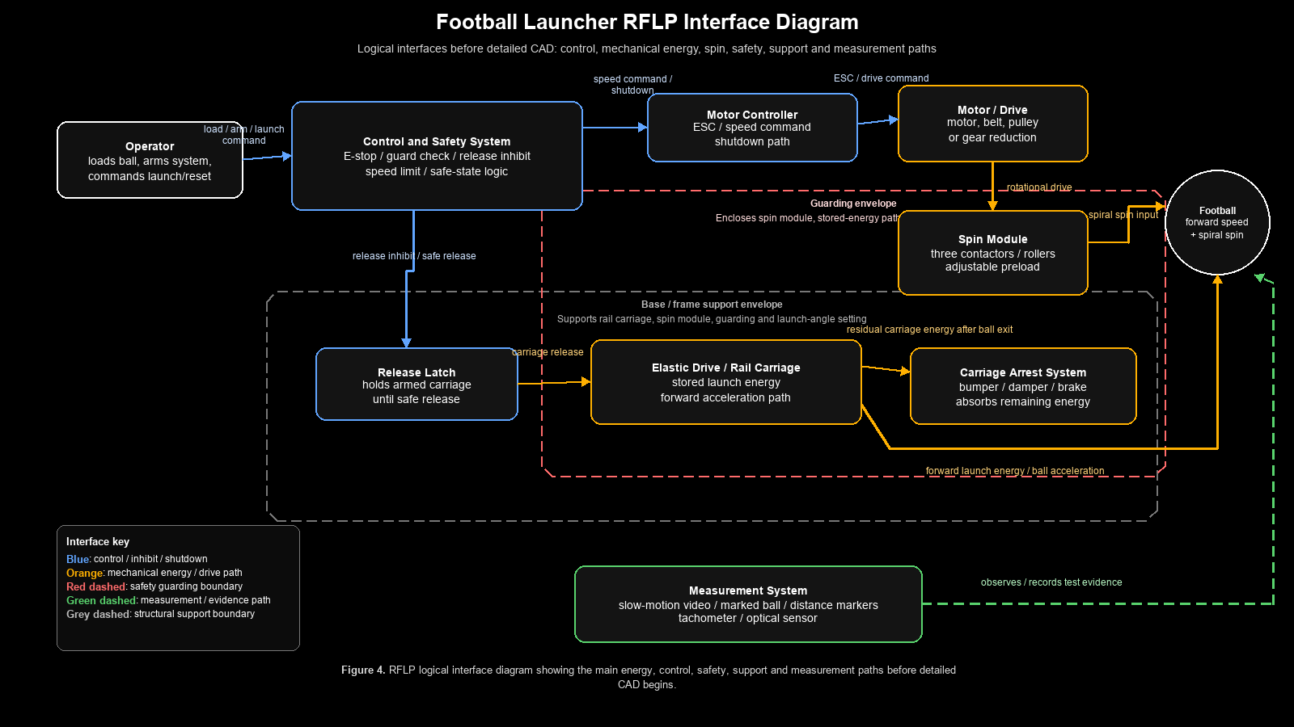
Figure 4. RFLP logical interface diagram for the football launcher.
The interface diagram shows the main energy, control and safety paths before detailed CAD begins. The football is affected by two controlled physical actions: forward acceleration from the rail carriage and spiral generation from the spin module. The control and safety system should govern spin-up, release inhibit and emergency shutdown, while the base/frame and guarding provide structural support and hazard separation.

4.2.6 RFLP Exit Gate
The RFLP decomposition is complete enough to support concept generation once each major function has at least one logical subsystem and at least one plausible physical implementation. The remaining work is not to expand RFLP further, but to use it to compare concepts, define interfaces and prevent CAD features from being added without a requirement or function behind them.
This traceability matrix and RFLP decomposition now provide the hand-off into Phase 5 concept generation and selection, because alternative launcher concepts can be judged against traced requirements, required functions, subsystem interfaces and plausible physical implementations rather than against isolated features.
Phase 5 — Concept Generation and Selection
This phase compares alternative launcher concepts against the requirements, CONOPS and RFLP decomposition already developed in Phases 1–4. The purpose is to avoid selecting a design purely because it is visually attractive or easy to model in CAD. Each concept is judged against the functions the launcher must perform, the safety conditions it must satisfy, and the evidence that will later be needed for verification.
The baseline concept is treated as one option within the trade study, not as an automatic final answer. The selected concept will only be carried forward if it scores well against the PDS and if the next phase confirms that the energy, force, torque, contact and safety requirements are physically achievable.
5.1 Concepts Considered
Concept | Name | Description
A | Elastic rail carriage + three-contactor spin module | Stored elastic energy accelerates the ball forward on a guided carriage. A separate driven three-contactor spin module applies spiral spin before the ball exits. The ball should leave before the carriage reaches the arrest system.
B | Dual-wheel friction launcher | Two powered wheels grip and accelerate the football directly. Speed is controlled by motor speed and wheel contact force. Spiral may be attempted through angled wheel contact or differential wheel speed.
C | Pneumatic piston launcher + passive spin guide | A pneumatic piston or air-powered carriage provides forward launch energy. Passive angled guide surfaces or fins attempt to impart spiral spin during launch.
D | Catapult arm launcher with spin guide | A rotating arm throws the football forward. A guide, cradle or shaped release path attempts to control ball orientation and spiral spin.
E | Belt/roller acceleration tunnel | Belts or rollers accelerate the football through a guided channel. Angled or offset roller contact is used to generate spiral spin while the ball travels through the tunnel.
5.2 Evaluation Criteria
The concepts are scored from 1 to 5 against each criterion.
Score | Meaning
1 | Very poor fit; major redesign or unacceptable risk likely.
2 | Weak fit; possible but with significant limitations.
3 | Acceptable but with clear concerns.
4 | Strong fit with manageable risks.
5 | Excellent fit; directly supports the requirement with low uncertainty.
The weighting reflects the importance of each criterion to the project. High-priority criteria are linked to must-have requirements such as controlled launch speed, spiral generation, nose-forward release, safety, repeatability and test evidence.
Criterion | Weight | Reason for weighting
Launch speed/range capability | 5 | The launcher must produce useful forward velocity and range.
Spiral quality | 5 | Spiral spin is central to the project aim and distinguishes the design from a simple projectile launcher.
Nose-forward release | 5 | The ball must leave in a stable orientation for spin and repeatability to be meaningful.
Repeatability | 5 | Repeatability is the main reason for replacing manual throwing.
Safety | 5 | The system contains rotating parts, stored energy and projectile hazards.
Build feasibility | 5 | The prototype must be achievable with student-level time, tools and budget.
Testability | 5 | The design must allow speed, spin, range, preload and safety to be verified.
Manufacturability / standard parts | 4 | The design should use bought-in components where possible and avoid unnecessary custom complexity.
CAD / mechanical design evidence | 4 | The project should demonstrate real mechanical design, interfaces, calculations and drawings.
Cost | 4 | The prototype must remain realistic for a student project.
Control-system opportunity | 3 | Useful for engineering depth, but secondary to the mechanical launch function.
Compactness / transportability | 3 | Important, but less critical than safety, repeatability and performance.
Novelty / portfolio value | 4 | The design should show more originality than a generic launcher while remaining achievable.
5.3 Detailed Scoring Matrix
Criterion | Weight | A: Elastic rail + 3-contactor | B: Dual-wheel friction | C: Pneumatic + passive spin | D: Catapult arm + spin guide | E: Belt/roller tunnel
Launch speed/range capability | 5 | 4 | 5 | 4 | 3 | 4
Spiral quality | 5 | 5 | 3 | 2 | 2 | 4
Nose-forward release | 5 | 5 | 3 | 2 | 2 | 4
Repeatability | 5 | 4 | 4 | 3 | 2 | 4
Safety | 5 | 3 | 3 | 2 | 2 | 3
Build feasibility | 5 | 3 | 4 | 2 | 3 | 2
Testability | 5 | 4 | 5 | 3 | 3 | 4
Manufacturability / standard parts | 4 | 3 | 4 | 3 | 3 | 2
CAD / mechanical design evidence | 4 | 5 | 3 | 3 | 4 | 5
Cost | 4 | 3 | 4 | 2 | 4 | 2
Control-system opportunity | 3 | 4 | 4 | 2 | 1 | 4
Compactness / transportability | 3 | 3 | 4 | 3 | 3 | 2
Novelty / portfolio value | 4 | 5 | 2 | 3 | 3 | 4
5.4 Weighted Results
Rank | Concept | Weighted score | Percentage | Interpretation
1 | A: Elastic rail carriage + three-contactor spin module | 225 / 285 | 78.9% | Best overall fit. Strongest for spiral quality, nose-forward release, CAD evidence and novelty, but has complexity and safety risks.
2 | B: Dual-wheel friction launcher | 211 / 285 | 74.0% | Very buildable and testable, but weaker for novelty and controlled football-specific spiral generation.
3 | E: Belt/roller acceleration tunnel | 195 / 285 | 68.4% | Good theoretical control of speed and spin, but high complexity, cost and integration burden.
4 | D: Catapult arm with spin guide | 153 / 285 | 53.7% | Cheap and visually simple, but weak for repeatability, spin control and safety.
5 | C: Pneumatic piston + passive spin guide | 149 / 285 | 52.3% | Capable of forward launch, but poor fit for controlled spiral, repeatability, safety and student-level build risk.
5.5 Concept-by-Concept Assessment
Concept A — Elastic rail carriage + three-contactor spin module
Concept A separates the forward launch function from the spin generation function. This is its main technical advantage. The elastic rail carriage provides forward velocity, while the three-contactor spin module can be tuned separately for preload, contact geometry and rotational speed. This directly supports the requirements for launch speed, spiral spin, nose-forward release, adjustable preload and repeatable testing.
Its main weakness is complexity. The concept requires a rail carriage, elastic energy storage, a release latch, carriage arrest, motor drive, rotating contactors, guarding and control/safety logic. It is therefore not the easiest concept to build. However, this complexity is also what gives the concept strong engineering value, provided it is managed through modular design, calculations, risk assessment and progressive testing.
Key risks:
- Excessive stored energy in the elastic launch system.
- Carriage arrest failure or unsafe rebound.
- Ball slip or jamming in the spin module.
- Poor alignment between carriage path and spin module.
- Increased CAD and assembly complexity.
Mitigations:
- Calculate stored energy before full-energy tests.
- Use progressive low-energy testing.
- Design the carriage arrest system as a separate verified subsystem.
- Make contactor preload adjustable.
- Use guarding and release inhibit logic.
- Build the CAD around a clear launch-axis datum.
Concept B — Dual-wheel friction launcher
Concept B is the most buildable alternative. It uses powered wheels to grip and accelerate the ball, making it easier to test speed, motor control and repeatability. It also benefits from available examples in pitching-machine-style mechanisms and can use standard motors, wheels, bearings and guards.
Its weakness is that an American football is not spherical. A dual-wheel system may launch the ball forward, but it may struggle to control nose-forward orientation and spiral spin unless the wheel geometry is carefully adapted. The concept risks becoming a generic ball launcher rather than a football-specific engineering solution.
Key risks:
- Ball deformation or inconsistent grip.
- Poor spiral control.
- Orientation sensitivity during loading.
- Wheel slip and wear.
- Less novelty than the baseline concept.
Mitigations:
- Add a football-shaped cradle or indexing ramp.
- Use adjustable wheel spacing and compliant wheel surfaces.
- Investigate angled or differential wheel speed for spin.
- Use this concept as a buildability benchmark against Concept A.
Concept C — Pneumatic piston launcher + passive spin guide
Concept C can generate forward launch energy effectively, but it scores poorly because spin generation is mostly passive. Pneumatic systems also introduce additional safety and integration issues, including pressure containment, valves, sealing, noise and control uncertainty. For a student-level prototype, the risk-to-benefit ratio is poor unless pneumatic hardware is already available and well understood.
Key risks:
- Pressure safety and leakage.
- Poor control of spiral spin.
- Extra hardware cost and complexity.
- Higher safety burden.
- Less direct mechanical design evidence for the spin system.
Mitigations:
- Use only low-pressure pneumatic components.
- Add pressure relief and guarding.
- Use passive spin only as a secondary comparison, not the preferred route.
Concept D — Catapult arm launcher with spin guide
Concept D is mechanically simple and potentially cheap, but it is weak against the most important football-specific requirements. A catapult arm can launch the ball, but controlling nose-forward release and spiral spin is difficult. The motion is also highly dynamic, which creates safety and repeatability concerns.
This concept may be useful for early inspiration, but it is not a strong final architecture for a controlled football launcher.
Key risks:
- Poor repeatability.
- Arm impact and rebound hazards.
- Difficult release timing.
- Poor spiral generation.
- Large swept volume requiring guarding.
Mitigations:
- Use only as a low-fidelity comparison.
- Avoid carrying forward unless all higher-scoring concepts become infeasible.
Concept E — Belt/roller acceleration tunnel
Concept E has good theoretical performance because the ball can remain in contact with driven surfaces for a longer time. This could improve speed and spin control. It also offers strong CAD and mechanical design content because it involves rollers, belts, supports, alignment and guarding.
Its weakness is integration complexity. A football has a changing cross-section along its length, so a roller tunnel may need compliant mounts, shaped guides or multiple adjustable contact points. This raises cost, CAD burden and risk of jamming.
Key risks:
- High part count.
- Alignment sensitivity.
- Ball jamming or excessive deformation.
- Higher cost.
- Difficult assembly and guarding.
Mitigations:
- Keep as a future development option.
- Use lessons from it to improve the contactor design in Concept A.
5.6 Selection Decision
The selected concept is:
Concept A — Elastic rail carriage + three-contactor spin module.
This concept scores highest because it best satisfies the football-specific requirements: controlled forward launch, spiral spin, nose-forward release, adjustable contactor preload, repeatable testing and strong CAD/mechanical design evidence. It also offers the strongest portfolio value because it is not just a generic launcher; it separates forward-speed generation from spin generation and creates clear subsystems for analysis, design, manufacture and verification.
The decision is not risk-free. Concept A is more complex than the dual-wheel launcher and will require careful management of stored energy, release timing, carriage arrest, alignment, guarding and contactor preload. However, these risks are visible and can be addressed through the existing V-model, RFLP structure and staged test plan. The concept should therefore move forward only after first-order engineering calculations confirm that the elastic energy, launch force, motor speed, contact preload and carriage arrest loads are plausible.
5.7 Architecture Freeze Conditions
Concept A should not move directly into detailed CAD until the following items are checked in Phase 6:
Check | Required outcome
Launch energy budget | Stored elastic energy can plausibly produce 10–20 m/s exit speed without excessive force.
Elastic drive sizing | Spring/elastic force and carriage travel are realistic for the frame and latch.
Spin module budget | Motor speed, contactor RPM and contact duration can plausibly produce 600–1000 rpm ball spin.
Contact preload check | Adjustable preload range is enough to prevent slip without excessive ball deformation.
Carriage arrest budget | End-stop or bumper can absorb residual carriage energy safely.
Stability check | Frame will not tip, slide or twist during launch.
Safety check | Guarding, emergency stop and release inhibit can be implemented at prototype level.
5.8 Phase 5 Exit Gate
Phase 5 is complete when the concept selection matrix, concept assessment and selected architecture are recorded. The selected concept is Concept A, but the choice remains provisional until Phase 6 confirms the first-order engineering budgets. If the calculations show that Concept A requires unrealistic launch force, unsafe stored energy, excessive contact preload or unmanageable carriage arrest loads, Concept B should be reconsidered as the lower-risk backup concept.
Phase 6 — First-Order Engineering Budgets and Feasibility Analysis
This phase tests whether Concept A is physically plausible before any detailed CAD is produced. It converts the Phase 5 architecture-freeze conditions into first-order engineering budgets for launch energy, elastic-drive force, spin generation, carriage arrest and frame stability. The intent is not to produce fake-precise final numbers, but to establish range-based feasibility and to identify which uncertain parameters dominate the design risk. All values are screening estimates and require physical measurement and refinement before the design is frozen.
Two operational refinements from the CONOPS were applied to the analysis. First, the spin module is brought to speed before the carriage is released, so the ball is pre-spun during a controlled dwell rather than during its brief transit. A conservative 0.5 s spin dwell time is used so that spin-up remains a real constraint rather than being treated as free. Second, the launch axis height is set to realistic quarterback release heights of approximately 4, 5 and 6 ft (1.22, 1.52 and 1.83 m), which deliberately increases the tipping demand on the frame.
6.1 Analysis Method
The analysis uses a range-based screening approach. Every input is specified as a low, nominal and high value reflecting genuine early-stage uncertainty. Three deterministic named cases are evaluated by setting every parameter to its low, nominal or high value in turn: a low-speed, short-travel conservative case, a nominal case, and a high-speed, long-travel performance case. These all-low and all-high combinations do not necessarily bound every output, because launch efficiency and carriage travel do not move monotonically with demand, so the Monte Carlo sweep is treated as the authoritative range. A Monte Carlo sweep of 20,000 samples draws every parameter uniformly across its range simultaneously, producing a probability distribution for each engineering output. A one-at-a-time sensitivity study perturbs each parameter between its bounds to rank the dominant variables. Finally, pass, caution and fail thresholds are applied to the safety-critical outputs. The calculations were implemented in Python using numpy, pandas and matplotlib, with results exported to a spreadsheet and supporting plots.
6.2 Input Parameter Ranges
The screening ranges below are used unless better measured values become available. They cover the football, the elastic launch system, the spin and contact system and the frame. The contact (dwell) time and launch height reflect the two operational refinements described above, and the arrest stroke is held at a fixed 200 mm design value; parameters shown with equal low, nominal and high values are fixed design choices rather than swept ranges.
Parameter | Unit | Low | Nominal | High
Ball mass | kg | 0.38 | 0.43 | 0.45
Ball radius (minor axis) | m | 0.08 | 0.0875 | 0.095
Ball exit speed | m/s | 10 | 15 | 20
Target ball spin | rpm | 600 | 800 | 1000
Launch efficiency | - | 0.3 | 0.5 | 0.7
Carriage travel | m | 0.4 | 0.7 | 1
Carriage mass | kg | 0.5 | 1.25 | 2
Carriage residual speed | m/s | 2 | 6 | 10
Arrest stopping distance (design value) | m | 0.2 | 0.2 | 0.2
Pre-launch spin dwell time | s | 0.5 | 0.5 | 0.5
Contactor friction coefficient | - | 0.3 | 0.55 | 0.8
Preload per contactor | N | 10 | 17.5 | 25
Number of contactors | - | 3 | 3 | 3
Contactor roller radius | m | 0.02 | 0.035 | 0.05
Frame weight | N | 80 | 165 | 250
Side half-width, CG to side tipping edge (roll) | m | 0.2 | 0.35 | 0.5
Launch axis height (4/5/6 ft) | m | 1.22 | 1.52 | 1.83
Ground friction coefficient | - | 0.3 | 0.5 | 0.7
Front foot extension, CG to front tipping edge (pitch) | m | 0.2 | 0.45 | 0.8
Rear foot extension, CG to rear tipping edge (pitch) | m | 0.2 | 0.55 | 1
Table 6.1. First-order input parameter ranges used for the Phase 6 screening calculations.
The previous single base half-width parameter is retained only as the side half-width for roll stability. Fore-aft pitching stability is now governed separately by the front and rear foot extensions measured from the vertical projection of the system centre of mass to the relevant tipping edge. These are candidate folding-leg/outrigger distances and are swept as independent variables in the stability model below; they must be refined against the actual support polygon after CAD skeleton modelling.
6.3 Governing Calculations
The first-order relationships below link each requirement to a calculable quantity. Symbols: m_b ball mass, v_b exit speed, η launch efficiency, x carriage travel, k spring stiffness, m_c carriage mass, v_c carriage residual speed, s arrest distance, N_b ball spin, ω angular speed, t_c spin dwell time, I_b ball axial inertia, μ contactor friction, N_c preload per contactor, r_b ball radius, r_c contactor radius, W frame weight, F_horizontal conservative destabilising horizontal force, h launch/reaction height, d_front, d_rear and d_side the distances from the centre-of-mass projection to the front, rear and side tipping edges, μ_g ground friction.
Quantity | First-order expression | Linked requirement
Ball kinetic energy | E_ball = ½ · m_b · v_b² | REQ-01
Stored elastic energy | E_stored = E_ball / η | REQ-17
Spring stiffness | k = 2 · E_stored / x² | REQ-17
Average launch force | F_avg = E_stored / x | REQ-01, REQ-17
Peak launch force | F_peak = k · x | REQ-17, REQ-19
Ball acceleration | a = v_b² / (2x) | REQ-01
Force on ball | F_ball = m_b · a | REQ-01
Carriage residual energy | E_c = ½ · m_c · v_c² | REQ-07, REQ-18
Average arrest force | F_arrest = E_c / s | REQ-18
Ball angular speed | ω = 2π · N_b / 60 | REQ-03
Angular acceleration | α = ω / t_c | REQ-03
Ball axial inertia | I_b ≈ 0.4 · m_b · r_b² | REQ-03
Spin-up torque | T = I_b · α | REQ-03, REQ-16
Available traction | F_avail = 3 · μ · N_c | REQ-05, REQ-06
Required traction | F_req = T / r_b | REQ-03
Spin friction margin | F_avail / F_req | REQ-03, REQ-06
Contactor surface speed | v_s = ω · r_b | REQ-03
Contactor RPM | (v_s / 2π r_c) × 60 | REQ-03, REQ-16
Tipping moment (fore-aft) | M_tip = F_horizontal · h | REQ-19
Front pitch restoring moment | M_stable,front = W · d_front | REQ-19, REQ-25
Rear pitch restoring moment | M_stable,rear = W · d_rear | REQ-19, REQ-25
Side roll restoring moment | M_stable,side = W · d_side | REQ-19, REQ-25
Front pitch stability ratio | SF_front = M_stable,front / M_tip | REQ-19, REQ-25
Rear pitch stability ratio | SF_rear = M_stable,rear / M_tip | REQ-19, REQ-25
Side roll stability ratio | SF_side = M_stable,side / M_tip,side | REQ-19, REQ-25
Sliding margin | SF_slide = μ_g · W / F_horizontal | REQ-19
Table 6.2. Governing first-order expressions and the requirements they inform.
For the present screening model, F_horizontal is conservatively taken as the peak launch force. This is deliberately cautious. A refined model should separate the ball acceleration reaction, carriage inertial reaction, spring-anchor load path and carriage-arrest reaction. The current approach is acceptable for identifying whether the base footprint is clearly inadequate, but it should not be treated as the final dynamic load model.
6.4 Named Design Cases
The three named cases below correspond to all-low, all-nominal and all-high input combinations rather than true best and worst cases. They are named for their dominant inputs: a low-speed, short-travel conservative case; a nominal case; and a high-speed, long-travel performance case. These combinations do not bound every output uniformly. For example, the short travel in the conservative case produces the highest peak launch force (317 N) of the three, because peak force scales inversely with carriage travel; the high-efficiency, long-travel performance case actually sees the lowest peak force (257 N). This non-monotonic behaviour is exactly why the Monte Carlo sweep in Section 6.5 is used to establish the true ranges. Pass, caution and fail flags follow the screening rules: spin and stability margins pass at or above 1.5 and fail below 1.0; arrest force passes below 1000 N; contactor speed passes below 4000 rpm.
Output | Unit | Low-speed / short-travel conservative case | Nominal case | High-speed / long-travel performance case
Ball kinetic energy | J | 19.0 | 48.4 | 90.0
Stored elastic energy | J | 63.3 | 96.8 | 128.6
Spring stiffness | N/m | 792 | 395 | 257
Average launch force | N | 158 | 138 | 129
Peak launch force | N | 317 | 276 | 257
Ball acceleration | m/s² | 125 | 161 | 200
Force on ball | N | 47.5 | 69.1 | 90.0
Carriage residual energy | J | 1.0 | 22.5 | 100.0
Average arrest force | N | 5 | 113 | 500
Spin-up torque | N·m | 0.12 | 0.22 | 0.34
Spin friction margin | - | 5.89 (pass) | 11.45 (pass) | 16.75 (pass)
Contactor RPM | rpm | 2400 | 2000 | 1900
Front pitch stability ratio | - | 0.04 (fail) | 0.18 (fail) | 0.43 (fail)
Rear pitch stability ratio | - | 0.04 (fail) | 0.22 (fail) | 0.53 (fail)
Side roll stability ratio | - | 0.04 (fail) | 0.14 (fail) | 0.27 (fail)
Sliding margin | - | 0.08 (fail) | 0.30 (fail) | 0.68 (fail)
Table 6.3. First-order outputs for the three named design cases, with pass/caution/fail flags. The stability rows use the split front/rear/side support-polygon model with the candidate folding-leg geometry of Table 6.1.
6.5 Monte Carlo Results
The 20,000-sample Monte Carlo sweep gives the distribution of each output across the full parameter space. The summary statistics below report the minimum, 5th percentile, median, mean, 95th percentile and maximum for the key outputs.
Output | Min | P5 | Median | Mean | P95 | Max
Ball kinetic energy (J) | 19.2 | 22.8 | 46.8 | 48.4 | 79.1 | 89.7
Stored elastic energy (J) | 28.4 | 41.7 | 94.6 | 102.9 | 195.4 | 293.8
Spring stiffness (N/m) | 62.7 | 128.7 | 395.8 | 513.9 | 1311 | 3216
Peak launch force (N) | 60.6 | 110.5 | 275.7 | 314.0 | 646.6 | 1288
Carriage arrest force (N) | 5.2 | 16.1 | 102.3 | 130.3 | 344.8 | 497.6
Spin-up torque (N·m) | 0.12 | 0.15 | 0.21 | 0.21 | 0.28 | 0.34
Spin friction margin | 2.79 | 5.50 | 11.41 | 12.21 | 21.61 | 35.51
Contactor RPM | 979 | 1275 | 2002 | 2140 | 3446 | 4594
Front pitch stability ratio | 0.01 | 0.05 | 0.18 | 0.23 | 0.59 | 2.00
Rear pitch stability ratio | 0.01 | 0.06 | 0.21 | 0.28 | 0.72 | 2.37
Side roll stability ratio | 0.01 | 0.04 | 0.13 | 0.16 | 0.40 | 1.27
Sliding margin | 0.03 | 0.09 | 0.28 | 0.35 | 0.85 | 2.47
Table 6.4. Monte Carlo summary statistics over 20,000 samples.
The proportion of samples falling into each risk band makes the dominant feasibility problems explicit.
Check | Fail % | Caution % | Pass %
Spin friction margin | 0.00 | 0.00 | 100.00
Front pitch stability | 99.35 | 0.60 | 0.04
Rear pitch stability | 98.41 | 1.38 | 0.21
Side roll stability | 99.97 | 0.03 | 0.00
Sliding stability | 97.33 | 2.37 | 0.30
Carriage arrest force | 0.00 | 0.00 | 100.00
Contactor RPM | 0.00 | 0.88 | 99.12
Table 6.5. Monte Carlo risk summary, showing the percentage of samples in each band.
The stability model has been split into front pitch, rear pitch and side roll margins and the Monte Carlo sweep now varies the front foot extension, rear foot extension and side half-width as independent support-polygon variables using the candidate folding-leg geometry of Table 6.1. The resulting margins are reported directly above; they are not the earlier compact-base figures.
6.6 Sensitivity Analysis
The one-at-a-time sensitivity study identifies which uncertain parameters dominate the critical outputs. Ranked by influence: exit speed dominates stored energy, launch force and the resulting reaction load, because energy scales with the square of speed; launch efficiency directly scales the stored-energy and force budget; carriage travel trades peak force against frame length; launch height dominates the tipping moment, so the move to realistic quarterback release heights is the single largest driver of the stability problem; and frame weight together with the front, rear and side support distances directly control the stability margins. The spin outputs are weakly sensitive across the board once the 0.5 s dwell time is assumed, which is why spin is no longer a feasibility risk.
6.7 Engineering Interpretation
The core launch mechanism is comfortably feasible. Stored energy stays modest (median 95 J, 28-294 J across the sweep) and peak launch force is manageable (median 276 N, with only 0.3% of samples above 1000 N), so a bungee or spring-driven carriage built from student-accessible hardware can plausibly deliver the 10-20 m/s exit speed of REQ-01 within the stored-energy intent of REQ-17.
Spin generation is no longer a feasibility risk. With the ball pre-spun over a 0.5 s dwell, the required spin-up torque is small (around 0.1-0.3 N·m) and the spin friction margin passes in 100% of Monte Carlo samples, with a worst case of 2.79. Contactor speed stays below 4000 rpm in over 99% of samples, well within standard motor capability. This satisfies REQ-03, REQ-05, REQ-06 and REQ-16 at screening level, although the effective contactor friction coefficient still requires physical measurement.
Carriage arrest is comfortably feasible following the design decision to fix the arrest stroke at 200 mm. With this longer stroke the average arrest force stays below the 1000 N caution threshold in 100% of Monte Carlo samples, and the three named cases give only 5, 113 and 500 N for the conservative, nominal and performance cases respectively. Because arrest force scales inversely with stroke length, increasing the stroke from the earlier 20-100 mm assumption to a fixed 200 mm removes the arrest force as a feasibility concern and satisfies REQ-07 and REQ-18 at screening level; the detailed design must still confirm that the bumper or damper can deliver a controlled 200 mm stroke without unsafe rebound.
The 200 mm arrest stroke is therefore a design allocation, not just a calculation assumption. The CAD layout must preserve this stroke using a progressive bumper, sliding friction brake, damper, or combined bumper/brake assembly. If packaging constraints later reduce the available arrest stroke, the arrest-force calculation must be repeated because arrest force scales inversely with stopping distance.
Frame stability is the dominant feasibility problem. The split model, run over the full Monte Carlo sweep with the candidate folding-leg geometry, fails the front pitch check in 99.3% of samples, the rear pitch check in 98.4%, the side roll check in 100.0% and the sliding check in 97.3%. At the nominal case the margins are only 0.18 (front pitch), 0.22 (rear pitch), 0.14 (side roll) and 0.30 (sliding), all far below the safety factor of 2.0 required by REQ-25. This is a direct challenge to REQ-19 and REQ-25 and confirms that the base must be treated as a designed subsystem rather than a simple support frame. The dominant drivers are the tall launch/reaction height and the low frame weight; the candidate front, rear and side foot extensions are not yet large enough to compensate. The required intervention is a substantially larger deployed footprint, a lower centre of mass, ballast near ground level, higher-friction feet, ground anchoring, a reduced exit speed, or a combination of these. The result is not a reason to abandon Concept A.
This finding supports the use of folding legs or outriggers: the launcher can remain compact for transport while deploying into a much larger support polygon for operation. The folding mechanism must use positive locking through pins, braces or over-centre links. A friction-tightened hinge alone is not acceptable because hinge slip would directly compromise REQ-19 and REQ-25.
6.8 Decision and Architecture Implication
The recommendation is to proceed to CAD skeleton modelling of Concept A, not detailed part design. The launch, spin and arrest budgets are within plausible, student-accessible ranges, so there is no engineering reason to abandon Concept A or fall back to Concept B at this stage. However, the base/frame architecture is not frozen. The CAD skeleton must first define the launch-axis datum, centre-of-mass estimate, folded and deployed leg envelopes, front/rear/side support distances and preserved 200 mm arrest stroke.
Condition one: the candidate folding-leg geometry evaluated in this revision still fails the front pitch, rear pitch, side roll and sliding checks, so the frame and folding-leg/outrigger base must be redesigned for stability before geometry is frozen, targeting all four safety factors above 2.0 at the 6 ft release height. The screening calculation must then be rerun with the enlarged support polygon and revised mass distribution. Condition two: an early bench test of a single contactor against a football surface should confirm the effective friction coefficient. The carriage arrest budget is no longer a limiting condition following the decision to fix the arrest stroke at 200 mm, and that 200 mm arrest stroke should be carried forward as a protected packaging requirement during skeleton modelling. If frame stability cannot be achieved within acceptable weight and size limits, the fallback is to cap the target exit speed at approximately 15 m/s, which roughly halves the reaction force and materially eases the stability problem before Concept B is reconsidered.
6.8.1 Folding-leg Design Implications
The folding-leg concept is realistic provided the deployed support system behaves as a locked structural frame. The hinge should only provide rotation during setup; once deployed, the load path should pass through locked braces, pins, collars or over-centre links. The support polygon should be defined by the deployed foot locations rather than by the folded envelope. A three-leg layout offers reliable ground contact on uneven surfaces, while a four-leg layout can provide a larger rectangular support polygon if adjustable feet are used to prevent rocking. Candidate layouts should be compared by their folded length, deployed front/rear/side support distances, lock simplicity, manufacturability and stability margin.
6.9 Phase 6 Exit Gate
Phase 6 is complete at first-order feasibility level, but the base/frame is not yet architecture-frozen. The split front/rear/side stability model has now been run with candidate folding-leg geometry and still fails at realistic release heights, so the project may proceed into CAD skeleton modelling only. Detailed CAD, drawings and part sizing should wait until the deployed support geometry has been enlarged and the stability sweep re-verifies front pitch, rear pitch, side roll and sliding safety factors above 2.0. The protected design allocations carried forward are the 200 mm arrest stroke, the controlled pre-spin dwell, the launch-axis datum and the deployed support-polygon requirement.
The next calculation tool should be a parameter sweep rather than a single-point calculation. The sweep should vary front foot extension, rear foot extension, side half-width, frame weight, launch height, ground friction coefficient and exit speed. Candidate designs should be ranked by stability safety factor, folded envelope, added mass and manufacturability.

