Christian Caldwell

Professor Wergeles

CS2830 – Web Dev

May 4th - 2018

**Final Project Documentation**

Project Link: <http://ec2-34-227-16-95.compute-1.amazonaws.com/FinalProject/puzzlerLogin.php>

**Project:** The project I produced is a simple yet very enjoyable and challenging puzzle game. The purpose was to make something that not only meets the requirements, but is fun and can last beyond the due date. There are two methods to playing the game, one: a user can log-in as a guest and play a limited version of the game, or two: the user can login and play the full version which includes a variety of levels and challenging difficulties.

**Requirements:**

* IN ORDER OF DOCUMENTATION REQUIREMENTS:

1. The page is made with HTML5 and CSS3. All the files include either the php or css tag. HTML5 is included with the php files.
2. There is a consistent design between the webpages. This is backed by the generalDesign.css file which is used between both the guest and member page. They are not different in appearance, only functionality.
3. Button designs and functionality are consistently used throughout each webpage. The pages are not sloppy and are organized.
4. Logging in allows users to play more levels and harder difficulties, whereas playing as a guest restricts the amount of levels and difficulties.
5. Username is indeed: test & Password is indeed: pass
6. PHP is the main file type. PHP is used for puzzlerLogin.php and logout.php, and much more.
7. POST is used for logging in (handleLogin.php) (puzzlerLogin.php line: 129). GET is used for the mail form (mail.php)
8. There is an email form that sends me an actual email. Proof can either be seen by the picture at the end of this document, or by getting a screenshot through email from me after a TA sends me an actual email through the form. (puzzlerMember.php Lines: 203-213). (mail.php)
9. An error appears if the login information is wrong. (handleLogin.php line: 33)
10. The game itself has multiple photos on the page when you start the game. When you start the game, a photo displays as a solution and another photo is dismantled and randomized to form another. Altogether, nine different photos are used for the game.
11. Upon clicking, “Watch Us On YouTube”, an embedded YouTube video pops up. (Line: 195-198) (buttonScript.js line: 161-163).
12. JavaScript is both used in gameScript.js and buttonScript.js. An example includes the common use of ‘document.getElementById’ in “buttonScript.js”.
13. A lot of jQuery is used in this application. Simply look at buttonScript.js to see a plethora of jQuery functions.
14. jQuery UI is used because the puzzles move through the use of ‘Draggable” and ‘Swappable’, both of which are jQuery UI. In addition, bootstrap dropdown buttons are used.
15. Although minimal, AJAX is used when the “about” button is clicked. Notice how it calls to webServiceAbout.php, which simply holds the about information. When the “about” button is clicked, it retrieves this information from the server and uses it to fill the solution div. (buttonScript.js lines: 121-134)) (webServiceAbout.php)

Proof email form works:

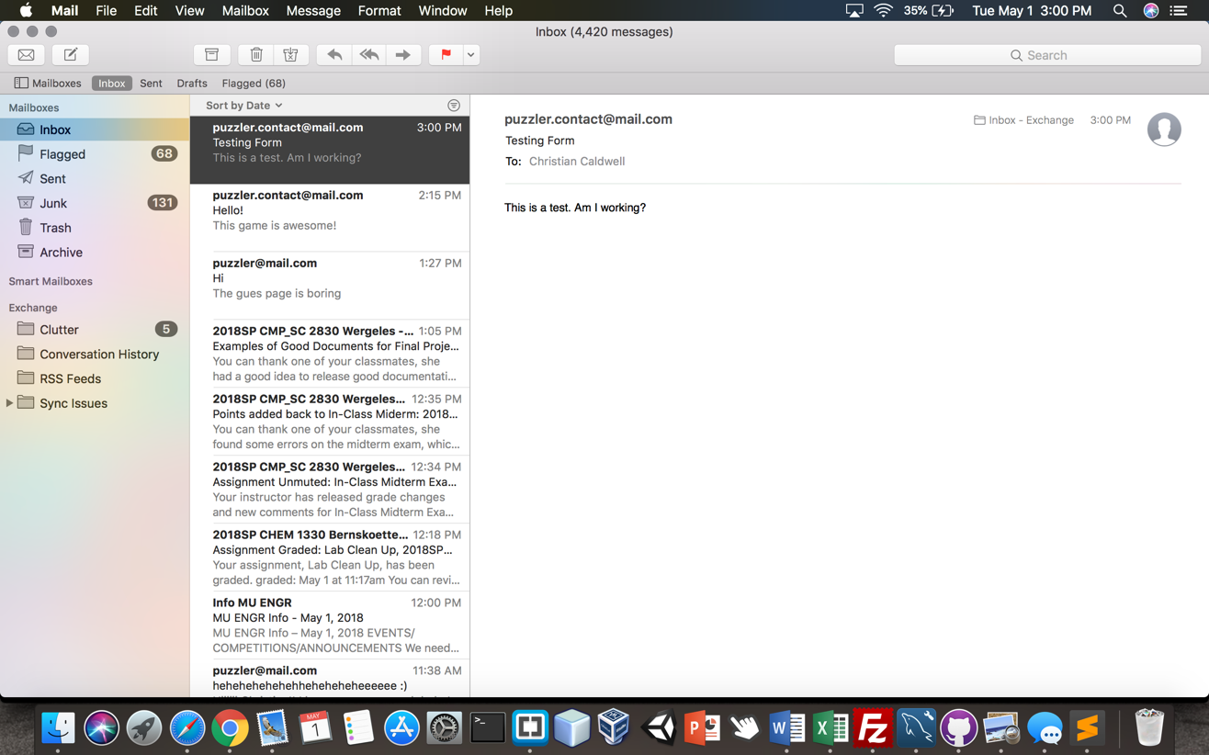

How to Play:

1. Select A level to play.
2. Select A difficulty. (It is recommended you start low and familiarize yourself with the picture before trying to go up in difficulties).
3. Hit the start button and begin moving pieces.
4. Pieces move as you swap them over other pieces on the left div. After dropping a piece, it will swap places with the piece you dropped it on.
5. Keep dragging and swapping pieces until your picture on the left looks like the solution image on the right.
6. You win if you can manage to match the solution before time expires.
7. You lose if you fail to match the solution image before time expires.

**References:**

1. Login.php and the logout function were largely takin from professor Wergeles.
2. The enableSwapping, setImage, and randomize functions seen within “gameScript.js” were sourced from Anurag Gandhi’s GitHub code. (<https://www.codeproject.com/Articles/810978/Image-Puzzle-A-Html-Game>).
3. The rest was a product of my own abilities or older projects done in this class.