| **Team Number** | Team 3 | **Section** | Sec 61 |
| --- | --- | --- | --- |
| **Team Members** | 1. Elibera Mansour 2. Niki Liao 3. Sarthak Chauhan 4. Chi Phan | | |
| **Software Name** | TimeCapsule | | |

# Introduction

## Objective

The objective of this technical specification is to guide the development for an open-source, desktop application personal journal application. The goal is to provide a description of the individual components of the application such as classes, interfaces, and class methods. It will also identify the relationships between these components.

## References

CS151-Term Project-00-Problem Statement-V1.pdf

## Acronyms and Abbreviations

N/A

|  |  |
| --- | --- |
|  |  |
|  |  |
|  |  |

# Software Overview

## Functional Requirements

1. The application will require a password to login
2. The application forces first time users to change their default password
3. The application allows the user to reset their password if they forgot their password
4. The application allows the user to logout which will redirect them to the home page (aka password entry page)
5. The application allows the user to create new journal entry
6. The application allows the user to save journal entry
7. The application allows the user to cancel out of a journal entry and return to home page
8. The application allows the user to search for journal entry based on journal entry context and title
9. The application allows the user to edit a old journal entry after searching for it
10. The application allows the user to delete an old journal entry after searching for it

# Detailed Design

## UML Class Diagrams (not all Classes/Interfaces)

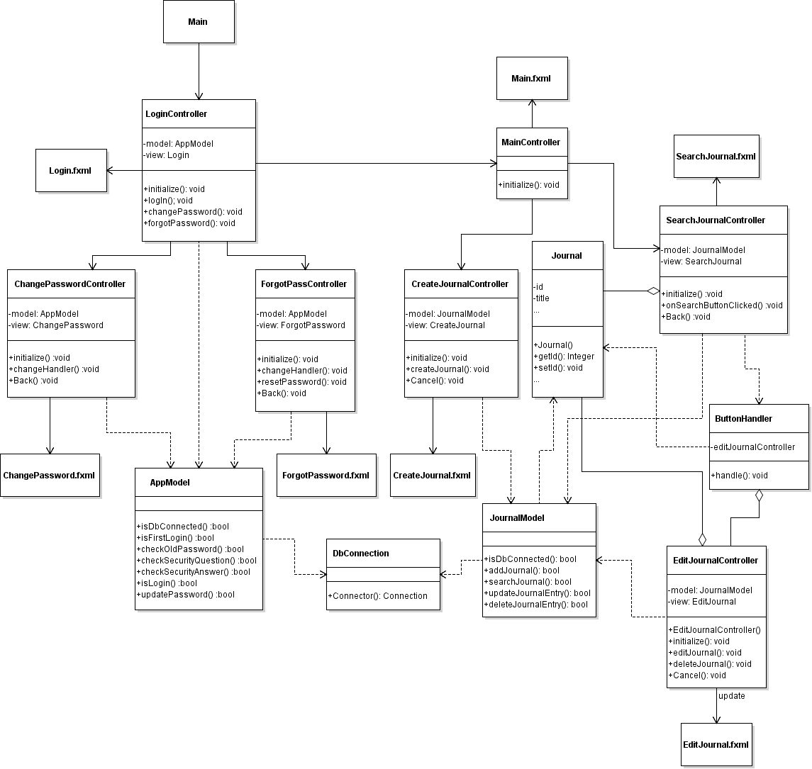

## UML Sequence and/or State Diagrams

**State Diagram:**

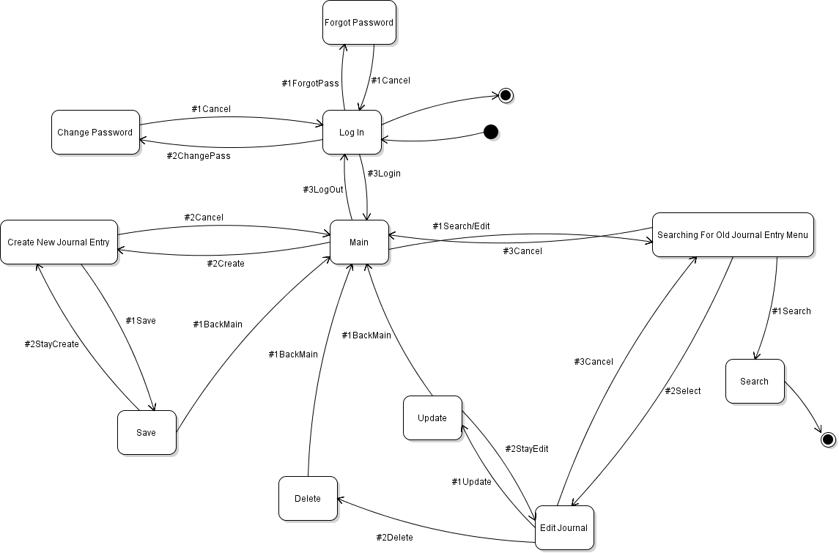

**Sequence Diagram for Resetting Password:**

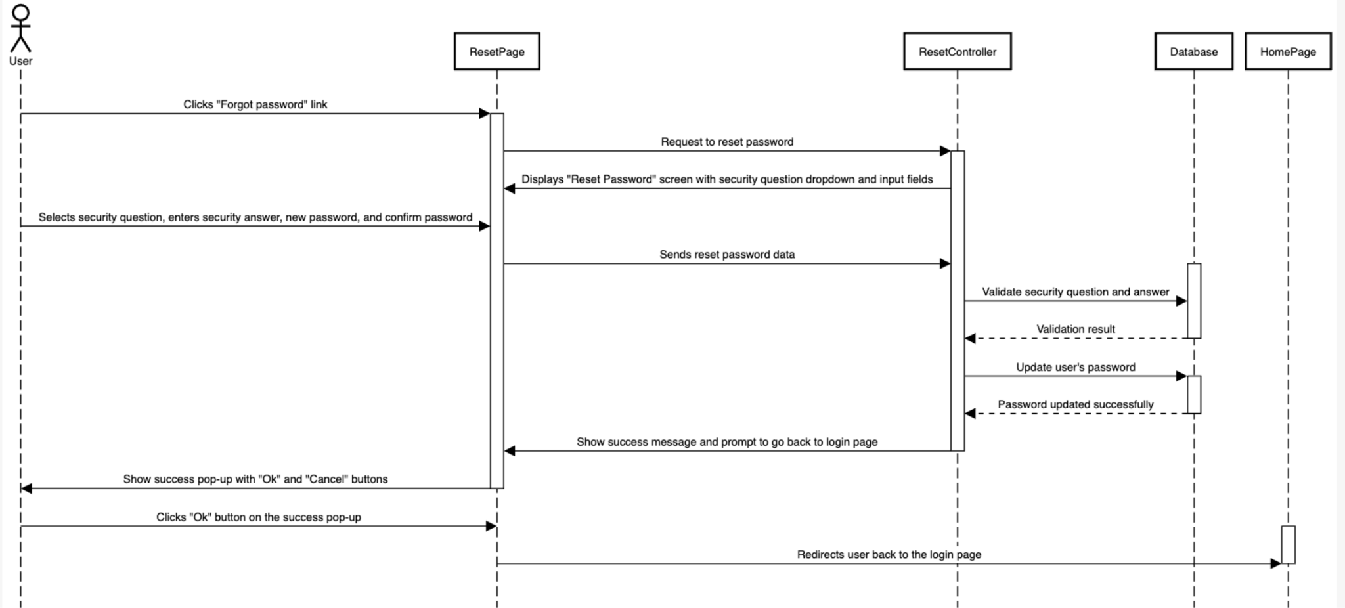

**Sequence Diagram for First Time Logging in**

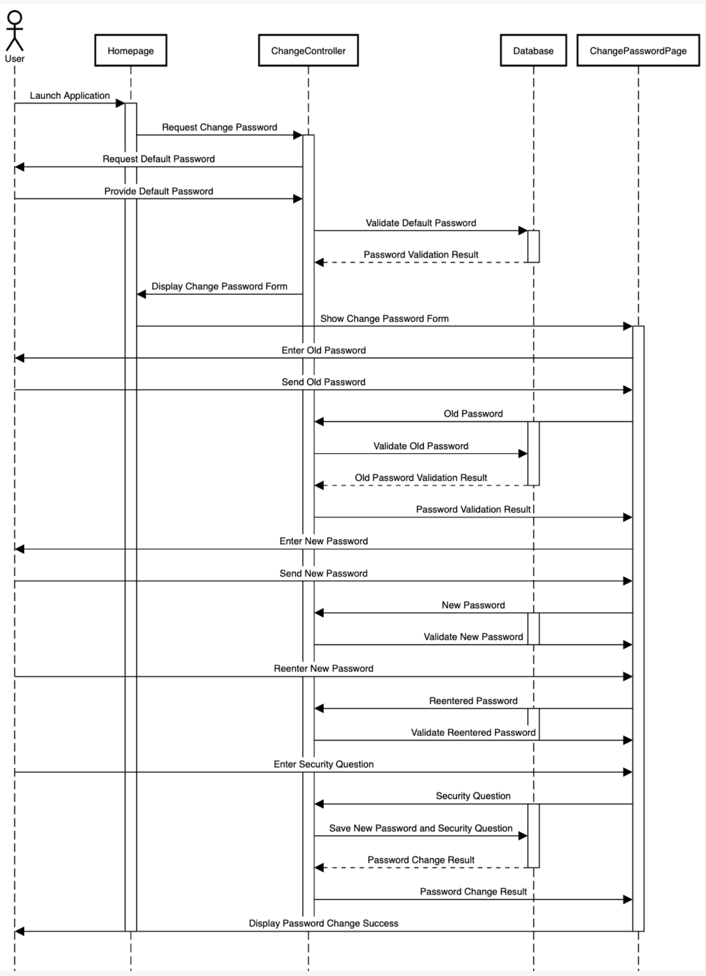

**Sequence Diagram for Creating a Journal Entry**

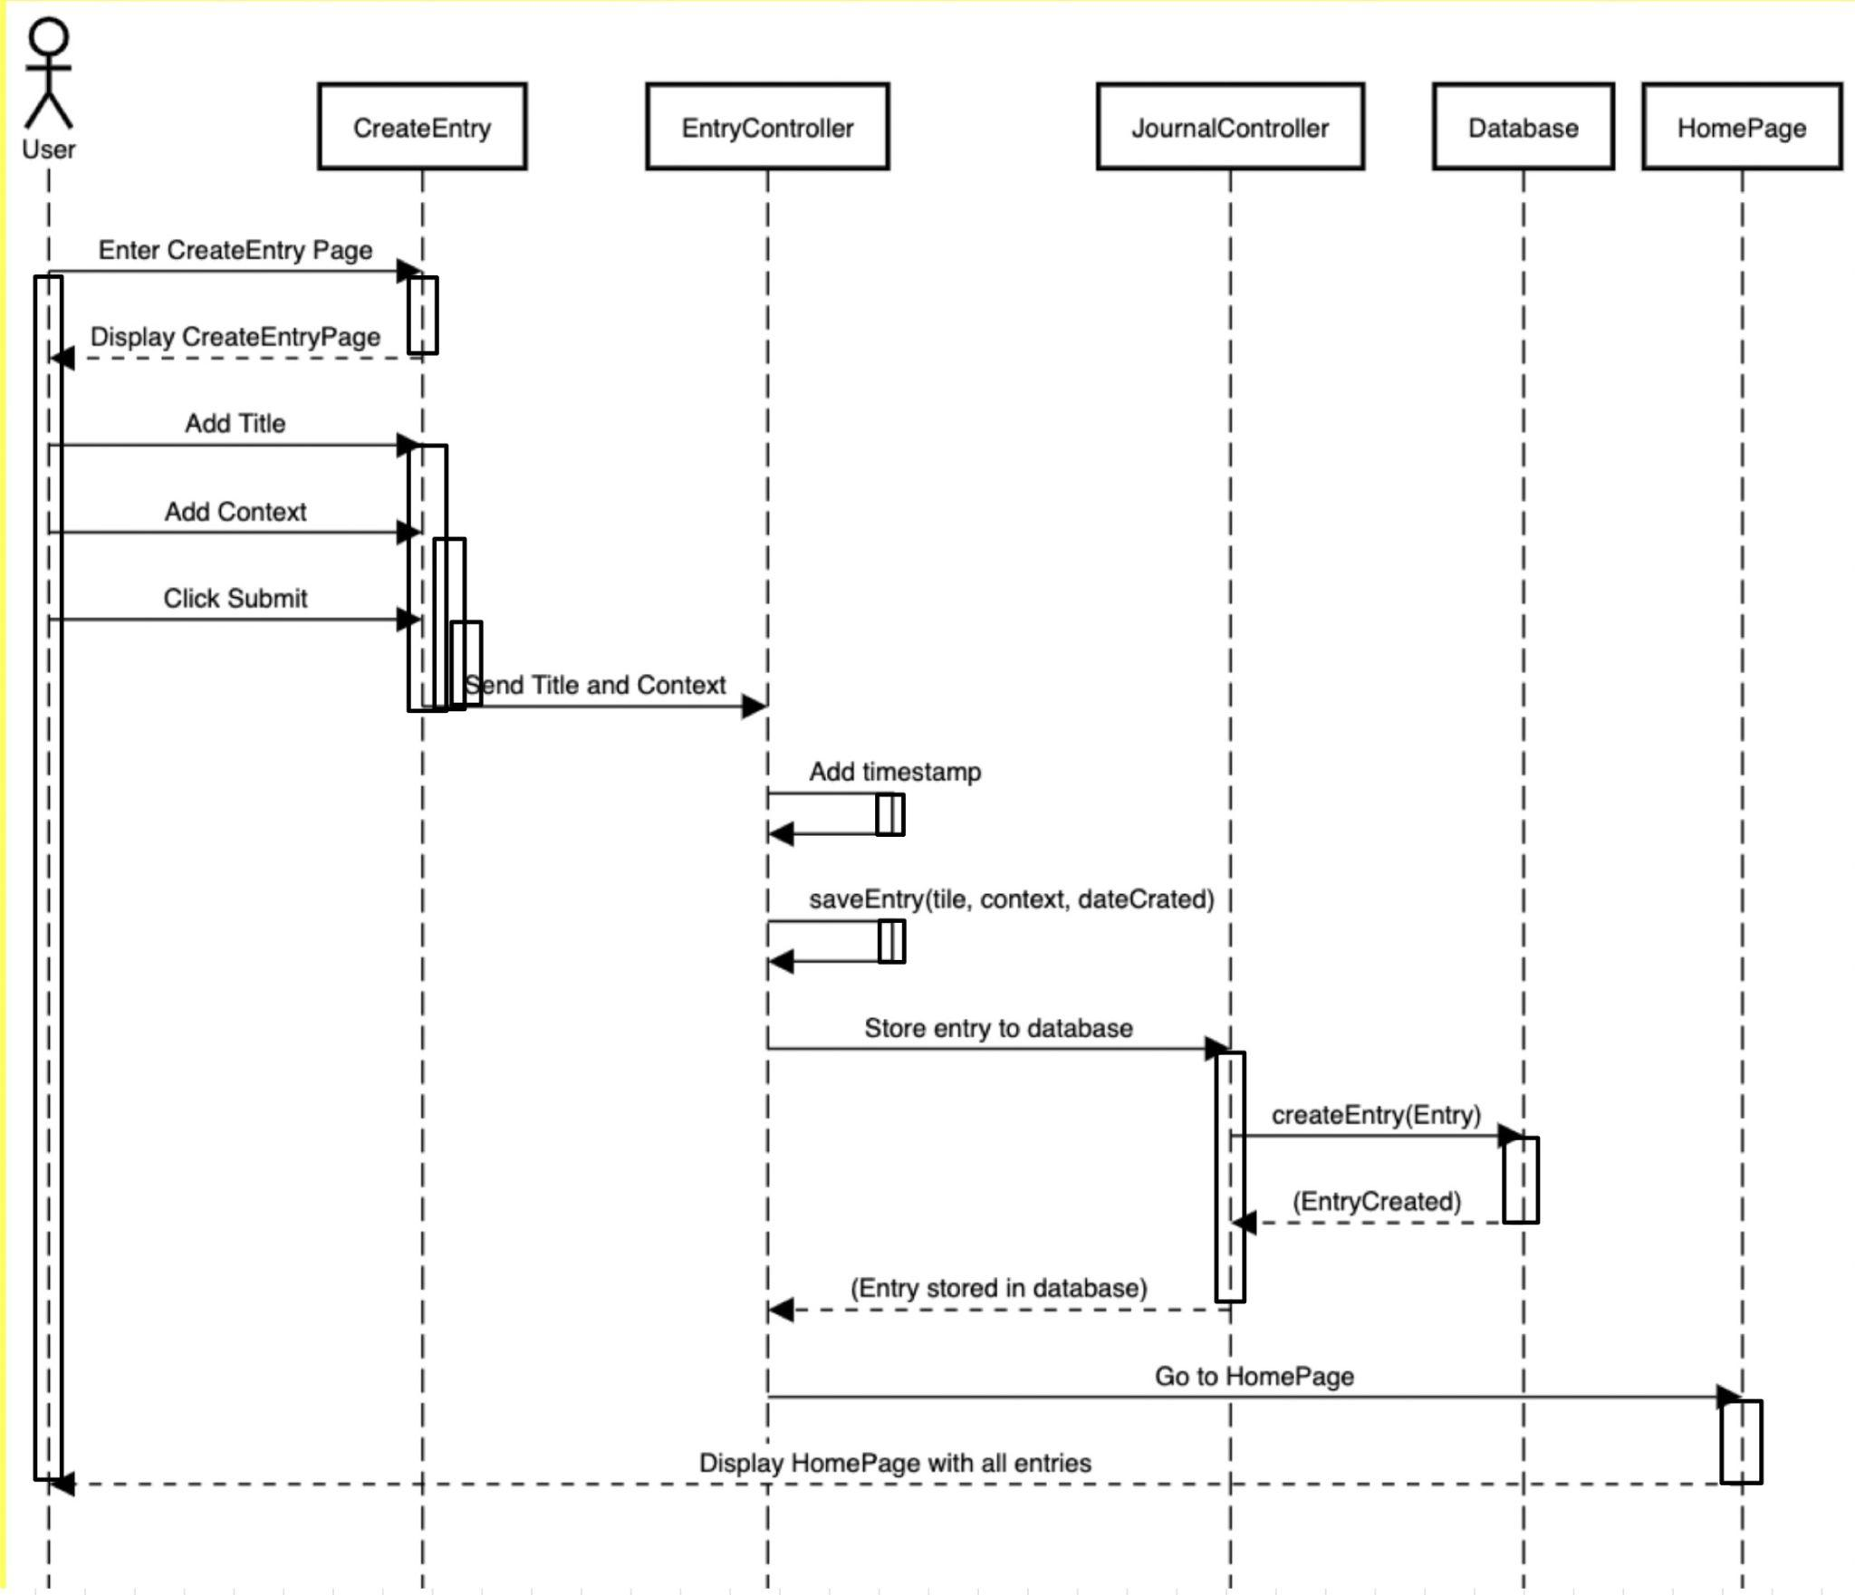

**Sequence Diagram for Searching a Journal Entry**

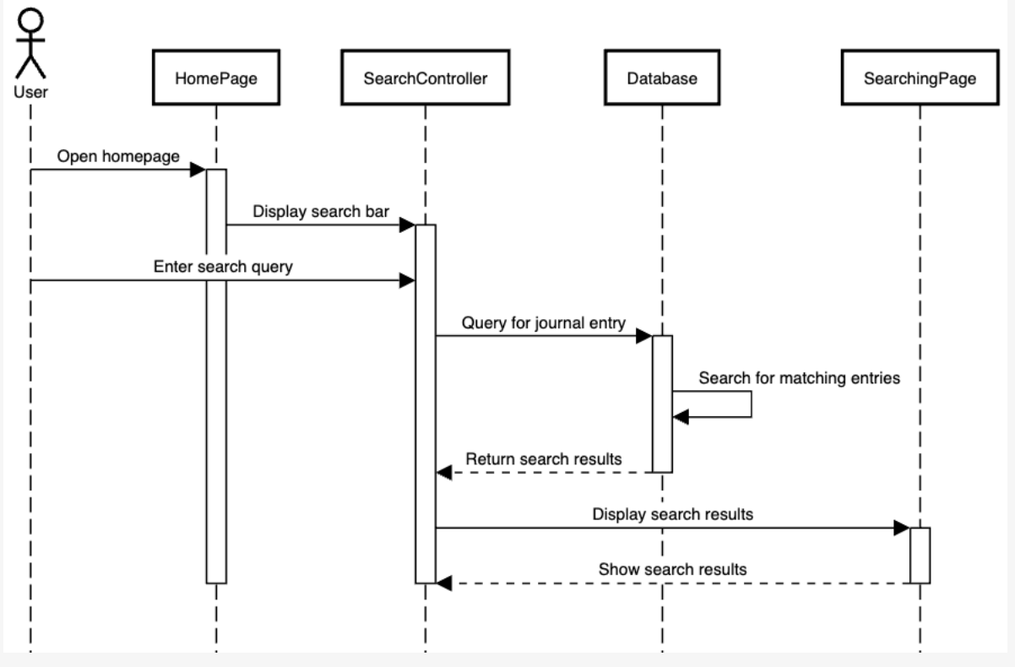

**Sequence Diagram for Editing a Journal Entry**

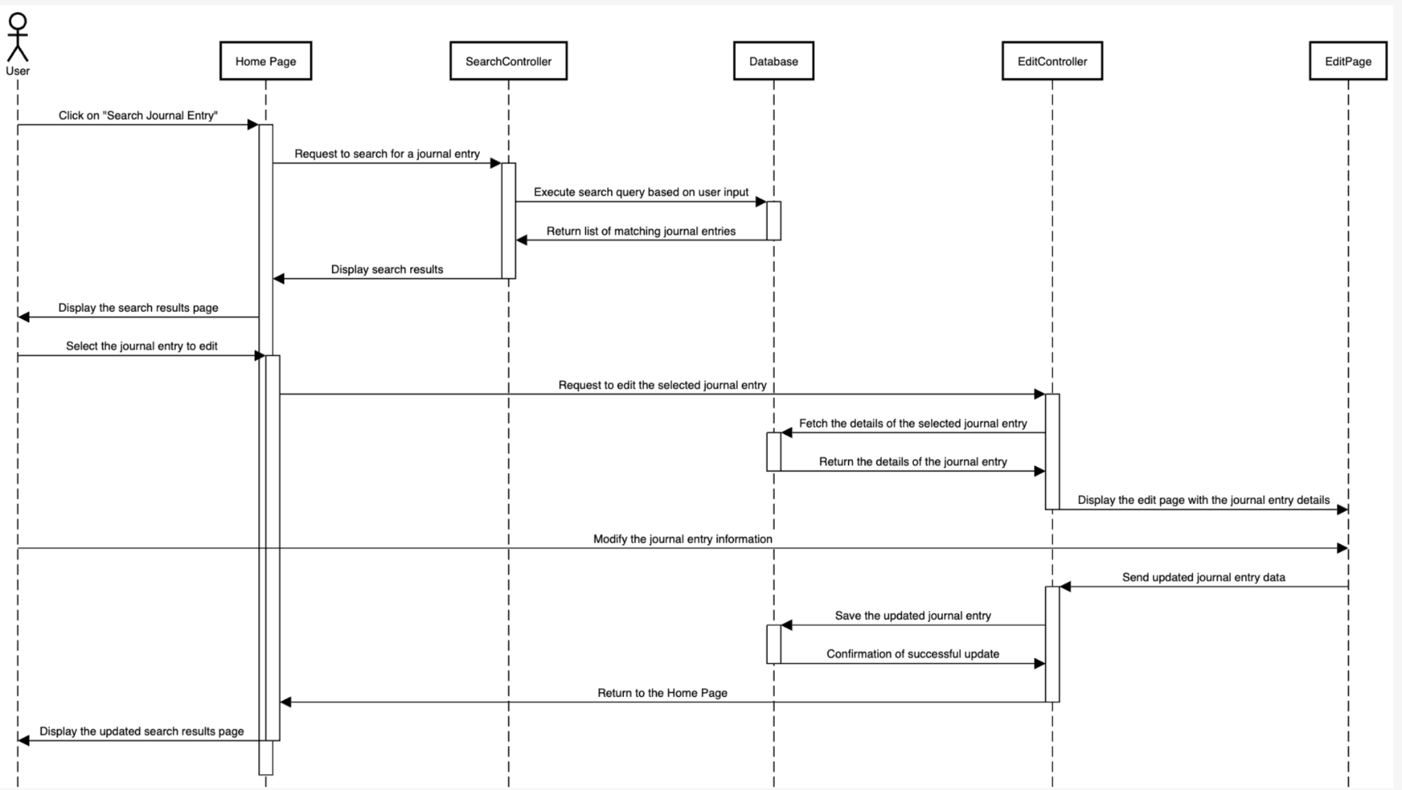

**Sequence Diagram for Deleting a Journal Entry**

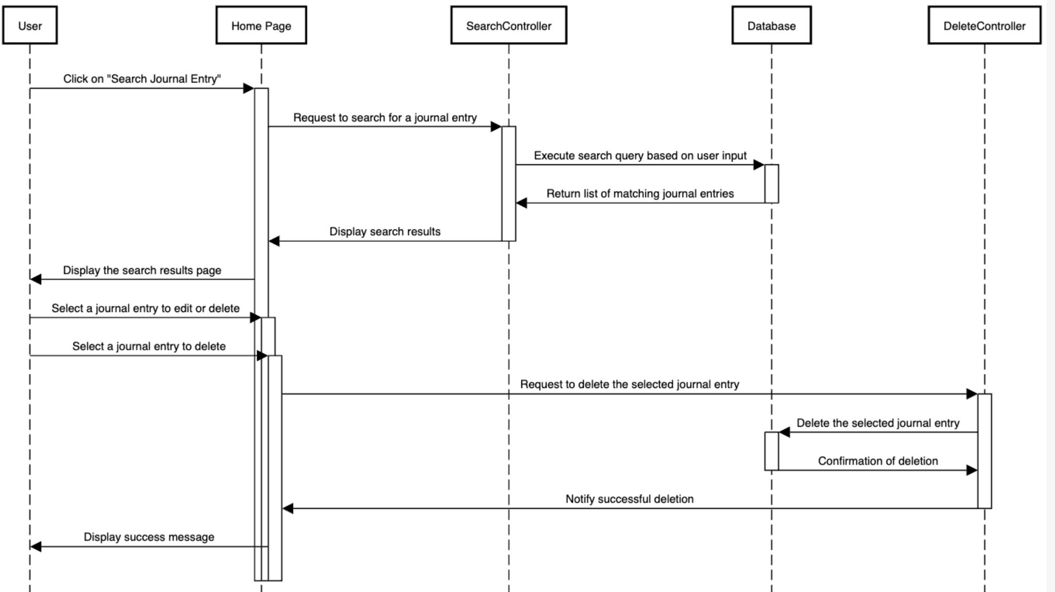

## Mockups

