91.350 + 70.108 Final Project

Bluetooth Monitor

Christian Everett

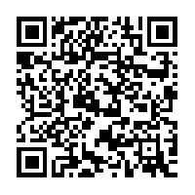

Username: user

Password: user

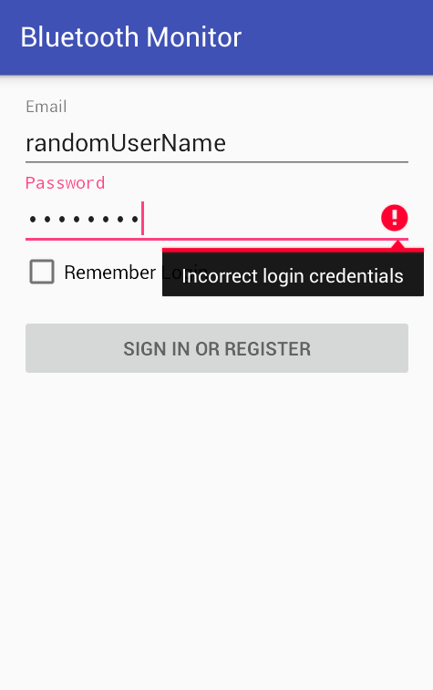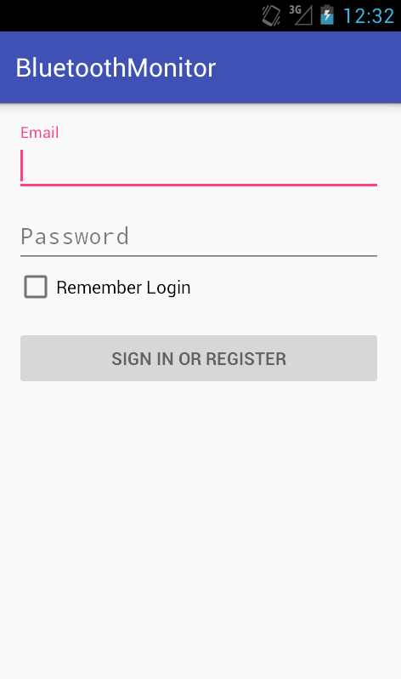Login Screen

* Authenticates username and password (over HTTP) against database of users
* Responds to user with an error message; error messages include(password too short, field is required, incorrect login credentials)



* Check box will flag app (client side only) to cache username and password
* On successful login a direct socket connection is created to the backend server (will be used for a server side push)

Area Status Screen

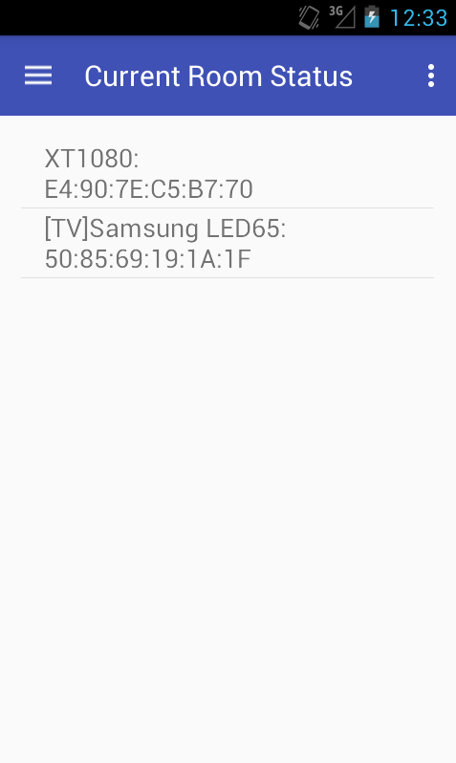

* Displays Device name and MAC of only present devices
* List view is auto refreshed/updated when new data arrives
* Extra feature not implemented: selecting list view item triggers dialog popup presenting user with ability to modify device (such as changing name, permissions, or deleting device data from the database)

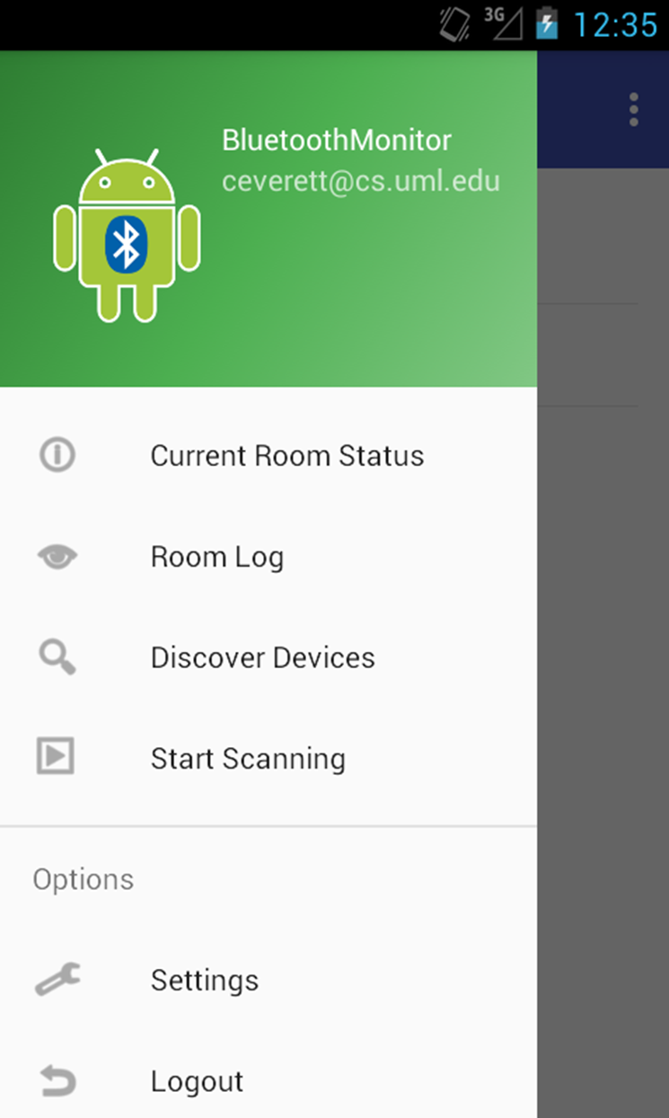Navigation Drawer

* 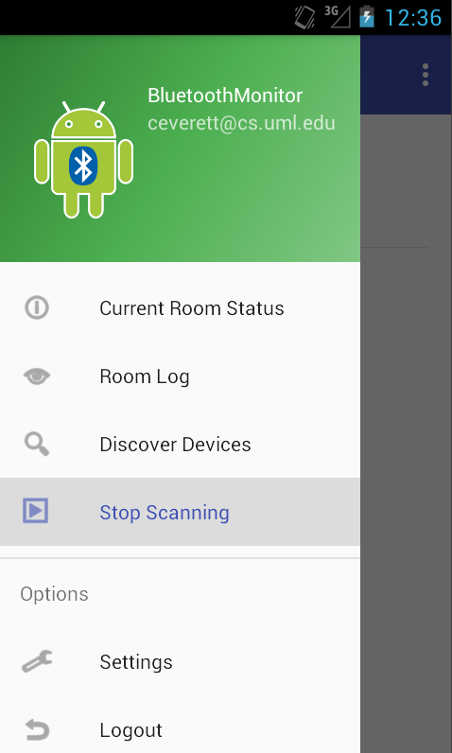
* Navigation through screens is done using the navigation drawer
* Discover Devices: action tells the server to start scanning the room for new devices and to then log there MAC addresses to a database
* Start Scanning/Stop Scanner: arms and disarms Bluetooth device ping (green led for armed, red led for disarmed)
* Logout: dumps cached sessionid, interrupts server side push thread, and sends logout request to php logout script

Room Log

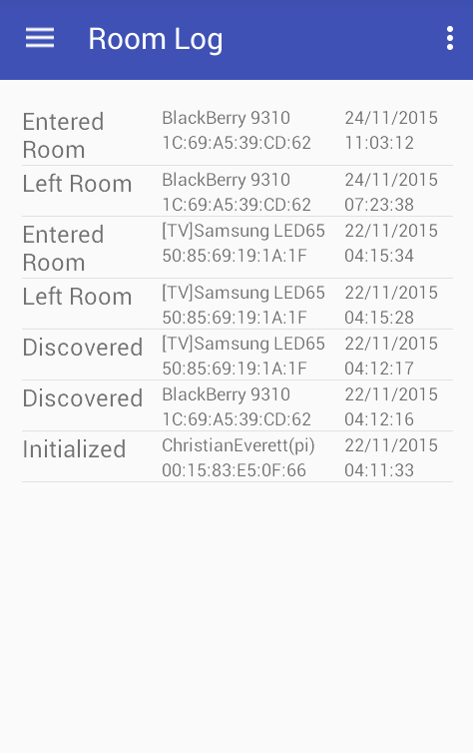

* Display all information about room activity such as device discovery, device presence, and timestamps
* For better usability the Room log screen displays the ten most recent activity’s
* Extra feature: Swipe refresh to request ten more entry’s
* Extra feature: log filter; allow user to filter the log by specified time period or action (such as yesterday’s activity, last week’s activity or only discover actions)

Device Discovered

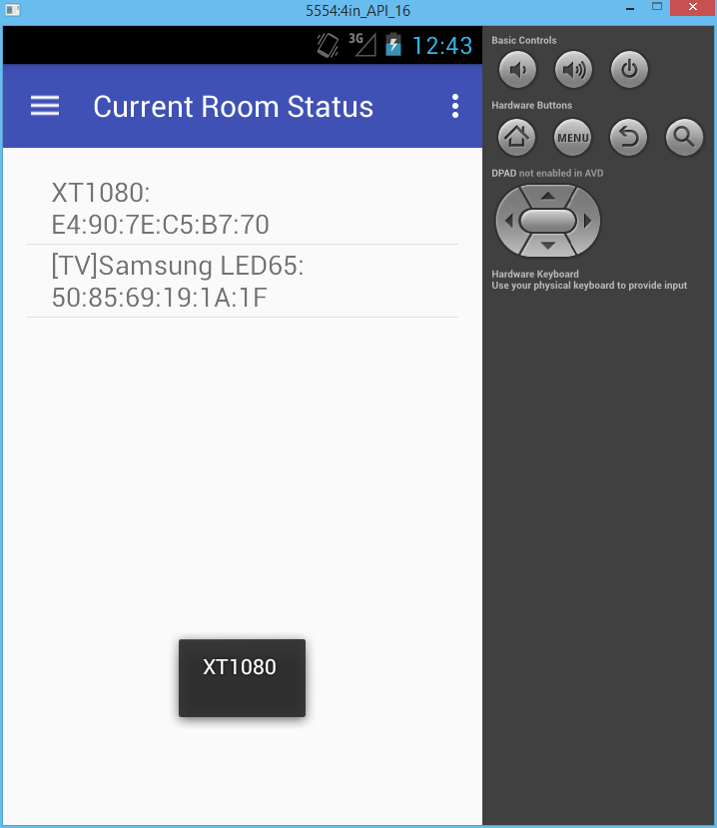

* When a new device is discovered the app will display the device name in a toast message for each new device or nothing if no **new** devices are found
* Can send out emails on new device discovery



App Icon

Server Side

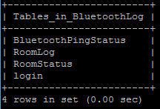

Database Schema

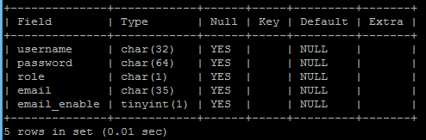

RoomStatus table hold all know MAC address with their corresponding names, and whether or not they are present in the area

Login table stores emails, user authentication information, and whether or not the subscribed to emails notifications

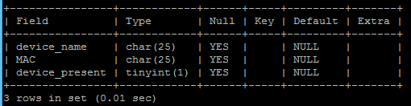

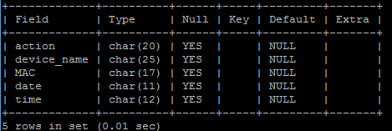

The RoomLog table hold information on all activity in the area; such as when devices enter, when the left, and when they were discovered along with a timestamp.

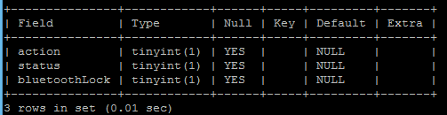

The action field tells the adapter to change states. The status field displays what state is running. The Lock prevents multiple processes from (from different clients) use the adapter at the same time.

Action and status: 1 = ping, 0 = sleep bluetoothLock: 1 = locked, 0 = unlocked

Extra Features:

* ARP packet Scanner
* Log Filter options
* Log Pull Down to refresh Menu
* App Settings Menu
* App capability: adding users