Salesforce Assignment

Detailed Technical Design Lite
Tweets Feed – timer and filter

Designer and Developer: Gang Liu
Date: May 24th, 2016

Table of Contents
1 INTRODUCTION 3
1.1 Overview 3
1.2 Related Documents 3
1.3 Common definitions 3
1.4 Design Considerations 3
2 CURRENT IMPLEMENTATION 4
3 Proposed IMPLEMENTATION 5
3.1 List of Use Cases 5
3.2 Detailed Application Flow Description 5
3.3 Screen Mockup/Design 6
3.4 Detailed changes to Presentation/Business/Service/Persistence Layer 6
3.5 Environment Changes 6

Amendment History

Date | Version | Author | Amendment Description
5/24/2016 | 1.0 | Gang Liu | Initial Draft

INTRODUCTION

Overview
This tiny project is to pull the last 10 tweets from salesforce twitter, and added interval, filter.

This is an implementation of the Salesforce Assignment - Tweets Feed (http://gangliu.info/sfTwitterFeeds/) ; it adds the following functionality -

- Show the last 10 tweets from salesforce
-- It will retrieve latest tweets every 1 minute
-- Added friendly style sheet for UI
-- Show the user screen name, portrait picture, tweets contents, tweets IMG (if it has), retweeted counts
- Filter
-- Added filter input box to all user to filter tweets by finding the keywords in the tweets content.
-- Highlights the keywords in the found tweets content (black background, white text).

Related Documents

Location | Description
JQuery Official Website | Jquery API
Twitter Dev Website | Twitter API PHP

Common definitions
Name | Description
OAuth | The user access authentication method by specifying customer and access token the secret
JQuery | The Javascript extension library

Design Considerations
1, the twitter timeline service should be called every 1 minute: - using built-in JS function setInterval;
2, the UI should be considerably friendly: using customized style sheet to polish the tweets feed;
3, the backend is leveraging the official Twitter PHP API;
4 use JQuery to improve the interactive responsive web experience.

CURRENT IMPLEMENTATION

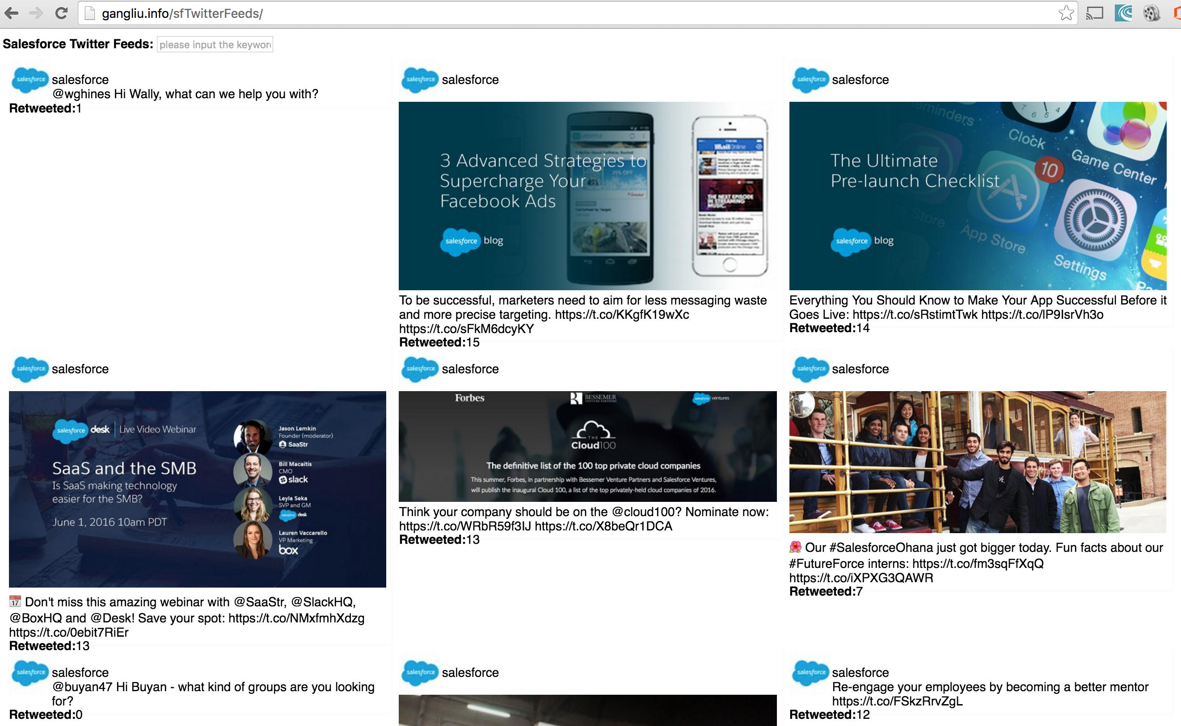

The screenshot shows how the salesforce looks like. It was already deployed on http://gangliu.info/sfTwitterFeeds/. It shows the latest 10 tweets from salsforce Twitter every 1 minute, and the tweets content was well organized.

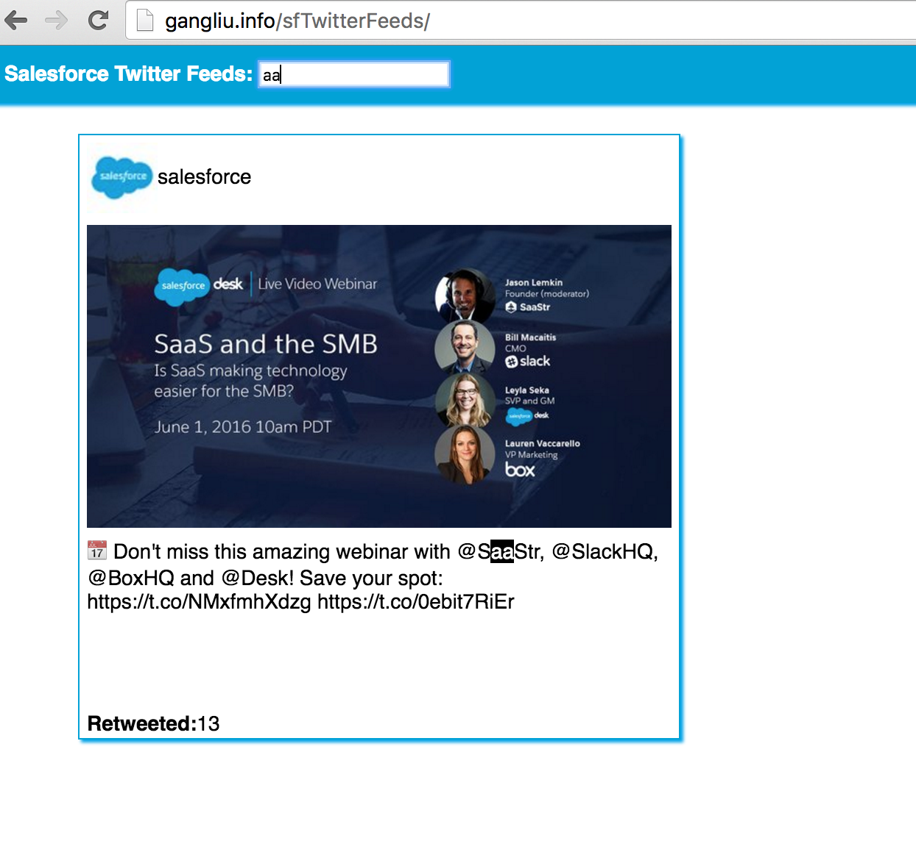
This is the feature to filter out tweets depending on the user inputs, besides the keyword gets highlights in tweet content.

Proposed IMPLEMENTATION

List of Use Cases

 | Functional Unit | Description
1 | User opened the index page. | User is able to see the latest 10 tweets (if there is)
2 | User wait for another 1 minute. | User is able to see the updated 10 tweets (if there is)
3 | User input keyword to search tweets | Only matching tweets show up
4 | No tweets found | User is able to see the warning message

Detailed Application Flow Description

Process Description
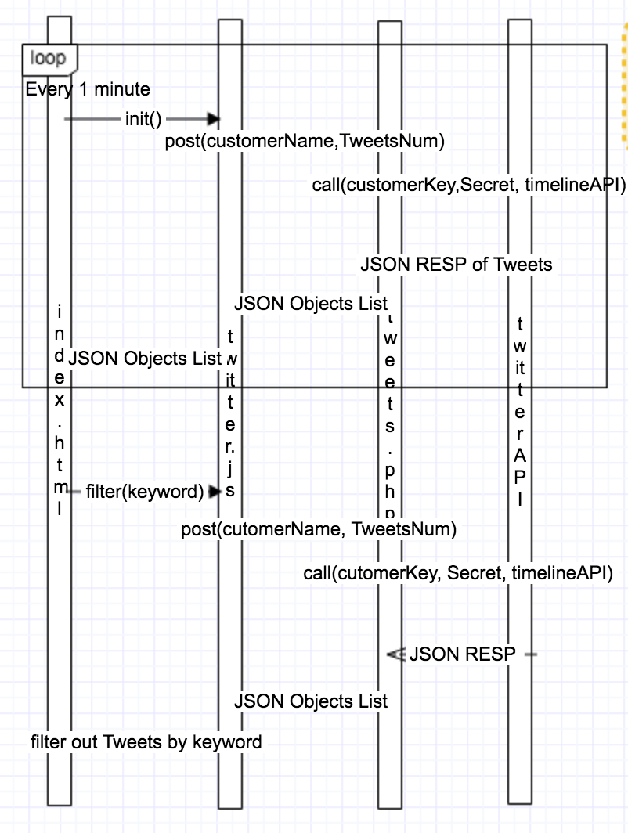

Environment
HTML+PHP+JQuery+Twitter API

