CSCI 6612 - Visual Analytics Fall 2019 - Assignment 4

Due 11:55 PM, Sunday, November 24th, 2019.

Instructions:
- Submit your assignment in Brightspace (https://dal.brightspace.com).
- Read the Dalhousie Policy on Plagiarism.
- The assignment must be done individually.
- Properly cite any external source that you used.
- You are not allowed to use or reuse any piece of code from other students.
- For this assignment, all implementation should be in JavaScript and Python 3+.
- We will run your code!
- Submit all your code in a zipped file using your B00 as filename: B00999999.zip

Problem:
Using your radviz (or Star Coordinates) visualization, integrate a backend to provide the data and other types of information to be visualized.

You can use any library for the python backend server. Recommendation: Flask (and extensions)

You can use any library for the front-end implementation.

Remember to properly state references for these libraries!

Submission:
Submit a zip file including all necessary files required to run the system. Include a README or instructions on how to execute your system.

[100 (+30)] Requirements:
Code will be marked based on functionality, structure, reusability, best practices, and documentation.

- [10 Marks] Create a backend that will provide the data and metadata that can be used to display the visualization
  - Use an HTTP request to retrieve data from the back-end and use it to generate the visualization on the front-end.
  - Tip: You can return, along with the data, some metadata like column names or other information that could be useful to handle and/or display the data in the front-end.
- [20 Marks] Add an option on the interface to choose a different dataset (iris or winequality)
  - The backend will return the new dataset
  - You can keep a state on the front-end and send it on every request to identify the current dataset in use.
- [20 Marks] When hovering an instance of a given cluster, show (as a tooltip or in other available space) the correlation matrix for instances of that cluster.
  - The correlation matrix should be calculated and returned by the back-end.
  - This should be displayed on the front-end through a color matrix. See example of such matrix below (Tip: feel free to use libraries to help you):

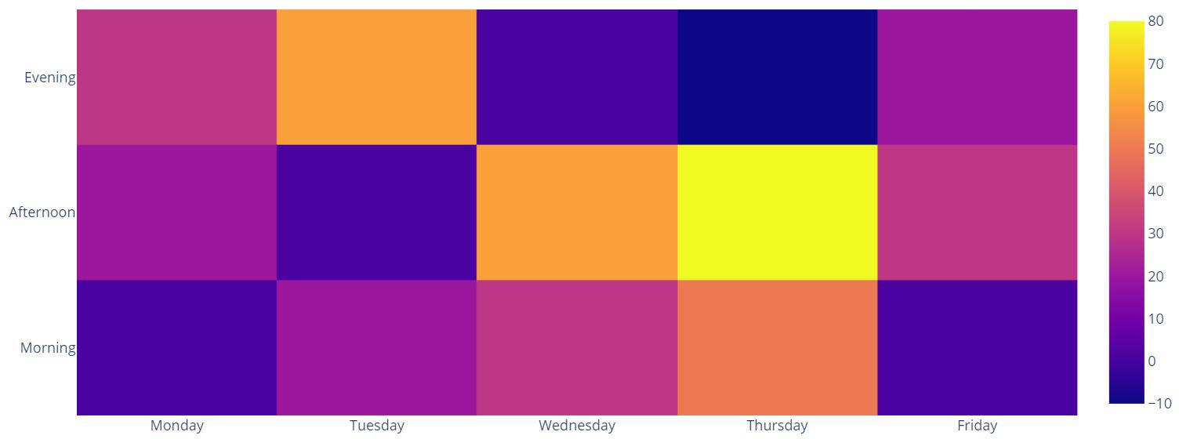

- [40 Marks] Implement a button that requests the backend to clusterize the data using one of:
K-Means or DBScan
  - You should color the instances using the clustering information
  - Add a switch button to choose between the color modes: cluster colors or class-based colors.
  - The clusterization should be performed on the same dataset currently seem in the visualization.
  - You just need to implement for one clusterization algorithm.
  - You may use existing implementations of the clustering algorithms.
- [10 Marks] Add one (or more) options to configure the parameters of the clustering algorithm
  - Clicking the button should make a new clusterization with the new parameters and update the colors on the visualization.
- [+30 Bonus Marks] Add an option on the interface to choose to see the preprocessed dataset generated by your A1 assignment.
  - RadViz/StarCoordinates should only show the numerical columns as anchor points
- The Categorical columns should be shown as the color of the plot. Make an input box selector in the interface to choose the categorical column to be shown as the color.

