

CORDOVA PUBLIC COLLEGE
COLLEGE OF COMPUTER STUDIES
GABI, CORDOVA, CEBU, PHILIPPINES
SOFTWARE REQUIREMENTS SPECIFICATIONS
for the
ProctorShield AI:
An AI-Powered Online Examination and Remote Proctoring System
Presented by:
INOC, JENELYN S.
PINO, DHEYAN J.
PACALDO, CHRISTIAN GLENN C.
Academic Year: 2025-2026
Bachelor of Science in Information Technology (BSIT)

Date of Publication: September 5, 2026

Signature Page
This Software Requirements Specification document has been reviewed and approved by the project team members, faculty advisers, internal adviser, external adviser, and the Capstone Evaluation Panel of the College of Computer Studies, Cordova Public College. By signing below, the parties agree that this document accurately represents the functional and non-functional requirements of the ProctorShield AI system.
_______________________________  System Developer / Project Manager  Jenelyn S. Inoc | _______________________________  BSIT Capstone Instructor  College of Computer Studies Faculty
_______________________________  Internal Adviser  _____________________ | _______________________________  External Adviser  _____________________
_______________________________  Panel Member  _____________________ | _______________________________  Dean, College of Computer Studies  Nicasio P. Amoin

Change History
The following table tracks the iterative revisions and updates made to the Software Requirements Specification document throughout the development lifecycle of ProctorShield AI.
Version | Date | Author(s) | Description of Changes
V0.1 | May 20, 2026 | Capstone Development Team | Initial Requirements Specification: Formulated the first structural draft of the SRS document. Authored the introduction, system purpose, scope, and initial feature lists for the secure exam client and AI proctoring engine.
V1.0 | May 25, 2026 | Capstone Development Team | Finalized the SRS document following the IEEE Std 830-1998 format, as prescribed by the Cordova Public College CCS capstone documentation guidelines, for submission to the Capstone Evaluation Panel.
V1.1 | July 11, 2026 | Capstone Development Team | Formatting revision: standardized document to Times New Roman (18 pt headings, 12 pt body text); rebuilt the Table of Contents with dot-leader page alignment; corrected sequential table numbering (Tables 1-7); and corrected the Design Constraints section to accurately reflect the custom JWT-based authentication scheme (removed erroneous NextAuth.js reference).
V2.0 | September 5, 2026 | Capstone Development Team | Major as-built baseline update: corrected the full-stack architecture; documented browser-side face and phone detection, teacher-controlled quiz lifecycle, mobile reduced assurance, short video evidence, Redis and S3-compatible storage, password recovery/session revocation, notifications, non-destructive retakes, Free/Pro entitlements, PayMongo test billing, maintenance controls, and automated verification.
Document Control Standards
To maintain absolute configuration integrity and prevent undocumented changes to the system requirements, modifications to this SRS document following the Version 1.0 baseline must comply with the following classification rules:
Document Versioning Updates:
Minor Amendments: Structural adjustments that do not impact the programming scope (e.g., correcting technical typos, expanding definitions, clarifying descriptive text) will increment the minor digit by one (e.g., v1.0 to v1.1).
Major Amendments: Modifications that change the functional scope of the software, alter the PostgreSQL relational schema managed through Prisma ORM, or re-engineer the AI proctoring or exam-generation subsystems will increment the major digit by one (e.g., v1.0 to v2.0) and require formal authorization from the Project Manager and the Capstone Panel.

Preface
ProctorShield AI is developed as a capstone project by BSIT students of Cordova Public College. This document provides a comprehensive blueprint of the software requirements, including functional specifications, database structure, security attributes, and user interactions, prepared in conformance with the IEEE Std 830-1998 recommended practice for Software Requirements Specifications. The objective of this project is to provide academic institutions with a low-cost, browser-based, and non-intrusive online examination platform that enforces academic integrity through AI-assisted visual proctoring, eliminating the need for expensive desktop installation utilities or root-access plugins.

Table of Contents
Signature Page 1
Change History 2
Document Control Standards 3
Preface 4
Table of Contents 5
1. Introduction 6
1.1. Purpose 6
1.2. Scope 6
1.3. Project Overview 7
1.3.1. Product Perspective 7
1.3.2. Product Functions 7
1.3.3. User Characteristics 8
1.3.4. Limitations 8
1.4. Definitions 9
2. References 11
3. Specific Requirements 12
3.1. External Interfaces 12
3.2. Functions 15
3.3. Usability Requirements 18
3.4. Performance Requirements 19
3.5. Logical Database Requirement 20
3.6. Design Constraints 21
3.7. Software System Attributes 22
1. Introduction
1.1. Purpose
The purpose of this Software Requirements Specification (SRS) is to provide a comprehensive technical blueprint for the ProctorShield AI platform, clearly defining its functional requirements, system architecture, and operational constraints to ensure consistent development, testing, and deployment. This document serves as a formal contractual basis between the development team and the academic panel of the Cordova Public College, College of Computer Studies, and as a definitive reference for implementing core features such as the AI-integrated visual proctoring engine, the secure exam client, and the automated exam-generation module, in conformance with IEEE Std 830-1998. The intended audience for this SRS includes the project proponents, who will utilize it as a roadmap for technical execution; the Capstone Defense Panel, who will evaluate the system's feasibility and alignment with CCS BSIT academic criteria; the CCS Technical Adviser and Development Team, who reference it as the master technical document governing implementation; and the Verification Panel/QA reviewers, who will execute system tests matching each functional "shall" statement to verify system stability and completeness.
1.2. Scope
ProctorShield AI is a responsive, browser-based quiz and remote-proctoring platform implemented as a unified Next.js 16 App Router application with React 19, Tailwind CSS v4, Next.js Route Handlers, Prisma ORM 7, and Neon PostgreSQL. Browser-side face-api.js and TensorFlow.js COCO-SSD models detect face absence, multiple faces, gaze deviation, and visible phones, while browser events detect focus loss, tab or app switching, fullscreen exit, prohibited shortcuts, clipboard activity, and abnormal audio. Pusher distributes lightweight real-time events, Redis stores shared rate limits and live snapshots, and S3-compatible object storage retains downloadable 3-5 second incident videos. Gemini provides AI quiz generation and post-submission integrity verdicts. PayMongo test-mode billing enforces Free and Pro teacher entitlements.
1.3. Project Overview
1.3.1. Product Perspective
ProctorShield AI is an independent full-stack web application. Next.js App Router renders the interfaces and exposes server-side Route Handlers in the same deployable application; no standalone Express.js server is used. Prisma connects the application to Neon PostgreSQL. The system integrates with Pusher for real-time events, Redis for shared transient state and rate limiting, S3-compatible storage for evidence files, Google OAuth for optional sign-in, Gemini for question generation and verdict assistance, SMTP for OTP delivery, and PayMongo in test mode for subscription checkout and signed webhook processing.
Figure 1: ProctorShield AI System Architecture
Table 1: ProctorShield AI System Architecture Summary
Layer | Technology | Responsibility
Frontend | Next.js (React) + Tailwind CSS | UI components, exam-taking interface, teacher dashboard, secure input locks.
Backend API | Next.js Route Handlers (Node.js runtime) | REST API, authentication, business logic, WebSocket dispatch.
Database | PostgreSQL + Prisma ORM | Persistent storage for users, exams, questions, and violations.
Real-time Engine | Pusher WebSockets | Broadcasts lightweight live alerts to teacher dashboards.
AI Engine | Google Gemini API | Generates quiz questions and assists post-submission integrity verdicts; visual detection runs locally in the browser.
1.3.2. Product Functions
The platform provides role-based authentication, email OTP password recovery, teacher-controlled quiz creation and lifecycle management, a real-time student waiting lobby, server-authoritative answer persistence and grading, browser-side proctoring, a three-strike auto-submission policy, downloadable incident evidence, teacher monitoring, reports, notifications with contextual navigation, non-destructive retakes, and administrative oversight. Teachers may author quizzes manually or use Gemini-assisted generation. Free teachers may create up to five lifetime manual quizzes, while an active Pro subscription unlocks unlimited quizzes, AI creation, Live Monitor, Evidence Replay, and AI reports. Student attempts and their evidence remain immutable when a retake is approved; the system creates a separately numbered attempt.
1.3.3. User Characteristics
The intended users of ProctorShield AI range from students with basic digital literacy, sufficient for navigating a standard browser-based exam interface, to teachers and administrators with a moderate level of technical aptitude, as their roles require managing exam schedules, reviewing AI-flagged evidence, and overseeing account verification. Understanding these user characteristics dictates specific requirements later in the SRS, such as the implementation of a distraction-free, dark-mode compliant secure exam interface for students, and the use of a data-dense but clearly organized teacher dashboard that allows educators to monitor multiple concurrent exam sessions without requiring advanced technical training.
Table 2: User Role Classifications and Privileges
User Role | Description | Key Privileges
Students | General users who take examinations under AI-assisted proctoring. | Join exams via access code, grant webcam consent, complete and submit multiple-choice questions.
Teachers | Instructors who manage classes, examinations, and monitor exam status. | Create and manage quizzes, start sessions, approve retakes, monitor students, review and download evidence, view reports, and manage Pro billing subject to entitlement.
Admin | Administrators who oversee the entire platform. | Full access to user management, system audit logs, and global configuration.
1.3.4. Limitations
I. Technical & Infrastructure
a. Browser Sandbox Limits: The client detects common screenshot and developer-tool shortcuts, focus loss, visibility changes, clipboard actions, and fullscreen exits when the browser exposes those events. A website cannot guarantee detection of operating-system screen capture, hardware capture devices, or every mobile screenshot gesture; mobile sessions are therefore labeled Reduced Assurance.
b. Pusher Payload Limits: Pusher transports compact status and violation metadata only. Live snapshots are kept in Redis and retrieved through authenticated polling, while permanent 3-5 second evidence clips are stored outside the database in S3-compatible object storage.
c. Client Detection Limits: Browser-side face and object inference depends on camera quality, lighting, device performance, and model confidence. Gemini quotas affect optional quiz generation and verdict assistance but do not stop an active quiz; a deterministic verdict fallback remains available.
II. Hardware & Environment
a. Hardware Dependency: Proctored participation requires a functioning front camera, a supported browser, and a stable connection. Mobile browsers are supported responsively but expose fewer enforceable controls and are explicitly classified as Reduced Assurance.
b. Cloud-Native Architecture: The system is constrained by the resource limits and configuration policies of the selected serverless hosting providers.
III. System Integrity & Operational Constraints
a. Audit Functions: All administrative actions, exam status changes, and detected violations must be logged to provide a complete audit trail for academic accountability.
b. Control Functions: Role-based access control (RBAC) is strictly enforced, restricting students from accessing teacher API routes and vice versa.
c. Criticality of the Application: Given its role in enforcing academic integrity, the system is classified as a mission-critical platform during live examination windows, requiring high fault tolerance.
IV. Documentation & Compliance
a. Standards Compliance: This SRS and all subsequent development activities must conform to the IEEE Std 830-1998 recommended practice, as prescribed by the Cordova Public College CCS capstone documentation guidelines.
1.4. Definitions
To ensure that all stakeholders — from the development team to the Capstone Evaluation Panel — have a clear understanding of the technical and operational terminology used throughout this document, the following table defines the key terms, acronyms, and abbreviations.
Table 3: System Definitions and Glossary
Term / Acronym | Definition
SRS | Software Requirements Specification — this document.
Next.js | The React-based fullstack framework used for rendering the frontend and API endpoints of ProctorShield AI.
Redis | The shared cache used for distributed rate limiting, short-lived live snapshots, and multi-instance transient state.
Prisma | A modern Object-Relational Mapper (ORM) used to interface the backend with the PostgreSQL database using object-oriented code instead of raw SQL.
PostgreSQL | A cloud-hosted, open-source relational database storing all system data, including users, exams, and violation records.
Pusher | A managed WebSockets service used to deliver sub-second, real-time violation notifications to teacher dashboards.
Gemini API | Google's generative AI service used for teacher-authorized quiz creation and post-submission integrity verdict assistance.
MCQ | Multiple-Choice Question, the primary question format supported by the AI exam generator.
FR | Functional Requirement — a "shall" statement describing a specific system behavior.
RBAC | Role-Based Access Control — the security model restricting functional capabilities by user role (Student, Teacher, Admin).
JWT | JSON Web Token, a compact, signed token format used in the authentication and session-management process.
Capstone | A culminating project for BSIT students that demonstrates the practical application of technical skills to solve real-world problems.
COCO-SSD | TensorFlow.js object-detection model used in the browser to identify visible phones and related objects.
MinIO / S3 | S3-compatible durable object storage used for bounded incident evidence files; MinIO provides the local Docker implementation.
PayMongo | Payment provider integrated in test mode for checkout, signed webhooks, persistent Pro subscriptions, and refunds.
2. References
The development and content of the ProctorShield AI platform rely on the following regulatory, academic, and technical sources:
I. IEEE Std 830-1998:
Used for: The formal documentation standard governing the structure and content of this SRS.
II. CPC BSIT Capstone Guidelines (2026):
Used for: Issued by the Cordova Public College CCS Faculty; used for academic formatting, documentation standards, and project criteria.
III. Next.js App Router Documentation:
Used for: Frontend framework architecture and server-side rendering reference.
IV. Prisma Client API and Migration Reference:
Used for: Database schema design, ORM usage, and migration management.
V. Google Gemini Multimodal API Guide:
Used for: Configuration of AI-assisted quiz generation and post-submission integrity verdicts.
VI. Pusher WebSockets Broadcast Guide:
Used for: Cloud-native, real-time notification architecture for the teacher monitoring dashboard.
3. Specific Requirements
3.1. External Interfaces
User Interface
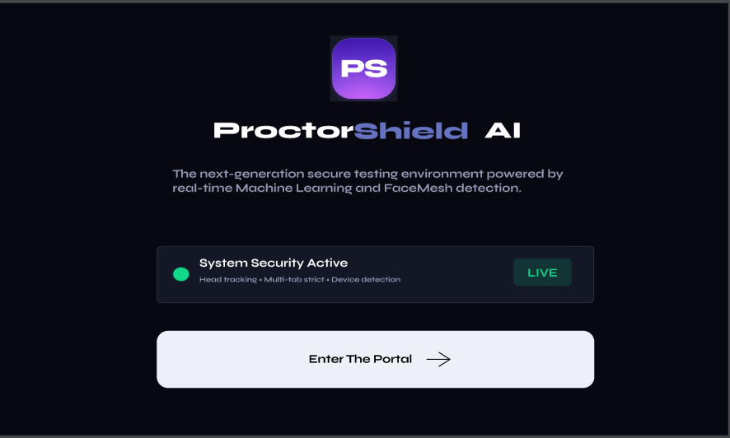
Figure 2: Landing Page
This is the landing page, serving as the primary gateway to ProctorShield AI, featuring role-based entry points and a concise overview of the platform's secure, AI-assisted proctoring capabilities.
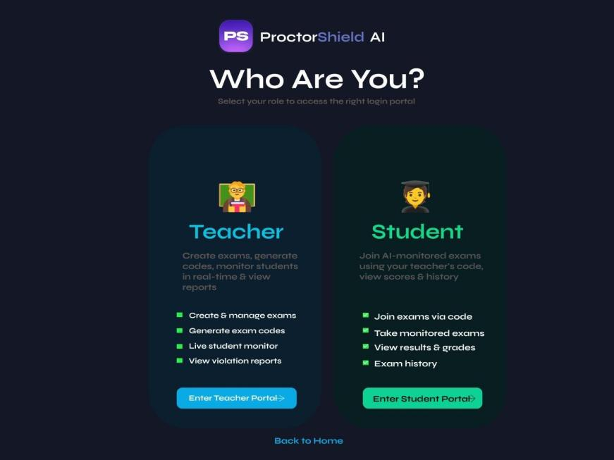
Figure 3: Role-Based Authentication
This is the Role Login interface, which directs Students, Teachers, and Admins to their respective secure sign-in portals, ensuring that access privileges are enforced from the point of entry.
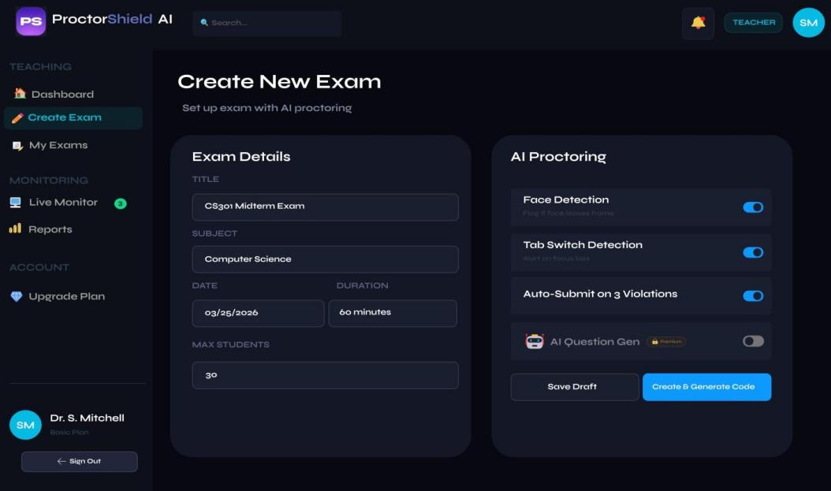
Figure 4: Teacher — Create Exam
This is the Create Exam page, which provides teachers with a structured interface to configure exam parameters and invoke the AI-powered question generator.
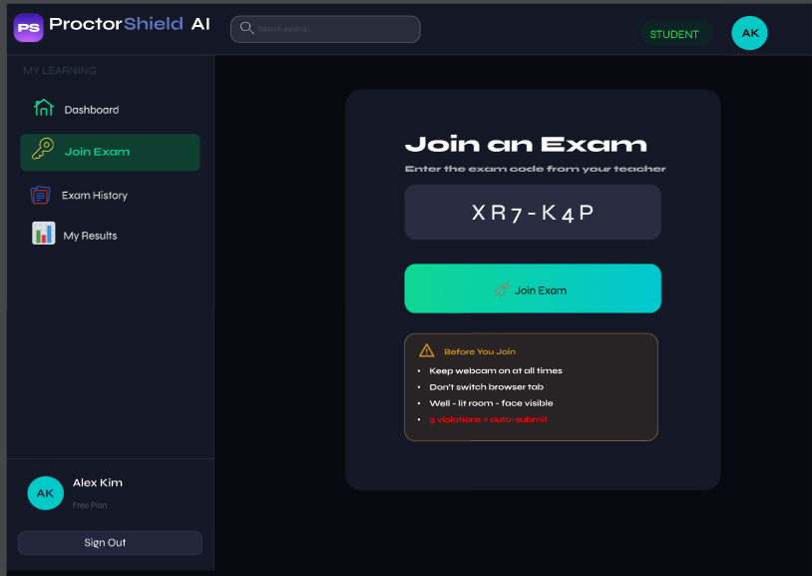
Figure 5: Student — Join Exam
This is the Join Exam page, which allows students to enter a unique access code to enroll in an active examination session.
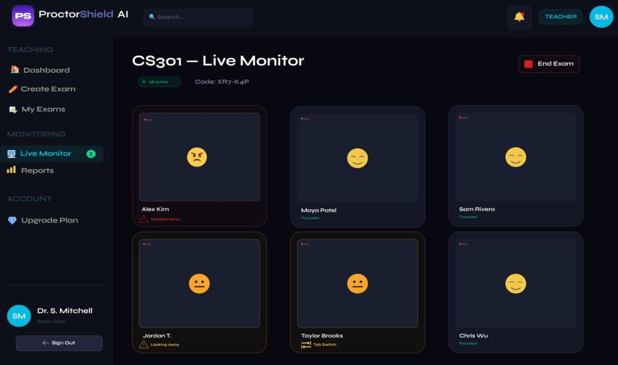
Figure 6: Teacher — Live Monitor
This is the Live Monitor dashboard, which serves as the real-time proctoring hub, displaying student statuses and instantly surfacing AI-detected violations during an active exam.
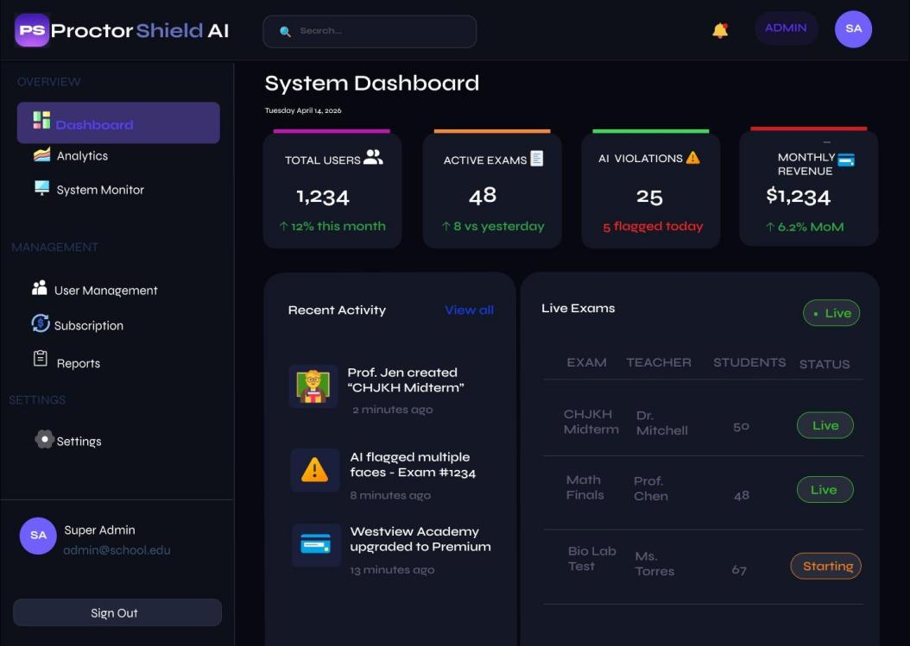
Figure 7: Admin Dashboard
This is the Admin Dashboard, which functions as the centralized management console for platform administrators to monitor system activity, manage user accounts, and review audit logs.
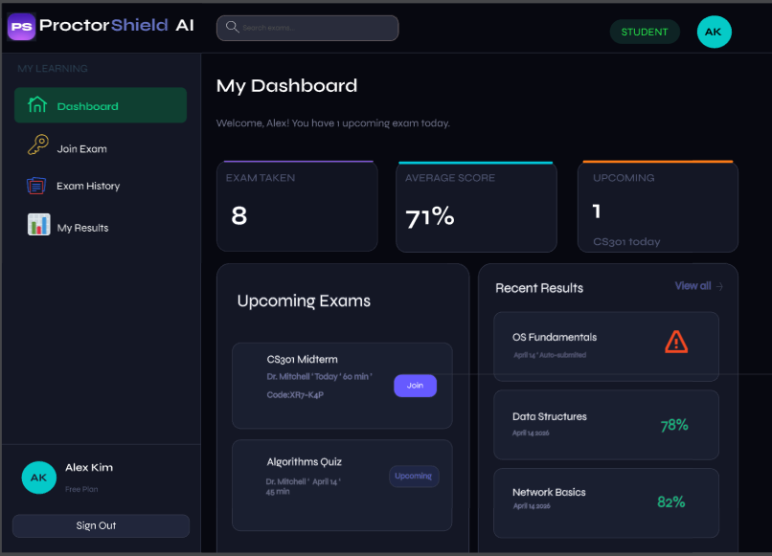
Figure 8: Student Dashboard
This is the Student Dashboard, which acts as a personalized command center for enrolled students, providing quick access to active and upcoming examinations and their submission history.
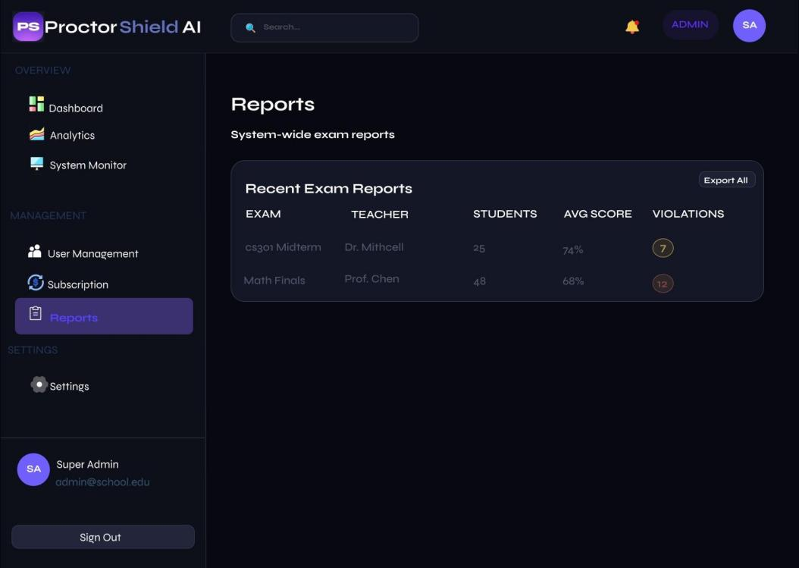
Figure 9: Teacher/Admin Reports
This is the Reports page, which aggregates class-wide integrity statistics and exam performance summaries for teachers and administrators.
Software Interfaces
Web requests route through authenticated Next.js Route Handlers over HTTPS.
Next.js Route Handlers communicate with PostgreSQL using Prisma and the PostgreSQL adapter.
Server-only Route Handlers communicate with Gemini, Pusher, PayMongo, Redis, SMTP, and S3-compatible storage using protected environment variables.
Table 4: API Endpoints (Primary)
Method | Endpoint | Description | Access
POST | /api/auth/login | Authenticate users and establish a session. | Public
POST | /api/quizzes/join | Enroll a student into an active exam using an access code. | Student
GET | /api/quizzes/[id] | Fetch exam details and questions. | Authenticated
PUT | /api/quizzes/[id] | Update exam status (Draft, Active, Ended) or duration. | Teacher
POST | /api/live/violation | Persist a validated proctoring violation and optional incident snapshot; evidence video is uploaded separately. | System/Student
GET | /api/dashboard/teacher/evidence | Fetch teacher-owned violation records and protected video evidence metadata (Pro entitlement). | Teacher
GET | /api/dashboard/teacher/reports | Fetch aggregated class integrity overview statistics. | Teacher
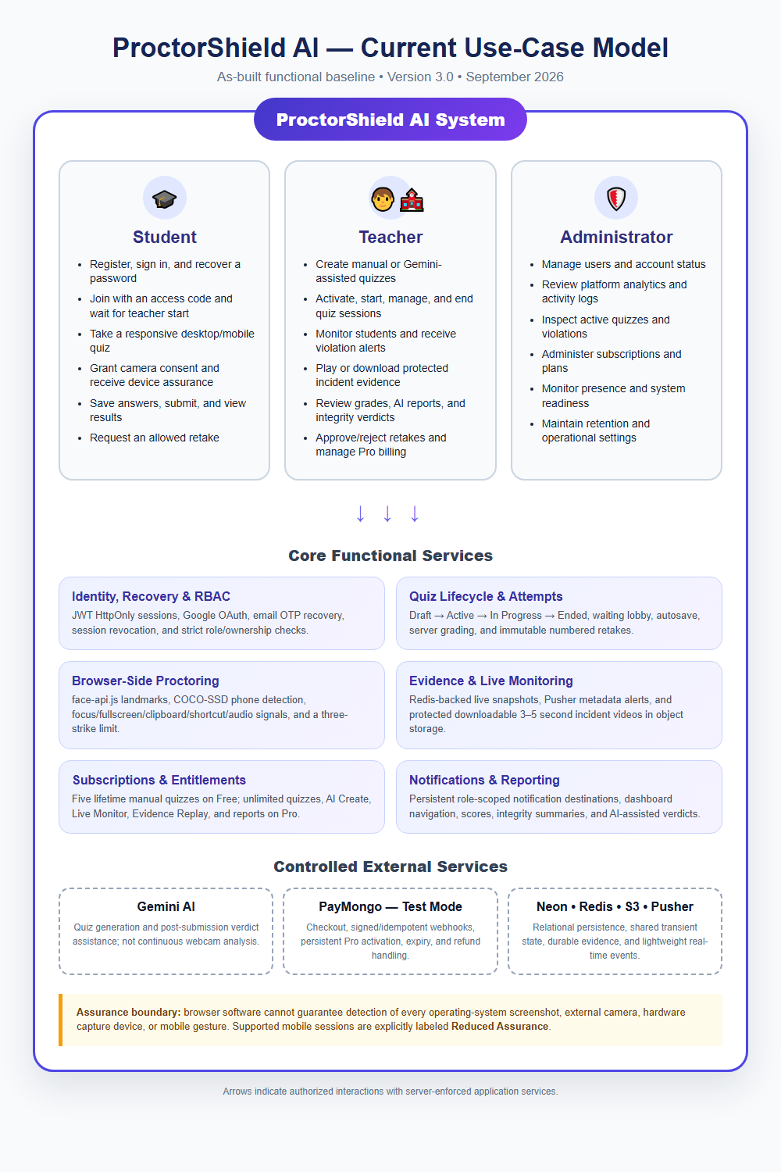
Figure 10: Use Case Diagram — Student, Teacher, and Admin Actors
The diagram above illustrates the primary interactions between the Student, Teacher, and Admin actors and the core system functions, including exam participation, monitoring, and administration.
3.2. Functions
I. Secure Client & Input Lockouts (FR-ROOM)
a. FR-ROOM-001: The system shall restrict right-clicks, text selection, and copy-pasting within the active exam room.
b. FR-ROOM-002: The system shall utilize the Page Visibility API to detect tab switching.
c. FR-ROOM-003: If a student switches tabs, the system shall record an immediate violation.
II. AI Proctoring Engine (FR-PROC)
a. FR-PROC-001: The system shall run face landmark detection and COCO-SSD object detection against the active webcam stream within the browser at controlled intervals.
b. FR-PROC-002: The system shall detect face absence, multiple faces, gaze deviation, and visible phone/device objects locally, and shall combine those detections with browser focus, fullscreen, shortcut, clipboard, and audio signals.
c. FR-PROC-003: The system shall enforce a three-strike rule, automatically submitting the exam once a student accumulates three violations.
III. Teacher Monitoring Dashboard (FR-MON)
a. FR-MON-001: The system shall provide a Live Monitor grid for teachers to view student statuses.
b. FR-MON-002: The system shall update student status cards with real-time WebSocket alerts when a violation occurs.
c. FR-MON-003: The system shall provide authorized Pro teachers with Evidence Replay for protected 3-5 second incident videos, snapshot fallback when recording is unavailable, and explicit download controls.
IV. AI Exam Generation (FR-GEN)
a. FR-GEN-001: The system shall allow teachers to request AI generation of multiple-choice questions.
b. FR-GEN-002: The AI output must be strictly parsed and inserted directly into the Prisma database as linked Question and Choice models.
V. User Authentication (FR-AUTH)
a. FR-AUTH-001: The system shall authenticate users and issue secure session tokens.
b. FR-AUTH-002: The system shall restrict students from accessing teacher API routes and vice versa.
VI. Quiz Lifecycle, Answers, and Retakes (FR-QUIZ)
a. FR-QUIZ-001: The system shall enforce the server-controlled lifecycle draft -> active -> in_progress -> ended; students may enroll only while active and may begin only after the teacher starts the quiz.
b. FR-QUIZ-002: The student shall remain in a real-time waiting lobby until the teacher start event is persisted and received.
c. FR-QUIZ-003: Answers, grading, violation limits, and submission state shall be validated server-side; reconnecting shall restore the latest active attempt and saved answers.
d. FR-QUIZ-004: An approved retake shall create a separately numbered attempt and preserve the original answers, score, violations, verdict, and evidence.
VII. Evidence Management (FR-EVID)
a. FR-EVID-001: For each persisted incident, the capable client shall upload a video clip of approximately 3-5 seconds; the server shall verify type, signature, duration, ownership, size, and active-attempt state.
b. FR-EVID-002: Authorized teachers shall be able to play and download evidence, while deletion and retention cleanup shall remove both database metadata and the corresponding storage object.
VIII. Subscription and Billing (FR-SUB)
a. FR-SUB-001: A Free teacher shall be limited to five lifetime manual quiz creations and shall not access AI Create, Live Monitor, Evidence Replay, or AI Reports.
b. FR-SUB-002: An active Pro teacher shall receive unlimited quiz creation and the gated Pro features; entitlement shall persist across logout/login and expire according to server-side subscription dates.
c. FR-SUB-003: In test mode, PayMongo shall activate or update subscriptions only after a valid, recent, mode-matching, idempotently processed signed webhook.
IX. Account Recovery and Notifications (FR-ACCOUNT)
a. FR-ACCOUNT-001: Student and teacher portals shall provide OTP-based password recovery without revealing whether an email address exists; a successful reset shall revoke older sessions.
b. FR-ACCOUNT-002: Notifications shall persist in the database, update the bell, and navigate only to a role-authorized destination derived by the application rather than a user-supplied URL.
X. Device Assurance (FR-DEVICE)
a. FR-DEVICE-001: The server shall combine browser capability data with the user agent, block clients lacking required camera/security capabilities, and label supported mobile sessions Reduced Assurance.
3.3. Usability Requirements
The usability requirements for ProctorShield AI prioritize an intuitive, distraction-free experience for students under exam pressure and a data-rich yet clear interface for teachers. The system shall achieve high effectiveness by providing an intuitive, modern, and dark-mode compliant UI that feels premium and unobtrusive during timed assessments. To ensure efficiency, the secure exam room layout shall prioritize readability and reduce student distraction, presenting only the elements essential to completing the exam. Regarding satisfaction, the Teacher dashboard must present large amounts of data — including active students, exam configurations, and violation evidence — clearly, using organized cards and data tables rather than dense, unstructured text. These requirements are designed to validate that the platform is not only functional but also inherently usable for students and educators of varying technical proficiency, fostering trust in the fairness of the AI-assisted proctoring process.
3.4. Performance Requirements
I. Static Requirements (Capacity)
a. Exam Capacity: The architecture shall support concurrent classroom sessions through pooled database access and shared Redis state. The maximum certified concurrency shall be established by a formal load test before production acceptance; the document does not claim an unverified fixed capacity.
b. Terminal Access: The system shall be compatible with all modern web browsers (Chrome, Firefox, Safari, Edge) that support the Page Visibility API and standard webcam access.
c. Data Handling: The system shall manage growing user, quiz, attempt, answer, violation, notification, billing, and audit records in PostgreSQL, while evidence metadata is stored relationally and bounded video objects are retained in S3-compatible storage with cleanup and legacy snapshot fallback.
II. Dynamic Requirements
a. PR-001 — Alert Propagation: Pusher WebSocket violation alerts must propagate to the teacher monitor dashboard in under 1.5 seconds.
b. PR-002 — Query Responsiveness: Database queries and API reads must resolve efficiently to maintain a responsive frontend experience for both students and teachers.
c. PR-003 — Graceful AI Degradation: AI processing requests must fail gracefully; if the Gemini API is rate-limited, the exam must continue without interrupting the student.
d. Proctoring Interval: Browser-side detection shall execute at a controlled interval appropriate to device capability. Evidence recording shall capture approximately 3-5 seconds around a persisted incident without continuously uploading the webcam stream.
3.5. Logical Database Requirement
The database uses PostgreSQL, accessed exclusively through the Prisma ORM, with the following core entity tables. The diagram below illustrates the schema architecture, defining the relationships between user accounts, examinations, and violation records.
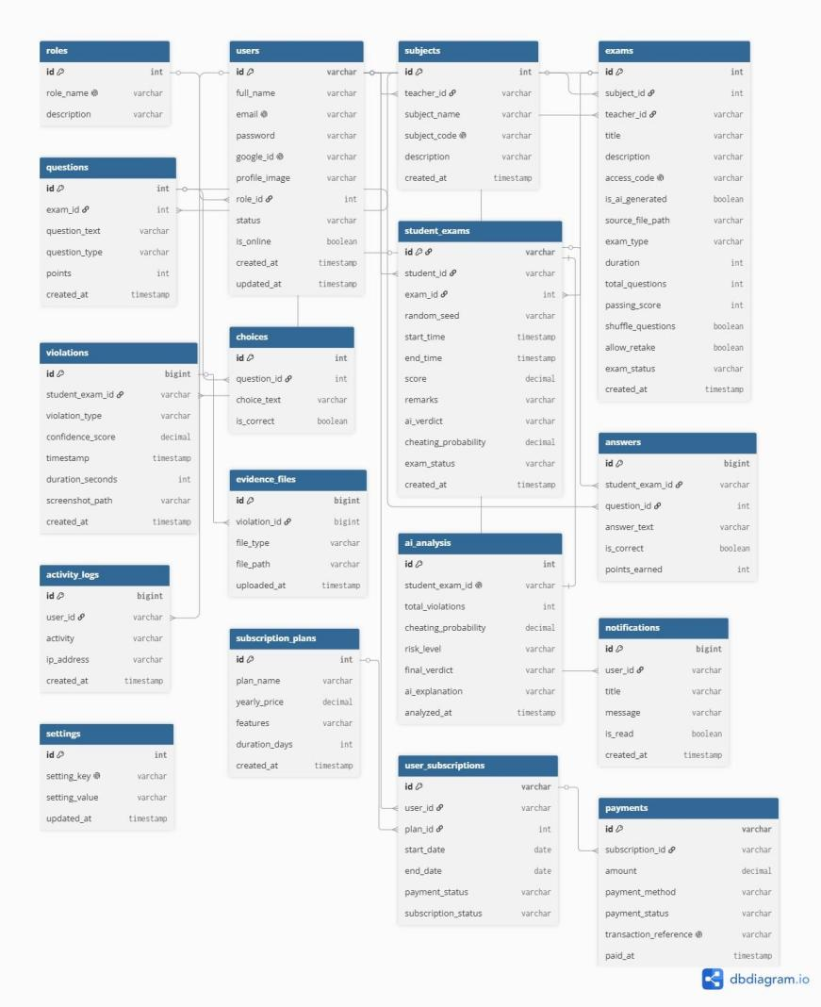
Figure 11: Entity Relationship Diagram
The diagram above illustrates the schema architecture, defining the relationships between user accounts, examination entities, and violation records. All database operations shall adhere to the constraints and primary/foreign key relationships established in this model.
Table 5: Database Schema — Users
Column | Data Type | Constraint | Description
id | String | PK | Unique user identifier
email | String | Unique | User login email
password | String | — | Hashed password
role | String | — | 'student', 'teacher', or 'admin'
Table 6: Database Schema — Exams & StudentExams
Column | Data Type | Constraint | Description
id | Int | PK | Exam ID
teacherId | String | FK | Creator of the exam
accessCode | String | Unique | Short code to join exam
status | String | — | 'draft', 'active', 'in_progress', or 'ended'
Table 7: Database Schema — Violations
Column | Data Type | Constraint | Description
id | BigInt | PK | Violation record ID
studentExamId | String | FK | Links to the student's attempt
violationType | String | — | e.g. 'tab_switch', 'no_face'
screenshotPath | String | — | Legacy snapshot fallback; primary evidence is represented by related EvidenceFile objects in S3-compatible storage.
3.6. Design Constraints
The design and implementation of ProctorShield AI are subject to the following technical constraints, which ensure compatibility, security, and adherence to the approved capstone technology stack.
I. Standards and Regulatory Compliance
a. Technology Stack: Next.js 16 App Router, React 19, Tailwind CSS v4, Node.js, Next.js Route Handlers, Prisma ORM 7 with PostgreSQL, browser-side face-api.js and TensorFlow.js COCO-SSD, Gemini, Pusher, Redis, S3-compatible storage, SMTP, PayMongo test mode, and custom JWT authentication. Substitutions require formal authorization.
b. API Security: Gemini and Pusher API keys must remain completely server-side and must never be exposed to the client.
c. Standardization: All API communications between the frontend dashboard and the backend server shall utilize RESTful principles with JSON formatting for interoperability.
II. Hardware and Environment Limitations
a. Platform Compatibility: The software shall be designed to be browser-agnostic, supporting the latest stable versions of Google Chrome, Mozilla Firefox, Microsoft Edge, and Apple Safari, without reliance on proprietary browser plugins.
b. Server Infrastructure: Deployment shall provide a long-running or otherwise state-safe Node.js environment, HTTPS, managed PostgreSQL, shared Redis, and durable S3-compatible object storage. Production must not depend on process-local memory for shared state.
c. Real-Time Limits: Pusher shall carry lightweight events only. Live snapshot bytes shall be retrieved through authenticated polling from shared Redis-backed state, and evidence objects shall be streamed through authorized server endpoints.
III. Documentation Constraints
a. Format Compliance: All project documentation, including this SRS, shall conform to the IEEE Std 830-1998 format as prescribed by the Cordova Public College CCS capstone documentation guidelines.
3.7. Software System Attributes
This section outlines the non-functional quality attributes required to ensure ProctorShield AI is reliable, secure, easy to maintain, and portable across standard browser environments.
I. Reliability
a. Fault Tolerance: Active quiz proctoring shall continue if Gemini is unavailable because visual detection is browser-side; grading shall use a deterministic integrity-verdict fallback when AI verdict generation fails.
b. Data Integrity: The system shall use Prisma's parameterized queries for all database operations to prevent malformed data or injection-based corruption.
c. Violation Logging: Valid client-detected violations shall be serialized per attempt, capped at three, and persisted immediately. Evidence upload failures shall not fabricate or duplicate violations.
II. Availability
a. Uptime: The deployed application shall expose readiness monitoring for PostgreSQL, Redis, and evidence storage; use a stable HTTPS host; and avoid process-local shared state so restarts or multiple instances do not silently lose monitoring data.
b. Scheduled Maintenance: System updates and maintenance routines shall be scheduled outside of designated examination windows to avoid disrupting active exam sessions.
III. Security
a. Session Management: The system shall issue signed JWT sessions in HttpOnly, Secure production cookies; compare a server-held session version on each request; revoke older sessions after password reset/change; and refresh bounded presence timestamps.
b. Data Access Control: All database queries shall use Prisma's parameter binding to prevent SQL injection, combined with strict role-based checks at the API layer.
c. Role-Based Access Control (RBAC): Functional capabilities shall be strictly isolated by user role; students are entirely restricted from accessing teacher or admin API routes, and vice versa.
IV. Maintainability
a. Modular Architecture: The system shall use feature-focused React components, shared server libraries, and Next.js Route Handlers within one TypeScript application, with Prisma, cache, storage, AI, email, payment, and real-time integrations isolated behind dedicated modules.
b. Standardized Documentation: The Prisma schema and all API endpoints must be documented using standardized conventions to ensure that future developers can quickly understand and modify the codebase.
V. Portability
a. Cross-Browser and OS Portability: The user-facing interfaces shall rely exclusively on compliant HTML5, CSS3, and JavaScript delivered through Next.js, ensuring identical presentation and performance across Windows, macOS, iOS, and Android without requiring environment-specific compilation or installation.

