Screenshot of the program functioning as expected.

Program called “ConsoleRegisterStudent” initializes by invoking the run method using the command (new Program()).run();.

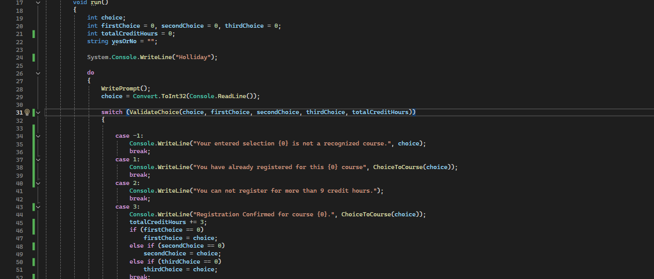

The run method starts by initializing the variables and running the WritePrompt function. From there it is ready to take in user input from the ReadLine() command. The input is converted to an integer and stored in the choice variable. The switch part of the program in the do while command runs the input choice, firstChoice, secondChoice, thirdChoice, and totalCreditHours variables through ValidateChoice. Based on what returns from that part is what the program will output to the screen. If -1 is returned, it tells the user that it is an invalid option. If 1 is returned, it tells the user that is already a selected course. A return of 2 will output that they have already met the 9 credit hour limit. If all of that passes, the program then checks which choice (first, second, or third) the choice is being assigned to while also outputting confirmation for the registration.

After the switch passes or fails, it outputs the currently registered courses (if any) and asks the user if they want to continue, only continuing if a y or Y are received. If anything else is input at this part, the program exits and says, “Thank you for registering with us.” The second half of the picture is the WritePrompt, which outputs all available courses.

This is the part of the program that validates the input int received from the user. -1 being an invalid choice (not between or including 1-7), 1 being returned if the choice has already been selected, 2 being returned if the user has already reached or exceeded their credit hours, and 3 returning for valid choices.

This is the part called in the do while loop that prints out courses that have been registered for, as long as a choice has been selected.

This is the part that takes the user’s input of a number and turns it into a string to return the chosen course through multiple different calls.

**Source Code**

using System;

using System.Collections.Generic;

using System.Linq;

using System.Text;

using System.Threading.Tasks;

namespace ConsoleRegisterStudent

{

class Program

{

static void Main(string[] args)

{

(new Program()).run();

}

void run()

{

int choice;

int firstChoice = 0, secondChoice = 0, thirdChoice = 0;

int totalCreditHours = 0;

string yesOrNo = "";

System.Console.WriteLine("Holliday");

do

{

WritePrompt();

choice = Convert.ToInt32(Console.ReadLine());

switch (ValidateChoice(choice, firstChoice, secondChoice, thirdChoice, totalCreditHours))

{

case -1:

Console.WriteLine("Your entered selection {0} is not a recognized course.", choice);

break;

case 1:

Console.WriteLine("You have already registered for this {0} course", ChoiceToCourse(choice));

break;

case 2:

Console.WriteLine("You can not register for more than 9 credit hours.");

break;

case 3:

Console.WriteLine("Registration Confirmed for course {0}.", ChoiceToCourse(choice));

totalCreditHours += 3;

if (firstChoice == 0)

firstChoice = choice;

else if (secondChoice == 0)

secondChoice = choice;

else if (thirdChoice == 0)

thirdChoice = choice;

break;

}

WriteCurrentRegistration(firstChoice, secondChoice, thirdChoice);

Console.Write("\nDo you want to try again? (Y|N)? : ");

yesOrNo = (Console.ReadLine()).ToUpper();

} while (yesOrNo == "Y");

Console.WriteLine("Thank you for registering with us");

}

void WritePrompt()

{

Console.WriteLine("Please select a course for which you want to register by typing the number inside []");

Console.WriteLine("[1]IT 145\n[2]IT 200\n[3]IT 201\n[4]IT 270\n[5]IT 315\n[6]IT 328\n[7]IT 330");

Console.Write("Enter your choice : ");

}

int ValidateChoice(int choice, int firstChoice, int secondChoice, int thirdChoice, int totalCredit)

{

if (choice < 1 || choice > 7)

{

return -1;

}

else if (choice == firstChoice || choice == secondChoice || choice == thirdChoice)

{

return 1;

}

else if (totalCredit >= 9)

{

return 2;

}

else

{

return 3;

}

}

void WriteCurrentRegistration(int firstChoice, int secondChoice, int thirdChoice)

{

if (firstChoice != 0 && secondChoice == 0 && thirdChoice == 0)

Console.WriteLine("You are currently registered for {0}", ChoiceToCourse(firstChoice));

else if (firstChoice != 0 && secondChoice != 0 && thirdChoice == 0)

Console.WriteLine("You are currently registered for {0}, {1}", ChoiceToCourse(firstChoice), ChoiceToCourse(secondChoice));

else if (firstChoice != 0 && secondChoice != 0 && thirdChoice != 0)

Console.WriteLine("You are currently registered for {0}, {1}, {2}", ChoiceToCourse(firstChoice), ChoiceToCourse(secondChoice), ChoiceToCourse(thirdChoice));

}

string ChoiceToCourse(int choice)

{

string course = "";

switch (choice)

{

case 1:

course = "IT 145";

break;

case 2:

course = "IT 200";

break;

case 3:

course = "IT 201";

break;

case 4:

course = "IT 270";

break;

case 5:

course = "IT 315";

break;

case 6:

course = "IT 328";

break;

case 7:

course = "IT 330";

break;

default:

break;

}

return course;

}

}

}