eBOSS Sabangan User Manual
Simple guide for daily use
Updated: March 22, 2026
What this system is
- eBOSS Sabangan is one system for business applications, mayor's clearance work, treasury records, and LGU status updates.
- It helps office users check files, save records, print forms, and keep work in one place.

Who uses this system
- Staff users
- Treasury users
- Admin users

Before you start
- Use a stable internet connection.
- Use your office email and password.
- Keep your browser up to date.
- If you cannot sign in, ask your admin to check your account.

Quick meaning of status
- Pending: The record still needs review.
- Approved: The record is done or accepted.
- Rejected: The record has a problem and needs changes.

Sign in

Staff sign in
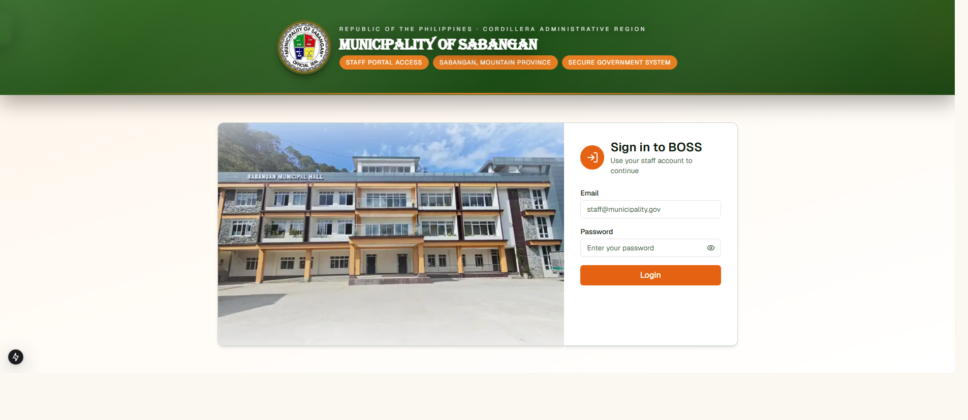
BOSS Staff Sign In
- Open the main eBOSS link.
- Type your email.
- Type your password.
- Click Sign in to BOSS.
- Wait for the Home page.

Treasury sign in
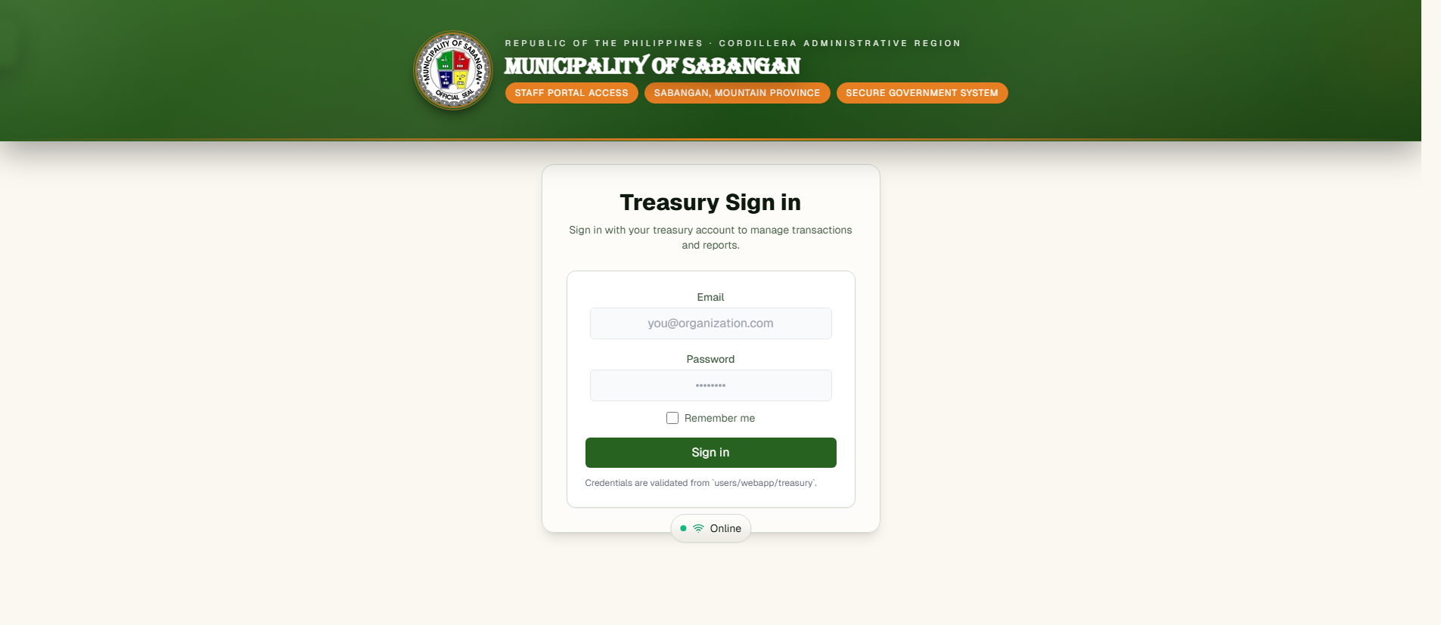
Treasury Sign In
- Open the Treasury link.
- Type your email.
- Type your password.
- Click Sign in.
- Wait for the Treasury Dashboard.

Admin sign in
- Open the Admin link.
- Type your email.
- Type your password.
- Click Login.
- Wait for the admin page to load.

Staff portal

Home page
- Home is your starting page after sign in.
- It shows the main menu.
- It also shows Recent Notifications.
- Use Messages to read or send messages for an application.

Business Application list
- Click Business Application.
- Use the search box to find a client.
- Use All, Approved, or Pending to narrow the list.
- Use Application Date if you need to check by date.
- Click a row to open the full record.

Check business files
- Open a business application.
- In the Requirements table, click View beside a file.
- Check the file in the preview window.
- Click Approve if the file is correct.
- Click Reject if the file is wrong, missing, or unclear.
- Type the reason for rejection.
- Click Confirm Rejection.

Preview and print the business form
- Open a business application.
- Click Preview Application Form.
- Check the form.
- Click Print if you need a copy.
- Click Close when you are done.

Mayor's Clearance Application
- Click Mayor's Clearance Application.
- Use the search box to find the applicant or purpose.
- Use All, Approved, Pending, or Rejected to narrow the list.
- Use Application Date if you need to check by date.
- Open the record you want.
- Review the clearance file.
- Click Approve or Reject.
- If you reject it, type the reason and confirm.

Mayor's Clearance records
- Click Mayor's Clearance.
- Use the search box to find a name, address, or number.
- Choose Monthly or Yearly.
- Review the list.
- Click Download Clearance File if you need a file copy.

LGU Status
- Click LGU Status.
- In Live Status Board, update the office status if needed.
- In Mayor Availability, click Update status after you change the mayor's status.
- In Featured Event Broadcast, edit the event details and click Save featured event.
- In Upcoming Events, add a new event or update an old one.
- Save your changes and check the board.

Messages
- Open the Messages panel from the Home page.
- Choose an application.
- Type your message.
- Send the message.
- Mark messages as read when needed.

Treasury portal

Treasury Dashboard
- Treasury Dashboard is the first page after sign in.
- It has a shortcut button called Open Clients.

Find a client
- Click Open Clients, or open the Clients page from the menu.
- Use the search box to find the client.
- Click the row you need.
- The Assessment Preview window will open.

Save assessment details
- In Assessment Preview, check the fee list.
- Click Edit if you need to change the details.
- Type the amounts and penalties if needed.
- Type the Cedula Number.
- Type the Official Receipt Number.
- Click Save.
- If Save stays disabled, make sure both numbers are filled in.

Admin portal

Create a staff or treasury user
- Sign in to the Admin page.
- Choose Staff or Treasury.
- Fill in first name, last name, email, and password.
- Add middle name if needed.
- Set the status if needed.
- Use Mark email as verified when needed.
- Click Create Staff user or Create Treasury user.

Edit a user
- Find the user in the table.
- Click the edit button on that row.
- Change the needed details.
- Click the save button.
- If you do not want to keep the change, cancel the edit.

Delete users
- Select the users you want to remove.
- Click Delete selected.
- Confirm the action.
- Be careful. The user may lose access right away.

Delete applications
- Go to the Applications table.
- Select the application records you want to remove.
- Click Delete selected.
- Confirm the action.
- Use this only when you are sure.

Log out
- Click Logout when you are done.
- Always log out before you leave a shared computer.

Common problems and easy fixes
- Wrong email or password: Check your typing and try again.
- Cannot sign in: Ask the admin to check if your account is active and verified.
- No record on the screen: Clear the search text, check the filter, and refresh the page.
- Cannot save in Treasury: Fill in both Cedula Number and Official Receipt Number.
- A file was rejected: Open the record, read the reason, then ask for the needed fix.
- Print or preview is slow: Wait a moment, then try again.
- Page is not loading well: Refresh the browser and check your internet connection.

Daily reminder
- Check records carefully before you approve.
- Type clear rejection reasons.
- Save your work before you leave the page.
- Log out after use.

