No. 236

MAYOR’S CLEARANCE

TO WHOM IT MAY CONCERN:

This is to CERTIFY that Manilyn Tammocho Cunod, a bona fide resident of Losad, Sabangan, Mountain Province with Community Tax Certificate No. 6172248 issued on January 20, 2026 at Sabangan, Mountain Province, has neither pending obligations nor derogatory record filed before this office as of date.

This clearance is issued upon the request of the above-mentioned person for the purpose of Securing Business Permit and for all legal purposes it may serve.

Issued this 23rd day of February 2026 at Poblacion, Sabangan, Mountain Province.

MARCIAL JR. C. LAWILAO
Municipal Mayor

Note:
O.R. No.: 6604137
Date:1/20/2026
D.S.T. Paid
Not valid without seal.
Valid for 6 months from date of issue

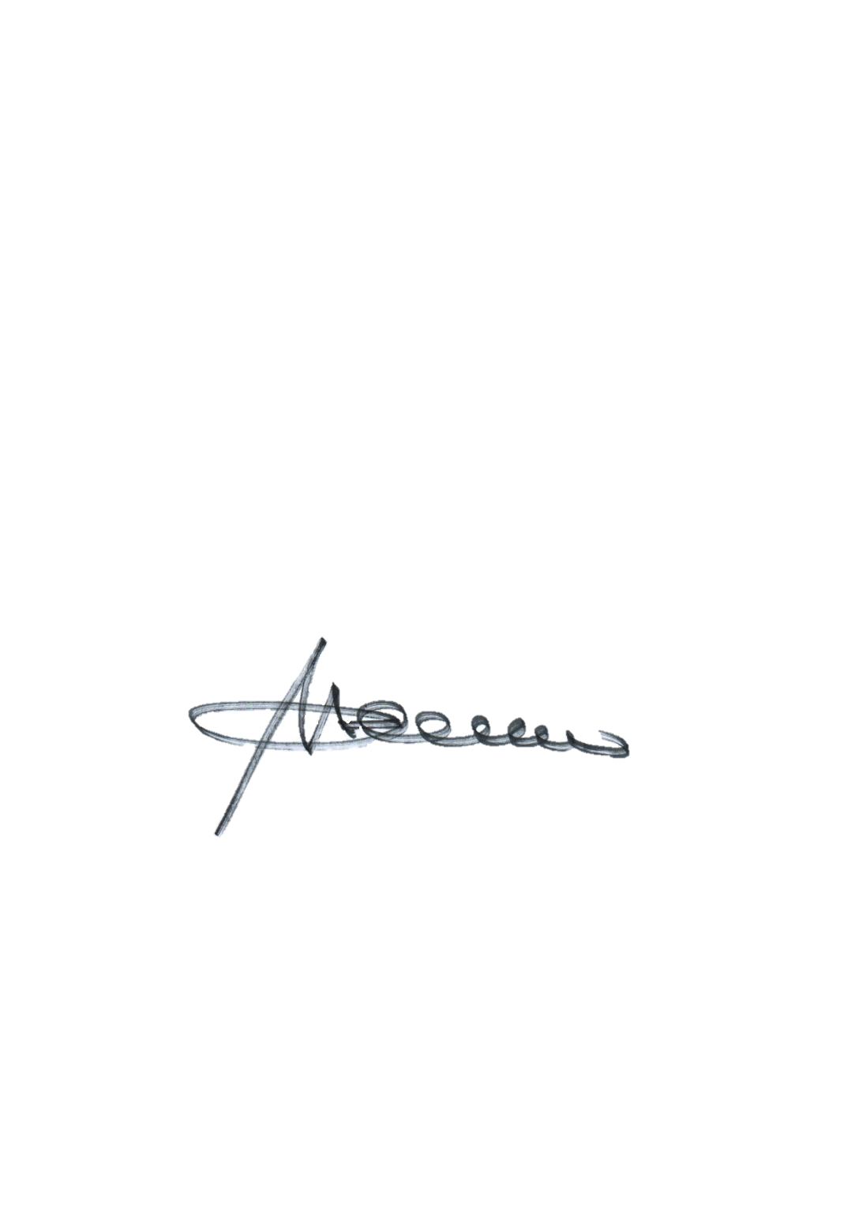
No. 00236

MAYOR’S CLEARANCE

TO WHOM IT MAY CONCERN:

This is to CERTIFY that Manilyn with a registered business address at Tambingan, Sabangan, Mountain Province and represented by JAIME T. TRINIDAD, with Community Tax Certificate No. 6172248 issued on January 6, 2026 at Sabangan, Mountain Province has neither pending obligations nor derogatory record filed before this office as of date.

This clearance is issued upon the request of the above-mentioned person for Securing Business Permit and all legal purposes it may serve.

Issued this 12th day of January 2026 at Poblacion, Sabangan, Mountain Province.

MARCIAL JR. C. LAWILAO
Municipal Mayor

Note:
O.R. No.: 6604137
Date: January 12, 2026
D.S.T. Paid
Not valid without seal.
Valid for 6 months from date of issue

