CprE 3810: Computer Organization and Assembly-Level Programming

Project Part 1 Report

Team Members: _Christian Lapnow & Jacob Dang_________________________

_________________

______________________________________________

Project Teams Group #:___A_08______________________

Refer to the highlighted language in the project 1 instruction for the context of the following questions.

[Part 2 (d)] Include your final RISC-V processor schematic in your lab report.
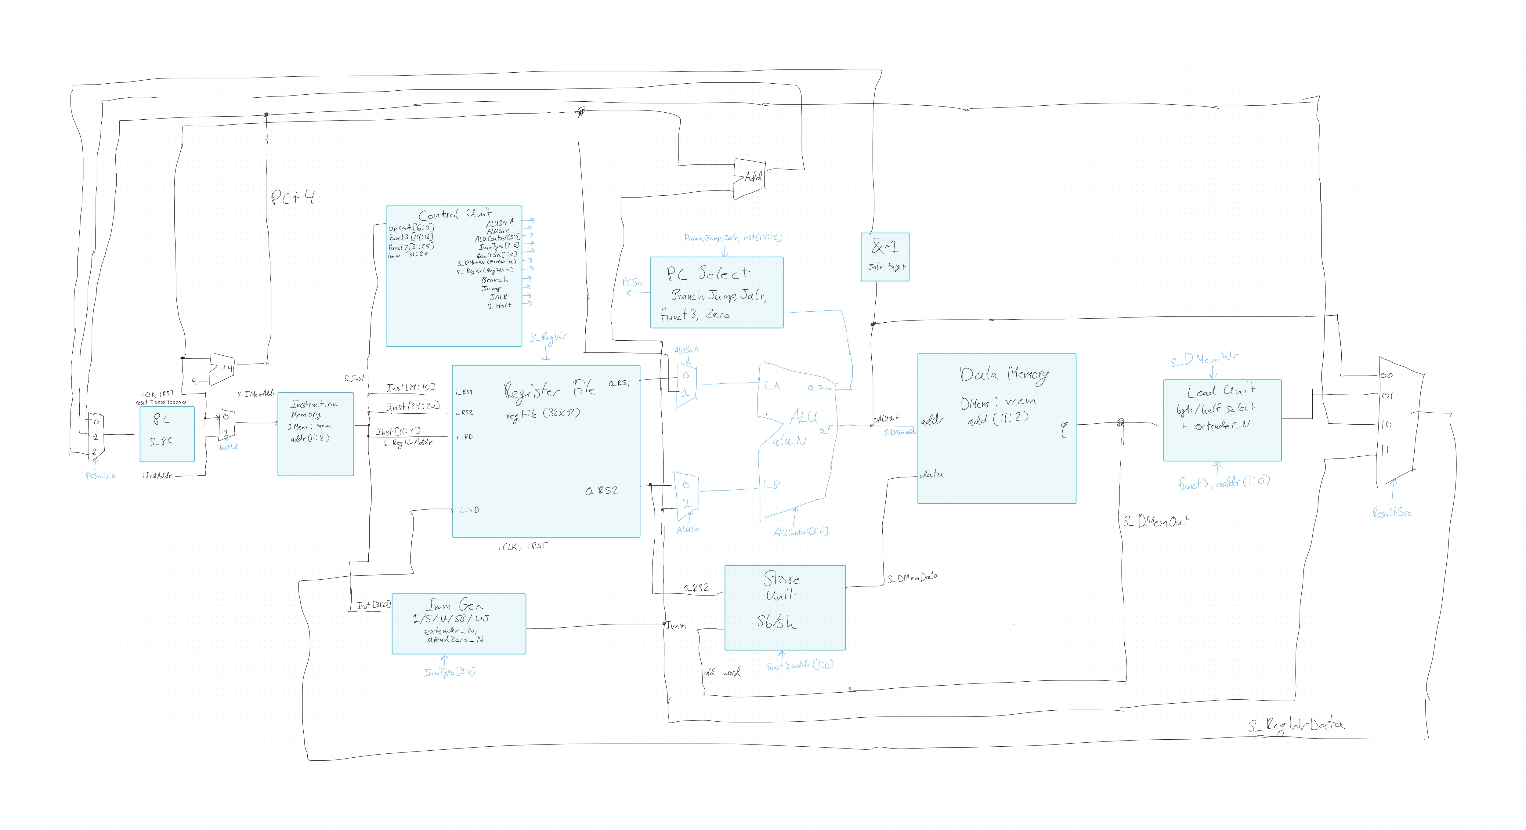
[Part 3.1.a.] Create a spreadsheet detailing the list of M instructions to be supported in your project alongside their binary opcodes and funct fields, if applicable. Create a separate column for each binary bit. Inside this spreadsheet, create a new column for the N control signals needed by your datapath implementation. The end result should be an N*M table where each row corresponds to the output of the control logic module for a given instruction.
Our spreadsheet (Proj1_control_signals.xlsx, included in the submission) has three tabs:
- Control Table: one row per instruction with its opcode, funct3, and funct7/immediate fields, the 11 control signal values, and a short description of what the instruction does. It covers all 37 required instructions, plus sltu (not required, but implemented) and an extra addi row with inst[30] = 1 to show it must stay ADD.
- Per-bit Table: the N*M table the assignment asks for. Each opcode, funct3, and funct7[5] bit has its own column, and every multi-bit signal is split into one column per bit (ALUControl[3:0], ImmType[2:0], ResultSrc[1:0]), for 28 columns per row.
- Signal Key: the width and encoding of each control signal, summarized below.
A "-" marks a don't care. The control unit drives 0 there and the testbench skips that field. funct3 is not a control unit output; it goes straight from the instruction to the fetch unit (branch type) and the load unit (size and sign).
Signal | Width | Meaning
ALUSrcA | 1 | 0 = rs1, 1 = PC (auipc)
ALUSrc | 1 | 0 = rs2, 1 = immediate
ALUControl | 4 | 0000 ADD, 0001 SUB, 0010 AND, 0011 OR, 0100 XOR, 0101 SLT, 0110 SLTU, 0111 SLL, 1000 SRL, 1001 SRA
ImmType | 3 | 000 I, 001 S, 010 B, 011 U, 100 J
ResultSrc | 2 | 00 ALU, 01 load unit, 10 PC+4 (jal/jalr), 11 imm (lui)
MemWrite (s_DMemWr) | 1 | Write data memory (sw)
RegWrite (s_RegWr) | 1 | Write register file
Branch | 1 | Conditional branch instruction
Jump | 1 | jal
JALR | 1 | jalr (next PC comes from the ALU)
Halt (s_Halt) | 1 | wfi: opcode 1110011, funct3 000, imm 0x105
a
[Part 3.1.(b)] Implement the control logic module using whatever method and coding style you prefer. Create a testbench to test this module individually and show that your output matches the expected control signals from problem 1(a).
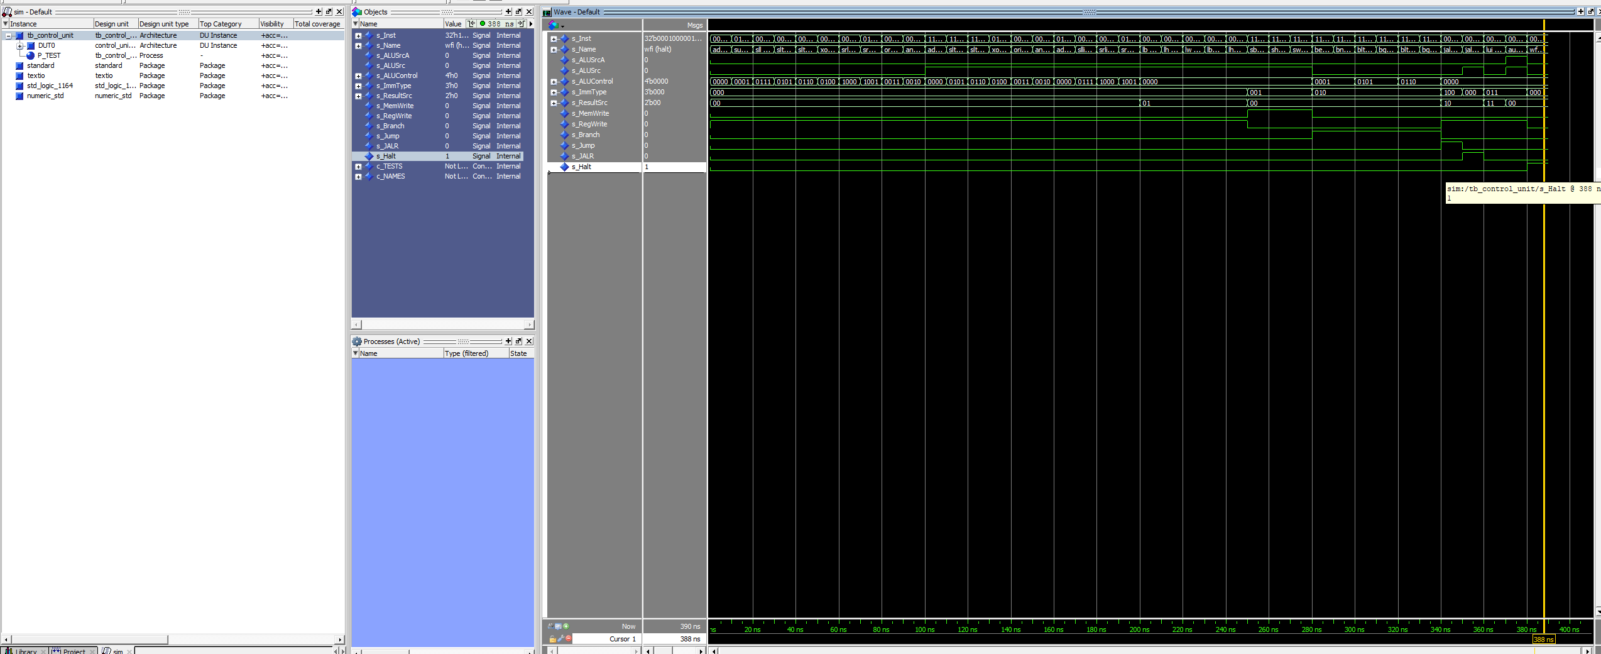
[Part 3.2. (a)] What are the control flow possibilities that your instruction fetch logic must support? Describe these possibilities as a function of the different control flow-related instructions you are required to implement.
The next PC is one of three values:
- PC + 4: every non-control-flow instruction, and any conditional branch whose condition is false.
- PC + imm: a taken branch (beq, bne, blt, bge, bltu, bgeu, using the B-type immediate) or jal (J-type immediate). Branches take this path only when their condition is true; jal always takes it.
- (rs1 + imm) with bit 0 cleared: jalr. The ALU already computes rs1 + imm, so fetch takes the ALU output and forces bit 0 to 0.
jal and jalr also write PC + 4 into rd (ResultSrc = 10). wfi ends the simulation through s_Halt rather than changing the PC.

[Part 3.2. (b)] Draw a schematic for the instruction fetch logic and any other datapath modifications needed for control flow instructions. What additional control signals are needed?
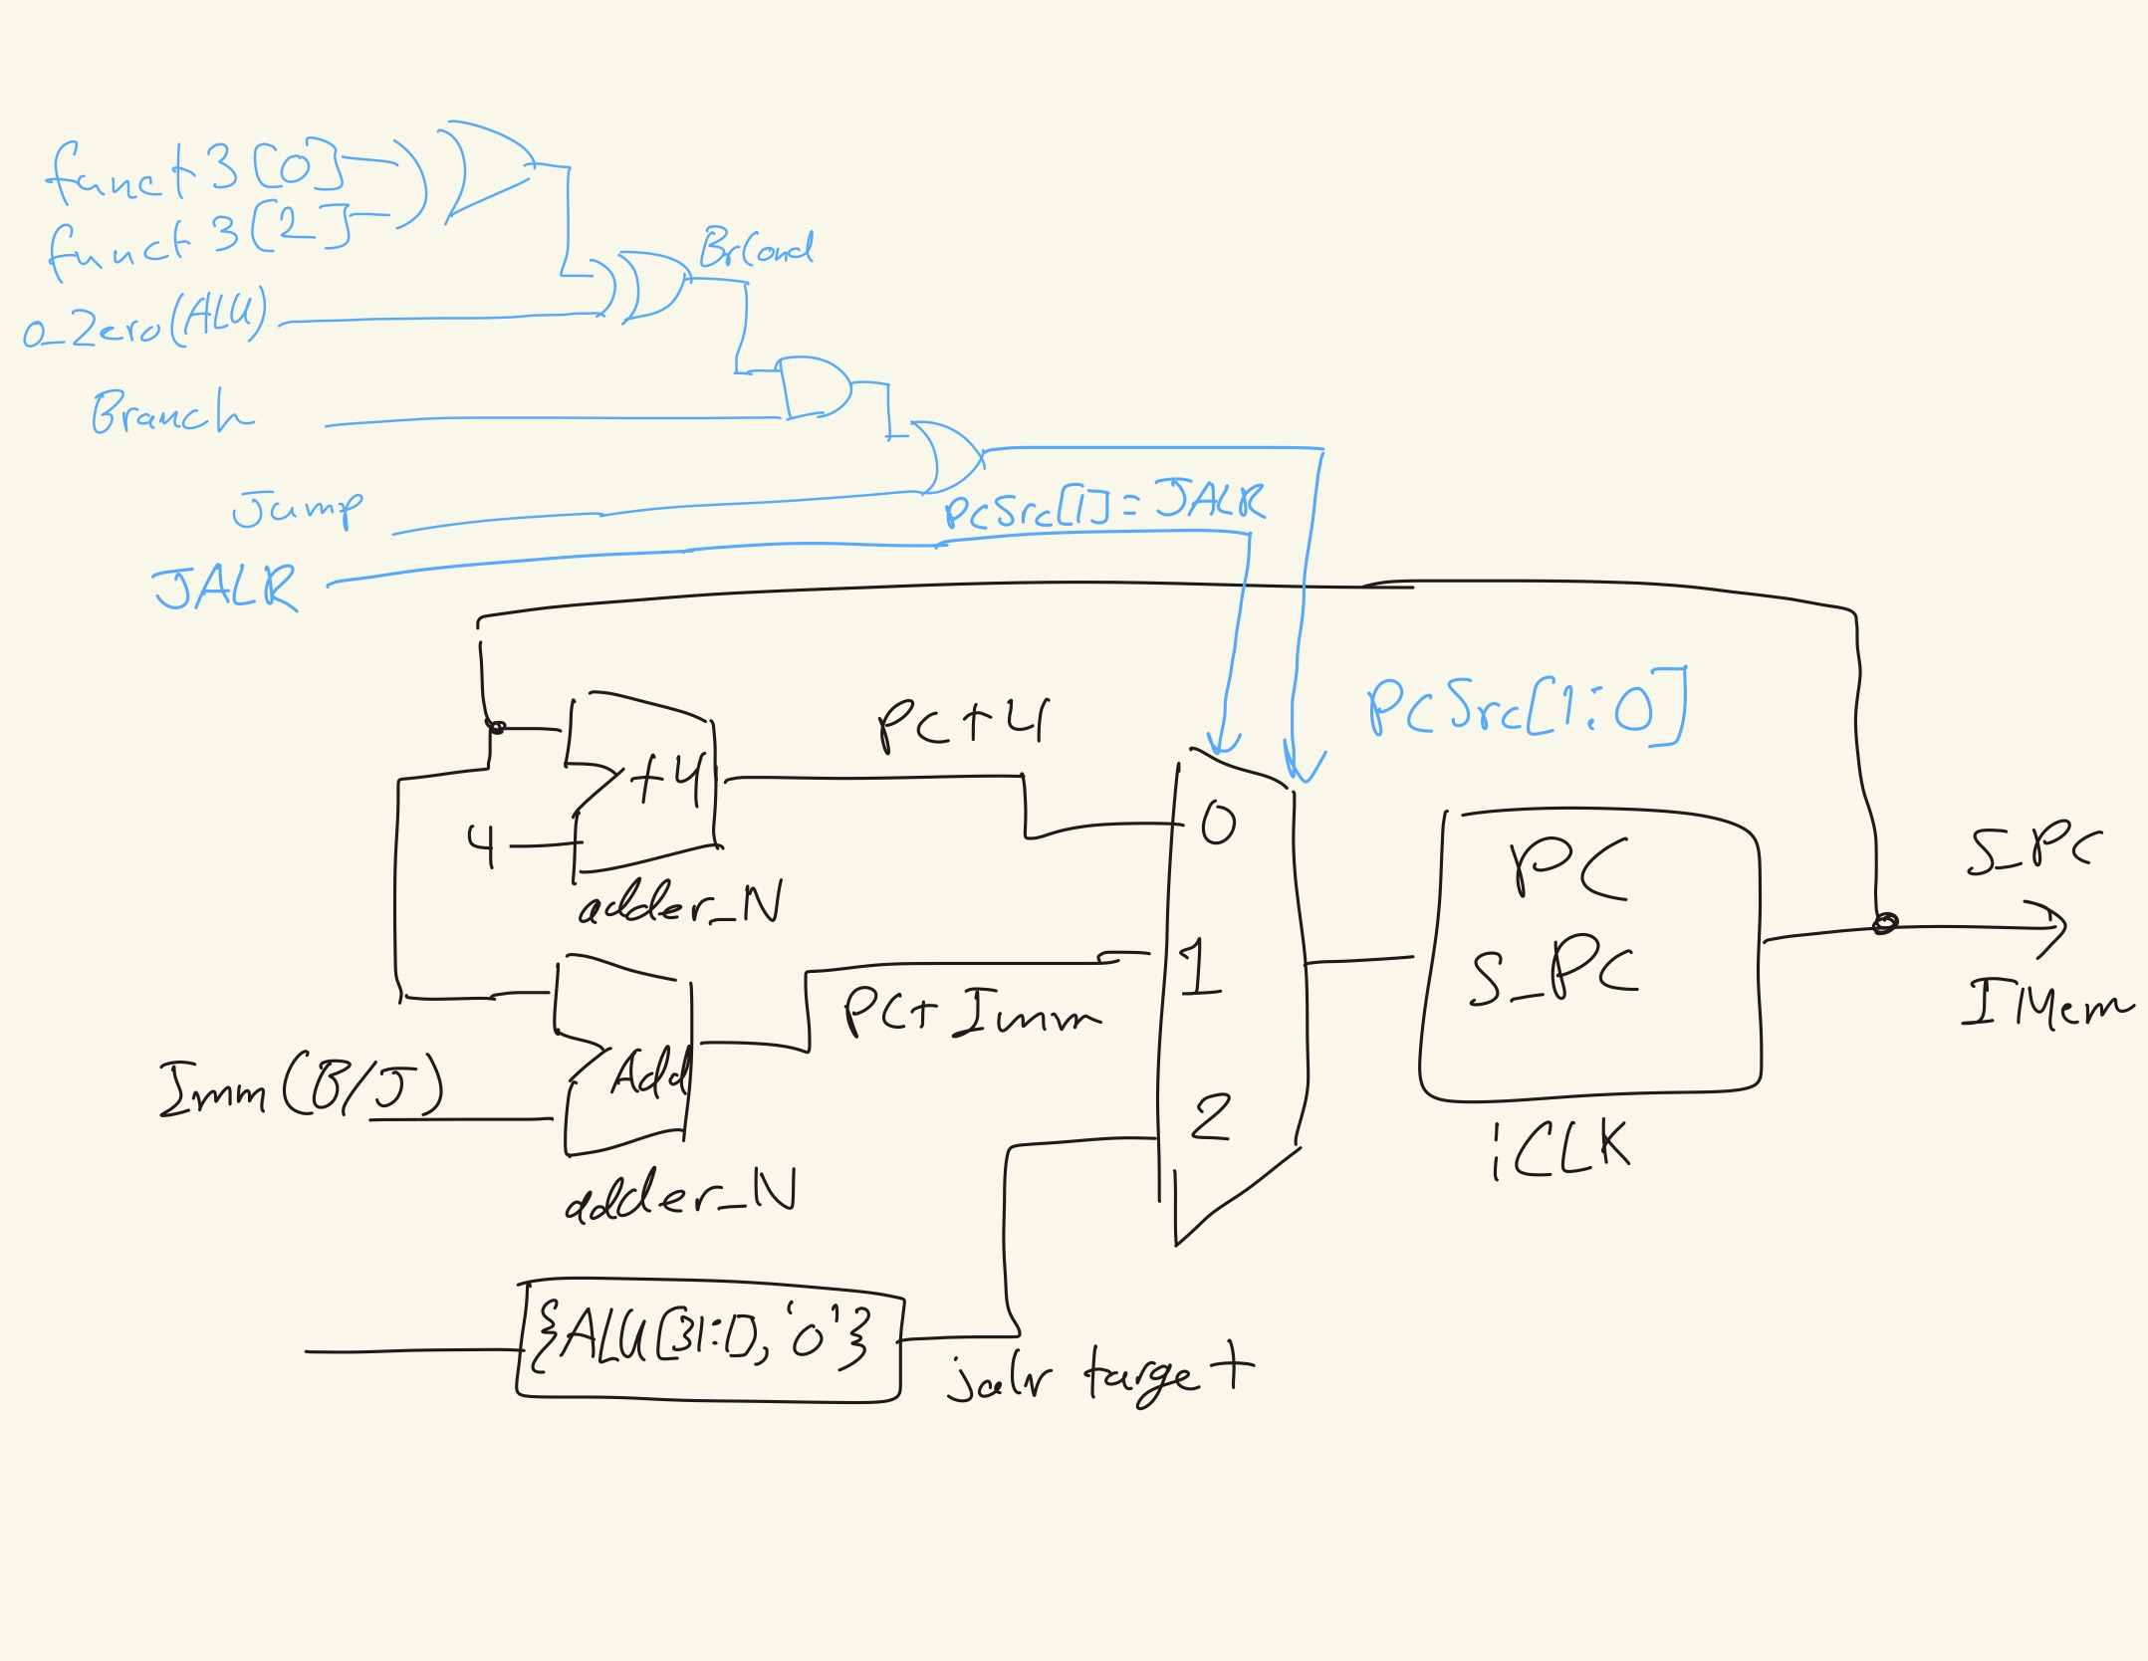
The figure shows our fetch logic. The PC register (s_PC) feeds IMem and two adder_N instances, one computing PC + 4 and one computing PC + imm (B-type for branches, J-type for jal). A 3:1 mux selected by PCSrc[1:0] chooses the next PC: 0 = PC + 4, 1 = PC + imm, 2 = the jalr target {ALU[31:1], ‘0’}. In VHDL this mux is two cascaded mux2t1_N, the first on PCSrc[0] and the second on PCSrc[1]. PCSrc = 11 never occurs because jalr sets Jump = 0. The PC register loads the mux output on iCLK and resets to 0x00400000 on iRST.
[Part 3.2.(c)] Implement your new instruction fetch logic using VHDL. Use QuestaSim to test your design thoroughly to make sure it is working as expected. Describe how the execution of the control flow possibilities corresponds to the QuestaSim waveforms in your writeup.
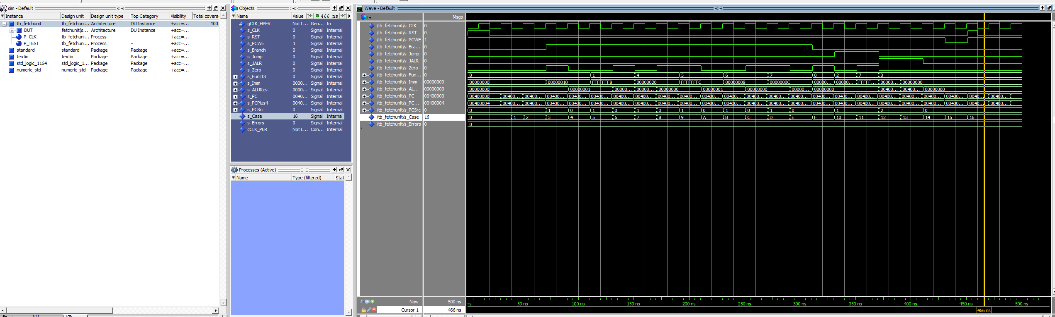

tb_fetchUnit.vhd runs 19 cycles that cover every control flow case the fetch logic must handle: reset, sequential execution, all six branch types both taken and not taken (with positive and negative offsets), jal forward and backward, jalr to an odd target, and an asynchronous reset mid-run. The testbench compares the PC each cycle against the expected value and reported 0 errors.
The waveform shows each case:
- Sequential: Branch, Jump, and JALR are all 0, so PCSrc = 00 and the PC advances by 4 each cycle.
- beq taken: Branch = 1 and Zero = 1 with funct3 = 000, so BrCond = 1 and PCSrc = 01. The PC jumps from 0x00400008 to 0x00400018 (+16).
- Branch not taken: Branch = 1 but BrCond = 0, so PCSrc stays 00 and the PC only advances by 4.
- blt/bge/bltu/bgeu: the ALU result is from slt/sltu, so Zero = 0 means “less than.” The funct3 bits flip the condition, and the PC takes or skips the branch the same way as beq/bne.
- jal backward: Jump = 1 forces PCSrc = 01 regardless of Zero, and the PC moves back by 320.
- jalr: JALR = 1 gives PCSrc = 10, selecting the jalr target. ALU result 0x00400101 becomes PC 0x00400100 because bit 0 is cleared.
- Reset: asserting iRST mid-run sends the PC back to 0x00400000 immediately, without waiting for a clock edge.

[Part 3.3.1.(a)] Describe the difference between logical (srl) and arithmetic (sra) shifts. Why does RISC-V not have a sla instruction?
srl fills the vacated upper bits with 0. sra fills them with copies of the sign bit (bit 31), so a negative number stays negative and the shift behaves like signed division by 2^n (rounding toward negative infinity). There is no sla because a left shift always fills the low bits with 0 whether the value is signed or not, so an "arithmetic" left shift would produce exactly the same bits as sll.

[Part 3.3.1.(b)] In your writeup, briefly describe how your VHDL code implements both the arithmetic and logical shifting operations.
The shifter has 5 stages, each a row of 32 2:1 muxes (mux2t1_N). Stage k shifts right by 2^k when shamt[k] = 1 and passes the value through otherwise, so any shift amount from 0 to 31 is a sum of stages (1, 2, 4, 8, 16). The bits shifted in at the top of each stage get a fill bit, fill = Arith AND A[31]: 0 for srl and the sign bit for sra. The stages are written with a generate loop over k, which is the repeating mux pattern the barrel shifter is built from. No shift_right or other one-line library functions are used.

[Part 3.3.1.(c)] In your writeup, explain how the right barrel shifter above can be enhanced to also support left shifting operations.
A left shift is a right shift of the bit-reversed value. We reverse the bit order of the input, shift right, then reverse the output. That takes one mux2t1_N on the input and one on the output, both selected by a Left signal, so no second shifter is needed. The fill bit is automatically 0 for sll because Arith is only 1 for sra.

[Part 3.3.1.(d)] Describe how the execution of the different shifting operations corresponds to the QuestaSim waveforms in your writeup.

[Part 3.3.2.(a)] In your writeup, briefly describe your design approach, including any resources you used to choose or implement the design. Include at least one design decision you had to make.
Load Unit: selects the byte (using addr[1:0]) or halfword (using addr[1]) from the word returned by data memory, then sign or zero extends it with the Lab 2 extender_N, with i_Sign = not funct3[2]. This handles lb, lh, lbu, lhu, and passes lw through unchanged.
Imm Gen: rebuilds the immediate for each format (I, S, B, U, J) from the instruction bits, reusing extender_N for I/S/B/J and appendZero_N for U.
Resources: the textbook (P&H RISC-V edition, Ch. 4 and the RISC-V reference card), lecture slides, and the RISC-V ISA specification for the immediate formats.
Design decision: our data memory is word addressed (addr[11:2]), so the low two address bits go to the load unit to pick the sub-word instead of going to memory. Another decision: the Lab 2 ALU "pass immediate" trick for lui would have broken slti/sltiu, so lui instead routes the immediate straight to the result mux (ResultSrc = 11).

[Part 3.3.2.(b)] Describe how the execution of the different operations corresponds to the QuestaSim waveforms in your writeup.

[Part 3.3.3] Draw a simplified, high-level schematic for the 32-bit ALU. Consider the following questions: How is Zero calculated? How is slt implemented?

[Part 3.3.5] Describe how the execution of the different operations corresponds to the QuestaSim waveforms in your writeup.

[Part 3.3.8] justify why your test plan is comprehensive. Include waveforms that demonstrate your test programs functioning.

[Part 4] In your writeup, show the QuestaSim output for each of the following tests, and provide a discussion of result correctness. It may be helpful to also annotate the waveforms directly.

[Part 4.a] Create a test application that makes use of every required arithmetic/logical instruction at least once. The application need not perform any particularly useful task, but it should demonstrate the full functionality of the processor (e.g., sequences of many instructions executed sequentially, 1 per cycle while data written into registers can be effectively retrieved and used by later instructions). Name this file Proj1_base_test.s.

[Part 4.b] Create and test an application which uses each of the required control-flow instructions and has a call depth of at least 5 (i.e., the number of activation records on the stack is at least 4). Name this file Proj1_cf_test.s.

[Part 4.c] Create and test an application that sorts an array with N elements using the MergeSort algorithm (link). Name this file Proj1_mergesort.s.

[Part 5] Report the maximum frequency your processor can run at and determine what your critical path is. Draw this critical path on top of your top-level schematic from part 1. What components would you focus on to improve the frequency?\

