**Block Diagrams and API**

**Group UG 05**

**Team Members:**

Christian Lisle

Carter Moseley

Jonah Decker

Victoria Helvie

**Project**:

RedPen



**Block Diagram (All backend has been completed. Frontend part is still from the sample we were provided with)**

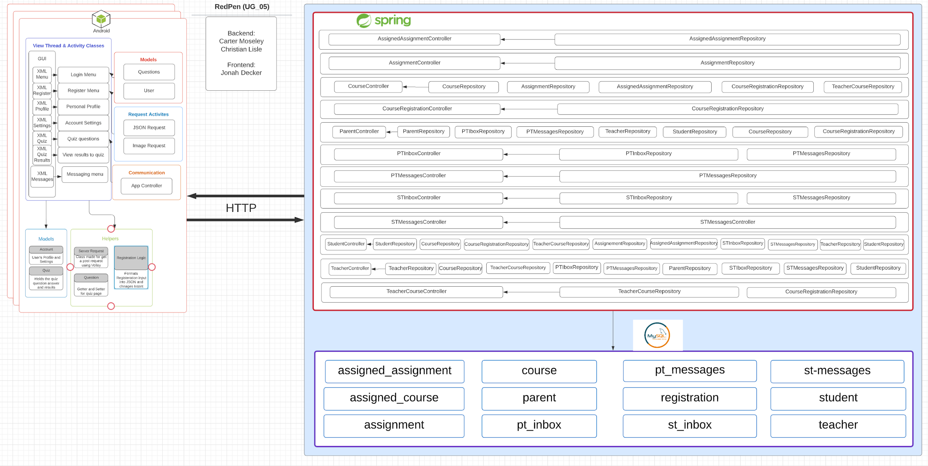

**Design Description**

Frontend

**Android User GUI**

…

**Android Code Helpers**

…

**Android Models**

…

**Android Communication**

…

Backend

**Entities**

* **Student** (user)*
* **Teacher** (user)*
* **Parent** (user)*
* **Course**
* **TeacherCourse** (course assigned to teacher)
* **CourseRegistration** (links TeacherCourse and student)
* **Assignment**
* **AssignedAssignment** (assignment assigned to students in course)
* **PTInbox** (an inbox between parents and teachers)
* **PTMessages** (all messages between parents and teachers)
* **STInbox** (an inbox between students and teachers)
* **STMessages** (all messages between students and teachers)

*Note that user entities have a password field (that allows them to login and register), but the password field has been developed such that it is never accessible to the frontend (through the use of write_only JSON access property).

**Spring Boot Controllers**

Each entity has a corresponding controller and repository.

**User Controllers**

Controllers for each type of user (Student, Parent, and Teacher) have methods for registering a new user and logging in. On a successful login or registration, these methods return the id of the user logged in (which allows the frontend to store the id of the current user logged in).

These controllers also have methods that allow for things such as students registering for courses, or teachers creating courses and assignments. These are just a couple examples of the user-type entity controller methods, but showcase the functionality provided by these controllers.

**Other Controllers** (Course, CourseRegistration, Assignment, etc.)

Controllers for basic entities include the simple methods (GET, POST, REQUEST, DELETE, etc.) that correspond to retrieving a single entity, creating and storing entity in database, retrieving multiple or all entities (some entities such as Assignment only belong to one course, so retrieving all assignment entities is different from returning all assignment entities for one course), deleting a single entity, and many others. The functionality provided by each of these controllers allows for RedPen to have a fully functional backend.

**Relationship Diagram**

