Jet Skis: What Are the Differences?

Christian Rodas

University of Missouri – Kansas City

Table of Contents
Vision Statement 3
Requirements 4
Product Backlog 5
Sprint #1 6
Review 6
Retrospective 6
Sprint #2 7
Review 7
Retrospective 7
Sprint #3 8
Review 8
Retrospective 8
Sprint #4 9
Review 9
Retrospective 9
Sprint #5 10
Review 10
Retrospective 10
Sprint #6 11
Review 11
Retrospective 11

Vision Statement

The vision of this program is to provide a simple, yet comprehensive view of the various types of Jet Skis. Such as the different makes, models, and trims along with some of their notable features such as seating capacity, technology, performance numbers, storage solutions, gas mileage, towing capacity, and weight. This will useful for users who are deciding which kind of Jet Ski would best meet their wants, all in one place. For the first immediate release, I’m expecting to add the main functionality of having the ability to use drop down menus showing all the makes.
For the future, I would like the ability of having the ability to select what model from another dropdown menu, and then another dropdown menu showing the trims available. After selecting those, the notable features will show up as an image. There will also be a brief FAQ and usability page that can be opened by tapping on a “?” button. I’d also like to add the ability of having 3 different comparisons at the same time by being able to switch between pages at the bottom of the app. Note that not all 3 will show up on the same screen, just the ability to switch screens.

Requirements
A discussion of what your application is required to have in functionality. It should identify user roles and goals/actions, and what the key features of the app should be.
Actor | Goal
Me | Main Page: 3 Dropdowns, with only one is usable at a time. 3 tappable pages at the bottom for comparison. A welcome header. A “?” button for a FAQ and usability guide.
Me | “?” Button: Opens a page that has a quick FAQ and a paragraph explaining how the app works. Possibly an about page with a contact page for users to submit a bug.
Me | Dropdown (Makes): Shows all the available Jet Ski makes. Tapping any make unlocks the model dropdown menu.
Me | Dropdown (Models): Shows all the available Jet Ski models available from that make. Tapping any model unlocks the trims dropdown menu.
Me | Dropdown (Trims): Shows all the available trims for that menu
Me | Comparison Pages: Tapping one of the 3 different pages allows you select another Jet Ski to view. Must also be able to save the page and clear the page.
Me | Jet Ski Features: Pulls an image that shows all of that specific Jet Ski’s features and is placed below the dropdown menus.
Me | Exit Button: Allow a user to exit the app.

Product Backlog
This will be updated throughout the semester as new PBIs are added, larger items are broken into smaller ones, and completed items removed.

Story ID | Story | Story Points  (in est. hours) | Priority | Status
Dropdown Menu | Shows all the available Jet Ski makes. | 3 | 1 | Complete
Unlock Additional Activates via Spinners | After user selects a Jet Ski make, it unlocks the Jet Ski model dropdown menu, which will in turn unlock the Jet Ski trim dropdown menu | 3 | 2 | In Progress
Jet Ski Specification and Features Picture | After the user selects the specific Jet Ski, an image will appear, showing the features and specifications for that specific Jet Ski | 3 | 3 | In Progress
Clear Comparison Button | Add a button that allows that page’s picture to be removed and for another Jet Ski to be selected. Should not erase anther page’s Jet Ski | 4 | 4
Comparison Pages | Allow up to 3 different pages, showing 3 different Jet Skis. Page 1 will be open by default, and the rest can be accessed by a button at the button of the app. Switching pages should not erase another page. I.e. it saves the picture to that page. | 4 | 5
Exit Button | A button that allows the user to exit the app. | .5 | 6
About/FAQ Button | Add a “?” button that opens a page explaining how the app works and to submit any bugs via contact address. | 1.5 | 7
Add Visual Enhancements | Make the app visually appealing to users. | 2 | 8

Sprint #1

Sprint Backlog: Dropdown Menu Functionality
Story ID | Story / Task | Estimated  Hours | Actual  Hours
Dropdown Menu | Add a dropdown menu | 1 | 2.5hrs
Research PWC | Look up popular Jet Ski makes, models and their notable features | .5 | 45 mins
Add Makes to Dropdown Menu | Add the various makes as selectable objects on the dropdown menu | 1 | 5mins
Display Current Make | Once user selects make, it should stay selected until user clears the whole page | .5 | .5

Review

[Screenshots, etc go here. This is where you discuss the product, describing what was done this sprint (potentially shippable product increment) and what was planned for the sprint but was not done. ]

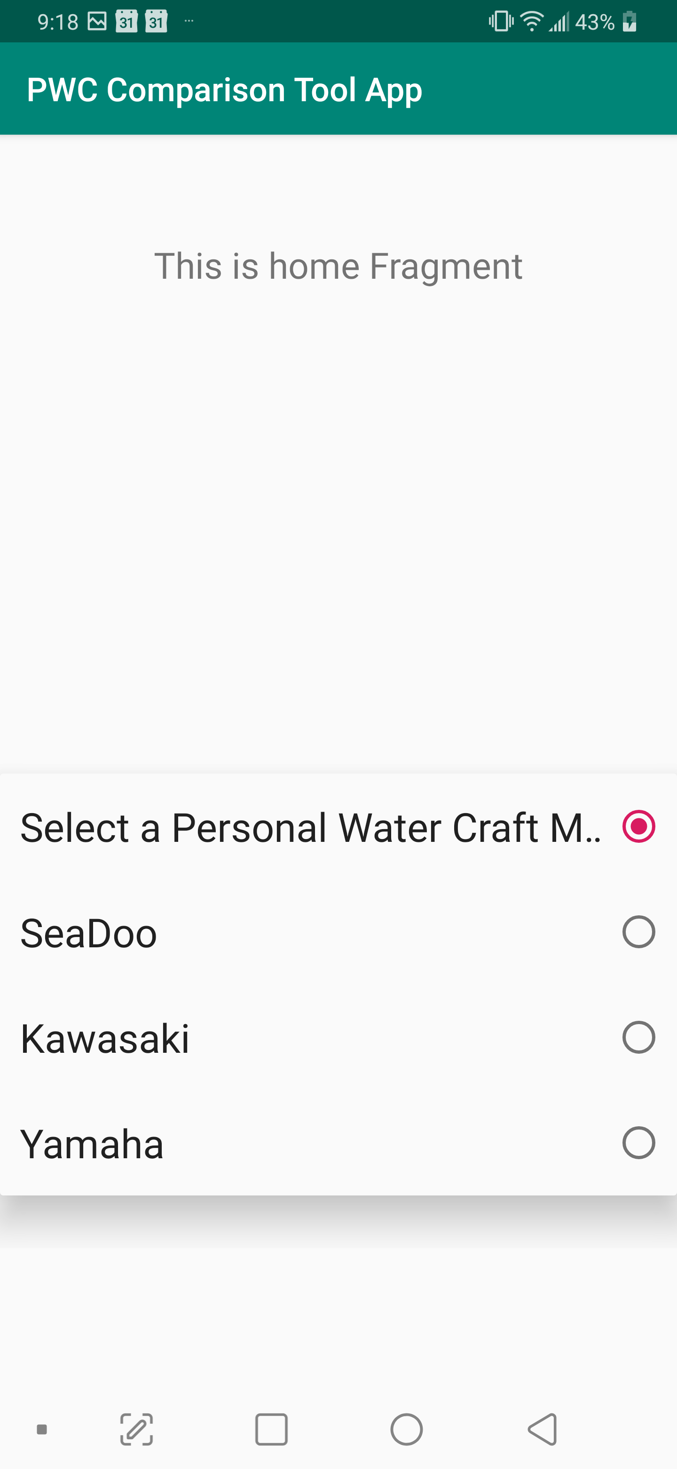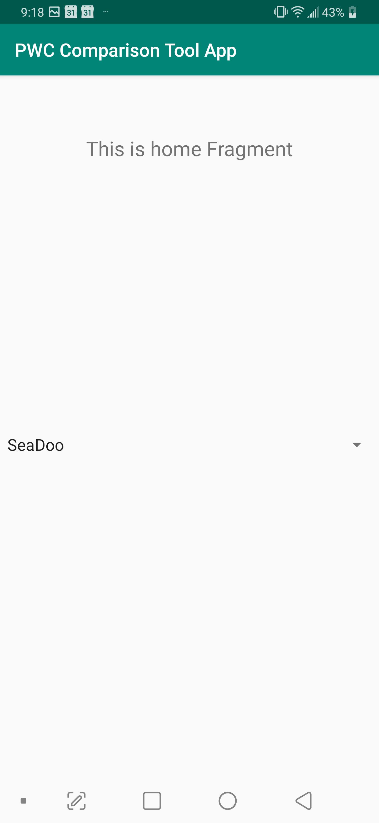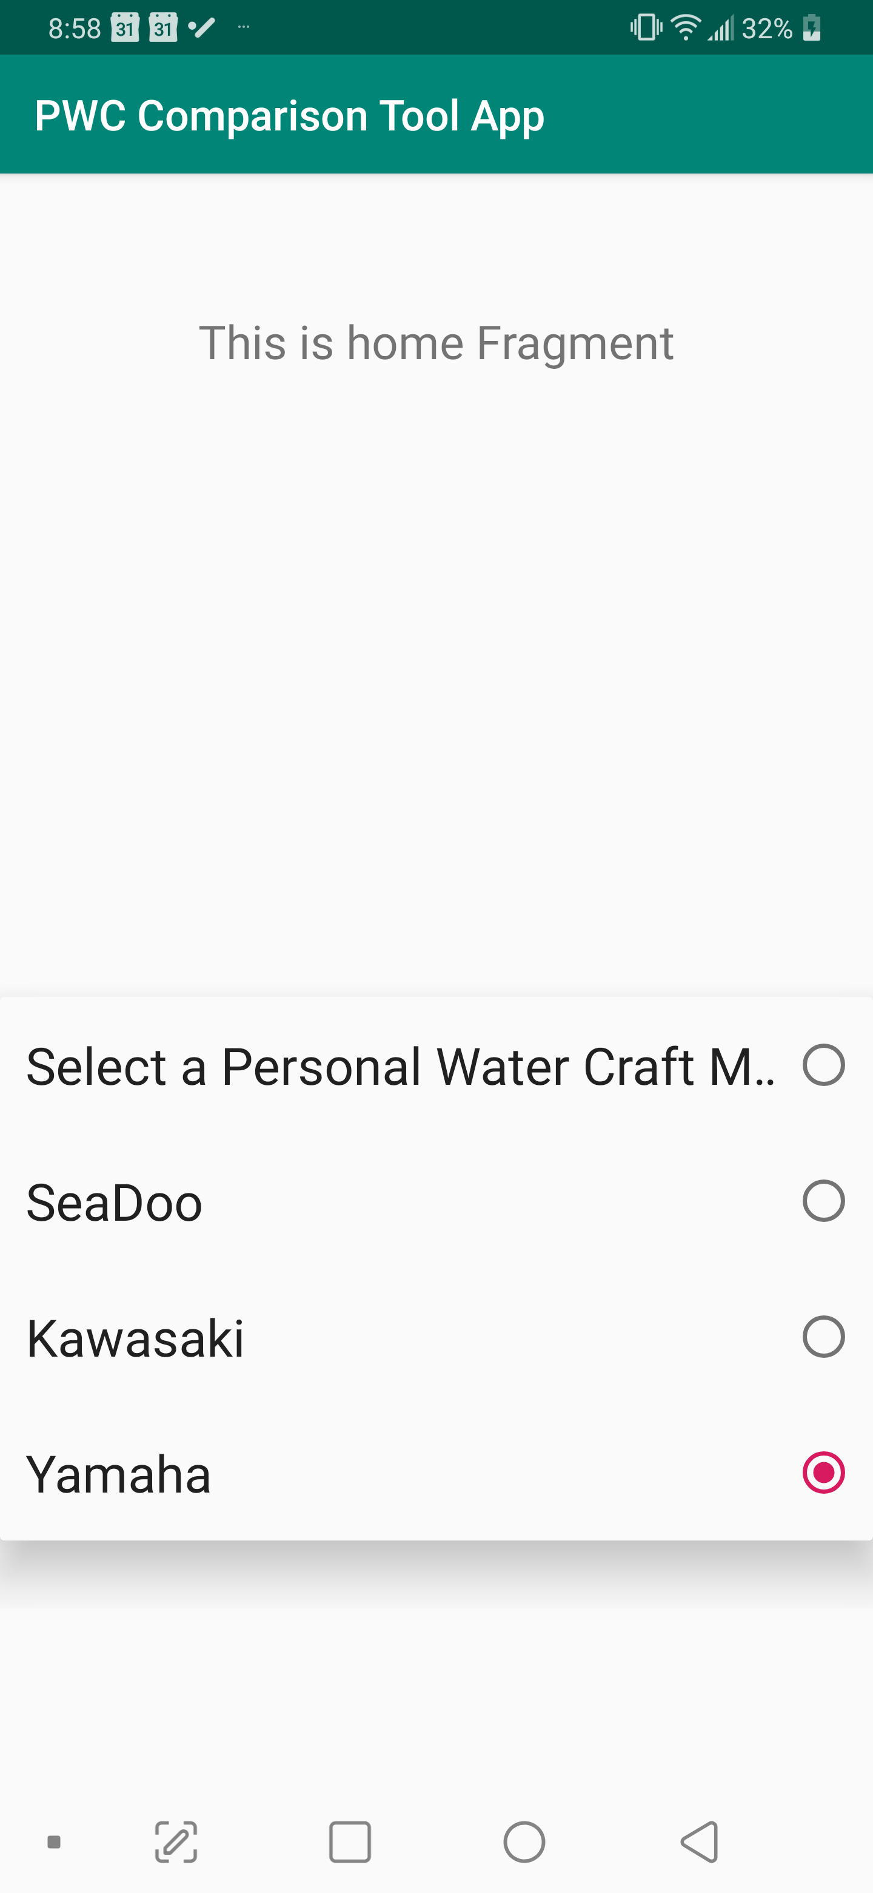

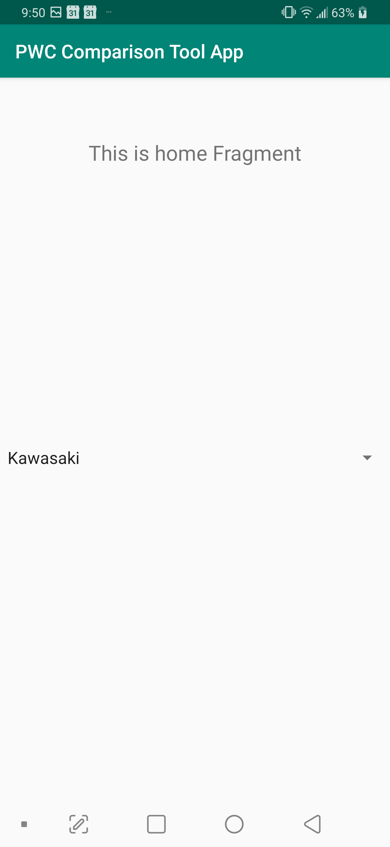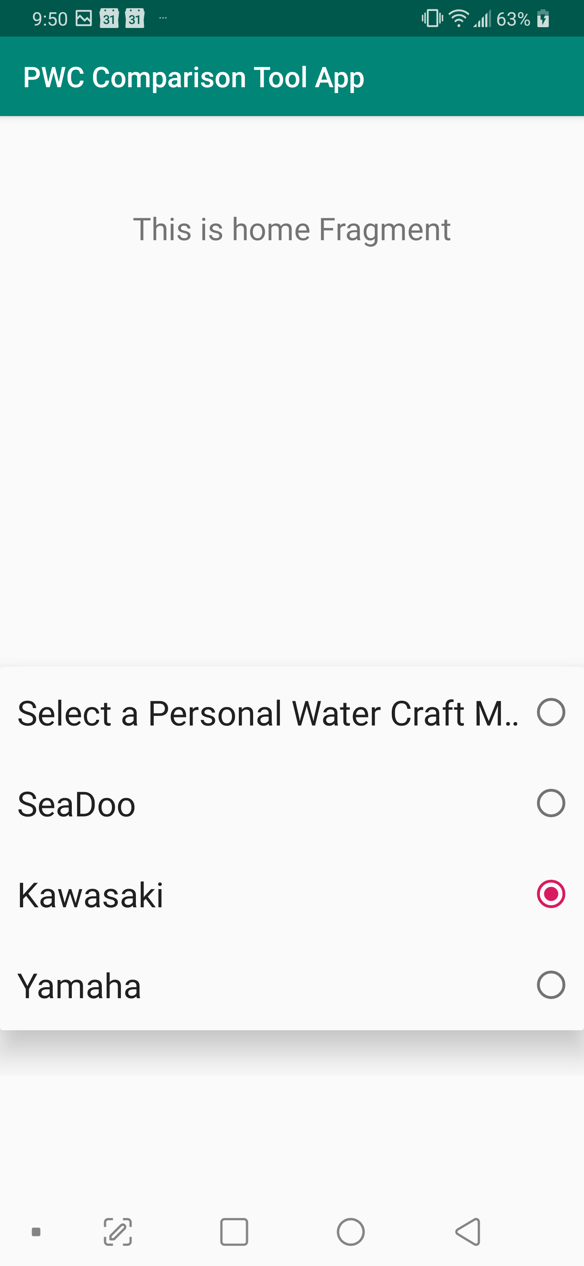

The PWC research is complete

The dropdown menu was implemented (or in Kotlin known as spinners), along with the ability to make & choose a PWC option.

The “Display Current Make” was not implemented for this sprint as upon looking further into it, I found a better approach by instead using new activities as a way to progress through the selection process.

There is currently no known bugs.

Retrospective
[This is where you discuss the process. What went well (and are you planning to do more of that?) What didn’t go so well (and do you have a way to do less of that)? What changes are you planning to make in how you plan & carry out the next sprint?]

I forgot to include startup time such as the time it takes to create a new project, connecting it to my phone and then connecting it to github.

The spinner implementation took longer than expected as my first 2 attempts ended in failure since the code was written in Java and I didn’t notice that until my 3rd attempt with Kotlin code finally worked. After looking through the Android Studio documentation, I’m able to better differentiate what is Java and what is Kotlin.

After the spinner was implemented, adding the ”Makes” to it was much more simple than I thought and so was modifying it.

Researching the PWC took a little more time than expected since there are way more models than I assumed. Thus, I’m only going to stick the most popular makes (i.e. Sea-doo, Yamaha, & Kawasaki) and their respective models. I also learned that Jetskis are actually just called that by Kawasaki and that the more general term is Personal Watercraft or PWC. So, I changed the app name to PWC Comparison Tool App instead.

I’ve also decided that after doing some research, a better approach would be to have the spinners open new activities as a way to ultimately selecting a model rather having all 3 spinners on the same page. This would make it easier to develop and still achieve the same functionality. Thus, the “Display Current Make” story wasn’t really completed and instead will be switched out for “New Activities Upon User Selection” for the next sprint.

Sprint #2

Sprint Backlog
Story ID | Story / Task | Estimated  Hours | Actual  Hours
New Activates Upon User Selection | Opens a new activity dependent on Make selection | 1
Add Models to makes | Upon user Make selection, all the models for that specific make should show up | .5
Add Specs to Models | Upon Model selection, either an image popup appears showing that models spec along with notable features | 1.5
Back Button | Allow user to go back a step to change selection | .5
Very Minor appearance cleanup | Remove the “This is home fragment” and minor placement adjustments | .5

Review

[Screenshots, etc go here. This is where you discuss the product, describing what was done this sprint (potentially shippable product increment) and what was planned for the sprint but was not done. ]

Retrospective
[This is where you discuss the process. What went well (and are you planning to do more of that?) What didn’t go so well (and do you have a way to do less of that)? What changes are you planning to make in how you plan & carry out the next sprint?]

Sprint #3

Sprint Backlog
Story ID | Story / Task | Estimated  Hours | Actual  Hours

Review

[Screenshots, etc go here. This is where you discuss the product, describing what was done this sprint (potentially shippable product increment) and what was planned for the sprint but was not done. ]

Retrospective
[This is where you discuss the process. What went well (and are you planning to do more of that?) What didn’t go so well (and do you have a way to do less of that)? What changes are you planning to make in how you plan & carry out the next sprint?]

Sprint #4

Sprint Backlog
Story ID | Story / Task | Estimated  Hours | Actual  Hours

Review

[Screenshots, etc go here. This is where you discuss the product, describing what was done this sprint (potentially shippable product increment) and what was planned for the sprint but was not done. ]

Retrospective
[This is where you discuss the process. What went well (and are you planning to do more of that?) What didn’t go so well (and do you have a way to do less of that)? What changes are you planning to make in how you plan & carry out the next sprint?]

Sprint #5

Sprint Backlog
Story ID | Story / Task | Estimated  Hours | Actual  Hours

Review

[Screenshots, etc go here. This is where you discuss the product, describing what was done this sprint (potentially shippable product increment) and what was planned for the sprint but was not done. ]

Retrospective
[This is where you discuss the process. What went well (and are you planning to do more of that?) What didn’t go so well (and do you have a way to do less of that)? What changes are you planning to make in how you plan & carry out the next sprint?]

Sprint #6

Sprint Backlog
Story ID | Story / Task | Estimated  Hours | Actual  Hours

Review

[Screenshots, etc go here. This is where you discuss the product, describing what was done this sprint (potentially shippable product increment) and what was planned for the sprint but was not done. ]

Retrospective
[This is where you discuss the process. What went well (and are you planning to do more of that?) What didn’t go so well (and do you have a way to do less of that)? What changes are you planning to make in how you plan & carry out the next sprint?]

