Exercises

Apply the four steps described on the poster:  - Put a crossing on each edge,  - Connect the bits of threads as in a maze,  - Stress the Over/Under features with the little guide,  - Thicken the threads by building a bridge for each crossing and extending the road. | Remember, each crossing is at the middle of an edge and each edge bears a crossing.
 | One edge = one crossing
 | And to connect the bits of threads, repeat
 | Follow the wall, turn the corner, follow the wall
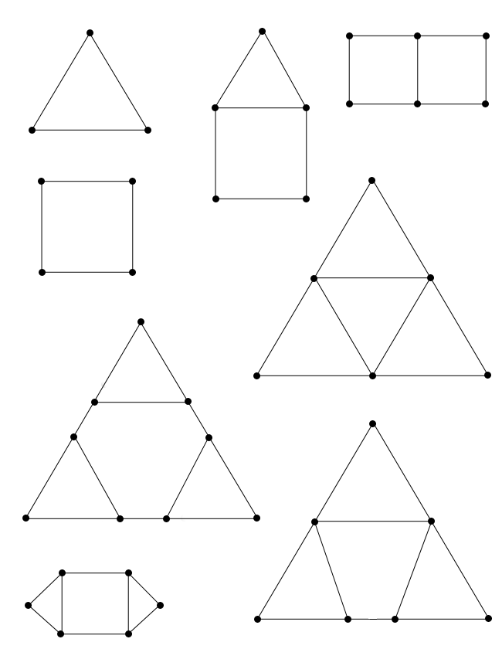
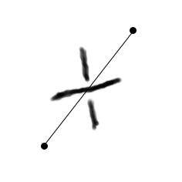 http://www.entrelacs.net/ 