Github chart with multiple Y axis:

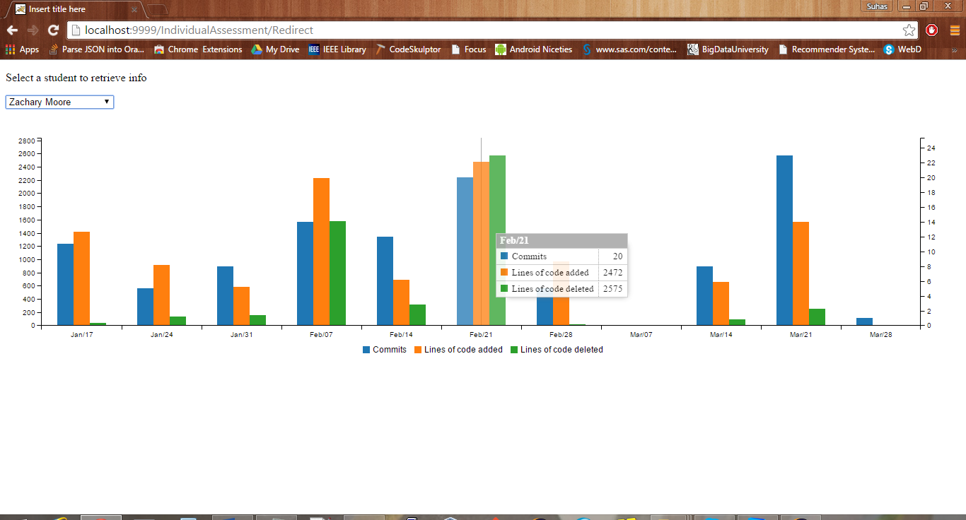

Spider chart comparing one’s performance to the team and the whole class

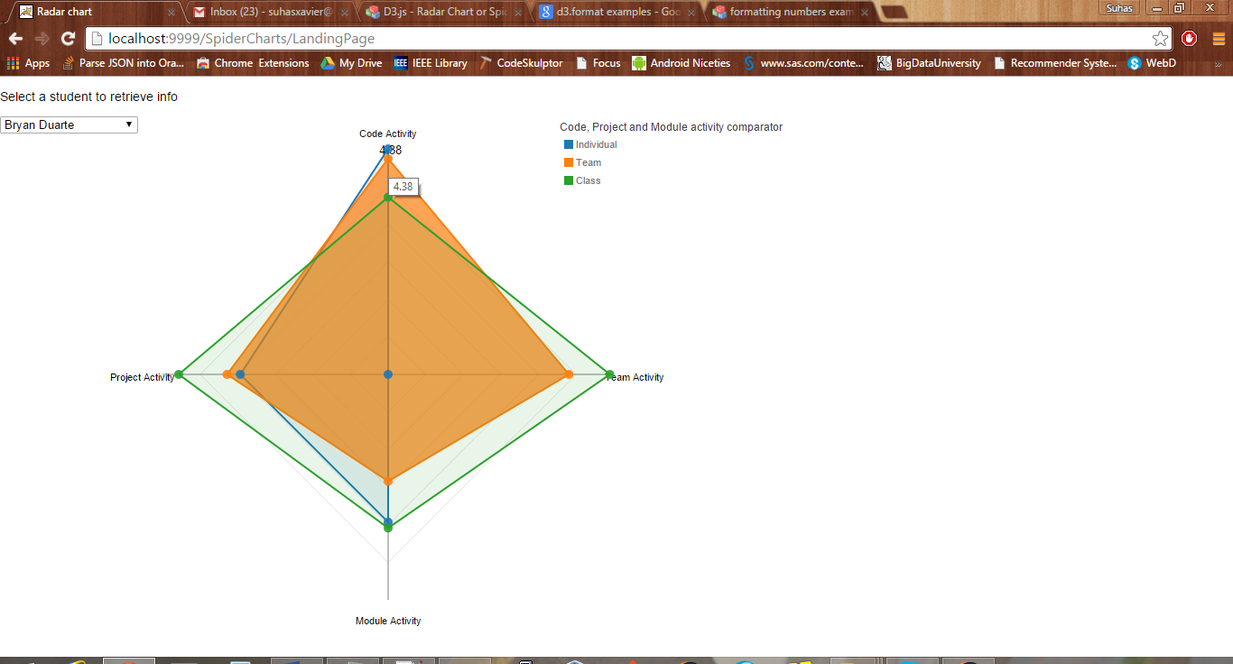

Scrumwise performance on a daily basis

