**EQUELLA**

**EQ101 EQUELLA Core**

**Principles**

Version 6.3

Table of Contents

Course Outline 3

EQUELLA repository 4

Session 1 5

EQUELLA digital repository 5

Dashboard page 5

Search, browse, save and share 8

Keyword and quick searches 9

Search page functionality 10

Save (or bookmark) the search results 11

Share search results 11

Cloud search 12

Collection and advanced searches 13

External repositories 14

Browse hierarchy 15

Resource summary and content 16

Comments 18

Add to favourites 18

Share with others 18

Structured and sequenced content 19

Favourites 21

Contribute resources 23

Collections and contribution forms 23

My resources 26

Edit a resource 27

Publish resources 28

Notifications 29

New versions 29

Thumbnails 30

Collaborate 30

Clone existing resources 31

Session 2 32

Content presentation 32

Find uses 36

Digital Rights Management (DRM) 39

User profile 41

Further exercises 42

EQUELLA Client support 47

International User Community 47

# Course Outline

This course is a practical exercise in understanding the EQUELLA Digital Repository.

EQ101 is a prerequisite for the other EQUELLA courses. Participants must complete all exercises in the workbook.

There are also extension exercises that participants are encouraged to complete where time permits.

The course covers the following areas of the EQUELLA Digital Repository:

* EQUELLA technology and terms
* EQUELLA structure and searches
* EQUELLA resources and lifecycle
* Favourites
* Contributing resources
* My Resources
* EQUELLA content and rights
* Integrated EQUELLA
* User Profile and Scrapbook
* EQUELLA support, Professional Services, User Community, and Repository Showcases.

#### A few important points about EQUELLA

* EQUELLA is customizable and therefore each educational institute can set up EQUELLA to suit their business needs. Often this makes learning EQUELLA seem confusing and complex at first as it can be different to the supplied documentation.
* EQUELLA is privilege (permission) based and different access privileges are given to different users. Some users can only search, while others can add content or have control of the security (privileges). It is important that different users have different privileges, for example, a student should only have access to exam questions while a teacher can also access the answers.
  + In EQ101 users are assigned *Educator/Researcher* role privileges and have access to search, contribute and manage their resources.
  + Participants interested in extending their EQUELLA knowledge should join an *EQ201 training course*, where users are assigned *Content Administrator* role privileges and have access to administer other users’ resources.

# EQUELLA repository

#### Architecture

EQUELLA’s architecture can include the following sections:

* **Presentation**—ways content stored within EQUELLA can be accessed include:
  + EQUELLA native UI—accessed using a browser and URL.
  + Integrated EQUELLA—accessed through a content presentation application or Learning Management System (LMS) such as Blackboard Learn™, Moodle™, Canvas, Learning Studio or Fronter.
  + Custom applications—accessed using EQUELLA’s SOAP or REST APIs.
  + Mobile app—accessed using an app tailored for iPads and Android tablets.
* **Management and storage**—EQUELLA enables tagging of content for easy search and discovery, and provides a range of other functionality such as DRM and workflow to ensure content is of good quality and is protected.
* **Resources**—EQUELLA can store and manage a range of content types including; simple descriptive text, Learning Objects (IMS, SCORM and METS packages), images, sounds, videos, PDFs, MS Office™, ZIP files, journal articles, book chapters, YouTube™ videos, Google Books™, iTunesU™ tracks, Flickr™ images, Kaltura™ media, Echo360 lectures, QTI, LTI, internal links to resources, files and webpages.

#### Anatomy

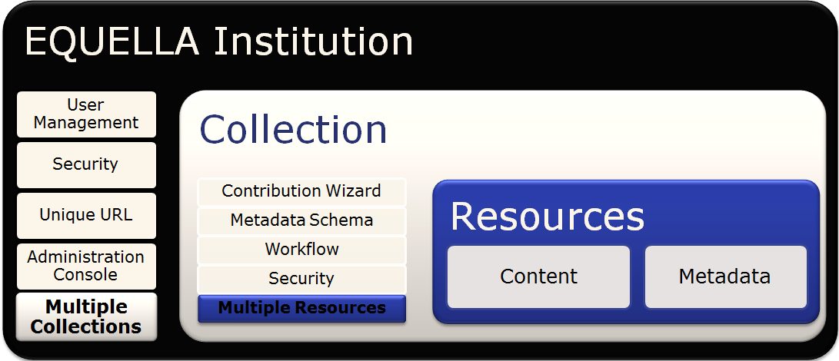EQUELLA Institutions provide access to stored content for users, external applications and repositories. They provide infrastructure for managing users and digital content, and administration settings options for managing all aspects of EQUELLA.

# Session 1

This session is to demonstrate and discuss:

* EQUELLA technology structure
* EQUELLA searches
* EQUELLA resources and lifecycle
* Favourites and sharing resources
* Contributing resources
* My resources
* Collaboration
* Notifications

## EQUELLA digital repository

To login:

1. Navigate to <url>
2. Enter the username and password given to you by the trainer.
3. Select **Login** then select **OK** for the **Notice** dialog to display the **Dashboard** page.

### Dashboard page

The user’s **Dashboard** page is customizable and includes a navigation menu, portlets and context sensitive help. An example **Dashboard** page is shown in *Figure 1* on page 7.

##### Navigation menu options

The navigation menu is displayed on the left-hand side of each page and contains options for accessing content that can include:

* + Standard group—**Dashboard**, **Favourites**, **My resources**, **Search** and **Contribute**

options.

* + Browse group—four hierarchy topics plus a **More…** option.
  + Custom group—options added, as required, by an administrator.
  + Administration group—**Manage tasks**, **Manage external resources**, **Manage resources**, **Manage activations**, **Reports** and **Settings** options.

##### Management options

**Tasks**, **Notifications** and your user profile are accessed at the top of the page.

##### Context sensitive help

Context sensitive help can be displayed by selecting the **Help** button.

<insert dashboard image>

###### Figure 1 Dashboard page

**Portlets**

Portlets are displayed in the central pane of the **Dashboard** page and typically display a summary of available content and links to access that content. The portlets can be added, edited, re-sized, re-ordered, removed and restored.

**Screen options**

Selecting the **Screen options** button on the **Dashboard** page displays a list of portlets that can be added including: **Browse**, **Favourites**, **Formatted text**, **My resources**, **Quick search**, **RSS or Atom feed**, **Recent contributions**, **Scripted**, **Task statistics**, **Tasks** and **Web page**.

Selecting the **Screen Options** button on the search pages displays a section where the results page display can be configured using the following options:

* + **Include results that are not-live**—check the box to include all resources in the results list.
  + **Number of results per page**—select an option from the drop-down list to vary the number of results displayed:
    - **Minimum**—10 results in Standard view; 30 results in Gallery view.
    - **Medium**—50 results in Standard view; 60 in Gallery view.
    - **Maximum**—100 results in Standard view; 90 in Gallery view (local only).
  + **Search attachments**—check the box to include attachment content in your search queries.

#### Breadcrumbs

Structural breadcrumbs can be displayed at the top of pages and provide a trail for the user to follow (e.g. *Learning resources collection* > *EQUELLA Documentation*).

#### Dashboard exercises

In these exercises you will learn about Help, Screen options and Portlets.

##### Help

1. Select the  button to display the help pane.
2. Read the section on the **Navigation menu**.
3. How would you find more information about this topic?

##### Screen options

1. Note the portlets types that are on your **Dashboard.**
2. Select the  button to display the dashboard options pane.
3. Note the other portlets types that can be added to your **Dashboard**.
4. Add **Browse** and **My resources** portlets.
5. Add a **Recent contributions** portlet (with default options).
6. Minimise the **Tasks** portlet.
7. Move the portlets around the **Dashboard** page.
8. Move a portlet to the top to make the portlet full sized.
9. Remove the **My Favourites** portlet.

##### Review the section then complete the extension exercises if time permits

**Extension exercises**

1. Add **Formatted text**, **RSS or Atom feed** and **Web page** portlets.

## Search, browse, save and share

EQUELLA provides a range of searching and browsing options for finding content including:

* + **Local resource search**—users can search for resources from all collections. The search results are displayed in the following views:
    - **Standard**—displays a results list with resource information, and users can select whether one, multiple or no attachment thumbnails are displayed.
    - **Gallery**—displays resources in a thumbnail format. Users can build a media gallery of image attachments in a grid style, and can select the thumbnail displayed.
  + **Cloud search**—provides access to resources stored in the cloud and occur simultaneously with the local keyword searches.
  + **Collection searches**—users can restrict their searches to within a selected collection.
  + **Advanced searches**—are customised searches used to find resources that match the selected search criteria.
  + **Remote repositories searches**—allows users to search multiple external sources including other EQUELLA repositories for content.
  + **Browse hierarchy (topic) searches**—users navigate through the sub-topics to find resources for specific topics.

EQUELLA users can:

* + Also search for content through their **Favourites**, **My resources** and **Tasks** options.
  + Share search results, and use resources by adding them as course content and to create other resources.

EQUELLA Administrators can configure:

* + Search relevance to be weighted by title, metadata or attachment.
  + EQUELLA collections so that resources can be included in common search engines, such as Google™ and Google Scholar search results.

Selecting **Search** from the navigation menu displays the **Search** page, an example is shown in *Figure 2*.

<insert image of Search page>

###### Figure 2 Search page

Further information on searching is provided in the *EQUELLA Searching Users Guide* and

*EQUELLA Discoverability Guide.*

### Keyword and quick searches

##### Search methods

* + **Keywords**—the keywords entered display resources that have an exact match in their title, description, attachment name or applicable attachment content. Single and multiple keywords can be entered in the search text box:
* Entering multiple keywords with a space between each word displays results that contain all of the entered keywords.
* Entering multiple keywords with *or* displays results that contain any of the words.
* Search queries can contain optional Boolean logic to target keywords associated with resources.
  + **Wildcard** (**\***)—a wildcard character can be used to substitute for any character or characters in a string.
  + **Autocomplete**—means that users can type two or more letters and EQUELLA suggests words and resource titles based on the letters entered.
  + **Stemming**—EQUELLA recognises the root (stem) of a word entered and performs the search using the root term instead. For example, if ‘*walked’* is entered the search

results for ‘*walk´* (the stem word), *‘walking’* and ‘*walks’* are also displayed.

##### Sort and filter options

Search results can be sorted and filtered to display more relevant results. Every results page in EQUELLA has sorting and filtering options that can change from page to page.

**Search exercises**

In these exercises you will learn about search results, sorting and filtering results.

##### Search and search results exercises

1. Select the **Search** button from the navigation menu to display the **Search** page.
2. Enter e*quella* in the **Search** box then select the  **Search** button or press *enter*.
3. View the results list and note the total number of results
4. Review the highlighted words for each result. Look at the relevance score and whether the key words were found in the title, metadata or attachment content. (*Note: This EQUELLA has been set up to boost the Title* x2.)
5. Select the **Gallery** button to view the results as a gallery of images.
6. Compare the results to the **Standard** page.
7. Select the **Standard** button to return the results to standard view.

##### Sort exercises

1. Select the **Sort** tab to display the **Sort by** options. Which option is the default?
2. Sort the results by **Title**. Did the order of the results change?
3. Reverse the order of the results.
4. Sort the results by **Date last modified**. Did the order of the results change?
5. Reverse the order of the results.

##### Filter exercises

1. Select the **Filter** tab to display the *filter by* options.
2. Filter the results list **by owner** (e.g. *teacher*) then select the **Clear** button.
3. Filter the results list by *PDFs* then close the filter pane:
   1. How many results are now displayed?
   2. How do you know that filters have been applied?
4. Select the **Show attachments** button for the *yourEQUELLA features request*

resource to display attachments and links to content.

### Search page functionality

When a user returns to a previously visited local search page, the results list displayed is for the last search criteria and options selected. If filters are currently applied the **Filter** tab will be coloured orange. The default settings are displayed each time a user logs in.

#### Search results exercises

In this exercise you will learn about search page functionality and clearing filters.

1. Select the **Dashboard** button to display the **Dashboard** page.
2. Select the **Search** button to display the **Search** page.
3. What do you notice about the results page?
4. List 2 ways that you can clear the filters:
5. Clear the filters and close the Filter pane, if applicable.

##### Review the section

### Save (or bookmark) the search results

Search queries can be saved so they can be re-run at a future time without the need to re- enter the terms.

#### Save search results exercise

In this exercise you will learn about adding the search to a favourites list.

1. Select the **Add search to favourites** button then save the search as *EQUELLA Resources.*

### Share search results

Search results can be shared by sending the search results to other users. The sharing options include:

* + **Share search results as an RSS or Atom feed**—select the **RSS feed** or **Atom feed** link to display a subscription page. Subscribed users are notified when resources are updated or added to the search results.
  + **Share search results via URL**—copy and paste the URL into an email or other document. The EQUELLA log in page is displayed when the link is selected.
  + **Share search results via e-mail**—users can send results to others via email. Enter an email address then select the **Send Email** button. Check the **Share only results viewable by guests** checkbox if sending to users outside your institution.

#### Share search results exercises

In this exercise you will learn about sharing the search results list.

1. Select the **Share** tab to display the *Share search results* options.
2. List the sharing options
3. Who will be able to access the search results when the URL is shared? _
4. How many resources will be itemised in the results list that is shared?
5. Close the **Share** pane.

### Cloud search

The Cloud search occurs simultaneously with the standard EQUELLA search, and allows users to search and select content from the Open Educational Resources (OER) on the cloud.

#### Cloud search exercises

In this exercise you will learn about finding resources using a cloud search.

1. Select the **Found X cloud results** button to display the **Cloud search** page.
2. Review the results. Are they different?
3. Select the search box then remove the search criteria then enter *australia* and press enter.
4. View the results list and note the total number of results
5. Filter the results list **by education level** (e.g. *Higher Education*) then remove the filter.
6. Select the **Local resources** link to display the **Search** page. Are they different?
7. Remove all search criteria.

#### Screen options exercises

In this exercise you will learn about changing the number of results displayed in the list.

1. Select the **Screen options** tab to display the option pane.
2. How many results per page are displayed by default
3. Review the available options.
4. Select the **Cloud search** and review the options.
5. Change the option to **Medium** (50 results per page).

##### Review the section

### Collection and advanced searches

**Collection search**

Collections are unique containers that group and store resources and associated information (metadata) within EQUELLA.

##### Collection search exercises

In this exercise you will learn about refining a search to a collection.

1. Select the **Within all resources** drop-down list.
2. Note the **Collections** listed.
3. Select the *Learning resources collection* to display a list of resources in the collection.
4. Enter *doc* in the **Search** box then select *equella documentation* and then press *enter*.
5. Select the **Add search to favourites** button then save the search as *Useful EQUELLA documents.*
6. Remove all the search terms and filters.

#### Advanced search

An advanced search enables searching specifically within the information (metadata) associated with resources.

##### Advanced search exercises

In this exercise you will learn how to search using specific information.

1. Select the **Within all resources** drop-down list then *Learning resources search* from the **Advanced searches** group.
2. Select *colour images* using the *Format of resource* and *Image type* options.
3. Enter *tas* in the **Search** box then select *tasmania* and then the **Search** button.
4. Save the search as *Images of Tasmania.*
5. Select the **Edit query** button to include *exam* as the *Learning resource type*.
6. Why were no local results found? _
7. Select the **Clear** button to remove the advanced search criteria.
8. Which search criteria were not removed?
9. Remove the search terms and change the drop-down list to **Within all resources**.

##### Review the section

## External repositories

EQUELLA currently supports the following remote repository search types:

* + Z39.50—libraries and major databases.
  + SRW—internet pages.
  + SRU—Search/retrieval via URL.
  + MERLOT—higher education learning materials.
  + EQUELLA—other EQUELLA repositories.

Search results can be imported into a configured collection contribution form. Remote repository searches can be accessed from the:

* + **Search** page—**Within all resources** drop-down list; or
  + **Contribute** page under the collection where the result information can be imported.

##### External repository search exercises

1. Select the *Libraries Australia* repository from **Within all resources**—**Remote repositories** options.
   1. Search for *tasmania* and view the results list.
   2. Search for other topics.

##### Review the section

**Notes**

## Browse hierarchy

Each topic (level) in the browse hierarchy can display key resources, resources and further topics. Users ‘drill-down’ by selecting a sub-topic or move up by selecting a breadcrumb link. Each topic can display the total number of resources displayed in its sub-topics.

**Key resources** are important resources for that topic and are displayed at the top of the results list.

##### Browse topics exercises

1. List 2 ways that you can access the browse hierarchy:
2. Browse to find the *Websites* folder (topic). How many resources contain a website?
3. **Filter** by *community* keyword.
4. Save the search as *User community.*

###### Clear filters.

1. Navigate to the **Browse** page using the breadcrumb navigation at the top of the page.
2. Browse the topics to find a **Key Resource.** What colour is used to highlight key resources?
3. What type of resources are key resources?

##### Review the section then complete the extension exercises if time permits

**Extension exercises**

1. Search for a video using 3 different search types. Which search types did you use?
2. Search an external repository for *nursing* content.
3. Where would you find a key resource?
4. How would you set up an RSS feed for search results? This exercise is intended to improve your familiarity with your EQUELLA.
5. Login to your EQUELLA (If you cannot do this then complete the *Further exercises*).
6. Repeat the exercises from the *Search, browse, bookmark and share* section, using applicable keywords.

##### Further exercises (using the training institution)

1. Refer to the *Further exercises* section on page 42.

## Resource summary and content

Selecting a resource title from the search results list displays the **Resource** page (Figure 3).

<insert image of Resource summary page>

###### Figure 3 Resource page

The Resource page provides a summary of the resource and can comprise *title*, *description*

and other descriptive data entered during contribution, plus the following:

* + **Links to resources** section—displays content, information and viewer options.
  + **<x> comment** section—displays previously added text and ratings.
  + **Add a comment** section—allows text and ratings to be added.
  + **Prev/Next** buttons—navigate to the previous or next resource in the results list.
  + **Add to favourites** button—allows the resource to be saved in Favourites list.
  + **Share with others** button**—**provides a resource link that can be emailed to colleagues, allowing them to view the resource for a specified time.
  + **Details** pane—displays information about the resource and can include: Owner, Collaborators, Collection, Version, Status, Find uses, Moderation history, Terms of use, Moderation Progress and Activations options.
  + **Actions** pane—displays operations that can be used for the resource and can include: Add to external system, Archive this version, Change ownership, Clone item into a collection, Create a new version, Delete this version, Edit this version, Export, Make this version live again, Mark this for review, Modify key resource, Move item into another collection, New contribution of same type, Purge from EQUELLA, Redraft this version, Restore this version, Resume this version and Suspend this version actions.

Content can be managed in EQUELLA or externally, and include:

* + uploaded—Word, Excel, PDF, ZIP, IMS, SCORM, METS, QTI, movies, audio, images
  + linked—URLs, YouTube, GoogleBooks, Flickr, iTunesU, Kaltura, LTI Further information is provided in the *EQUELLA My Resources User Guide*.

**Resource summary and content exercises**

In these exercises you will learn about resource summary details, actions, and content types.

1. Enter *equella* in the **Quick search** portlet then select *equella user community* and then the search button to display the search results.
2. Why is the *EQUELLA User Community* resource not at the top of the results list?
3. Change the **Sort results by** drop-down list to **Relevance** and review the results.
4. Select the  **Show attachments** button to display attachments and links to content.
5. Select *EQUELLA User Community* resource title to display the resource summary page.

##### Details pane and information

* 1. Who is the **Owner** of this resource?
  2. Which **Collection** is it in?
  3. Note the resource’s **Version** number _ **Status**

##### Actions pane

1. Review the operations that are available for an *Educator/Researcher* role user:
2. Why shouldn’t a user with an *Educator/Researcher* role have permissions to edit or delete this resource?

##### Information and links to resources

1. Note the other information (metadata) provided on the summary page.
2. Select the **Show details** drop-down arrow to display information about the content.
   1. Is the content uploaded or external (linked) content?
3. Select the *EQUELLA User Community website* link. It is useful to join the EQUELLA International User Community. If you are interested then please send an email.

#### Next/Previous

The  buttons allow a user to move through the resource summary pages without having to return to the results page.

##### Next/Previous exercises

In this exercise you will learn about navigating through search results.

1. Select the **Next** button. What is displayed? _
2. Select the **Next** button then the **Prev** button.
3. Select the **Search** button from the navigation menu. Compare the search results to the resources you have been scrolling through.

##### Review the section

### Comments

Users can add comments and rate resources. When resources have been given a rating then users can **Sort results by** *User rating* to find quality resources.

#### Comment exercises

In this exercise you will learn about adding comments and ratings.

1. Add a comment to the resource.
2. Add a rating to the resource.
3. View all comments added to the resource.
4. Find other resources that have a user rating. Which **Sort** option did you use?

### Add to favourites

Individual resources that are frequently used can be added to the **Favourites**|**Resources** list to enable quick access. The added tags can be used in a keyword search to discover the resource.

#### Favourites exercises

In this exercise you will learn about adding a resource to a favourites list.

1. Navigate to the *equella user community* resource summary.
2. Select the **Add to favourites** button then add tags (e.g. *join, worldwide*).
   1. If the **Always use latest version** option is selected, will the resource saved in

**Favourites** be updated when a new version of this resource is added?

1. Select the **Add** button to add the resource to your **Favourites** | **Resources** list.

### Share with others

Users can share the resource with an outside source by sending an email containing a link that is accessible for a set period of time.

#### Share exercises

In this exercise you will learn about sharing the resource.

1. Select the **Share with others** button to display the **Share with others** dialog.
   1. What is the shared users access restricted by?_
2. Use the breadcrumb to return to the *EQUELLA User Community* resource.

##### Review the section

### Structured and sequenced content

EQUELLA resources can be packaged by adding a navigation structure. Combining the resource content allows teachers to group activities into a sequence of tasks.

#### Sequence exercises

In these exercises you will learn about organised content.

1. Navigate to the *EQUELLA documentation* resource summary page:
   1. Review the information (metadata) provided on the summary page.
   2. Select the *EQUELLA Support* link and review how the content is displayed.
   3. Is this content stored and managed in EQUELLA or externally?
   4. Select the *Glossary* link and review how the content is displayed.
   5. Is this content stored and managed in EQUELLA or externally?
   6. Select the **Full Screen** link and compare how the content is displayed.
   7. Select the resource’s title link (e.g. *EQUELLA Documentation*) to return to the resource summary page.
   8. Select the **Full screen (new window)** link then compare the content display.
   9. Return to the resource summary page.
   10. Save the resource to your **Favourites** list.
2. Find the *Overland Track* resource and review the information (metadata) provided on the summary page.
   1. List an external (or linked) content type:
   2. List an uploaded content type:
   3. Select the **Full Screen** link then **Full screen (new window)** and compare how the content is displayed.
   4. Return to the resource summary page then **Add to Favourites**.

#### Thumbnail view exercises

1. Search for the *EQUELLA Institutions* resource. Review how the resource content is displayed on the search page and the resource summary page.
   1. Why are these different to other resources?
   2. Which collection is this resource stored in?

##### Review the section then complete the extension exercises if time permits

**Extension exercises**

1. On which page is the date when the resource was last modified displayed?
2. On which page are resource comments and ratings displayed?
3. How would you share search results with other users? _
4. Sharing a resource via email is intended for regular or casual EQUELLA users?
5. Find and familiarise yourself with the *EQUELLA Searching User Guide* and *My Resources User Guides*.

This exercise is intended to improve your familiarity with your EQUELLA.

1. Login to your EQUELLA (If you cannot do this then complete the *Further exercises*).
   1. Find a resource and repeat the exercises from the *Resource summary* section.

##### Further exercises (using the training institution)

1. Refer to (or continue with) the *Further exercises* section on page 42.

## Favourites

Users can save (or bookmark) resources and searches they find useful by using EQUELLA’s Favourites functionality.

The Favourites page is displayed by selecting the:

* + **Favourites** button from the navigation menu; or
  + **Show all** button from the **Favourites** portlet.

The **Favourites** page contains **Resources** and **Searches** categories, an shown in Figure 4.

<insert image of the Favourites page>

###### Figure 4 Favourites page

Further information is provided in the *EQUELLA My Resources User Guide*.

**Favourites exercises**

In these exercises you will learn about bookmarked searches and resources.

1. Add a **Favourites** portlet to the **Dashboard** page and review the list.
2. What other option can you use to access the Favourites page?
3. Access the **Favourites** page via the **Show all** button in the portlet or the **Favourites**

button in the navigation menu.

1. The **Favourites** page contains which 2 categories?
2. Is the currently displayed category shown in black or blue?

##### Resources category

1. Select the **Resources** option.
2. What type of results are listed in the **Resources** category?
3. What type of information is displayed for each resource?
4. What option has been added to the **Sort results by** list?
5. Search for a resource using the tags you entered.
6. View the resource summary.
7. Navigate back to the **Favourites** page.
8. Which category is currently displayed? _

##### Searches category

1. Select the **Searches** option.
2. What type of results are listed in the **Searches** category?
3. What type of information can be displayed for each result?
4. Select a link to view the results list (e.g. *EQUELLA resources*).
5. How many resources are displayed?
6. Navigate back to the **Favourites** page.
7. Which category is currently displayed?

##### Remove Favourites

1. **Remove** the *Overland Track* resource from your **Favourites | Resources**.
2. **Remove** the *Images of Tasmania* search from your **Favourites | Searches**.

##### Review the section then complete the extension exercises if time permits

**Extension exercises**

This exercise is intended to improve your familiarity with your EQUELLA.

1. Login to your EQUELLA (If you cannot do this then complete the *Further exercises*).
   1. Repeat the exercises from the *Favourites* section using applicable information.

##### Further exercises (using the training institution)

1. Refer to (or continue with) the *Further exercises* section on page 42.

## Contribute resources

### Collections and contribution forms

EQUELLA Collections are used to group and store resources. Each Collection has a different Contribution form that is customised to suit the type of content they store.

Selecting the **Contribute** button displays the **Contribute** page with a list of *Categories* and

*Collections*. A list of Contributions in progress can also be displayed.

Selecting a Collection (e.g. *Learning resources collection*) displays a contribution form, an example is shown in Figure 5.

<insert contribution form>

###### Figure 5 Contribution Form

Some Contribution forms are dynamic and only display controls or pages when a particular option is selected. This helps to collect meaningful information during the contribution process because only relevant fields are displayed.

The example contribution form shown in *Figure 5*, contains text boxes (*Title, Description*), a group of check boxes to select multiple options (*Media*) and the ability to add attachments and link content (*Add media to your resource*).

Mandatory fields are denoted by an *. These fields must be filled out before the resource can be published to the repository or submitted for moderation. If all mandatory fields are not completed the resource can only be saved as a *Draft* resource.

Each Contribution form can contain multiple pages and the page names (e.g. *About, DRM*) are displayed on the right-hand side of the page.

Further information is provided in the *EQUELLA Contribution User Guide*.

**Contribute a resource exercises**

In these exercises you will learn about adding resources to the repository.

The exercises suggest that you add *<yourname>* in the title. This is only necessary for training and helps you to easily identify your resources while you familiarise yourself with EQUELLA.

##### To display the contribution form

1. Select the **Contribute** button from the menu to display the **Contribute** page.
2. Select the *Learning resources collection* in the *Training Collections* category to display the Contribution form.
3. How many pages does this form have?
4. What information (metadata) is mandatory?
5. If you leave out the mandatory information what effect does this have?_
6. Enter *EQ101 new resource <yourname>* in the **Title** field.
7. Enter *This is an exercise for contributing a resource* in the **Description** field.
8. Select the *Media* checkbox from the *Media* section.
   1. What happens?
9. Is this a dynamic or static contribution form?

##### To add content

1. Select the **Add a resource** link.
2. Review the content type options. How many are there?
3. Select the **Upload a file** option then the **Next** button.
4. **Browse** to find and select a *Word document* and *image* file then select the **Add** button.
5. Add a **URL** (e.g. [*http://www.equella.com*](http://www.equella.com/)) then change the **Display name** (e.g.

*EQUELLA website*) and then select the **Save** button.

1. Add a **YouTube** video (e.g. *EQUELLA with love*).
   1. Can you select more than one result?
2. Select the **Edit** link then change the display name for the image.

##### To add extra information (metadata)

1. Select the *Classification metadata* checkbox from the *Media* section.
   1. How does the Contribution form change?
2. Select the **Classification** button to display the next page.
3. How would you know if this is the last page that needs to be completed? _
4. Enter *Keywords*.
5. Select the **Select terms** link to display the *Learning Resource Type* dialog.
   1. **Browse** or **Search** for terms then select the **View** link.
   2. **Select** the applicable terms then select the **OK** button.
6. Select the *Formats of files stored in this resource* (e.g. *document, video, website etc*).
7. **Preview** the resource.
   1. Select the **Reorder attachments** link and move the *image* to be the first attachment. (*Note: drag-n-drop the attachment or use the up and down arrows*.)
   2. **Save** the reordering then close the preview.
8. Select the **Save** button then the **Save draft** button to add a draft resource to EQUELLA.

#### Notifications

Contributors can notify other users that a resource is publically available.

##### Add users to notify exercise

1. Select the **Share with others** button to display the **Share with others** page.
2. Select the **Select more users to notify** link to display the **Select users** dialog.
3. Enter search terms (e.g. *user*) then select the **Search** button.
4. Check the boxes for *all us*ers in the training group (and include yourself).
5. Select the **Select these users** button to display a list of users in the **Users** pane.

##### Review the section then complete the extension exercises if time permits

**Extension exercises**

1. Does the newly contributed resource appear in the results of a saved Favourite search?
   1. If not why not?
2. Access the *Books - Libraries Australia* repository from the **Contribute** page.
   1. **Import** a search result then review the imported information.
   2. Add any required information then **Save** the resource to EQUELLA.
   3. View the information displayed. Which collection was the resource added?
3. Access the *Journals - Libraries Australia* repository from the **Contribute** page. Repeat the *Books - Libraries Australia* exercises.
4. Look at other collections, select options and use different types of controls.
5. What is the advantage of dynamic contribution forms?
6. Add two extra **Recent contribution** portlets to the **Dashboard** page with different

**Status** and **Query** information.

* 1. Compare the results for the **Recent contribution** portlets.

1. Find and familiarise yourself with the *EQUELLA Contribution User Guide*.

##### Further exercises (using the training institution)

1. Refer to (or continue with) the *Further exercises* section on page 42.

## My resources

The **My resources** page displays resources that belong to the currently logged in user. A category bar at the top of the page provides the following options:

* + **Published**—displays all published resources.
  + **Drafts**—displays unpublished resources.
  + **Scrapbook**—displays personal resources.
  + **Moderation queue**—displays resources in moderation workflow process.
  + **Archive**—displays the previous versions of resources that have been archived.
  + **All resources**—displays all content including resources and personal resources.
  + **Purchased**—displays purchased resources.

The current category selection is shown in black and the others in blue, an example is shown in Figure 6.

<insert My resources page image>

###### Figure 6 My resources page

Further information is provided in the *EQUELLA My Resources User Guide*.

**Notes**

**My Resources exercises**

In this exercise you will learn about finding your resources.

1. Find your *Draft* resource using a navigation menu button.
   1. Which menu button did you select?
   2. Which **My resources** category link did you select?
2. Note which thumbnails are displayed in the search results list?
3. View the resource summary page.
4. From the **Details** section note the:

###### Owner:

* 1. **Collection:**
  2. **Version:**
  3. **Status:**

1. Review the **Actions** that are available for an Educator/Researcher role user for their

*Draft* resources.

1. Why should a user with an Educator/Researcher role have permissions to edit or delete this resource?
2. Select the **Reorder attachments** button and move the *Word document* to be the first attachment.
   1. Will this change which thumbnail is displayed in the search results?

### Edit a resource

#### Edit the resource exercise

In this exercise you will learn how to edit your resources.

1. Select the **Edit this version** option from the **Actions** pane to display the contribute form.
2. Select the **Edit** link for the attached *Word™ document* to display the **Upload files from your computer** dialog. An example is shown in Figure 7.

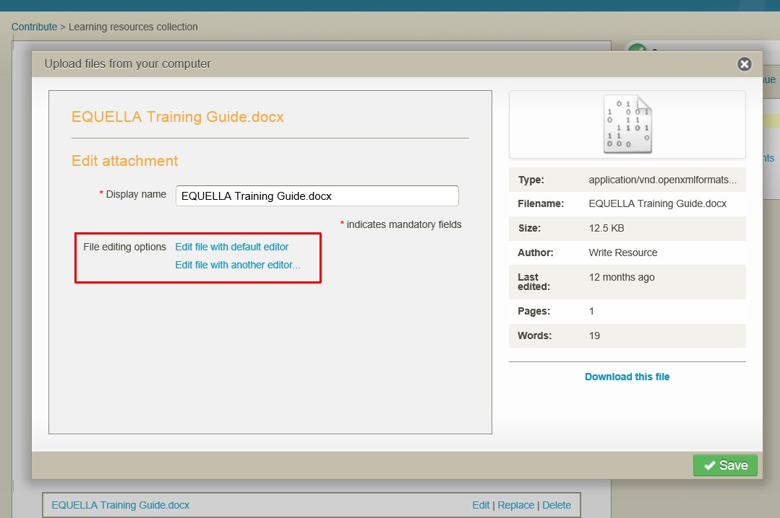

###### Figure 7 File editing options

1. Select the **Edit file with default editor** link to display the document in Word™.
2. Change the document then **Save** and **Close** the document.
3. Select the **Upload changes** button to add the edited document to the resource then select the **Save** button.

### Publish resources

1. Select the **Save** button and **Publish** it to the repository.
2. What did the **Status** change to?
3. Why didn’t the **Version** number change?
4. Review the **Actions** that are available for an *Educator/Researcher* role user for their

*Live* resources.

1. Why shouldn’t a user with an *Educator/Researcher* role have permissions to edit or delete their *Live* resource?
2. Why should you be able to create a new version of this resource? _
3. Add a comment and rate the resource.
4. **Add to Favourites** using the **This version** option.
5. Which navigation menu options can you use to find your *Live* resource?
6. Which portlets help you find your *Live* resources?

### Notifications

The user is alerted to notifications in the **All notifications** section of the **Tasks** portlet, and a bell icon with the number of notifications at the top of the page.

#### Notification exercises

In this exercise you will learn how to check and clear your notifications.

1. Select the **Notifications** icon to display the **Notifications** page.
   1. Review the **Reason** listed and the **Filters** that are applied.
2. Select the **Dashboard** button to display the **Dashboard** page.
3. Select **Resources which the owner notified you of going LIVE** from the **All notifications** section of the **Tasks** portlet to display the **Notifications** page.
   1. Review the **Reason** listed and the **Filters** that are applied.
4. **Clear** the notification.

### New versions

#### Create a new version exercise

In this exercise you will learn how to create a new version of the resource.

1. **Create a new version** of the resource and change the content.
2. **Save** and **Publish** the resource to the EQUELLA Digital Repository.
3. Note any changes in the **Details** section:
4. View the **Moderation history**.
5. Why isn’t the comment displayed?
6. Which version of the resource is displayed in **Favourites**?

##### Review the section

### Thumbnails

The following image thumbnail options can be selected:

* + **Default thumbnail**—displays the first thumbnail listed in the resource on the **Gallery** page. And displays a rotating thumbnail on the **Standard** results page when there are multiple thumbnails listed.
  + **No thumbnail**—no thumbnail is displayed on the **Gallery** page or on the **Standard**

results page.

* + **Select thumbnail**—allows the user to select the thumbnail that is displayed on the

**Gallery** and **Standard** results pages. (The image thumbnails will not rotate).

#### Thumbnail display and reordering exercise

In this exercise you will learn the different image display options.

1. Find your *Live* resource. Note how it is displayed in the **Standard** view
2. Note how it is displayed in the **Gallery** view search results
3. Select the title then select **Edit this version** action to display the contribution form.
4. Select the **Select thumbnail** link. Which thumbnail will be displayed for each option:

###### Default thumbnail

* 1. **No thumbnail**
  2. **Select thumbnail**

1. Choose the *video* using the **Select thumbnail** option then the **Save** button.
2. **Save** the resource. Why aren’t there options to **Save draft** or **Publish**?
3. Note any changes in the **Standard** view search results:
4. Note any changes in the **Gallery** view search results: _

### Collaborate

When a contributor shares the ownership of a resource, they grant the selected users the same permissions as they have.

#### Collaborate exercises

In this exercise you will learn how to add collaborators to a resource.

1. Find your *Live* resource.
2. Select **Change ownership** from the **Actions** pane then select **Add collaborators** link.
3. Use a letter (e.g. *u*), partial name or name (e.g. *user1*) to search for a class participant.
4. Check the box then select the **Select these users** button.
5. What actions will the collaborator now have for this resource that they didn’t have before you shared ownership?
6. What other option is available in the **Owner and collaborators** page?

### Clone existing resources

The **Clone item into a collection** operation allows a resource to be duplicated without saving the history of the original resource. The cloned resource can be added to the same or a different collection, with or without attachments and the original version remains live.

#### Clone a resource exercise

In this exercise you will learn how to clone a resource.

1. Search for *EQUELLA Documentation* resource.
2. Note the **Version** number
3. Review the **Moderation history**.
4. Select the **Clone item into a collection** operation from the **Actions** pane.
5. Select *Learning resources collection* from the **Select a collection** drop-down list.
6. Select the **Clone** button to display the contribution form.
7. Add *<yourname>* to the beginning of the **Title** field (e.g. *Sandra’s Documentation*).
8. Select the **Save** button then **Publish** to add a cloned resource.
9. Why did the version number change? _

##### Review the section then complete the extension exercises if time permits

**Extension exercises**

1. Add Kaltura, Google Book, Flickr and LTI attachments to your resource.
2. Find and familiarise yourself with the *EQUELLA Contribution User Guide*.
3. Refer to (or continue with) the *Further exercises* section on page 42.

# Session 2

This session is to demonstrate and discuss:

* + Learning Management Systems (LMS):
    - Adding resources from EQUELLA to LMS
    - Adding EQUELLA resources through a LMS
  + Digital Rights Management (DRM)
  + User Profile
  + Scrapbook (personal resources), Repository Showcases and selecting existing EQUELLA resources.
  + EQUELLA Support, Professional Services, User Community and Training Courses.

## Content presentation

EQUELLA can be integrated with content presentation software aka Learning Management Systems (LMS). EQUELLA can integrate with:

* + 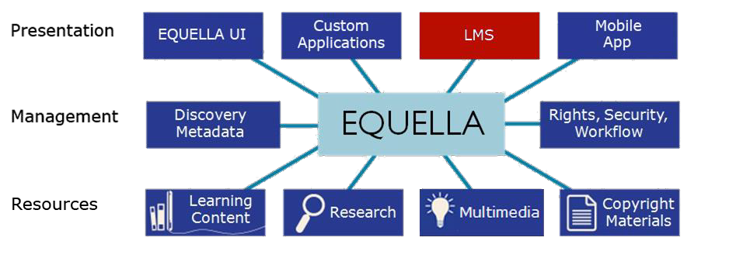Pearson LearningStudio, Fronter, Moodle™, Blackboard Learn™, Sakai™, Canvas and Angel.

Users can create and add resources to courses or contribute resources to EQUELLA from within the LMS.

In Moodle, Blackboard Learn and Canvas LMSs, resources stored in EQUELLA can be linked to in two ways:

* + From EQUELLA using the **Add to external system** action (aka push to LMS).
  + From the LMS using the add EQUELLA resources or object options.

Further information is provided in the *EQUELLA Push to LMS Guide*, *EQUELLA Moodle User Guide*, *EQUELLA Blackboard Learn User Guide* and *EQUELLA Canvas User Guide*.

#### EQUELLA Integration page

The EQUELLA Integration page can allow users to:

* + Search and Browse for resources.
  + Sort, filter and share searches.
  + Add resources and searches to Favourites.
  + View the My resources page.
  + Contribute resources using standard contributions or Quick contribute option.
  + Edit resources and add resources to the LMS. An example EQUELLA page is shown in Figure 8.

<insert Choose EQUELLA resources image>

###### Figure 8 Choose EQUELLA resources page

**Add resources to an LMS exercises**

These exercises use Moodle. Although this may not be your LMS the exercises are designed to show how the EQUELLA integration page works with most LMSs.

In the training Moodle, the courses are listed by course title then the course is set out in sections (e.g. *Introduction*, *User1, User2*).

The courses need to be in editing mode to access EQUELLA.

Login to Moodle

1. Login to <moodle url> using the same username and password given to you by the trainer for EQUELLA.
2. Select the training course for your institution (e.g. *EQUELLA University*, *Sample College*) in the **Navigation** or **My courses** pane to display the course sections.

##### Link EQUELLA resources to a course from the LMS

1. Select the **Turn editing on** button.
2. Select the **+Add an activity or resource** link for your users’ section (e.g. *User 2)*.
3. Select **EQUELLA Resource** option from the **RESOURCES** group.
4. Select the **Add** button to display the **Choose EQUELLA resources**—**Search** page.
5. Which navigation options are available at the top of the page? _
6. Where would you find resources that you have previously contributed?

##### Search for existing resources

1. Search for *The Overland Track* resource.
2. Select the  **Show attachment** button to display the resource content.
3. Select at least 2 content attachments (parts) from the resource (e.g. *Cradle*, *Lake Will*).
4. Which section of the *Training* course will the content be added to? _

##### Browse for existing resources

1. Select the **Browse** option then browse to find the *EQUELLA Documentation* resource summary.
2. Note the four different  options available to select resources to link to your resource. (*Hint: mouse over the + signs*):
3. Select at least 2 content attachments (one uploaded and one external resource) from the resource (e.g. EQUELLA *Support, Overview*).
4. Select the **+ Select package** button.
5. Select the **My resources** option and find your resource.
6. Select the **+ Select all attachments** button.
7. Drag the resource title to the *Introduction* section of the course.
   1. What has been added?_
   2. List an example where you would add a resource summary to your LMS course, class or room?

##### Using Favourites

1. Select the **Favourites** option and find the *EQUELLA User Community* resource.
2. Select the **Show attachments** option then drag an attachment to your section.

##### Review selections

1. Select the **Review all selections** link:
   1. How many sections has content been added to?
   2. Which option from the **Version** list will update these resources when a new live version is added to the repository? _
   3. What will happen when the **Fixed to v<x>** option is selected?
   4. Remove one individual attachment.
   5. Choose applicable version options then select the **OK** button.
2. Select the **Save** button to add the resources to the training course for your institution.
3. Select each of the links to ensure you understand the different ways that content is added. Which button did you select to add the:
   1. Resource summary page
   2. Entire resource content
   3. Individual resource content
   4. Sequenced resource content

##### Review the section

**Link resources to the LMS course from EQUELLA (Push to LMS) exercise**

1. Return to <training url/*<training_id>*
2. Find the *EQ101 new resource <yourname>* resource summary page.
3. Select the **Add to external system** operation from the **Actions** pane.
4. Select an attachment checkbox from the **Select the resources to add** section.
5. Expand your training course in the **Select the locations to add to** section
6. Select your users’ checkbox (e.g. *User 2*).
7. Select the **Add selected resources** button to display a message listing the selected resources in the selected courses.

##### Find the EQUELLA resources linked to the LMS course

1. Return to <moodle url>
2. Select your training course in the **Navigation** or **My courses** pane to display the course sections.
3. Find the resources you added from EQUELLA (using the push to LMS process).
4. Review the **Course updates** list and find the resources you added from EQUELLA.

##### Review the section

### Find uses

The **Find uses** page in EQUELLA displays a list of resources and courses that are linked to this resource or the content attached to this resource.

#### Find uses exercises

In this exercise you will learn where this resource is being used.

1. Return to <training url>*<training_id>*
2. Find the *EQ101 new resource <yourname>* resource then select the **Find uses**

operation from the **Details** section.

* 1. Select the *Moodle* option from the **Searching** drop-down list to display a list of

**Courses** that use this resource.

* 1. Select the **Show details** down arrows on the right of the listed course to display

**Resource version**, **Date modified**, **Name in external system** and course details.

1. **Find uses** for the other resources you added to:
   1. The Moodle course

#### Quick contribute

Quick contribute allows users to upload a file, using the file name as the resource title and description.

##### Quick Contribute exercises

1. Return to [<moodle url>](http://cert-moodle.equella.com/)
2. Select your training course.
3. Select the **+Add an activity or resource** link for your users’ section (e.g. *User 2)*.
4. Select **EQUELLA Resource** option from the **RESOURCES** group.
5. Select the **Add** button to display the **Choose EQUELLA resources**—**Search** page.
6. Select the **Contribute** option to display a list of Collections.
7. **Browse** to select a file then select the **Upload** button.
8. Return to <Equella training url>/*<training_id>*
9. Find the resource.
10. Which collection was the resource added to?
11. Review the information (metadata) and content.

#### Delete resources from the LMS exercises

1. Select the *Training* course and find the resources you added to Moodle
2. Select the **Edit** icon then the **Delete** option to delete all the links that you added.

##### Review the section then complete the extension exercises if time permits

**Extension exercises**

1. Contribute a resource to the Learning resources collection from Moodle.

##### Moodle drag and drop/auto add to EQUELLA

Files can be automatically contributed to EQUELLA when dragging and dropping onto a Moodle course page. If the file already exists in EQUELLA a link to the file is created, otherwise the file is contributed into the configured collection.

##### To drag and drop/auto add to EQUELLA

1. Drag and drop the required file onto the appropriate course section.
2. Search for the file in EQUELLA and review the added information.

#### Delete resources from the LMS exercises

1. Delete all resources you have added in Moodle.

## Digital Rights Management (DRM)

EQUELLA provides digital rights management (DRM) functionality within collections. The attribution of rights to content can be specified by the contributor or automatically generated by the system depending on institutional needs. An example is shown in Figure 9.

The DRM areas are:

* + **Recording ownership**—allows a contributor to attribute ownership rights to one or more parties.
  + **Reuse of the material**—that can include specifying:
    - Broad access rights such as the right to display, print, execute, annotate, etc;
    - That materials can only be used in the educational sector; and
    - That users attribute ownership of the material to the original owners.
  + **Access control**—that can include:
    - Restrictions based on users, groups and IP address ranges; and
    - Specifying a limited number of accesses or restricted date range.
  + **Acceptance of terms**—configured by an administrator or contributor.
  + **Acceptance of a DRM agreement**—by selected:
    - Users, groups or roles; and
    - IP address, HTTP referrer or with SSO identifier.

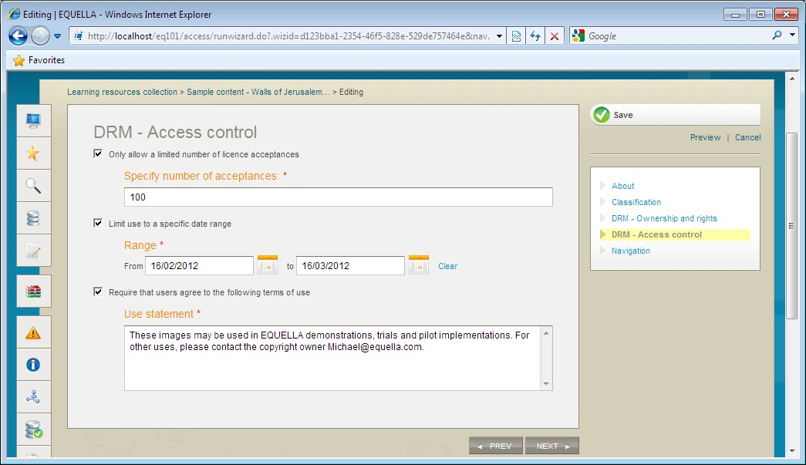

###### Figure 9 Collecting advanced digital rights information

A DRM licence with acceptance requirements can be displayed to users accessing content. An example is shown in Figure 10.

A user can choose to accept, reject or preview the terms.

Licence acceptances are recorded by EQUELLA enabling tracking for review by contributors and administrators.

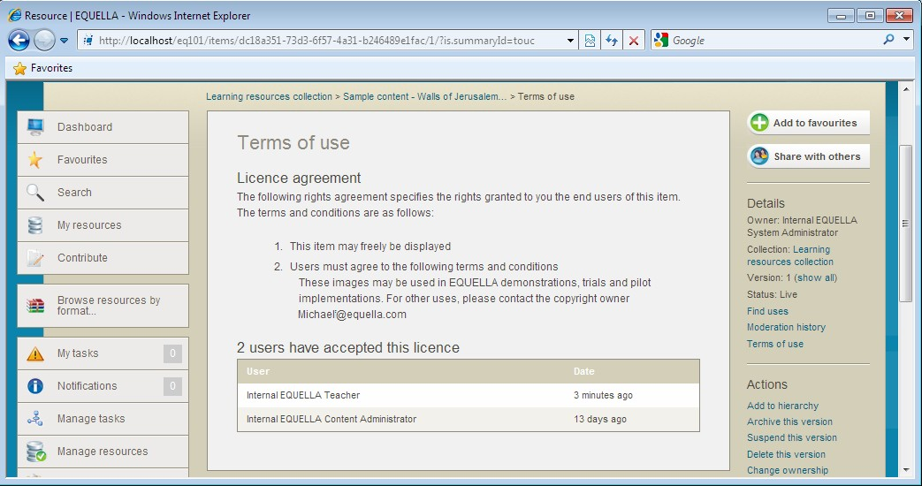

###### Figure 10 Terms of use page

Add DRM to an existing resource

1. **Create a new version** of one of your resources.
2. Select the *Digital Rights Management (DRM)* checkbox to add the *DRM* pages.
3. Select and add details to the **DRM – Ownership and rights** page.
4. Note the ways to limit usage of this resource on the **DRM – Access control** page:
5. Add a **Use statement**.
6. **Save** and **Publish** the resource to the EQUELLA Digital Repository.
7. Read the conditions displayed on the **Terms of use** page then select **Accept**.
8. Select the **Terms of use** link from the **Details** pane.
9. Who has agreed to the licence conditions?

 Review the section then complete the extension exercises if time permits

**Extension exercises**

1. **Create a new version** of one of your resources.
2. Select and change the details on the **DRM – Ownership and rights** page.
3. **Save** and **Publish** the resource.
4. Read the conditions displayed on the Terms of use page. Have they changed?

##### Further exercises (using the training institution)

1. Refer to (or continue with) the *Further exercises* section on page 42.

## User profile

The **Edit user** page displays options that users can change including login notice, accessibility, notifications, language, time zone and date format settings.

#### Edit user profile exercises

1. Select the **Search** button. Review how the **Last updated** date is displayed.
2. Select the **Edit user details** button to display the **Edit user** page, shown in Figure 11.

<insert edit user image>

###### Figure 11 Edit user page

1. Select to **Enable accessibility mode**.
2. Select to be notified when live resources are added or edited in the *Learning resources collection*.
3. Select the *Exact date* option from the **Display date format** drop-down list.
4. Review the other options available.
5. Select the **Save** button.
6. Select the **Search** navigation menu option and review how the:
   1. Drop-down list options and text input fields have changed in accessibility mode.
   2. Last updated date has changed.

## Further exercises

These exercises are intended to improve your familiarity with EQUELLA. Using the training institution, please continue with the exercises in this section as time permits.

#### Scrapbook

The **Scrapbook** page displays personal resources that can include files and web pages.

1. Select the **My Resources** button then **Scrapbook** option to display the **Scrapbook**

results list. An example is shown in Figure 12.

<insert scrapbook page image>

###### Figure 12 My resources | Scrapbook page

**Upload files**

Add a single resource exercise

1. Select the **Upload files** link.
2. Select the **Browse** button to search and select an image file.
3. Select the **Upload file** button to upload the file.
4. Select the **Edit** button and review the **Edit file** options.
5. Enter a **descriptive name** and **tags**.
6. Select the **Save** button.
7. Review the changes.

Add multiple resources exercises

1. Select the **Upload files** link.
2. Drag n drop multiple attachments then select the **Return to scrapbook** button.
3. Review the number of resources uploaded.
4. Enter **Tags** then add a zip file then select an **Archive extraction options** drop-down.
5. Select the **Return to scrapbook** button and review the number of resources uploaded.

#### Author web pages

##### Create web page exercises

1. Select the **Author new web pages** link.
2. Enter a **Description** then select the **Add Page** link.
3. Enter a **Title** then enter text into the editor.
4. Select the **Embed EQUELLA Scrapbook Content** button then the **+** button for your uploaded image file and **OK**.
5. **Save** the page.
6. Select the **Edit** button to display the webpage.
7. Select the **Add page** link.
8. Enter a page **Title** then select the **Toggle full-screen** link.
9. Enter text into the editor then select the **Insert EQUELLA Content** button then select a resource to add a link to the editor.
10. Select the **Add page** link.
11. Enter a page **Title** then enter text into the editor.
12. Select the **Upload a file** button then **Browse** and select a file.
13. Select the **Upload** button to add a link in the editor.
14. **Save** the page.
15. Review all the added resources.

#### Find scrapbook resources

1. Navigate to the **Scrapbook** page from the **My resources** portlet.

#### Use scrapbook resources

The personal resources saved in Scrapbook can be used when users are contributing published resources.

When users are selecting resource types to attach to contributed resources:

* + Scrapbook Files are accessed by selecting the **Upload a file** option then **Import files from scrapbook** link.
  + Scrapbook Web pages are accessed by selecting the **Web pages** option then **Import files from scrapbook** link.

##### Contribute a resource that includes scrapbook content exercise

1. Contribute a resource to the *Learning resources collection* that includes a web page and file from your scrapbook.

#### Repository showcases

##### Common repository types

* + Teaching and Learning, and Research repositories
  + Copyright and Document Management
  + Content Production and Knowledge Management
  + Image Gallery

The following links provide access to a range of other EQUELLA repositories.

* + University of Canberra (Research repository)

[http://www.canberra.edu.au/researchrepository](http://www.canberra.edu.au/researchrepository/access/home.do)

* + Griffith University

<http://equella.rcs.griffith.edu.au/research>

* + Utah Education Network *(Multimedia)*

[http://eq.uen.org/emedia](http://eq.uen.org/emedia/access/home.do)

* + University of Nottingham *(fishbone collection)* <http://fishbone.nottingham.ac.uk>
  + Florida Orange Grove (Content tagged to standards)

<http://florida.theorangegrove.org/og>

* + Oxford Brookes University *(Research repository)*

[https://radar.brookes.ac.uk/radar](https://radar.brookes.ac.uk/radar/access/home.do)

* + North Carolina Community College System

[http://www.nclor.org/nclorprod](http://www.nclor.org/nclorprod/access/home.do)

* + Royal Holloway, University of London

[http://digirep.rhul.ac.uk](http://digirep.rhul.ac.uk/)

#### Use existing resources and content

Resources and content (attachments and links) associated with existing EQUELLA resources can be linked to other resources.

The EQUELLA select page allows users to search for and find resources in EQUELLA and link to them. The Home page features **Search**, **Contribute**, **Browse**, **Selection** and **Recent: Favourites | Contributed | Selected** options**.** An example is shown in Figure 13.

###### <insert equella home page image>

###### Figure 13 EQUELLA Home page

**Select resources exercises**

1. Select the **Contribute** button then the *Learning resources collection*.
2. Enter *EQ101 existing resources<yourname>* in the *Title* field.
3. Enter *An exercise using existing EQUELLA content* in the *Description* field.
4. Select the *Media* checkbox then select the **Add a resource** link.
5. Select the **EQUELLA Resource** option then the **Next** button to display the EQUELLA

**Home** page.

1. Note the search types available:
2. Where would you find resources that you have previously contributed?

Search for existing resources

1. Search for *The Overland Track* resource and *v*iew the resource summary.
2. Note the four different  options available to select resources to link to your resource. (*Hint: mouse over the + signs*):

##### Select existing resources

1. Select at least 2 content attachments (parts) from the resource (e.g. *Cradle*, *Lake Will*).
2. Select the **Browse** option then browse to find the *EQUELLA Documentation* resource.
3. Select the **Show attachment** button.
4. Select at least 2 attachments (one uploaded and one external resource) from the resource (e.g. *Support Site, Overview*).
5. Select the **Return selections** button to display the **My selections** dialog.
6. Will these resources be updated when a new live version is added to the repository?
7. Select the **Return selections** button to add the selections to your resource.
8. **Preview** the resource (*Note*: *Temporarily allow pop-ups*) then close the dialog.
9. **Save** as a **Draft** resource.
10. Review the resource summary and the added resources.
11. Does the newly contributed resource appear in the results of a saved Favourite search?
12. Create another resource using attachments from your computer, a YouTube video and existing EQUELLA resources.
13. Find the *EQUELLA Documentation* resource then select the **Find uses** operation from the **Details** section.
14. .Select the locations to add to:
    1. Select the **EQUELLA** option from the **Searching** drop-down list to display a list of EQUELLA Linking resources that use this resource.
    2. Select the **Show details** down arrows on the right of the listed resource to display Resource version, Date modified, Attachment, Name in external system and Owner details.
    3. Find the <*yourname*> Documentation resource then select the **Find uses**

operation from the **Details** section.

* 1. Select the **Moodle** option from the **Searching** drop-down list to display a list of

**Courses** that use this resource.

* 1. Select the Show details down arrows on the right of the listed course to display Resource version, Date modified, Name in external system and course details.

1. **Find uses** for the other resources you added to:
   1. The Moodle course
   2. EQUELLA resources.

## EQUELLA Client support

* User level support—typically provided by a local support team lead by the system administrator. Contact your local support team as the first step to resolving user issues.
* Institution level support— <insert additional support info here>

#### Training Courses

EQUELLA provides the following training courses:

* **EQ101**—Core Principles (1 day workshop)
* **EQ201**—Content Administrator (1 day workshop)
* **EQ301**—Application Administrator (3 day workshop)
* **EQ302**—Advanced Application Administrator (1 day workshop)
* **EQ303**—Reporting Workshop (2-3 day workshop)
* **EQ304**—EBI Workshop (1/2 day workshop)
* **EQ305**—Scripting Workshop (1 day workshop)
* **EQ306**—Advanced Scripting Workshop (2 day workshop)
* **EQ401**—System Administrator (2 day workshop)

## International User Community

The EQUELLA User Community enables members to contribute, share and stay connected with other users globally, while extending their knowledge of EQUELLA.

The following EQUELLA resources can be accessed:

* EQUELLA documentation
* Installer, upgrades, Internationalisation packs, sample reports and miscellaneous tools.

To join the EQUELLA User Community please see [www.equella.com](http://www.equella.com)