**EQUELLA**

**EQ201 CONTENT ADMINISTRATOR WORKBOOK**

###### Version 6.3

#### Table of Contents

Course Outline 5

Session 1 6

EQ201 introduction 6

Use existing resources and content 6

Create a navigation structure 8

Metadata schemas 10

XML example 11

Viewing XML information 11

Moderation workflow 13

Moderate a resource 15

Redraft a rejected resource 18

Manage moderation tasks 19

Notifications 20

Resource management 21

Manage resources 23

Session 2 28

Copyright compliance management 28

Contributing copied material 29

Use and activation of copied content 29

Managing activations 30

Generating copyright compliance reports 30

Activation 32

Manage the activations 32

Review activations 33

Manage external resources 34

Reports 36

EQUELLA bulk upload options 38

User profile 39

EQUELLA Client support 40

Training 40

International User Community 40

Repository showcases 41

# Course Outline

This course is a practical exercise in understanding the EQUELLA Digital Repository. It is designed for users who manage resources in the EQUELLA Digital Repository. EQ201 covers the following areas of EQUELLA Digital Repository:

* Content Management
* Searching and indexing
* Resource structure and XML
* Creating a structure for EQUELLA resources
* Moderation Workflow
* Bulk Resource Management
* Content, Rights and Copyright Collections
* Bulk upload options
* Generate Reports
* User details
* EQUELLA support

EQ101 is a prerequisite for this and other EQUELLA courses.

#### A few important points about EQUELLA

* EQUELLA is customisable and therefore each educational institute can set up EQUELLA to suit their business needs. Often this makes learning EQUELLA seem confusing and complex at first as it is different to the supplied documentation.
* EQUELLA is privilege/permission based and different access privileges are given to different users. Some users can only search, others can add content or have control of the security (privileges). It is important that different users have different privileges, for example a student can only access exam questions while a teacher can also access the answers.
  + In EQ201 users are assigned *Content Administrator* role privileges and have access to administer other user’s resources.
  + Participants interested in extending their EQUELLA knowledge should join an EQ301 Application Administrator training course, which is a practical course in configuring an EQUELLA institution for organisational use.

# Session 1

This session is to demonstrate and discuss:

* Creating a structure for EQUELLA resources
* Restricting attachments and Content management
* Searching and indexing
* Resource structure and XML
* Moderation workflow
* Bulk resource management

## EQ201 introduction

To login:

1. Navigate to <training url>/*<training_id>*
2. Enter the username and password given to you by the trainer.
3. Select **Login** then select **OK** for the Notice dialog to display the **Dashboard** page.

## Use existing resources and content

Attachments and links associated with existing EQUELLA resources can be linked to other resources. Users can also organise resource content (attachments and links) into a structure with customised navigation (also known as sequenced content).

The EQUELLA select page allows users to search for and find resources in EQUELLA and link to them. An example is shown in Figure 1.

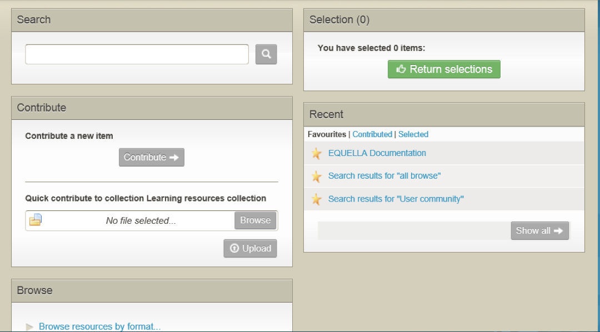

###### Figure 1 EQUELLA select page

**Select resources exercises**

In these exercises you will learn how to create a new resource using existing content.

Select existing EQUELLA resources

1. Select the **Contribute** button then the *Learning resources* collection.
2. Enter a **Title** (e.g. *Structure example <yourname>*) and **Description**.
3. Select the *Media* checkbox then select the **Add a resource** link.
4. Select the **EQUELLA Resource** option then **Next** button to display the **Home** page.

##### Search for existing resources

1. Search for *The Overland Track* resource and view the resource summary.
2. Note the four different  options available to select resources to link to your resource. (*Hint: mouse over the + signs*):
3. Select at least 2 attachments resources (e.g. *Cradle*, *Lake Will*).
4. Select the **Browse** option then browse to find the *EQUELLA Documentation* resource.
5. Select the **Show attachment** button.
6. Select the *EQUELLA Support* link plus one PDF attachment (e.g. *Overview*) from the resource.
7. Select the **Return selections** button to display the **My selections** dialog.
   1. Selecting which **Version** option means resources will be updated when a new live version is added to the repository?
   2. Selecting which **Version** option means the resources will always be linked to this version?
8. Select the **Return selections** button to add the selections to your resource.

##### Add restricted resources

1. Select the **Add a resource** link then select the **Upload a file** option.
2. Select the **Next** button then add a Word document file (e.g. *EQUELLA Overview.doc*).
3. Select the **Next** button.
4. Check the **Restrict** box then select the **Save** button.
5. **Preview** the resource (*Note: Temporarily allow pop-ups*)
6. Is the file you restricted displayed?
7. Select the **Reorder attachments** link and move the attachments.
8. **Save** the reordering then close the preview and select **Save Draft**.
9. Review the resource summary and note how the added resources are displayed.

##### Review the section

### Create a navigation structure

In these exercises you will learn how to add structure to a resource.

**Build a structure (sequenced content) exercises**

1. Find your draft resource (e.g. *Structure example <yourname>*).
2. Select **Edit this version** in the **Actions** pane to display the contribution form.
3. Select the **Add a structure or sequence to the content** checkbox to add the

**Navigation** page.

1. Go to the **Navigation** page.
2. 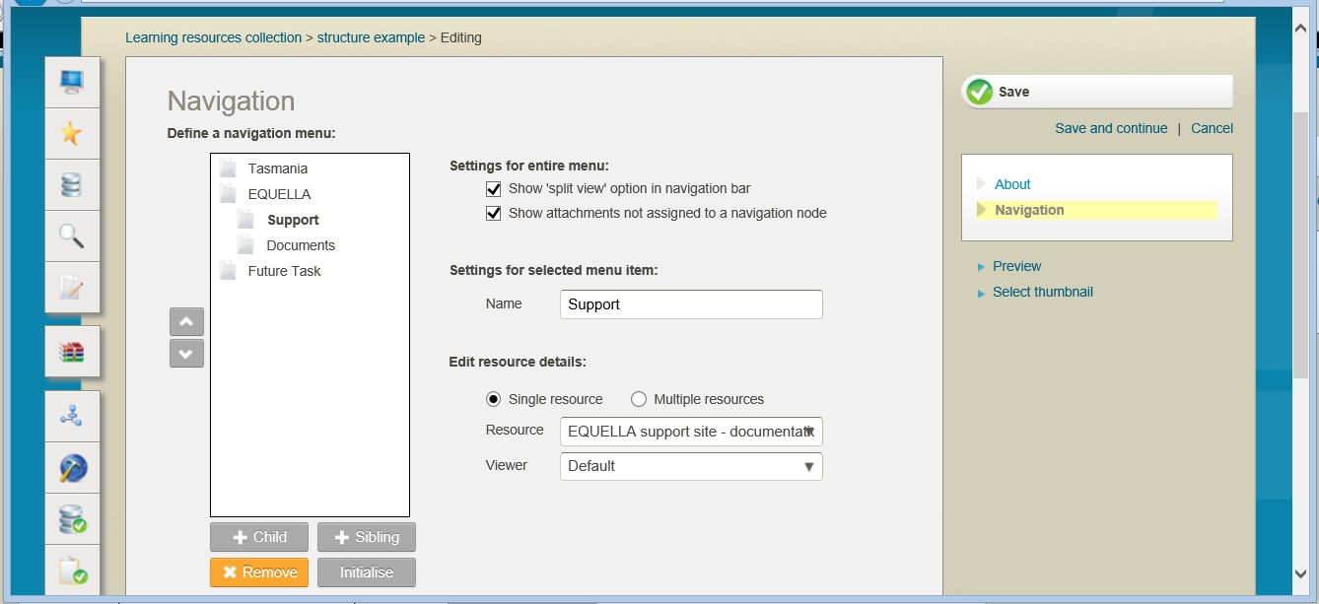Check the **Show ‘split view’** option in navigation bar checkbox to allow users to view different tabs side by side. A completed example is shown in Figure 2.

###### Figure 2 Navigation page

1. Select the **Sibling** button to add a folder.
2. Enter a **Name** (e.g. *Tasmania*).

Add structure with multiple resources (tabs)

1. Select **Multiple resources** option then **Tab** 1 link.
2. Select a resource (e.g. *Cradle*) from the **Resource** drop-down list.
3. Change the **Name** of the tab (e.g. *Mountain*) then select **Save**.
4. Select the **Add resource** button.
5. Select a resource (e.g. *Lake Will*) from the **Resource** drop-down list.
6. Change the Name of the tab (e.g. *Lake*) then select **Save**.

##### Add structure with sub-folders

1. Select the **Sibling** button to add a folder.
2. Enter a **Name** (e.g. *EQUELLA*).
3. Select the **Child** button to add a folder.
4. Enter a **Name** (e.g. *Support*).
5. Select **Single resources** option.
6. Select a resource (e.g. *EQUELLA Support*) from the **Resource** drop-down list.
7. Select the **Sibling** button to add a folder.
8. Enter a **Name** (e.g. *Documents*).
9. Select the **Single resources** option.
10. Select a resource (e.g. *Overview Whitepaper*) from the **Resource** drop-down list.
11. Preview the resource (Note: *Temporarily allow pop-ups*) then close the dialog.
12. Save and **Publish** the resource to the EQUELLA Digital Repository.

##### To view the resource structure

1. Select the **Full screen** link under the **Links to resources** section to display the structured resources.
2. Select the resource title (e.g. *Structure example <yourname>*) to return to the resource summary.

##### To view restricted attachments

1. Login using *student* **Username** and *equella* **Password**.
2. Find your resource summary (e.g. *Structure example <yourname>*).
3. Is the file you restricted displayed?

##### Review the section then complete the extension exercises if time permits

**Extension exercises**

1. Create a structured resource using attachments from your computer, a YouTube video and existing EQUELLA resources.

## Metadata schemas

The information collected during contribution is in fact metadata and its fundamental purpose is to make content discovery and management easier.

Organisation of metadata is controlled by the metadata template called a **Metadata Schema**. A metadata schema:

* Typically comprises a number of elements or nodes arranged in a hierarchy.
* Provides a structure for information that is copied each time a new resource is contributed.
* Provides a map for EQUELLA to enable it to find or store the required information.
* Written using XML (Extensible Markup Language)
* Schemas are used in collections, workflows and searching.

Schemas provide structure and organisation to data. It ensures that there are consistent labels and locations for data stored with resources.

Standard schemas have been developed to improve the reusability of digital materials between repositories. Commonly used standards are Learning object metadata (LOM) (<http://www.imsglobal.org/metadata/mdv1p3/imsmd_bestv1p3.html#1621612>), and Dublin Core (DC) (<http://dublincore.org/documents/dces/>).

##### EQUELLA Metadata Schema editor

EQUELLA provides an editor for creating schemas and places no restrictions on their structure. EQUELLA implements all schemas using XML enabling:

* Translation or mapping of metadata from one schema to another using XSLT.
* Importation of existing XML schemas.

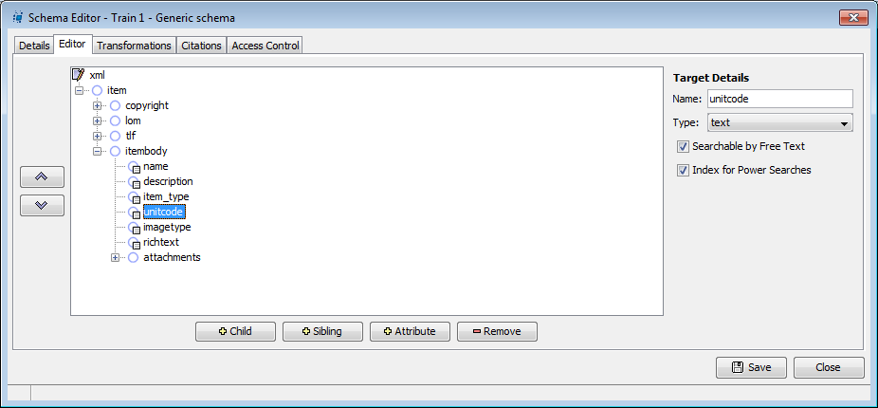

###### Figure 3 Metadata schema

**Locating XML information**

XML information is located in nodes (sometimes called elements). To find the data in a node a consistent means of describing the location of each node is needed. This is called the Xpath and describes all the nodes that surround the data from the top down e.g. *item/itembody/unitcode*.

### XML example

XML is a text file that comprises tags that mark out data. XML files comprise a lot of

‘visual noise’ but they are only structured text files that have data surrounded by tags.

Within an XML file a start tag and end tag pair define an element, commonly called a node. An element can comprise data; data and attributes; or child elements, data and attributes.

#### A simple element

<description lang=”en-AU”>This resource comprises electron microscope images of water microbes.</description>

This element comprises data and attributes:

* **Data**—the text that appears between the start and end tag, This resource comprises electron microscope images of water microbes.
* **Attributes**—any *name=value* pair that appears inside the start tag, in this example

*lang=”en-AU”*.

### Viewing XML information

EQUELLA resources, their attachments and XSLTs can be viewed by inserting a tildé character ‘~’ immediately after the version number in the URL e.g.

[*http://myequella.edu.au/learning/resources5b0dbc71-b444-3789-d6e5/2/~*](http://myequella.edu.au/learning/items5b0dbc71-b444-3789-d6e5/2/%7E)

#### Resource structure and XML exercises

In these exercises you will learn about components of the URL and resource XML.

##### Contribute a resource

1. Find your resource (e.g. *Structure example <yourname>*) and view the summary.
2. **Edit** the resource and attach a file.
3. Add applicable **Classification information (metadata)**.
4. **Save** the resource.
5. **Browse** to find the resource and view the summary.

#### Components of the EQUELLA URL

1. Note the 4 components of the URL.
   1. EQUELLA server name_
   2. Institution name
   3. Resource unique ID
   4. Version number

#### Resource XML

1. Use the tilde (~) to view the resource XML and parts.
2. What is listed on the page?
3. Why is the attached file the only resource content that is listed?

#### Resource and system metadata

1. Use *<XML>* to view the resource and system metadata.
2. Note the two ways to do this:

#### Generated XML

The displayed XML will be a combination of:

* entered metadata and
* system generated metadata.

The system generated XML nodes are appended to the resource metadata schema and cannot be accessed when editing a schema. System generated XML contains system related information such as:

* resource ID
* version number
* date of creation or editing
* workflow steps

From the resource’s XML:

1. Note an example of system generated XML
2. Note an example of user entered metadata

##### Review the section then complete the extension exercises if time permits

**Extension exercises**

1. Find the *EQUELLA Documentation* resource then repeat the exercises. This exercise is intended to improve your familiarity with your EQUELLA.

1. Login to your EQUELLA (not the training institution) then find a resource.
2. Repeat the exercises from the *Components of the URL* section.

## Moderation workflow

Workflows are associated with a collection and can be a simple one-step review or complex multi-step editorial and technical review comprising multiple publication paths.

EQUELLA automatically notifies users when they must review or moderate a repository resource.

Users can review their resource’s moderation status from the:

* **My resources | Moderation queue** page—displays resources currently waiting for moderation for the logged in user.

Moderators can be notified about tasks in various ways including:

* **Tasks** portlet—displays the number of pending tasks.
* **My tasks** page—displays the tasks waiting to be moderated, shown in Figure 4 on page 13.
* **RSS feeds**—displays updated information about tasks and notifications.
* **Notifications** page:
* **Moderation overdue**—notification displayed when the date for the current moderation task has passed.
* **Rejected**—notification displayed when a resource has been rejected during a moderation task.
* **Notifications** portlet:
* **Resources that are overdue to be moderated**—notification displayed when the date for the current task to be moderated by has passed.
* **Resources that were rejected**—notification displayed when a resource has been rejected during a moderation task.
* **Notification emails**—sent to alert the user to new notifications, moderation tasks and when moderation is overdue.

Content administrators can manage resource progress through moderation from the:

* **Manage tasks** page—displays the moderation progress of all moderation tasks.
* **Task statistic** portlet—displays information relating to the number of tasks in a workflow over a weekly or monthly time period.

<insert image of My tasks page>

###### Figure 4 My tasks page

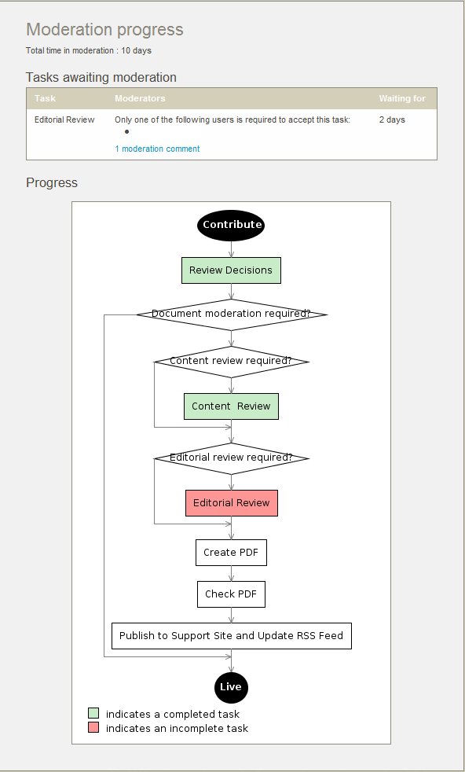Once the moderators have completed their review the next step in the workflow is determined by the moderator’s responses. The moderation progress and history pages display the resource’s moderator details, all task review events and moderation progress, an example is shown in Figure 5.

###### Figure 5 Moderation progress

Resources enter a workflow when they are:

* **Contributed**—the resource enters the workflow associated with the contributed collection.
* **Versioned**—a new version enters the workflow and on completion archives all other ‘live’ versions.
* **Reviewed**—a resource that has been ‘live’ for some period is checked for currency. The resource remains searchable during this review.

Further information is provided in the *EQUELLA Moderation Workflow User Guide.*

**Moderation workflow exercises**

In these exercises you will add a resource to the *training* moderation workflow and moderate it at two different tasks.

##### Contribute a resource

1. Contribute a resource (e.g. *Moderation example<yourname>*) to the *Learning resources* collection.
   1. Attach a Word Document.
2. Select the **Save** button and add a message for the moderator (e.g. *please check the attached document*).
3. Select the **Submit for moderation** button.

##### Share with others

For *moderating* resources, the *Share with others* function enables the user to set up a notification to be sent to selected EQUELLA users when the resource status becomes *Live*, so they are aware that the resource is available for use.

1. Select the **Share with others** button then the **Select more users to notify** link.
2. Use a letter, partial name or name to search and find then **Select these users** to notify all the other users in the class (including yourself) about this resource.

##### Review the section

### Moderate a resource

To moderate the first task

1. Select the **Tasks** button to display the **My task** page with a list of resources you can moderate.
2. The list can be sorted by:
3. Familiarise yourself with the filters that can be applied.
4. Filter the list to *Assigned to me* then **Clear** the filters.
5. Select the **Select user** button to filter the list to only include your resources.
6. For the resource (e.g. *Moderation example<yourname>*) note the:

###### Status

* 1. **Task** and **Expiry date**
  2. **Time at this task**
  3. **Priority**
  4. Read the **moderation comment** then close the dialog.

1. Select the **Moderate** button to display a **Task** pane.
2. Read the task description.
3. View the list of moderators for this task.

##### To assign and review the task

1. Select **assign to me** to assign the task to yourself.
2. Select the **View summary** button.
3. Note the:

###### Version

* 1. **Status**

1. Select **Moderation progress** from the **Details** pane.
2. Review the information this page provides.
3. Select the **View metadata** button to display the un-editable contribution form.

##### To edit the resource

1. Select the **Edit resource** button to display the editable contribution form.
2. Review the information (metadata) and make a change to the title or description.
3. Select the **Edit** link for the attached document to display the **Upload files from your computer** dialog.
4. Select a **File editing option** to open the document then make a change and save.
5. Select the **Upload changes** button then the **Save** button.
6. Select the *Classification information* checkbox to add the **Classification** page.
7. Go to the **Classification** page then add some applicable information.
8. Select the **Save** button to save the edited resource.

##### To approve the task

1. Select the **Approve** button.
2. Note the comments previously added then enter an applicable **Approving task**

message.

1. Select the **Submit** button.

##### Review the section

To moderate the next task

1. Select the **Tasks** button to display the **My task** page with a list of resources you can moderate.
2. Find your resource (e.g. *Moderation example <yourname>*) then review the information.

##### To review and assign the task

1. Select the **Moderation progress** link.
2. Review the information this page provides and note the completed and current tasks.
3. Read the task description.
4. View the list of possible moderators for this task.
5. Why is this task already assigned to me?
6. If you had not been a moderator at the previous task, would the task be assigned to anyone or unassigned?_
7. Note the:

###### Version

* 1. **Status**

1. Select **Moderation history** from the **Details** pane.
2. Review the information and read the comments that have been added.
3. Note the moderation task that has just been accepted
4. Select the **View metadata** button to display the un-editable contribution form.

##### To reject the task

1. Select the **Reject** button.
2. Add a mandatory comment.
3. Select the *Original Contributor* from the **Rejection back to** drop-down list.
4. Note the other rejection destination list option
5. Select the **Submit** button to confirm the rejection.

##### Review the section

### Redraft a rejected resource

To re-enter a workflow the *Redraft* action must be used.

##### To find the rejected resource

1. Select the **Dashboard** button to display the **Dashboard** page.
2. List 2 places where notifications are shown:
3. Review the **All notifications** section of the **Tasks** portlet.
4. Select the **Resources that were rejected** notification category.
5. Select the  **Notifications** button to display the **Notifications** page with a list of resources that have been rejected or you were notified about.
6. Which filter has been applied and why?
7. Select the resource (e.g. *Moderation example<yourname>*) title to display the resource summary page.
8. Note the:

###### Version

* 1. **Status**

1. Select **Moderation history** from the **Details** pane to display the **Moderation history** list.
2. Select the **Show comment** link and read the **Rejected** comment.

##### To redraft the resource

1. Select the **Include all moderation details** option.
2. Select the **Redraft this version** option from the **Actions** pane.
3. What will happen when the following options are selected?

###### Redraft

* 1. **Edit this version**
  2. **Create a new version**

1. Review the information (metadata) and make a change.
2. Complete the form then **Save** and resubmit the resource into the moderation workflow.

*(NOTE: the Rejected notification is automatically cleared when the resource has been redrafted.)*

##### Review the section

## Manage moderation tasks

Content administrators can manage the progress of resources through multiple moderation processes.

Tasks can be managed from the:

* **Tasks Statistics** portlet and
* **Manage tasks** page.

#### Task statistics exercises

In these exercises you will learn about task statistics.

1. Add a **Tasks statistics** portlet to your **Dashboard** page.
2. Review the **Tasks statistics** portlet on your Dashboard page.
3. Select **Weekly** trend:
   1. Review the number of resources currently **Waiting** moderation at each task.
   2. Review the **Trend** changes from the previous week.
4. Select **Monthly** trend:
   1. Review the number of resources currently **Waiting** moderation at each task.
   2. Review the **Trend** changes from the previous month.

#### Manage tasks exercises

In these exercises you will learn about managing tasks.

1. Select the **Manage tasks** button to display the **Manage task** page with a list of resources manage.
2. Review the information provided to the tasks manager.
3. Select the **Share** tab and review the options provided.
4. The list can be sorted by:
5. **Filter by moderator** to only display your resources.
6. Select the **<x> remaining moderators** link to display the moderators list.
7. Select the resource (e.g. *Moderation example<yourname>*) title to display the

###### Moderation progress page.

1. Select the **Manage tasks** button to display the **Manage task** page.

 Review the section

## Notifications

Notifications are messages related to a moderation workflow including when a task has been has been rejected, moderation is overdue or a resource becomes *Live.*

Notifications are available from the **Notifications** section of the **Tasks** portlet and

**Notifications** page and include:

* **Moderation overdue**—current task moderation date has passed. These notifications are automatically cleared once the overdue task is moderated.
* **Watched resource became LIVE**—a resource belonging to a collection selected for notifications has become *Live.* These notifications are cleared manually.
* **Bad URL**—a resource contains a URL that has an invalid web address. These notifications are automatically cleared once all bad links are corrected.
* **Owner notified you**—the owner has notified the logged in user that a resource has become available *Live*. These notifications are cleared manually.
* **Rejected**—a resource has been rejected during a moderation task. These notifications are automatically cleared once the associated resources have been redrafted.

#### Notification exercises

1. Moderate your resource and publish it. (It should have a *Live* status.)
2. Have you received any notifications about resources going Live?
3. List 2 places where these notifications are displayed
4. Note each **Reason** on the **Notifications** page and find its corresponding link in the

**Notifications** list of the **Tasks** portlet:



##### Review the section then complete the extension exercises if time permits

**Extension exercises**

1. Add a resource to a workflow collection then reject it.
2. Edit the rejected resource then create a new version to ensure you understand the differences.
3. Refer to the *EQUELLA Workflow Moderation User Guide*.

This exercise is intended to improve your familiarity with your EQUELLA.

1. Login to your EQUELLA (not the training institution).
2. Repeat the exercises from the *Moderation* section.

## Resource management

Content administrators can manage resources, either individually or as bulk actions, regardless of ownership.

Resources can be managed:

* Individually from the resource’s summary page.
* As bulk actions from the Manage resources page.

#### Resource summary exercises

In these exercises you will learn about managing resources in EQUELLA. Resources can be managed individually from the resource summary page.

1. Find the *EQUELLA Documentation* resource and view the resource summary.

#### Details pane

The **Details** area of the resource summary displays information about the resource.

##### Find uses option

The **Find uses** page displays a list of the current uses of this resource in a connected LMS (Moodle or Blackboard Learn) course or EQUELLA resources.

1. Select **Find uses** from the **Details** pane.
2. Select *EQUELLA* from the **Searching** drop-down list.
   1. Review where the content from this resource is being used.
   2. Select the **Show all versions of this resource** checkbox.
   3. Select the **Include non-live items** checkbox.

##### History option

1. Select **Moderation history** option from the **Details** pane.
2. View all edits, details and comments.

##### Review the section

**Actions pane**

The **Actions** area of the resource summary displays options for editing and managing the resource.

1. Find your resource (e.g. *Structure example <yourname>*) and view the resource summary.

##### Key resource option

**Key resources** are important resources for a browse hierarchy topic and are displayed at the top of the results list. Resources can be added as key resources to one or more hierarchy topics.

1. Select the **Modify key resource** option from the **Actions** pane.
2. Browse the hierarchy topics then select the applicable checkbox.
3. Select the **Save** button.
4. Navigate to the **Browse** hierarchy topics and find your resource.
5. What special type of resource has this resource been added as?
6. Remove this resource as a key resource from the hierarchy topic.
7. What other options would be applicable hierarchy topics for this resource?

##### Export option

1. Find your resource (e.g. *Structure example <yourname>*) and view the resource summary.
2. Select the **Export** option to display the **Export** page.
3. Note the **formats** that can be used when exporting this resource:

##### Review the section

## Manage resources

Bulk management actions can be performed on the **Manage Resources** page (accessed through the **Manage Resources** button). An example is shown in Figure 6.

###### 

###### Figure 6 Manage resources page

Actions that can be carried out include:

* **Re-draft**—returns the selected resources to *Draft* status.
* **Submit for Moderation**—submits the selected *Draft* resources to the moderation queue.
* **Delete**—removes resources from the repository, sets the resource status to *Deleted*

and marks it for purging with the next scheduled purge task.

* + **Restore**—sets the *Deleted* resource status back to *Live.*
  + **Purge**—permanently removes *Deleted* resources. It is irreversible and purged resources ***cannot*** be recovered as they are removed from the database.
* **Archive**—changes a *Live* status to *Archived.*
  + **Make live**—sets the *Archived* resource status back to *Live.*
* **Reset Workflow**—restarts the Moderation Workflow.
* **Suspend**—sets the selected resources to *Suspended* which hides the resource from searches and is intended for temporary removal of resources from the repository
  + **Resume**—sets the *Suspended* resource status back to *Live.*
* **Review**—puts a resource back into a Moderation Workflow and sets the resource status to *Review*. It is intended for resources that have completed a workflow and allows resources in the *live* state to be checked for currency.
* **Change Owner**—allows the resource owner to be changed to another EQUELLA user.
* **Clone**—allows a resource to be duplicated without saving the history of the original resource.
* **Move**—allows a resource to be transferred to a new Collection.

*(Note: Care is required when using these actions.)*

Further information is provided in the *EQUELLA Manage Resources User Guide*.

#### Resource administration exercises

In these exercises you will learn about managing all resources in EQUELLA.

1. Select the **Manage resources** button to display the **Manage resources** page.
2. Filter the list to *Live* resources.
3. Reduce the number of resources by:
   1. Search terms (e.g. *equella*).
   2. Collection (e.g. *Learning resources collection).*
   3. A different status.
   4. Date last modified.
4. Clear the filters.
5. Which search criteria were not removed?
6. Remove the search terms and options.

##### Advanced Management exercises

1. Select the *Learning resources collection* from the **Within** drop-down list.
2. Select the **+Add criterion** button to display the **Add search criteria** dialog.
3. Enter a query using the operators (e.g. **Where** *item/lom/technical/format* **is** *video*).
4. Select the **Add criterion** then **Search** button to find resources.
5. Select the **Edit query** button and add extra criteria (e.g. **AND**

*item/itembody/imagetype* **is** *Colour photo*).

1. Select the **Add criterion** then **Search** button to find resources.
2. **Clear** the query then search terms and options.

##### Review the section

**Perform an action**

In these exercises you will learn about bulk actions.

1. **Filter by owner** to only display your resources.
2. **Clone** a *Live* resource and select the *Draft* option.
3. **Clone** a *Live* resource and select the *Moderating* option.
4. View the **Moderation history** for the original resource and the cloned resources and compare.
5. Select the **Manage resources** button to display the **Managed resources** page.
   1. Is the list still filtered by owner?
6. **Move** a resource.
   1. How is this different to a cloned resource?
7. **Delete** a resource.
   1. What happens if the resource is *Purged*?
   2. **Restore** the resource.
8. **Change ownership** of a resource to another class member.
   1. Why is the resource not listed in the **Manage resources** results list?
   2. To find the resource in the **Manage resources** results list you would have to?
9. **Archive** one of your resources.
   1. What status does a resource have to be before it can be archived?
   2. Make the resource *Live* again.
10. **Re-draft** a *Live* resource.
    1. Note the resource status and version
11. Change a resource to **Review** status*.*
12. **Create a new version** for a *Live* resource.
    1. Note the resource status and version
13. **Edit** the new versioned resource.
    1. Note the resource status and version

##### View resources currently in a moderation

1. Filter the resource using the **Only show resources in moderation** checkbox.
2. Which other Filter by section is displayed?
3. List the resource status types:

##### Filters

1. Review the filters available.
2. When would you use the **Show items with no owner** option?

#### Actions exercises

In this exercise you will compare the actions that are available using the **Manage resources** page and through a resource summary page.

1. Find one of your *Live* resources and view a resource summary.
2. What **Actions** are available to a Content Administrator?

then

then or

* 1. then

1. Which **Actions** are only available through the:
   1. Manage resources page
   2. Resource summary page

#### Review exercises

1. Search for all resources in the repository.
2. List the resource status types:
3. Where would you find *Archived* resources:
   1. As an owner?
   2. As a Content administrator? Filter by
4. Where would you find *Moderating* resources:
   1. As an owner?
   2. As a Content administrator? Filter by
5. List the workflow status types that can be displayed on the **My task** page:
6. List the workflow status type that can be displayed on the **Notifications** page:

##### Review the section then complete the extension exercises if time permits

**Extension exercises**

1. Find the EQUELLA User Community resource and remove a comment.
2. Refer to the *EQUELLA Manage Resources User Guide.*

This exercise is intended to improve your familiarity with your EQUELLA.

1. Login to your EQUELLA (not the training institution).
2. View the actions available from a resource summary for a resource you own.
3. Review all actions in the **Bulk actions** dialog. *Recall that care is required for actions.*

# Session 2

This session is to:

* Demonstrate and discuss:
* Content, rights and copyright collections
* Generate reports
* Bulk upload options
* User details
* EQUELLA support

## Copyright compliance management

EQUELLA supports the concurrent use of Australian Copyright Agency Limited (CAL) and the United Kingdom Copyright Licensing Agency Limited (CLA) agreements.

The EQUELLA copyright compliance features include the ability to activate specific attachments (typically book chapters and journal articles) for particular periods within a course to ensure compliance with local copyright laws. EQUELLA automatically tracks content usage of the activated resources and produces the appropriate reports, reducing the reporting work load for institutions.

The copyright features provide custom activation error messages and copyright status agreements for display to users.

Further information is available in the *EQUELLA Copyright (CAL & CLA) Enhancements Overview Guide.*

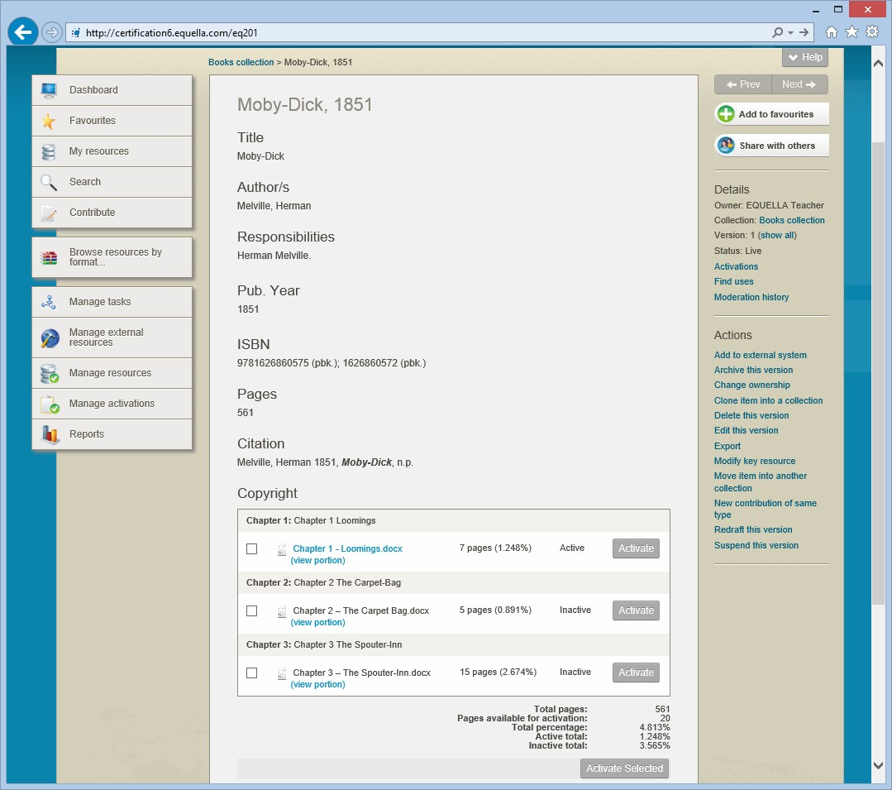

###### Figure 7 Active and inactive portions that are linked to a parent resource

### Contributing copied material

Copyright resources are contributed to the repository through interrelated collection definitions. Typically a parent resource (source book or journal details) is contributed to a holding collection then the sections (copied or electronic book chapters or journal articles) are added to the portion collection and linked to the parent resource in the holding collection.

The remote repository search features allow users to search for source details from a variety of external sources and automatically add them to EQUELLA.

### Use and activation of copied content

There are no restrictions on the amount of copyright content that can be contributed to the repository but it cannot be used until it has been activated. Content is activated when it is added to a course. Activation signals to the copyright compliance module that content usage should now be recorded and copyright compliance enforced. If the activation violates the copyright requirements, an error message is displayed and the content will not be made active. Once activated the content is viewable by course users.

The copyright states include:

* **Inactive**—not currently activated
* **Active**—currently activated
* **Pending**—date set for future activation.

### Managing activations

Resource activations can be tracked by content contributors and deleted, deactivated or rolled over for future courses by administrators.

Multiple or individual resources can be:

* **Deactivated**—if they are not required prior to the end of the activation period.
* **Deleted**—if they have been incorrectly activated.
* **Rolled-over**—if they are required for a new time period, for the same or different course.

Activation details are stored in the portion resource’s unified xml.

### Generating copyright compliance reports

EQUELLA generates reports that show all activated content for the reporting period. These reports are provided in a CAL or CLA format.

#### Notes

**Copyright exercises**

In these exercise you will learn about holdings, portions, activations and managing copyright resources.

The *Books collection* used in the following sections has been set up using 10% (default) as the Part VB book percentage.

##### Contribute a holding resource

1. Select the *Books – Libraries Australia* source from the **Contribute** page.
2. What type of repository are you searching?
3. Enter search terms (e.g. *Global education*) then select the **Search** button.
4. Select a result to display the information page.
5. Select the **Import** button to display the contribution form.
6. Add <*yourname*> to the beginning of the **Book Title** (*Note: this is only something for this training*).
7. Ensure all the mandatory fields are completed.
8. Make the **Total number of pages** for this book a number (e.g. *100*).
9. **Save** and **Publish** the holding resource.
10. Review the **Copyright** section at the bottom of the summary page.

##### Contribute a portion resource

1. Select the **Contribute** button to display the **Contribute** page.
2. Select the *eReserve articles collection* in the *Copyright* category to display the contribution form.
3. Add an attachment (e.g. *Global Education Overview.pdf*).
4. Enter a **Page range** (e.g. *1-10*).
5. Select the **Type** (e.g. *Book extract*).
6. Search and select the **Book** (e.g. *<yourname> Education for a global society*).
7. Select the **Select item** button then **Return selection** button.
8. Select the **Save** button to link the holding resource to the portion contribution form.
9. Enter **Chapter number** (e.g. *1*).
10. Enter a **Title** (e.g. *Overview <yourname>)*
11. **Save** and **Publish** the portion resource.
12. Review the **Copyright** section at the bottom of the summary page.
13. Can the attachment be accessed?

##### Review the section

### Activation

Activate a portion resource

1. Select the **Manage activations** button from the navigation menu to display the

**Manage activations** page.

1. Are your resources currently displayed on this page?
2. Find the holding (parent) resource and select it to display the resource summary page. Note the:

###### Total pages

* 1. **Pages available for activation**
  2. **Total percentage**
  3. **Active total**
  4. **Inactive total**

1. Check the box for the portion resource then the **Activate** button to display the

###### Activate attachments page.

1. Select a **Course** then **Search for a course** (e.g. *EQ201*) then select **OK** button.
2. Select dates to **Activate from** and **until.**
3. Select the **Activate** button to display the holding (parent) resource. Note the:

###### Total pages

* 1. **Pages available for activation**
  2. **Total percentage**
  3. **Active total**
  4. **Inactive total**

1. Which resource is active, the portion (section) or the holding (parent)?

### Manage the activations

1. Select the **Manage activations** button from the navigation menu to display the

**Manage activations** page.

1. Find *your* activated portion resource using the **Filter by owner** filter.
2. Note the:

###### Course

* 1. Activated **From** date
  2. Activated **Until** date
  3. Copyright **Status**

1. Select the **Select** button for the resource.
2. Review the actions available in the **Selection** pane.
3. Select the **Perform an action** button.
4. Note the **Bulk actions** that are available:
5. Select **Rollover Activations** from the drop-down list then the **Next** button.
6. Select a different **Course** from the drop-down list.
7. Check to **Deactivate** existing.
8. Select future **Start date** and **End date**.
9. Select the **Execute** button then **OK** and the **Close Window** button.
10. Find *your portion* resource:
    1. How many times is it listed?
    2. Note the copyright **Status** for each listing of your resource
    3. Review the differences for the two results.
11. Why is the *holding* resource not listed in the **Manage Activations** results list?
12. What **Status** will resources listed in the **Manage Activations** results list have?

### Review activations

1. Search to find *your portion* resource’s summary page.
2. Select the **Activations** option from the **Details** pane to display the **Activations**

page.

1. Note the information listed on the page.
2. Select the **Edit** link for the **Active** portion. Which settings can be changed?
3. Select the **Edit** link for the **Pending** portion. Which settings can be changed?
4. Find *your holding* resource.
5. Review the information listed on the **Activations** page.
6. Is it different to the information on the portion resource’s **Activations** page?

##### Review the section then complete the extension exercises if time permits

**Extension exercises**

1. Add another portion resource and link it to your holding resource.
2. Can you activate it?
3. If a portion resource is linked to an LMS but it is not activated will students be able to view it?
4. View the resource XML using the ~.

This exercise is intended to improve your familiarity with your EQUELLA.

1. Login to your EQUELLA (not the training institution).
2. Compare your available options with those from your training institution.

## Manage external resources

The **Manage external resources** function enables users to manage EQUELLA resources or resource attachments that have been added to an LMS (Moodle and Blackboard) or another EQUELLA resource. The results list displays information such as the **EQUELLA resource** name, **EQUELLA attachment** name, **Course** name, course **Location** and **Enrolments**. An example with results from a Moodle connector is shown in Figure 8.

###### <insert Manage external resources image>

###### Figure 8 Manage external resources—Moodle

When more than one connector is configured a drop-down list displays the options before results are displayed. The options include:

* **EQUELLA**—displays EQUELLA resources and resource attachments that are linked to other EQUELLA resources. The results can be sorted and filtered.
* **Moodle**—displays EQUELLA resources and resource attachments that are linked to Moodle courses. The results can be sorted and filtered. The resource and attachment LMS names can be edited and links deleted. Multiple resources can be deleted and moved in bulk actions.
* **Blackboard**—displays EQUELLA resources and resource attachments that are linked to Blackboard courses. The resource and attachment LMS names can be edited and links deleted. Multiple resources can be deleted and moved in bulk actions.
* **Canvas**—displays EQUELLA resources and resource attachments that are linked to Canvas courses.

**Manage external resources exercises**

##### EQUELLA resources

1. Select the **Manage external resources** menu button to display the **Manage external resources** page.
2. Select *EQUELLA* option from the **Within** drop-down list to display a results list.
3. Review the type of information displayed.
4. The results list can be **Sorted by**?
5. The results list can be **Filtered by**?

##### LMS resources

1. Select *Moodle* option from the **Within** drop-down list to display a results list.
2. Review the type of information displayed.
3. The results list can be **Sorted by**?
4. The results list can be **Filtered by**?
5. Select the **Select** button for a resource.
6. Review the actions available in the **Selection** pane.
7. Select the **Perform an action** button.
8. Note the **Bulk actions** that are available:

##### Bulk actions

* **Move**—this action moves the selected resources from the current location within the associated LMS to the ones selected in the **Move** dialog.
* **Remove**—this action removes the selected resources from their location within the associated LMS. They are also removed from the Manage external resources results page.

1. Select the **Move** action then the **Remove** action and review the functions.

#### Extension exercises

This exercise is intended to improve your familiarity with your EQUELLA.

1. Login to your EQUELLA (not the training institution).
2. Compare your available options with those from your training institution.

## Reports

New reports can be created using the BIRT report designer available from the EQUELLA support site. Using BIRT requires experience with SQL.

Reports with parameters require a user to input variables such as date ranges to filter results.

Parameters can also be used to pass variables to another report and allow users to generate further reports or get more information about a resource listed in the report.

###### <insert Sample reports image>

###### Figure 9 Sample reports

Reports can be generated in HTML, PDF or Excel format and can be printed.

*(****NOTE****: reports should not be run during peak times as generating large reports can impact on system performance.)*

**Notes**

**Report exercises**

In these exercises you will learn about generating reports.

##### Run reports

1. Select the **Reports** button to display the **Reports** page.
2. Select the **Sample Reports** link then the **OK** button.
3. Select the **Top searches queries** report link to generate the report.
   1. Select the **Edit parameters** button and change the parameters.
   2. Select the **Execute Report** button.
   3. Select a resource to display a sub-report.
   4. Select the **Show as…** drop-down list. Note the default format
   5. Change the sub-report to **PDF** format.
   6. Change the sub-report to **Excel** format.
4. Change the **Show as…** drop-down list to **HTML** format.
5. Generate the **Top 10 users by login** report.
6. Select other reports and find a report:
   1. With parameters
   2. That drills down to another report

##### Review the section then complete the extension exercises if time permits

**Extension exercises**

This exercise is intended to improve your familiarity with your EQUELLA.

1. Login to your EQUELLA (not the training institution).
2. Select **Reports**:
   1. Review the available reports.
   2. Discuss when to run the reports with your system administrator. Some reports can be resource intensive on large systems.
3. Compare your available options with those from the training institution.
   1. Note any differences.
   2. How will the differences affect your content management role?

## EQUELLA bulk upload options

The multiple options for bulk loading data into EQUELLA include:

* **Java utilities**—there are two utilities that allow resources, or resources plus attachments, to be exported and imported.
  + **Export tool—**exports records from a collection as XML files plus linked attachments. The original resources and attachments remain in the original collection.
  + **Import tool—**reloads the exported files into another EQUELLA collection or different server as long as both schemas match.
* **Custom programming**—gives an organisation or institute flexibility in exporting and importing data from legacy systems to EQUELLA. Typically it is programs that are written by an EQUELLA consultant to client specifications.
  + Python (an open source computer language) is the preferred scripting language for these activities. Python uses SOAP calls that can manipulate existing EQUELLA XML or create and upload new XML and can be used to upload attachments.
  + The EQUELLAizer is a Moodle Content Harvester that allows users to utilise the EQUELLA SOAP API to read a Moodle course backup. Users can upload local Moodle content to EQUELLA as resources with attachments, adding metadata nodes and values as required.
* **EQUELLA Bulk Importer (EBI)**—creates EQUELLA resources from data contained in a CSV file, an example is shown in Figure 10. The EBI:
* Creates EQUELLA resources from data contained in a CSV file.
* 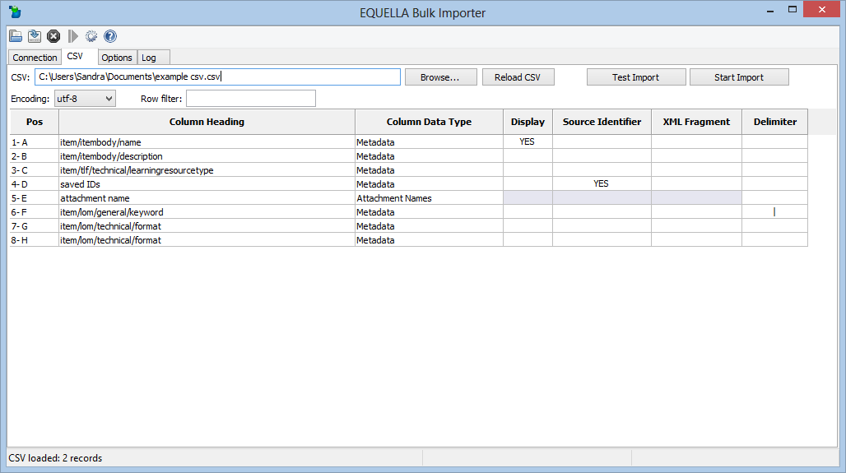Uses XML paths to configure where the data is stored.

###### Figure 10 EBI

## User profile

Editable details can include notifications and language settings.

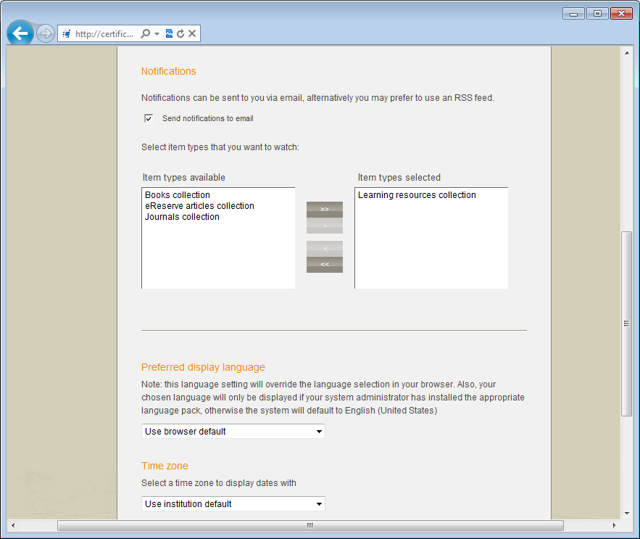

###### Figure 11 Edit user page

**Profile exercises**

Edit user details

1. Select the **Edit user details** link to display the **Edit user** page.
2. Select the **Send notifications to email** checkbox to receive moderation workflow notifications. Selecting this option sends an email to the user when a new moderation task is added. Uncheck this option to switch off email notifications (except moderation overdue messages).
3. Select the *Teaching resources collection* checkbox to be notified when live resources are added or edited in the collection.
4. Review the options available.
5. Add a resource to the *Teaching resources collection.*
6. Where did you receive a notification about the *Live* resource?

**Extension exercises**

1. Login to your EQUELLA (not the training institution).
2. Select the **Edit user details** link to display the **Edit user** page.
3. Compare your available options with those from your training institution.
   1. Note any differences.
4. How will the differences affect your content management role?

## EQUELLA Client support

* User level support—typically provided by a local support team lead by the system administrator. Contact your local support team as the first step to resolving user issues.
* Institution level support—<insert additional support info here>

### Training

EQUELLA provides the following training courses:

* **EQ101**—Core Principles (1 day workshop).
* **EQ201**—Content Administrator (1 day workshop).
* **EQ301**—Application Administrator (3 day workshop).
* **EQ302**—Advanced Application Administrator (1 day workshop).
* **EQ303**—Reporting Workshop (2-3 day workshop).
* **EQ304**—EBI Workshop (1/2 day workshop).
* **EQ305**—Scripting Workshop (1 day workshop).
* **EQ306**—Advanced Scripting Workshop (2 day workshop).
* **EQ401**—System Administrator (2 day workshop).

## International User Community

The EQUELLA User Community enables members to contribute, share and stay connected with other users globally, while extending their knowledge of EQUELLA.

The following EQUELLA resources can be accessed:

* EQUELLA documentation
* Installer, upgrades, Internationalisation packs, sample reports and miscellaneous tools.

To join the EQUELLA User Community please see www.equella.com

Common repository types

* Teaching and Learning, and Research repositories
* Copyright and Document Management
* Content Production and Knowledge Management
* Image Gallery

## Repository showcases

The following links provide Guest access to different EQUELLA clients around the globe. Discover how they are utilising the digital repository for a range of diverse requirements.

* University of Canberra (Research repository)

[http://www.canberra.edu.au/researchrepository](http://www.canberra.edu.au/researchrepository/access/home.do)

* Griffith University

<http://equella.rcs.griffith.edu.au/research>

* Utah Education Network *(Multimedia)*

[http://eq.uen.org/emedia](http://eq.uen.org/emedia/access/home.do)

* University of Nottingham *(fishbone collection)*

[http://fishbone.nottingham.ac.uk](http://fishbone.nottingham.ac.uk/)

* Florida Orange Grove (Content tagged to standards)

<http://florida.theorangegrove.org/og>

* Oxford Brookes University *(Research repository)*

[https://radar.brookes.ac.uk/radar](https://radar.brookes.ac.uk/radar/access/home.do)

* North Carolina Community College System

[http://www.nclor.org/nclorprod](http://www.nclor.org/nclorprod/access/home.do)

* Coventry University

[http://curve.coventry.ac.uk/cu](http://curve.coventry.ac.uk/cu/access/home.do)

* Royal Holloway, University of London

http://digirep.rhul.ac.uk