**EQUELLA**

**EQ301 APPLICATION ADMINISTRATOR WORKBOOK**

Version 6.3

# Contents

Contents 2

Course Outline 4

Session 1 5

EQ301 Introduction 5

Administration Console 6

User management 10

Schemas 13

Locating XML information 15

Collections 18

Scripting 23

Display metadata 25

Session 2 29

Taxonomies 29

Searches 32

Advanced searches 32

Remote repositories 35

Session 3 38

ACL overview 38

Resource metadata ACL exercise 39

Collection ACL exercise 41

Diagnostics 42

Workflows 43

Workflow creation 43

Workflow steps 44

Session 4 47

Hierarchies 47

Virtual hierarchies 51

Virtual hierarchy creation exercise 51

Session 5 53

Portlets 53

Dynamic collections 55

Notes 55

Theming and accessibility 57

Customising a contribution wizard exercise 58

Practice scenario exercise 60

Existing EQUELLA objects 61

Training 62

International User Community 62

Export/Import tools 63

Export tool 63

Import tool 64

EQUELLA Bulk Importer (EBI) 65

How the EQUELLA Bulk importer works 65

EBI exercise 66

# Course Outline

This course is a practical exercise in configuring an EQUELLA institution for organisational use. Each participant will have their own institution to manage that will be configured during the course.

The course covers the following areas of EQUELLA management:

* Getting started: managing users, developing collections and schemas.
* An overview of EQUELLA security and metadata ACL and managing consistent metadata with taxonomies.
* Development of workflows and searches.
* Development of browse hierarchies.
* Making content repository content available externally.
* Theming and accessibility.
* Portlet and diagnostic administration functions.

# Session 1

This session is to:

* Briefly review EQ101-201.
* Demonstrate and discuss:
  + User management—Overview.
  + Schemas and their creation—Introduce elements important for collections, schemas and workflows.
  + Collections and their creation.
  + Scripting.

## EQ301 Introduction

EQ301 training is for Application Administrators, users who manage an EQUELLA institution. EQUELLA institutions are managed using the **Administration Console**. This console is the main tool for creating and managing collections, schemas, workflow and users.

In future EQUELLA releases the tools displayed in the Administration Console will be migrated to the **Settings** page.

To access the Administration Console you must have suitable privileges. Application Administrators are typically created by the System Administrator immediately after installation.

In this training a default user with sufficient privileges has been created that you can use to make yourself an administrator.

To login:

1. Navigate to <url>
2. Enter *eq301admin* for the username.
3. Enter *equella* for the password then select **Login**.
4. Select **OK** for the Notice dialog to display the **Dashboard** page.

The Administration Console link is provided in **Settings**:

1. Select **Settings** then the **Administration Console** link to start the download and display the Administration Console. An example is shown in Figure 1.
2. Complete the *User creation* exercise with this console (as the *eq301admin* user) then use your login created in the next section for all other exercises.

## Administration Console

The EQUELLA Administration Console provides a range of tools and plug-ins that simplify the management and configuration of EQUELLA. An example of the Administration Console is displayed in Figure 1.

###### <insert Admin Console image>

###### Figure 1 EQUELLA Administration Console

All available tools are displayed on the left-hand side of the page.

<insert Collection Definitions pane image>

###### Figure 2 Administration Console—Collection Definitions pane

Figure 2 shows an example Administration Console after the **Collection Definitions** tool has been selected. The areas shown in Figure 2 are:

1. **Area 1**—where all the user tools are displayed. The tools displayed will depend on the user privileges.
2. **Area 2**—where the plug-ins or tool objects are displayed.
3. **Area 3**—where the action buttons are displayed. Some buttons require an object to be selected in *Area 2* before being enabled.

***Administration Console tools***

Each Administration Console tool provides an interface to edit or configure a series of EQUELLA properties. The following is an overview of all available Administration Console tools:

* **Metadata Schemas**—enables the creation of schemas that are used to hold the metadata for collections. One schema can be used in multiple collections. Further information is provided in the *EQUELLA Metadata Schema Configuration Guide.*
* **Collection Definitions**—the type of resources stored in the EQUELLA Digital Repository. A Collection represents a unique container to store resources within EQUELLA and provides information about the resource, assisting in activities such as searching, storage, collaboration and contribution. Further information is provided in the *EQUELLA Collection Definitions Guide*.
* **Advanced Searches**—creates custom searches by searching specified metadata nodes and collections. Further information is provided in the *EQUELLA Advanced Search Configuration Guide*.
* **Taxonomies**—enables the creation and use of large taxonomies for improved resource classification. Further information is provided in the *EQUELLA Taxonomies Guide*.
* **Dynamic Collections**—the EQUELLA implementation of OAI-PMH Sets based on collection resources from one or more collections. Further information is provided in the *EQUELLA Dynamic Collections Guide*.
* **Workflow Templates**—allows content moderation and quality assurance processes to be customised and automated for each associated collection. Further information is provided in the *EQUELLA Workflow Configuration Guide*.
* **Hierarchy Editor**—configures the display of resources in the EQUELLA Digital Repository, allowing flexible presentation of resources to users. Further information is provided in the *EQUELLA Hierarchy Configuration Guide*.
* **Reporting**—manages the EQUELLA Digital Repository report availability, imports and exports. Further information is provided in the *EQUELLA Reporting Guide*.
* **Harvester Profiles**—configures links that are displayed in the EQUELLA Digital Repository. Further information is provided in the *EQUELLA Harvester Profile Configuration Guide*.
* **Remote Repositories**—controls the repositories used in Remote Repository searches. Further information is provided in the *EQUELLA Remote Repositories Configuration Guide*.
* **Courses**—configures a list of courses for use with a copyright or integrated third- party system. Further information is provided in the *EQUELLA Administration Overview Guide.*
* **User Management**—configures the plug-ins for user management in EQUELLA. Further information is provided in the *EQUELLA User Management Configuration Guide*.
* **Security Manager**—manages the privileges and groups associated with users allowing fine-grained control of user privileges for all areas of EQUELLA. Further information is provided in the *EQUELLA Security Administration Guide*.

Selecting the:

* **Hierarchy Editor**, or **Security Manager** displays an editor.

###### Metadata Schemas, Collection Definitions, Advanced Searches, Taxonomies, Dynamic Collections, Workflow Templates, Reporting, Remote Repositories or Courses enables:

* + A list that appears in *Area 2*, an example is shown in *Figure 2*.
  + The **Add**, **Edit**, **Remove**, **Clone**, **Import** and **Export** buttons, shown in *Area 3*. The **Courses** tool also has **Bulk**, **Archive** and **Unarchive** buttons. (Providing the correct privileges have been granted, refer to the *EQUELLA Security Administration Guide* for further information.)
* **User Management** tool enables a list that appears in *Area 2* and a **Configure**

button.

**Administration Console buttons**

The following action buttons are shown in *Area 3* of Figure 2. The buttons displayed depend on the tool or plug-in selected:



Select the **Add** button to display an editor and create a new object.



Select an object then select the **Edit** button (or double-click the object) to open the editor and make changes.

If the selection is being edited by another user a **Locked** dialog is displayed and provides the following options:

* **Open as read-only**—disables the **Save** button so that no changes can be made.
* **Force unlock**—unlocks the entity from the previous owner. Editing can occur but changes can be lost from one or other user.
* **Do not open**—the selected editor is not opened.



Select the **Remove** button to delete the selection.



Select the **Clone** button to copy an existing selection. Select **Yes** to confirm and display a confirmation dialog then select **OK** to close the dialog. The cloned instance can then be modified by selecting it and selecting the **Edit** button.



Select the **Import** button to import a file that has previously been exported from the Administration Console. A warning dialog is displayed.

(*Note: Only import ZIP files that have been exported from the Administration Console— other ZIP files can adversely affect the stability of the system*.)



Select the **Export** button to export the selection as a ZIP file.



Select the **Bulk** button to import multiple Courses as a CSV file.



Select the **Archive** button to store selected Courses for future use.



Select the **Unarchive** button to reinstate a previously archived Course.



Select the **Configure** button to display the selected plug-in’s dialog.

## User management

EQUELLA has the following user management model:

* **Roles**—roles are usually associated with an area of EQUELLA such as Content Administration. These typically translate directly to a role within the organisation. Using these roles within EQUELLA simplifies management and reduces confusion.
* **Groups**—groups are used to simplify the management of users and typically reflect the organisational structure.
* **Users**—individual users, typically a large number that are difficult to manage unless assigned to a group.

To simplify user management for an organisation it is suggested that users are assigned to groups and groups are assigned to roles with security privileges being set at the role or group level. This provides the following benefits:

* Reducing the workload when users change organisational role or leave.
* Easily identifying users with a particular organisational role.

When LDAP authentication is used users are displayed in the **User Management** tool— **Internal Users** plug-in and LDAP groups are only displayed in the **Internal Roles** plug- in. This leads to the typical setup where:

* Roles are used to manage user security privileges.
* EQUELLA groups are created as required to manage LDAP users that are not in a suitable LDAP group. In this case the group can be assigned privileges or the group can be assigned to a role with the required privileges.

It is important to name your groups and roles carefully to avoid confusion between roles and groups and also to provide a little context for the group.

Because of the benefits of group management it is worthwhile even when there is only one user assigned to a group.

Further information on user management is provided in the *EQUELLA User Management Configuration Guide.*

#### Notes

***User creation exercise***

In these exercises you will create the following users, role and group assignments:

|  |  |  |  |
| --- | --- | --- | --- |
| Name | Username | Group assignment | Role assignment |
| **<Your name>** | <your username> | Administrator | System Administrator |
| **Jon Fleming** | jfleming | Manager | Content Administrator |
| **Mel Smith** | msmith | Staff, Contributor | Contributor |
| **Ben Day** | bday | Staff | Viewer |
| **Hugh Wright** | hwright | Staff, Contributor | Contributor |

1. Open the Administration Console **User Management** tool.

##### To add internal users

1. Select the **Internal Users** plug-in then **Configure**.
2. Select the **Add** button to enable the entry fields.
3. Add each of the following users using *equella* as the password for each new user:
   1. <yourself>
   2. Jon Fleming
   3. Mel Smith
   4. Ben Day
   5. Hugh Wright
4. Save each user and close the **Internal Users** plug-in.

##### To add internal groups

1. Select the **Internal Groups** plug-in then **Configure** to display the **Group** dialog.
2. Select the **+Add** button create the top level **Institute** group.
   1. **Add** all users to this group then **Save** this group.
3. Select the **Institute** group then the **+Add** button and name this group

###### Administrators:

* 1. **Add** yourself to this group then **Save** this group.

1. Select the **Institute** group then add the following sub-groups:
   1. **Managers**—add Jon to this group.
   2. **Staff**—add Mel, Ben and Hugh to this group.
2. Select the **Staff** group then add the following sub-group:
   1. **Contributors**—add Hugh and Mel to this group.
3. **Save** the groups then close the **Internal Groups** plug-in. Figure 3 shows an example of a completed group structure.

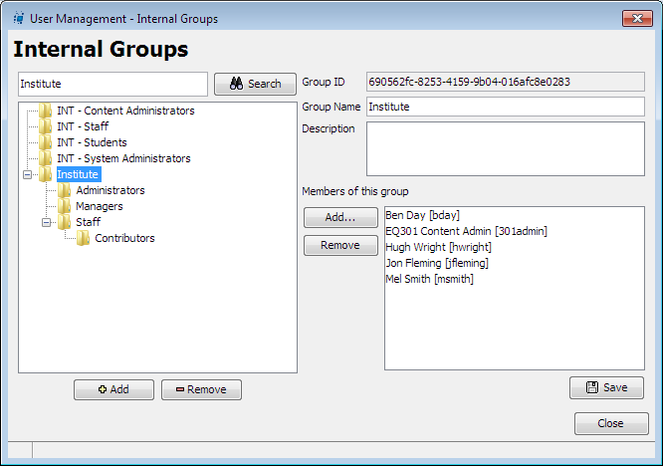

###### Figure 3 Completed group structure

To add groups to roles

1. Select the **Internal Roles** plug-in then **Configure.**
2. **Search** for the groups you have created and use the **>** button to add them to the following roles:
   1. **Viewer Role**—add the *Institute* group to this role.
   2. **Contributor Role**—add the *Contributors* groups to this role.
   3. **Content Administrator Role**—add the *Managers* group to this role.
   4. **System Administrator Role**—add the *Administrators* group to this role.

##### Testing

Whenever you make changes it is important to test to ensure that the changes work as expected.

1. Close the **Administration Console** and logout as *eq301admin* user.
2. Login to your institution using two of the users you have created to check that they have been created correctly.
3. Login using your newly created administration user.
4. Open the **Administration Console**.

*(Note for IE users: Multiple users can be logged in from the same browser simply by selecting File > New Session for each new user. This saves having to logout and login multiple times to test multiple users.)*

***Notes***

## Schemas

Schemas provide structure and organisation to data. They ensure that there are consistent labels and locations for data stored with resources. Schemas provide unambiguous rules for storing data using XML. Any XML file that matches the schema is said to be schema compliant.

Standard schemas have been developed to improve the reusability of digital materials between repositories. Two commonly used standards are Learning Object Metadata (LOM) and Dublin Core (DC).

An organisation that is likely to share digital content with external repositories should ensure that there is some way of translating their metadata into a common standard format. This does not necessarily mean to implement one of the common standards but it does mean that your schema should collect the minimum information required for sharing. A translation of this metadata into the shared format can occur as part of the export. If the information does not exist then it cannot be translated.

Dublin core has a base 15 elements (<http://dublincore.org/documents/dces/>) many with a specified vocabulary (these can run to hundreds of terms) and the LOM schema is huge (<http://www.imsglobal.org/metadata/mdv1p3/imsmd_bestv1p3.html#1621612>) so developing to a standard can be a significant investment in:

* Creating and maintaining the schema and associated wizards.
* Entering metadata whether during contribution or through some specialist workflow review.

Further information on creating a schema is provided in the *EQUELLA Metadata Schema Configuration Guide*.

An example EQUELLA schema is shown in Figure 4.

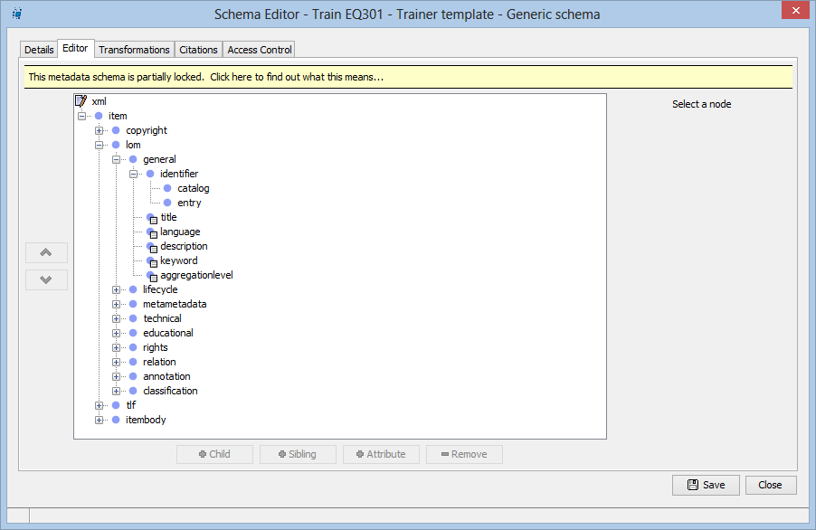

###### Figure 4 Metadata Schema Editor

***Some brief XML examples***

XML is a text file that comprises tags that mark out data. XML files comprise a lot of ‘visual noise’ but they are only structured text files that have data surrounded by tags.

Within an XML file a start tag and end tag pair define an element, commonly called a node. An element can comprise:

* data;
* data and attributes; or
* child elements, data and attributes.

**A simple element**

<description lang=”en-AU”>This resource comprises electron microscope images of water microbes.</description>

This element comprises data and attributes:

* **Data**—the information that is being stored that appears between the start and end tag. In this example it is the text, *This resource comprises electron microscope images of water microbes.*
* **Attributes**—any *name=value* pair that appears inside the start tag, in this example

*lang=”en-AU”*.

#### When do you use attributes?

Attributes are used to describe a property of the data, in the example this is the language used for the description *lang=“en-AU”.*

#### A more complex element

<attachments>

<attachment disabled="false" type="remote">

<uuid>78272b48-9822-40d1-aaa7-1fb5ef733e65</uuid>

[<file>http://www.siamfishingtours.com/fishspecies.html</file>](http://www.siamfishingtours.com/fishspecies.html)

<description>Fresh water fish of Thailand</description>

</attachment>

<attachment type="local">

<conversion>true</conversion>

<size>157186</size>

<thumbnail>_THUMBS/mainartotherspecies.jpg.jpeg</thumbnail>

<uuid>e8a41aad-2e55-4163-851b-22a0404acf75</uuid>

<file>mainartotherspecies.jpg</file>

<description>mainartotherspecies.jpg</description>

</attachment>

</attachments>

This example comprises an element *attachments* that has two *attachment* child elements that comprise data, attributes and child elements.

### Locating XML information

A schema for the complex example above has the following nodes:

* Attachments—a parent element.
  + Attachment—a child element of the Attachments element.
    - @ type (the @ indicates an attribute)—an attribute that describes whether the element is held outside of EQUELLA.
    - @ disabled—an attribute that determines whether the element can be used.
    - UUID—a child element of Attachment that uniquely identifies the attachment in EQUELLA.
    - File—a child element of Attachment that contains a URL or file location.
    - Description—a child element of Attachment that is used to hold a textual description of the attachment.
    - Conversion—a child element of Attachment that determines if the attachment can be converted to different formats.
    - Size—a child element of Attachment that stores the file size in bytes (used when the attachment is a file).
    - Thumbnail—a child element of Attachment that stores the location of thumbnail views (used when the attachment is an image).

To find the data in a node a consistent means of describing the location of each node is needed. This is called the *Xpath* and it describes all the nodes that surround the data from the top XML node down.

Each node is separated by a forward slash. This is similar to the file and folder structure of your computer or an address where we describe the country, state, city, street and number.

An example *Xpath* that describes the location of the UUID data in the complex example above is *attachments/attachment/uuid*.

Further information on metadata schemas is provided in the *EQUELLA Metadata Schema Configuration Guide*.

#### Notes

***Schema creation exercise***

In this exercise you will create a schema for use with a collection, a workflow and an advanced search. The schema has the following nodes:

* *xml*
  + *resourcebody*
    - *name*
    - *description*
    - *author*
    - *faculty*
    - *purpose*
    - *examDate—schema node names cannot have spaces.*
    - *attachments*
    - *additionalInformation—schema node names cannot have spaces.*

Figure 5 shows an example of a completed metadata schema.

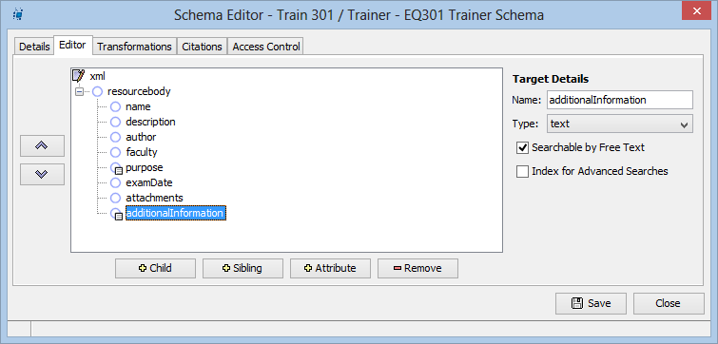

###### Figure 5 Schema Editor

1. Open the Administration Console **Metadata Schemas** tool then select the **Add** button to display the **Metadata Schema Editor**.
2. On the **Details** page enter a schema name and description (e.g. *EQ301 training schema*).
3. On the **Editor** page select the **xml** node to enable the **Child** button.
4. Select the **Child** button to add the first node and enter the node *resourcebody*.
5. Select the **Child** button to add the first node and enter the node *name*.
6. Select the **Sibling** button to add the remaining listed nodes.
7. Select the **Searchable by Free text** option for the:
   1. *Purpose* node
   2. *AdditionalInformation* node.
8. Select the **Index for Advanced Searches** check box for the *Purpose* node.

Every EQUELLA schema must have a node designated for the resource name and a node for the resource description before it can be saved.

1. Select the **Details** tab to display the **Details** page then select the **Browse** button for the **Resource Name Path** to display the **Choose a schema element?** dialog.
2. Select the *name* schema node.

*(Note: The* ***Resource Name Path*** *is the* Xpath *to the resource from the topmost resource (the XML node of the schema).)*

1. Select the **Browse** button for the **Resource Description Path** then choose the

*description* node.

1. **Save** then close the Schema Editor.

 Review the section then complete the extension exercises if time permits

***Schema creation extension exercise***

1. Open the **Generic Schema** and find nodes that could be used as alternative nodes for the exercise schema:

* xml
  + resourcebody

*Generic Schema* Alternative node

* + - Name

*Generic Schema* Alternative node

* + - Description

*Generic Schema* Alternative node

* + - Author

*Generic Schema* Alternative node

* + - Faculty

*Generic Schema* Alternative node

* + - Purpose

*Generic Schema* Alternative node

* + - ExamDate

*Generic Schema* Alternative node

* + - Attachments

*Generic Schema* Alternative node

* + - AdditionalInformation

*Generic Schema* Alternative node

1. To start understanding your organisation’s EQUELLA configuration view the available schemas and their structure using the processes from the previous exercise.

## Collections

Collections are the core of EQUELLA and are used to categorise and store resources. Collections group content so that it can be easily managed. The **Collection Definition** tool is where new collections are created.

A collection definition provides:

* A means for associating a metadata schema and metadata mappings, workflow and contribution category.
* A contribution wizard editor where controls are configured for collecting information about the content being added to the repository.
* A security editor where resource privileges can be assigned or controlled by resource metadata.
* Customisation of resource display templates.
* Automated processing of resources with scripts when resources are saved or versioned.

These features enable most aspects of a resource to be managed and customised; from the metadata gathered to how the resource is displayed in EQUELLA.

Creating a collection typically requires the incremental development of a metadata schema, workflow and display templates.

Further information on creating a collection is provided in the *EQUELLA Collection Definitions Guide*.

Information on the collection definition wizard controls is provided in the *EQUELLA Wizard Controls Reference Guide*.

A Collection Definition example is shown in Figure 6.

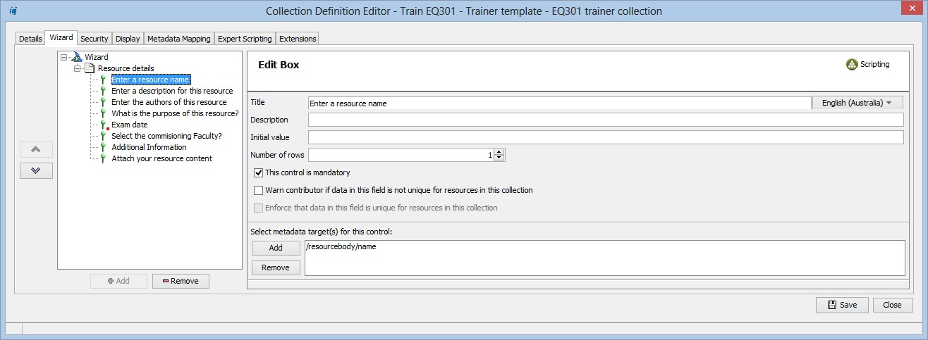

###### Figure 6 Collection Definition Editor

***Collection creation exercise***

In this exercise the contribution wizard is developed and the recently created schema is associated with the collection.

The collection will comprise a single page contribution wizard that includes the following controls for gathering metadata:

* Name field
* Description field
* Author field
* Purpose group
* Faculty list
* Additional information field
* Attachments control

Further configuration will occur in following exercises.

Figure 7 shows an example of a completed Contribution Wizard (form).

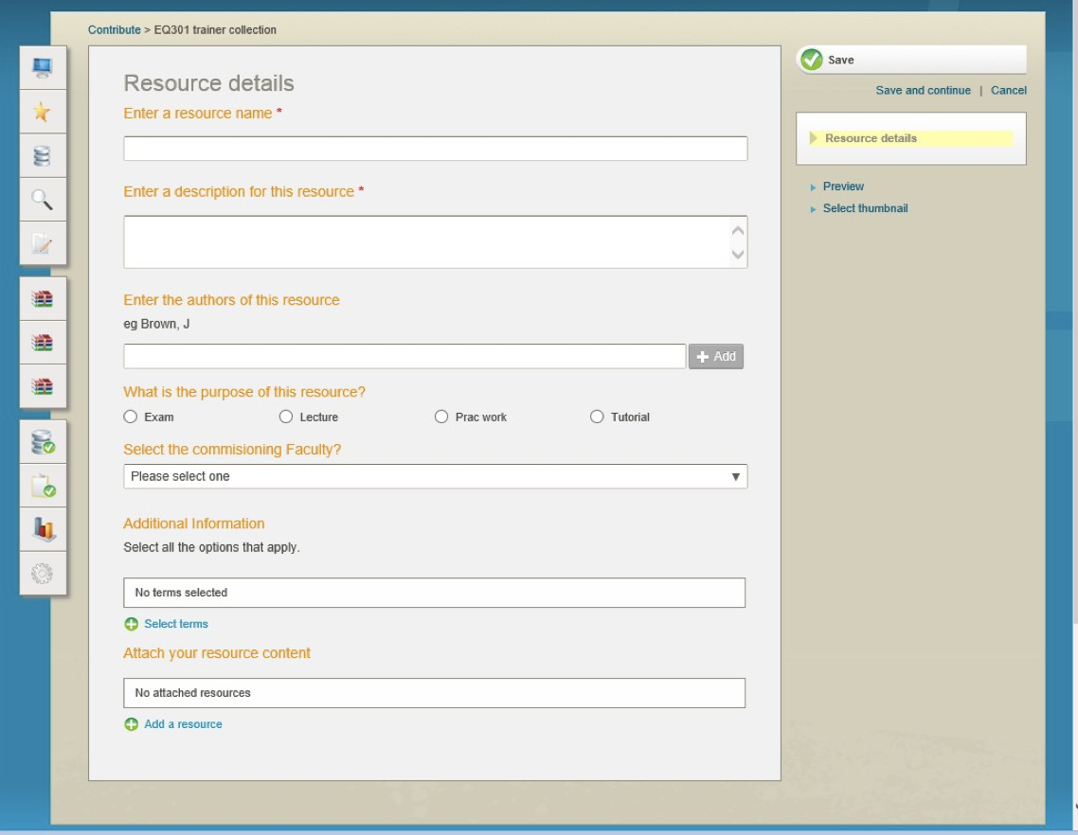

###### Figure 7 Contribution Wizard

To create a collection

1. Open the Administration Console **Collection Definitions Editor** tool then select the

**Add** button. It may take a few moments to display the editor.

1. On the **Details** page enter or select:
   1. A name for the collection—use your name in the collection name (e.g. *Sandra EQ301materials*).
   2. A description.
   3. Select your metadata schema from the drop-down list.
2. Select the **Add….** link for the **Select wizard category** drop-down list to display a dialog. Enter *EQ301* then select **OK** to create and select the new category.

*(Note: Each category should contain multiple collections, so new categories are rarely added.)*

To add page controls:

1. Select the **Wizard** tab to display the **Wizard** page.
2. Select the **Wizard** hat in the left-hand pane to enable the **Add** button and display the wizard options.
3. Check the **Show page titles on Next/Prev buttons** option.
4. Select the **Add** button to display the **Select a control…** dialog then select **Page**. The other resources are used for:
   1. **DRM**—when rights management is required for a collection.
   2. **Navigation Builder**—when a flow or sequence is required for viewing a multiple resources attachments.
   3. **Static Metadata**—when every resource in the collection requires standard metadata that does not change (e.g. *an institution name*).
5. Enter the **Page** title *Resource details* then add a **CSS Class** of *detailsPage.*
6. Select the page in the left-hand pane then select the **Add** button to display the

**Select a control…** dialog.

1. Select **Edit box** then **OK** and add the following values:
   1. **Title**—*Resource name*
   2. **Description**—only enter a description for fields where the title does not clearly describe the purpose or type of information required.
   3. Select the **This control is mandatory** checkbox.
   4. Leave the other fields with their default settings.

Controls are used to populate metadata schema nodes and require selection of the schema node. To select the schema node:

1. Select the **Add** button in the **Select metadata target(s)** for this control area to display the **Choose a schema element?** Dialog.
   1. Select the *name* node then **OK** to populate the field.
2. Select the **Save** button to save the collection.

To add wizard controls to the page:

1. Select the *Resource details* page in the left-hand pane to enable the **Add** button.
2. Add the following controls to the page and target their respective metadata nodes:
   1. *Description*—**edit box** control set the **Number of rows** value to 3.
   2. *Author*—**shuffle list** control.
   3. *Purpose*—**radio button group** with the names and values (*Exam, Lecture, Prac work, Tutorial*). *Note: It is generally easier to use the radio button name as the radio button value.*
   4. *Faculty*—**list box** names and values (*Arts, Fine Arts, Engineering, Science*).
   5. *Additional Information*—**edit box** control with 3 rows.
   6. *Attachments*—**attachments** control allows the configuration of the type of content that can be included in the resource. Select the **Files** content type as a minimum. Other content types can be selected and their options reviewed.
3. Save the collection.

Testing

1. Login to EQUELLA as a contributor user (*msmith* or *hwright*) and contribute a resource. Check the pages have all the required fields.

***Exporting wizards and pages***

Contribution wizards can be exported from the Administration Console using the Collection Definitions tool.

Wizard pages and controls can be exported from within the Collection Definition Editor, this can be very useful when you have configured a control that can be used as a starting point for another control.

#### Export a wizard

1. Open the **Collection Definitions** tool in the Administration Console.
2. Select your collection then select the **Export** button.
3. Select a location for the download then select **OK** (do not export security attributes).

#### Export a Wizard Control

This procedure can be used for both pages and individual controls.

1. Open the **Collection Definitions** tool in the Administration Console.
2. Open your collection then display the **Wizard** tab.
3. Right-click the control or page then select **Export**.
4. Select a location for the download then select **Save**.

 Review the section then complete the extension exercises if time permits

***Collection creation extension exercise***

View your resource’s underlying metadata.

1. Insert a tildé character ‘~’ immediately after the version number in the URL e.g.

[*http://myequella.edu.au/learning/resources5b0dbc71-b444-3789-d6e5/2/~*](http://myequella.edu.au/learning/items5b0dbc71-b444-3789-d6e5/2/%7E)

Extend your contribution wizard by providing a page for gathering further metadata for a resource. Commonly basic metadata is entered by the contributor with more sophisticated metadata being added by librarians during the moderation review.

1. Add a new page to the contribution wizard for further metadata.
2. Add controls to the page:
   1. Choosing one that can be used for a controlled vocabulary.
   2. Add two other controls that allow users to enter metadata. What other metadata may be useful? Reviewing the generic metadata schema nodes may provide some hints.

Existing collections wizards can be used to provide copies of pages and controls for a new wizard.

1. Create a new collection then import your *Resource details* page into the new wizard.
   1. What do you need to do to make this work?

## Scripting

EQUELLA provides scripting to enable system administrators to exercise fine grain control over processes and workflows within EQUELLA. Scripting can be used in collections, advanced searches, system settings, workflow template security and in topic hierarchies.

All basic scripts comprise statements that evaluate to *true* or *false* allowing such things as:

* controls to be displayed in wizards;
* granting or revoking of collection resource privileges;
* the display of content in a Hierarchy topic.

A basic script in essence provides a logical *true* or *false* value that is used to determine if an action should be triggered. Actions typically result in the display of controls or resources.

Every script comprises one or more statements.

* A statement comprises a:
  + **Start term**—starts every statement and is a Boolean term or logical clause.
  + **Test term**—the metadata, user role or resource status that holds terms to compare with the test value.
  + **Relational operator**—determines how the statement is compared to the test value.
  + **Test value**—the value that the test term is being compared to when establishing whether the statement is true or not. This value can be a user entered value or a value from the controlled vocabulary of the control.
  + **End if**—ends all statements beginning with ‘if’. This is automatically added to each statement by the system.

Scripts are built one statement at a time using the script editor.

Creating a script using the basic script editor follows the same process for all scripts:

* Select the object to be scripted.
* Create a statement that is true for some distinguishing user or metadata.

This simple process assumes that the metadata or user is available from the collection schema or user group. So some careful planning is typically required to develop suitable metadata or user distinctions.

Further information on scripting is provided in the *EQUELLA Scripting Guide (Basic)*.

#### Notes

***Script a control exercise***

In this exercise you will script a control that will require the date of the exam sitting to be entered for new exam resources.

1. Open the **Wizard** page for your collection.
2. Add a **Calendar** control to the *Resource Details* page.
3. Move the calendar control to just below the *Purpose* control with the button.
4. Enter a **Title** (e.g. *Exam date*) select the **Default Date** checkbox.
5. Select **Today +1 Week** as the default date then select the radio button beside this drop-down list.
6. Select the *examDate* node as the metadata target for this control.
7. Select the **Scripting** button to display the **Script Editor**—**Basic editor** page.
8. Select the  button associated with the ‘*if’* clause to display the **What is being evaluated?** dialog.
9. Select the **Schema Item** radio button to enable the schema nodes.
10. Select the *Purpose* value then the **OK** button.
11. Select *Exam* from the drop-down list field to the right of the = sign.
12. Select the **Add** button to add the script to the **Script** area then select the **OK** button to close the editor.
13. Select the *Purpose* control then select the **Automatically reload controls after this one on selection** checkbox and confirm this action. This makes the values selected for this control available for evaluation in the *examDate* script.
14. Save the collection.

##### Testing

1. Login as a contributor user (*msmith* or *hwright*) and contribute an exam Resource. The exam calendar control should be displayed only when the *Purpose* field has *Exam* selected.

 Review the section then complete the extension exercises if time permits

***Scripting extension exercise***

In this exercise:

1. Add a metadata page to the wizard (it can just be a blank page) then script the page so that it will only be displayed to users that are system administrators.
2. Test the script works by:
   1. Checking that the page is visible to the system administrator.
   2. Then login as a contributor to check the page is not shown.

## Display metadata

The **Display** page configures what resource metadata is displayed on resource information pages and includes:

###### Resource Summary Display Template:

* + Configures the fields displayed for collection Resources when the Resource summary page is viewed.
  + Allows for the names of owners and contributors to be hidden.

###### Search Results Template:

* + Configures the fields displayed for Resources listed in search results, including disabling thumbnails showing in search results.
  + Allows attachments to be displayed as a structured view or a thumbnail grid.

Each template provides multiple options that can be used for displaying extra resource metadata including, addition of single fields to existing displays through to organisation specific XSLTs that provide greater flexibility over how metadata is presented.

An example Resource summary display is shown in Figure 8*.*

###### <sample resource summary page image>

###### Figure 8 Resource summary display

An example Search results display is shown in Figure 9.

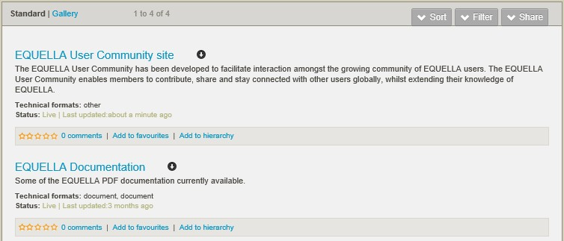

###### Figure 9 Search results display

***Display template exercises***

In these exercises you will display the *Faculty* field information by adding a *Faculty* field to each standard template.

**Resource summary display template**

To display the faculty information using the **Resource Summary Display Template**:

1. Select the **Display** tab to display the configuration options.
2. Select the **Resource Summary Display Template** tab to display the configuration page.
3. Note the existing entries on this page.
4. Select each of the existing entries to determine what they add to the Resource summary page.

To add a new field to the Resource Summary that will display the commissioning faculty:

1. Select the **Add** button to display the **Add A New Resource Summary Section**

dialog.

1. Select the **Extra information from the Resource metadata** radio button then the

**+Add** button to add an **Extra Metadata** option to the display pane and a further pane.

1. Select the +**Add** button for the new pane to display the field configuration page.
2. Enter a **Title** (e.g. *Faculty*).
3. Select the **Target Node Browse** button to display the **Choose a schema element?**

dialog.

1. Select the *Faculty* node then the **OK** button.
2. Select *Text* as **Type** and a **Display Mode**.

To position the field on the Resource summary page:

1. Select the **Extra Metadata** option from the leftmost pane then select the button to move the **Extra Metadata** option above the **Attachments** option.
2. Select the **Save** button.

#### Search results template

For consistency the *Faculty* field should be added to the **Search Results** template. To add the *Faculty* field to the **Search Results** template:

1. Select the **Search Results Template** tab to display the configuration page.
2. Review the options and existing entries to determine what they add to the Search page.
3. Select the **Thumbnail grid** option.
4. Select the **+Add** button to display an untitled configuration page.
5. Enter *Faculty* in the **Title** field then select *Faculty* as the **Target Node**.
6. Select *Text* as **Type** then select the **Save** button.

##### Testing

1. Login to EQUELLA as a contributor user (*msmith* or *hwright*).
2. Contribute a resource to your collection and check that the Preview page displays the

*Faculty* field.

1. Search for the contributed resource and check that the *Faculty* field appears in the search results list.
2. Select the **Show attachment** button and review how the attachments are displayed.
3. Select the resource from the search results list and check that the *Faculty* field has been added to the Resource summary.
4. Search for the *EQUELLA Documentation* resource then select the **Show attachment**

button and compare how the attachments are displayed.

 Review the section then complete the extension exercises if time permits

***Further collection pages***

It is worth having a look at the other wizard pages for familiarity. They can be left with their default settings:

* **Security**—configures how users can use the collection. This page is configured in a later session.
* **Metadata Mapping**—configures the mapping of resource metadata to commonly used schemas.
* **Expert Scripting**—enables scripts to be run at important points of a resource’s lifecycle. These scripts are covered in EQ302.
* **Extensions**—configures copyright compliant collections.

***Display metadata extension exercises***

1. Add a control to the *Resource Details* page of your wizard for users to add a help URL (make one up e.g. [www.google.com](http://www.google.com/)) for the resource (use the *AdditionalInformation* metadata target). Display the help URL on the resource summary page so that it can be used (hint use the correct type).

Open a browser and navigate to your organisation’s EQUELLA:

1. What metadata is displayed using the organisational display template?
2. Display further information in the training institution based on what you found.

# Session 2

This session covers:

* Taxonomies—what they are and how they are used.
* Developing searches:
  + Advanced searches;
  + Remote Repository searches; and
  + Other searches.

## Taxonomies

Taxonomies are controlled vocabularies used to describe entities, an example taxonomy is the ‘Country/State/Suburb’ list frequently used online.

In EQUELLA taxonomies are used to provide consistent terms for resource metadata. Using a taxonomy for controlling the terms entered during contribution improves searching relevancy.

Simple taxonomies can be entered manually while complex taxonomies can be uploaded from file or SQL database using the Administration Console Taxonomies tool.

As with any terms used to simplify or categorise information creating a useful taxonomy can take a lot of work and discussion. Some sources of further information are:

* <http://www.imsglobal.org/metadata/mdv1p3/imsmd_bestv1p3.html#1621766>
* <http://www.taxonomystrategies.com/html/bibliography.htm>
* <http://en.wikipedia.org/wiki/Taxonomy>

Further information on taxonomies is provided in the *EQUELLA Taxonomies Guide*. An example Taxonomy is shown in Figure 10.

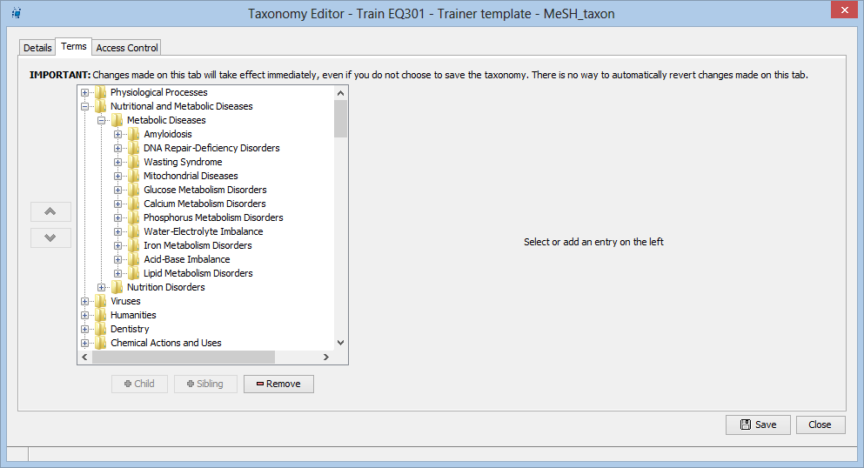

###### Figure 10 Taxonomy Editor

***Taxonomy creation exercise***

In this exercise you will create a taxonomy for the *Additional Information* control used in the collection and includes the following terms:

* Reference
  + Theory
  + Topic History
  + Equipment list
* Procedure
  + Safety
  + Experimental

To create a taxonomy

1. Open the **Administration Console Taxonomies** tool then select the **Add** button to display the **Taxonomy Editor**.
2. Enter a taxonomy **Name** (e.g. *EQ301 Taxonomy)* and **Description**.
3. Select the **Locally Defined Terms** option leaving the default values. Large taxonomies can be imported directly from a database.
4. **Save** the taxonomy.
5. Select the **Terms** tab to display the **Terms** page.
6. Select the **Child** button to display a **Please enter a new name** dialog for entering the taxonomy node name, enter *Reference****.***

Data can be associated with a taxonomy term such as descriptive text. This feature will not be used in this training.

1. **Save** the taxonomy.
2. Repeat steps 6-7 adding children and siblings as required to create the taxonomy described above.
3. Close the Taxonomy Editor.

##### To add the taxonomy to your collection

1. Open the Administration Console **Collection Definitions** tool and select your collection definition.
2. Select the **Edit** button to open the collection definition then select the **Wizard** tab.
3. Select the existing *Additional Information* control then the **Remove** button. Confirm this action.
4. Add a **Term Selector** control to the *Resource details* page with the following:
   1. **Title—***Additional Information*
   2. **Description**—*Select all the options that apply for this resource*
   3. Select your taxonomy from the **Taxonomy** drop-down list.
   4. Select **Allow multiple terms to be selected** checkbox.
   5. Select the **Detailed Pop-up Browser** from the **Display the taxonomy using the following control** radio button.
   6. Add the *AdditionalInformation* metadata schema node as the metadata target.
   7. Leave all other fields with their default values.
5. Move the *Additional Information* control to just below the *Faculty* field using the button.
6. **Save** the wizard.

##### Testing

1. Login as a contributor (*msmith* or *hwright*) and contribute a resource to view the changes.

 Review the section then complete the extension exercises if time permits

***Taxonomy creation extension exercise***

To view some other taxonomy control modes:

1. Change the taxonomy pop-up browser to an Autocomplete edit box.
2. Change the way users can access taxonomy terms.
3. Review the options available for data that can be associated with a taxonomy term such as descriptive text.

There is a whole field of endeavour based around taxonomies and categorisation.

## Searches

An essential part of managing an EQUELLA institution is to ensure that users can find resources easily. EQUELLA provides a range of searches that can be configured to control the matches returned in the results list.

This exercise configures two different search types:

* **Advanced searches**—that display results based on resource metadata.
* **Remote Repositories**—searches that display results from external repositories. Further information is provided in the *EQUELLA Searching User Guide, Remote Repositories Configuration Guide* and *Advanced Search Configuration Guide*.

## Advanced searches

Advanced searches are linked to a metadata schema and are used to return resources with metadata that matches the search criteria. Because advanced searches are linked to a schema they can return resources from any collection that uses that schema.

Figure 11 shows an example of a completed advanced search.

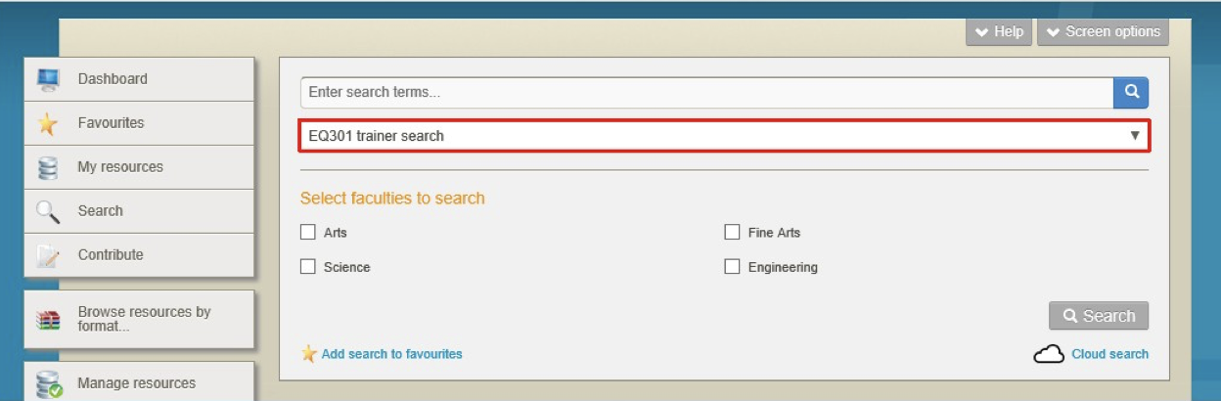

###### Figure 11 Advanced search page example

***Advanced search creation exercise***

Before creating an advanced search the metadata nodes within a schema must be indexed for advanced searches.

1. Open the previously created metadata schema using the Administration Console

**Metadata Schemas** tool then navigate to the **Editor** page.

You will find that the schema is partially locked as it is associated with a collection. During collection development it is safe to unlock the metadata schema and change it. In the production environment where there are many thousands of resources associated with a collection changing a metadata schema can cause immediate automatic reindexing

of the collection resources (for each collection where the schema is used) this is generally best avoided while there are people using the system as it typically slows the system.

1. Select the yellow banner then unlock the schema.
2. Edit the schema and ensure that the **Index for Advanced Searches** check box is selected for the *Faculty* node.
3. Save and close the Schema Editor.

Now that the schema nodes have been prepared in this exercise you will create an advanced search that will return content using the values stored in the *faculty* metadata node:

1. Select the Administration Console **Advanced Searches** tool then the **Add** button to display the **Details** page.
2. Provide a name (e.g. *EQ301 content search)* and description for the search.
3. Select *your metadata schema* from the **You must select a schema to continue**

drop-down list to populate the shuffle box.

1. Select *your collection* from the **Select collections to search** pane then select the  button to move the collection to the right-hand pane.
2. Select the **Editor** tab to display the **Editor** page.

The user needs to be able to make a selection of the required faculties so this exercise uses a check box so that more than one faculty can be selected.

If you needed to restrict selection what other controls should be used?_

1. Select the **Add** button to display the **Select a control…** dialog.
2. Add the following control and target the *Faculty* metadata node:
   1. **Faculty**—add a check box group then add a check box for each of the faculty values *Arts*, *Engineering*, *Fine Arts*, *Science*. Ensure that the **Value** associated with each checkbox is entered exactly as it was (including letter case) when creating the contribution wizard values.
   2. Enter *Faculty being searched* in the **Friendly Name** field.
3. **Save** then close the **Advanced Search Editor**.

Figure 12 shows an example of a completed advanced search.

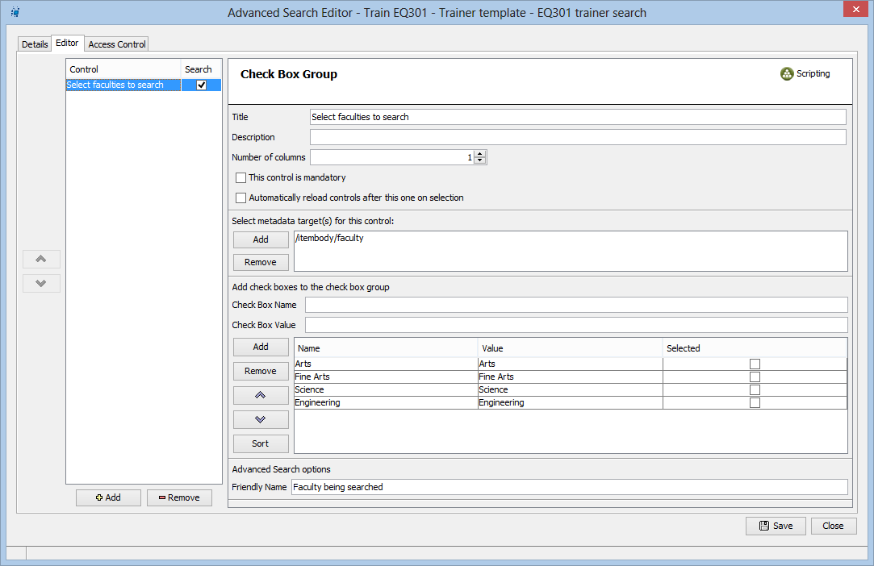

###### Figure 12 Advanced Search Editor

Testing

The resources will not be returned by the advanced search until the server has reindexed the collection. Indexing for contributed resources happens during contribution so newly contributed resources should appear immediately.

1. Login as a contributor and contribute a resource, alternatively allow a few minutes for the server to index the existing resources so they can appear in the search results.
2. Run the search in EQUELLA selecting faculties you have entered for your resources during contribution.

 Review the section then complete the extension exercises if time permits

***Advanced search extension exercise***

Advanced searches help in improving the relevance of search results by targeting searches:

1. What other metadata would be useful to search on?
2. Add further controls to *EQ301 content search* to target other metadata.

## Remote repositories

Remote repository searching allows users to search multiple external sources including other EQUELLA repositories, for content using a single search query. Search sources can include such entities as university library databases, internet search engines and online course management systems.

EQUELLA currently supports searching repositories that meet the following standards or protocols:

* Z39.50—libraries and major databases.
* SRW—internet pages.
* SRU—Search/retrieval via URL.
* MERLOT—higher education learning materials.
* EQUELLA—other EQUELLA repositories.

Typically access to external repositories requires a login or licence key.

Search results can be imported into a configured collection contribution wizard.

#### Notes

***Remote repository search creation exercise***

Remote repository searches are created using the Administration Console **Remote Repositories** tool.

To configure a typical remote repository search a URL is required for the location of the repository and credentials are required to login to that URL. Usually credentials are provided through a single remote searcher user that everyone uses.

In this exercise you will create a remote repository search from your institution to the trainer’s institution (feel free to partner up with one of a class member and create remote repository searches between your institutions if you are feeling confident).

This will require the trainer to:

1. Provide the URL of their institution.
2. Create a shared secret for communicating with the other institutions.
3. Create a user with appropriate privileges to download and discover the resources.

##### To configure a remote repository search

1. Open the Administration Console **Remote Repositories** tool then select the **Add**

button to display the **Search Types** dialog.

1. Select **EQUELLA** from the list of available searches then **OK** to display the **Remote Repository Editor**.
2. Enter a search name (e.g. *EQ301Training search)***.**
3. Enter the institution URL for the trainer’s institution.
4. Enter the Share secret ID (*remoteRepository*)and Value (*123remoteRepository*)
5. Select **Always login with the following username** and enter a user name (*remoteSearcher* for the trainer’s institution).
6. Save the search.

##### Testing

1. Check the search by logging in to EQUELLA (any user can use the remote repository search with the training security configuration) select **Search** from the Navigation pane, then select your configured remote repository search from the **Within** drop down list. Alternatively, select the **Search other repositories** button from the right hand pane.
2. Select the repository you just added, enter a search term (e.g. *EQ301*) then select

**Search** to display the results.

*(NOTE: some repositories support more search options than others, e.g. MERLOT allows a user to specify Community, Material type and Category in addition to search terms, as part of the search.)*

 Review the section then complete the extension exercises if time permits

***Remote repositories search extension exercises***

Other Remote Repository search types are explored in this exercise:

1. Review the configuration requirements for the other search types.
2. Create an SRU repository search.

***Other searches***

*EQUELLA* provides a comprehensive set of search options including:

* Dashboard searches:
  + Quick search (keyword searching)
  + Favourites
  + Search (includes keyword searching, Search by individual collection, Remote repositories search, Advanced search, Cloud search)
  + My Resources
  + Browse the repository
  + Task list search
* Contribution based searches:
  + YouTube™
  + GoogleBooks™
  + iTunesU™ tracks
  + Flickr™ images
  + Kaltura™ media
  + Echo360 lectures
  + QTI and LTI
  + Scrapbook
  + HTML Editor
  + EQUELLA Resources

# Session 3

This session covers:

* ACL overview—a brief high level view of privileges to help with understanding Metadata ACL.
* Metadata ACL—how metadata can be used to control the content available to users.
* Diagnostics—reviewing a user’s groups and group information.
* Workflow development:
  + Introducing workflow elements;
  + Creating a simple workflow; and
  + Adding a workflow to a collection.

## ACL overview

EQUELLA uses a hierarchy of access control lists (ACL) to manage security. Each level of the security hierarchy by default inherits actions from its parent level.

An example ACL is shown in Figure 13.

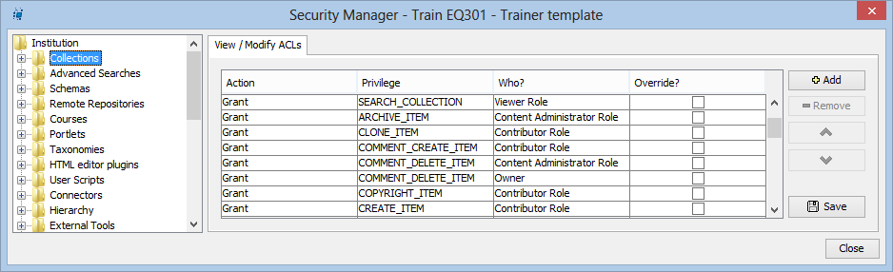

###### Figure 13 Security Manager—ACL

EQUELLA security works by matching the first action it can when traversing the ACL from the current object to the institution level. This ensures that:

* Actions set on a resource have precedence over actions set at the institution level.
  + Parent level actions can be set to override child actions overriding this natural precedence. Overrides should be used with caution as it is very easy to introduce unexpected behaviour. Typically an override is used at the institution level for the system admin so they always have access to all resources.
* Institution level actions are the ‘default’ settings for any objects.

General hints for simplifying ACL management:

* Set the ACL at the highest level in the security hierarchy that will give the required result. When you have a choice, set the privilege at the ‘logical’ place for example, set collection based privileges at the collections level rather than the institution level for users.
* Use care when adding a ‘Revoke’ action because managing several levels of ‘security logic’ can be difficult enough without adding negating terms.
* Use the Basic Editor where possible.
* Use the simplest possible ACL to provide the required access.
* Group ACLs by assignee where possible (this makes it simpler to find who is assigned what privilege).

***Resource metadata ACL***

Resource metadata ACL pages enable the entry of scripts that control actions based on resource metadata. Any schema node associated with the resource can be used to modify any available security action providing a powerful and flexible tool for managing resources.

Further information on ACLs is provided in the *EQUELLA Security Administration Guide*.

### Resource metadata ACL exercise

One use of resource metadata is to control the resources displayed to users based on resource metadata. This is one method for increasing the relevancy of search results for users.

In this exercise you will create a view privilege script based on the metadata contained in the *Purpose* node that will restrict access to resources contributed as exams. It requires the creation of an *Examiners* group to assign to this privilege.

##### To create the Examiners group

1. Open the **Internal Groups** plug-in from the **User management** tool then create the

*Examiners* group as a child of the *Institution* group.

1. Add *Mel Smith* and *Hugh Wright* to this group.

##### To create the metadata ACL at the resource level

1. Open your *EQ301 collection* in the **Collection Definition Editor**.
2. Select the **Security** tab to display the ACL tabs.
3. Select the **Resource Metadata ACLs** tab to display the resource metadata configuration page.
4. Select the **Add** button to display a blank configuration screen.
5. Enter a name (e.g. *Exam ACL*).
6. Select the  button associated with the ‘*if’* clause to display the **What is being evaluated?** dialog.
7. Select the **Schema Item** radio button to enable the schema nodes.
8. Select the *Purpose* value then the **OK** button.
9. Select *Exam* from the drop-down list to the right of the ‘=’ sign.
10. Select the **Add** button to display the script.
11. Select the **…then apply the following…** tab to display the privileges page.
12. Select *view resources matching this rule* from the **Who can** drop-down list.
13. Select the **Basic** radio button and confirm this action.
14. Select the **A limited set of users, groups, and/or roles** radio button.
15. Select the **Select** button to display a **Select Recipients…** dialog.
16. Select **Groups** option then search to display all the groups in the institution.
17. Select the *Examiners* group then move them to the right-hand pane.
18. Select the **OK** button. An example is shown in Figure 14.

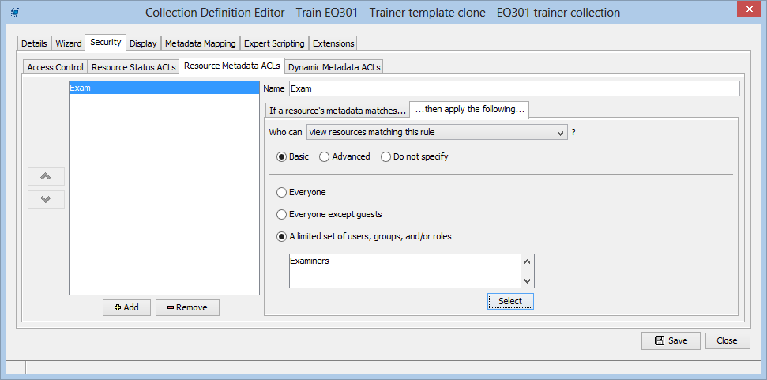

###### Figure 14 Example Resource metadata ACL

1. Select the **Save** button.

##### Testing

1. Login as a contributor and contribute an *Exam* resource with an attachment.
2. Login as a non-Examiner (for example Ben Day), search for the exam then view the resource summary.
3. The resource summary is displayed but the attachments are not.

This is a simple use of resource metadata ACL showing how a collection creator can control resource viewing.

### Collection ACL exercise

EQUELLA uses a hierarchy of access control lists (ACL) to manage security. Each level of the security hierarchy by default inherits actions from its parent level.

This exercise provides a basic understanding of the ACL structure provided with EQUELLA.

##### To view collection ACLs

*(Note: Care is required for this exercise.* ***Discard*** *any changes.)*

1. Open the **Security Manager** tool.
2. Review the privileges granted for all **Collections** and complete the following:

|  |  |  |
| --- | --- | --- |
| **Privilege** | **Who? (EQUELLA Role)**  **e.g. Viewer Role** | **EQUELLA User**  **e.g. Ben Day** |
| VIEW_ITEM |  |  |
| DISCOVER_ITEM |  |  |
| CREATE_ITEM |  |  |
| DELETE_ITEM |  |  |
| RAW_VIEW_ITEM |  |  |
| RESTRICT_ATTACHMENT |  |  |

1. List the ITEM privileges granted for all **Collections** to only the *Content Administrator*

e.g. DELETE_ITEM:

|  |  |  |
| --- | --- | --- |
|  |  |  |
|  |  |  |
|  |  |  |

Creating a consistent security pattern throughout an institution requires an organised approach and a deeper understanding of the ACL structure provided with EQUELLA. Participants interested in extending their security knowledge should join an *EQ302 Advanced Application Administrator* training course.

## Diagnostics

The **Diagnostics** function allows administrators to view the information about users and members of groups. The options include:

* **View groups for a user**—select a user to display all the groups where that user has been added.
* **View users in a group**—select a group to display all the group members. Figure 15 shows example diagnostic results.

###### 

###### Figure 15 Diagnostics page

***Diagnostics exercise***

In these exercises you will search for a user and members of a group.

To view groups for a user

1. Log in as *yourself*.
2. Select **Settings** in the navigation options then select the **Diagnostics** option.
3. Select the **Select user** button from the **View groups for a user** section to display the **Select user** dialog.
4. Search for *yourself* then select the required user option.
5. Select the **Select this user** button to display a list of groups that you belong to.

##### To view users in a group

1. Select the **Select group** button from the **View users in a group** section.
2. Search for the *Institute* group then select the required group option.
3. Select the **Select this group** button to display a list of users in the group.

## Workflows

Workflows are associated with a collection and can be a simple one-step review or complex multi-step editorial and technical review comprising multiple publication paths. EQUELLA workflows are processes that automatically notify users when they must review or moderate a repository resource.

The content administrator creates workflow steps then assigns users, groups or roles to a workflow step to create workflow step moderators. Workflow step moderators can be allocated to multiple workflow steps with moderator options being determined by the workflow creator and can include: rejection, modification, acceptance by one group member or acceptance by all group members.

Once the moderators have completed their review the next step in the workflow is determined by the moderators’ responses. The workflow history displays the resource’s workflow progress and can be used to view all review events and moderators.

Resources enter a workflow when:

* **Contributed**—the contributor chooses to submit the resource for moderation and the resource enters the workflow associated with the contributed collection.
* **Versioned**—a new version enters the workflow and on completion archives all other ‘live’ versions.
* **Reviewed**—a resource that has been ‘live’ for some period is checked for currency using its associated workflow. This process can be triggered manually by the resource owner or automatically by the collection definition. The resource has a ‘review’ state but remains searchable during this review.

Further information on workflows is provided in the *EQUELLA Workflow Configuration Guide*.

### Workflow creation

A typical workflow template is created using the following broad steps:

* Establish the required business process for the workflow. This is typically modelled on an existing process.
* Determine the users (group) who will moderate each task.
* Create a workflow template using the Workflow Template Editor that applies the business process established in the preceding step.
* Integrate with a metadata schema—creation of the workflow frequently requires the addition of nodes to the metadata schema for workflow node scripting.
* Integrate the workflow template with a collection—create any data entry controls for data required for workflow node scripting.
* Test the workflow from contribution to going live—modify the workflow template, metadata schema or collection if required and repeat the test.
* Make the collection available for general use.

There are no restrictions to the number of collections or metadata schemas associated with a workflow, however the number of collections and schemas that use an individual workflow template is restricted by the schema nodes required by the workflow and the controls provided by the collection.

### Workflow steps

The available workflow steps are:

* **Decision Point**—allows a workflow to be branched. Decision points require a script for differentiating between the branches. A decision point can have the following child nodes: decision point, parallel step, sequential step or workflow task.
* **Parallel Steps**—allows a workflow to be branched to multiple branches that can be completed concurrently. All branches must be completed for the workflow to leave a parallel step. A parallel step can have the following child steps: decision point, parallel step, sequential step or workflow task.
* **Sequential Steps**—allows a sequence of workflow steps to be chained together for completion. A sequential step can have the following child steps: decision point, parallel step, sequential step or workflow task.
* **Workflow Task**—the step where moderation occurs. Moderators must be allocated to workflow tasks before a workflow task can be saved in the workflow template. A workflow task has no child steps but may have sibling steps when used in conjunction with a sequential or parallel step.

Figure 16 shows an example of a completed workflow.

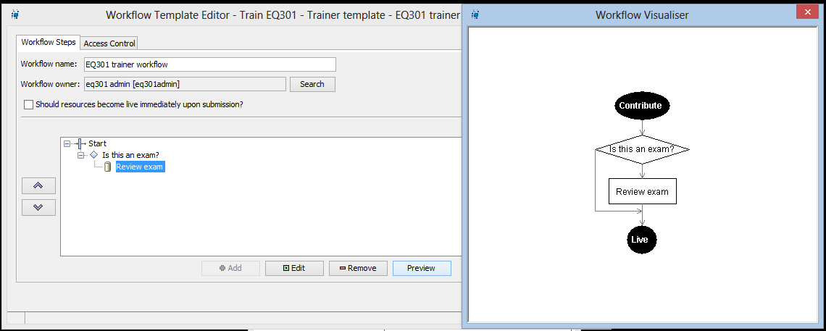

###### Figure 16 Workflow example

***Workflow creation exercise***

In this exercise you will create a simple workflow that will enter a workflow task when the contributed resource is an *Exam* document.

1. Open the Administration Console **Workflow Templates** tool then select the **Add**

button to display the **Workflow Template Editor**.

1. Enter a **Workflow name** (e.g. *EQ301 workflow)*.
2. Select **Start** in the editing pane to enable the **Add** button.
3. Select the **Add** button to display the **Select a step type…** dialog then select

**Decision Point** and **OK** to display the **Decision Point Editor**.

1. Enter a name (e.g. *Is the resource an exam?*) then select the **Open script editor**

button to display the **Script Editor**.

* 1. Select *your collection* from the **Select Collection** drop-down list then select the  button from the *‘if’* line to display the **What is being evaluated?** dialog.
  2. Select the **Schema Item** radio button to enable the schema nodes then select the *Purpose* node.
  3. Select the **OK** button then select *Exam* from the drop-down list field to the right of the = sign.
  4. Select the **Add** button to add the script to the **Script** area then select the **OK**

button to close the editor.

1. Select the **Save** button to close the **Decision Point Editor**.
2. Select the *Is the resource an exam?* decision point then the **Add** button to display the

**Select a step type…** dialog.

1. Select **Workflow Task** and **OK** to display the **Workflow Task Editor**.
2. Enter a **Task Name** (e.g. *Review exam)* and description.
3. Review then leave all other default values:
   1. **Priority**—select from the drop-down list options to manage the importance of the workflow task.
   2. **Remind users if not moderated within <x> days since submission**— selecting this option will trigger an email to the user selected as the moderator. Further options are provided to configure actions when the reminder is triggered.
   3. **Make this resource live automatically**—selecting an option here will publish the resource before completing the workflow.
   4. **Allow moderators to reject resources back to this task**—selecting this option allows resources rejected in later workflow tasks to re-enter the workflow at this point. This is useful for multiple task workflows.

To add moderators:

1. Select the **Moderators** tab to display the **Moderators** page.
2. Select the **Groups** radio button then the **Search** button to display all the available groups.
3. Select the *Examiners* group then the **>** button to move the group to the selected pane on the right-hand side.

###### Select the All moderators must unanimously accept this resource to continue escalation.

1. Select the **Allow moderators to edit the metadata of resources for this task**

checkbox.

1. Select the **Save** button to close the **Workflow Task Editor** and display the task in the workflow pane.

##### To preview the workflow

1. Select the **Preview** button to display a workflow diagram.
2. Close the diagram then **Save** and **Close** the **Workflow Template Editor**.

##### To add the workflow to the contribution wizard

1. Open the Administration Console **Collection Definitions** tool then open *your collection* to display the **Details** page.
2. Select *your workflow* from the **Map to a workflow** drop-down list.
3. Select **Save** then **Close** the Collection Definition Editor.

##### Testing

1. Login as a contributor (e.g. *hwright*) then contribute two resources to your collection and select *exam* as the purpose for one and *tutorial* for the other.
2. View the Resource summary page for each resource and check that:
   1. The exam resource has entered moderation and has a moderating status.
   2. The other resource has been published and has a live status.
3. Login as the other contributor (e.g. *msmith*) and note the moderation resource in the task list.

 Review the section then complete the extension exercises if time permits

***Workflow creation extension exercise***

The following exercises provide further insight into moderation:

1. Complete the moderation of the resource (both *hwright* and *msmith* will have to approve the resource).
2. Create a workflow branch by using another decision point that is only used for

*Engineering* resources, add yourself as moderator.

# Session 4

This session covers:

* Hierarchies (Browse resources):
  + Hierarchy creation;
  + Access control;
  + Key resources; and
  + Virtual hierarchies.

## Hierarchies

Browse Hierarchies provide a direct and simple means to present users with commonly used resources or information and provide a convenient alternative to searching.

The hierarchy is displayed in the **Browse** portlet on the EQUELLA **Dashboard** and as topic buttons in the left hand navigation menu. Up to four topics and a More… button can be displayed in the navigation menu.

The hierarchy is typically used by users to browse resources. Navigation is by selecting a topic from the current level to display topics in the next level down.

An example browse hierarchy is shown in Figure 17.

###### 

###### Figure 17 Browse resources hierarchy

Each level of the hierarchy can comprise resources and hierarchy topics. The resources and topics displayed can be based on metadata or user role.

Topics can be:

* **Dynamic**—resources selected as key resources.
* **Virtual**—resources are dynamically filtered enabling more flexible hierarchies to be created.
* **Filtered**—by Advanced Search criteria, free text query, by collection or metadata values.
* **Inherited**—child hierarchy topics can inherit filter queries from parent resources.

An example Hierarchy Editor is shown in Figure 18.

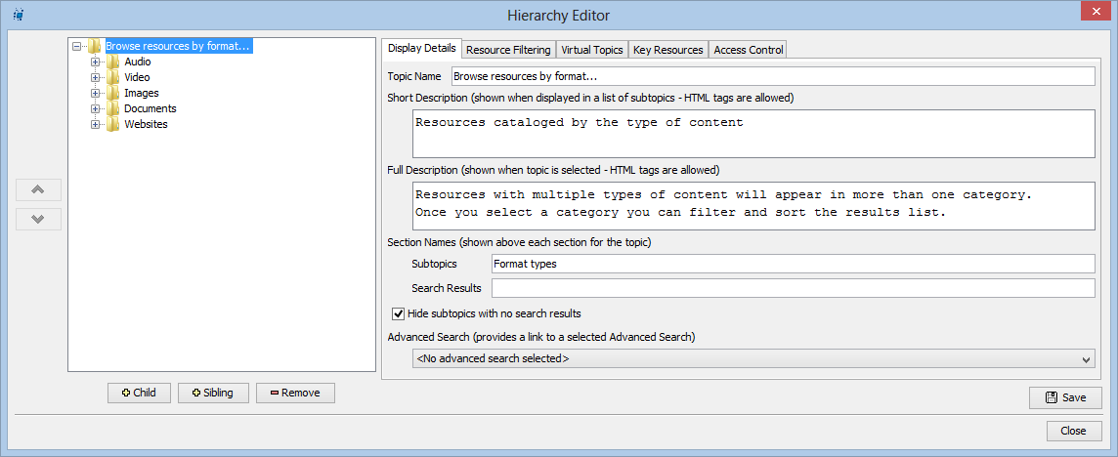

###### Figure 18 Hierarchy Editor

Further information is provided in the *EQUELLA Hierarchy Configuration Guide*.

***Notes***

***Hierarchy creation exercise***

In this exercise you will create topics based on the user role and resource metadata. The topics structure is:

* *EQ301 resources*—with the following sub-topics:
  + *Lectures*—displays all the lecture resources.
  + *Prac work*—displays all the prac work resources.
  + *Tutorials*—displays all the tutorial resources.
  + *Exams*—displays all the exam resources.

##### To create a hierarchy

1. Open the Administration Console **Hierarchy Editor**.
2. Select a top level Hierarchy node from the left-hand pane then select the **Sibling**

button to display an **Input** dialog.

Creating a top-level Hierarchy node will create a new button on the Dashboard menu that users can select to open the associated browse hierarchy.

1. Enter a name (e.g. *EQ301 resources)* then select **OK** to display the **Display Details**

page.

1. Deselect the **Hide subtopics with no search results** checkbox.
2. Leave the other default values for this page.
3. Select the **Resource Filtering** tab to display the resource filtering configuration page.
4. Deselect the **Display resources for this topic** check box as we only want to show the resources in sub topics.
5. Save the Hierarchy.

Leave all other pages for the topic with the default values.

##### To create a sub-topic

1. Select the **Child** button and add a node called *Lectures* and inherit constraints automatically.
2. Select the **Resource filtering** tab to display the **Resource Filtering** page.

To restrict the resources displayed to lecture resources a filter must be applied to the displayed resources. You will add a script that only displays resources with the *Lecture* value for the *Purpose* node metadata:

1. Select the **Add** button for the **Search the following collections** pane to display the

**Select a Collection** dialog.

1. Select your collection then **OK** to add an entry in the pane.
2. Select **[Add script]** to display the **Script Editor**—**Basic** page.
3. Select the  button on the **where** line to display the **Choose a schema element?**

dialog.

Only schema elements that have been selected for advanced search indexing are enabled for selection in the Hierarchy script.

1. Select the *Purpose* node then **OK**.
2. Select *Lecture* from the drop-down list in the next field on the **where** line then select the **Add** button to display the script in the **Script** pane.
3. Select the **OK** button to close the **Script Editor**.
4. Select the **Save** button to save the partially completed Hierarchy.
5. Repeat steps 1-10 to create the following child topics:
   1. *Prac work*—use *Prac work* for the script entry.
   2. *Tutorial*—use *Tutorial* for the script entry.
   3. *Exams*—use *Exam* for the script entry.

##### Testing

1. Add a **Browse** portlet to your **Dashboard** page.
2. Traverse the newly created topics from the **Browse** portlet and the **Browse**

navigation menu option.

1. Note all the hierarchy topics are visible to all users though only the *Examiners* group can view the exam attachments.

##### To add a script

To avoid the confusion this can create we will add a script to hide the *Exams* topic from all users except members of the *Examiners* group.

1. Open the **Hierarchy Editor** then select the *Exams* Hierarchy topic.
2. Select the **Access Control** tab to display the privilege configuration page.
3. Select *view this hierarchy topic* from the **Who can** drop-down list.
4. Select the **Basic** radio button then select **A limited set of users, groups and/or roles** radio button.
5. Select the **Select** button to display the **Select Recipients…** dialog.
6. Select **Groups** then search to display all the groups in the institution.
7. Select the *Examiners* group then move them to the right-hand pane.
8. Select the **OK** button.
9. Select the **Save** button then **OK**.

##### Testing

1. Login as *jfleming* and view the Hierarchy to ensure that the *Exams* topic is not visible.
2. Login as *hwright* and view the Hierarchy to ensure that the *Exams* topic is visible.

## Virtual hierarchies

EQUELLA provides the ability to automatically create a virtual hierarchy. A virtual hierarchy is useful when you have a large number of topics that change frequently. Virtual topics are restricted in the granularity of access control they can provide, so the preceding example hierarchy would be difficult to implement using virtual topics only.

### Virtual hierarchy creation exercise

In this exercise you will create a virtual hierarchy for content based on the commissioning faculty.

##### To create a virtual hierarchy

1. Select a top level Hierarchy node from the left-hand pane then select the **Sibling**

button to display an **Input** dialog.

1. Enter a name (e.g. *EQ301 Faculty resources)* then select **OK** to display the **Display Details** page.
2. Deselect the **Hide subtopics with no search results** checkbox.
3. Leave the other default values for this page.
4. Select the **Resource Filtering** tab to display the resource filtering configuration page.
5. Deselect the **Display resources for this topic** check box as we only want to show the resources in sub topics.
6. Save the hierarchy.

Now a sub-topic template folder must be created that will display the topics and be named correctly.

##### To create a sub-topic

1. Select the **Child** button then add a node called *%s* and inherit constraints automatically.

This subtopic has a special name that will be replaced by the node metadata. To configure the node used by the virtual topic:

1. Select the **Virtual Topics** tab to display the **Virtual Topics** page.
2. Check the **Enable Dynamic Filtering** checkbox.
3. Select the **Select…** button to display the **Choose a Schema Target** dialog.
4. Choose your schema then the *Faculty* node.

To select the topics displayed you can choose to display a topic for each different faculty found in the metadata node or only use some of them by manually entering a list.

*(Note: Some care is needed for the manual list as the entered names must match the stored metadata exactly.)*

1. Select the **Contributed Resources** radio button then **Save** the hierarchy.

##### Testing

1. Login as an examiner (*hwright*) and view both hierarchies.
2. Login as *bday* and view both hierarchies.

What are the differences between the two hierarchies?

Review the section then complete the extension exercises if time permits

***Hierarchy creation extension exercise***

Further exercises for hierarchies include:

1. Make a mixed hierarchy (one with virtual and standard topics) that behaves like the first hierarchy created.
2. Modify the Hierarchy topic you configured in the Hierarchy creation exercise to include a key resource. Check that it works by logging on as a suitable user.

# Session 5

This session covers:

* Portlets
* Dynamic collections
* Theming and accessibility
* Practice scenario exercise
* Existing EQUELLA objects
* EQUELLA Client Support processes and protocols
* Import/Export tools
* EQUELLA Bulk Importer

## Portlets

Portlets are displayed in the central pane of the **Dashboard** page and typically display a summary of available content and links to access that content. The portlets can be added, edited, re-sized, re-ordered, removed and restored.

An administrator can configure portlets to appear on other users Dashboards. An example Dashboard page with portlets is shown in *Figure 19*.

<insert Dashboard page with portlets image>

###### Figure 19 Dashboard page with portlets

***Portlets creation and administration exercise***

In this exercise you will create portlets and configure them for others to use.

To add portlets to your dashboard

1. Log in as *yourself*.
2. Select the **Dashboard** option then select **Screen options** at the top of the page.
3. Select the **My resources** option then select **Save**.
4. Observe the changes to the **Dashboard** page.
5. Add a **Browse** and **Favourites** portlet.
6. Move the **My resources** portlet to a new position.
7. Minimise then restore the **Browse** portlet.
8. Add a **Formatted text** portlet with a *Welcome* **Title** and helpful introductory text that will suit all users of your institution.
9. Save the *Welcome* portlet and position it in the top position of the Dashboard.

##### Testing

1. Login as *jfleming* and observe the **Dashboard** page.

##### To add portlets to other user’s dashboard

1. Log back in as *yourself*.
2. Select **Settings** in the navigation options then select the **Dashboard** option.
3. Select the **Edit** button for your *Welcome* portlet.
4. Check the **Show for other users** option.
5. Uncheck the **Users can close** option.
6. Select the **Change** button from the **Visible to** section to display the **Choose who can view this portlet** dialog.
7. Search for the *Institute* group then select the **+Add selected** button then select **OK**.
8. Select the **Save** button.

##### Testing

1. Login as *jfleming* and view the *Welcome* portlet on the Dashboard.
2. Observe what options are available on the portlet.

***Portlets extension exercise***

Further exercises for portlets include:

1. Select the **Edit** button for your *Welcome* portlet.
2. Select the **Insert EQUELLA content** to find content such as images to embed or link into your portlet.
3. Add **Quick search**, **RSS**, **Recent contibutions**, **Task statistics** and **Tasks** portlets.

## Dynamic collections

Dynamic collections are method for exposing EQUELLA content outside of EQUELLA. A dynamic collection can provide content using:

* **Searching**—this adds the dynamic collection to the list of searches available through the standard EQUELLA search.
* **OAI_PMH set**—this makes the content available to external users that can access the EQUELLA OAI_PMH endpoint URL.
* **Harvester Collection**—enables the collection to be harvested by other EQUELLA repositories.

Further information is provided in the *EQUELLA Dynamic Collections Guide*

### Notes

***Dynamic collections exercises***

This exercise will create a dynamic collection of resources excluding exams and provide them using an OAI_PMH set.

##### To create the OAI_PMH set

1. Open the **Dynamic Collections** tool in the Administration Console.
2. Select the **Add** button to display the **Dynamic Collections Editor**.
3. On the **Details** page enter a name and description.
4. Select **Searching** then select **OAI_PMH Set** options.
5. On the **Resource Filtering** page add your collection in the **Search the following collections** area.
6. Select **[Add Script]** to display the **Script Editor** add a script that excludes exams (e.g. *where purpose is not Exam*).
7. Save the collection.

To find the URL that EQUELLA uses to provide the OAI_PMH set add ‘*/p/oai?verb=ListSets’* to the end of your institution URL an example is [*http://training.equella.com/eq301/p/oai?verb=ListSets*](http://training.equella.com/eq301/p/oai?verb=ListSets)*.*

An example response is shown in Figure 20.

###### <Insert sample image>

###### Figure 20 Dynamic Collections available as OAI_PMH sets

Testing

1. Login to your institution then add ‘/*p/oai?verb=ListSets’* after your institution name in the browser address field.
2. Check your set is available.
3. Select the dynamic search from the **Within all resources**—**Collections** dropdown- list and review the results.

## Theming and accessibility

EQUELLA provides functionality to customise how the EQUELLA User interface is displayed to:

* Make it accessible to a wider range of users.
* Customise it to a client’s look and feel.

This exercise uses the Custom CSS classes in the contribution wizard to modify the wizard appearance. This exercise may be extended to provide a high contrast wizard for accessibility or to differentiate wizards within an institution.

An example wizard with modified theme is shown in Figure 21.

###### 

###### Figure 21 Modified theme

Further information on theming EQUELLA is provided in the *EQUELLA Theming Guide*.

***Notes***

***Customising a contribution wizard***

To modify how EQUELLA is displayed the following actions must be performed:

1. Add a Custom CSS class identifier to the wizard page.
2. Determine what needs to be modified and how it needs to be modified. This is typically performed using one of the browser based CSS viewers.
3. Create a theme zip file that contains the modifications:
   1. CSS file; and
   2. Images and other resources.
4. Upload the zip file to EQUELLA.

The complete process is described in detail in the *EQUELLA Theming Guide*.

### Customising a contribution wizard exercise

In this exercise:

* Step one is part of the exercise.
* Step two has been performed already and what you need to modify is discussed in the exercise.
* Step three is simplified by using one of the themes provided in your institution and can be found by searching for *EQ301 Wizard Theming example* resource.
* Step four is part of the exercise.

##### Create the CSS classes in the wizard

1. Open the **Collection Definition** tool in the **Administration Console**.
2. Open the contribution wizard created earlier.
3. Navigate to the **Wizard** tab then select the *Resource Details* page.
4. Enter *detailsPage* in the **CSS Class** field.
5. Save the contribution wizard.

The text entered in this field creates a CSS identifier for the wizard page that can be used in the CSS file. So we have completed step one.

1. Search for the *EQ301 Wizard Theming example* resource in your repository.
2. Create a folder on your desktop (e.g. *EQ301Theme*).
3. Download the attachment then unzip the file to the *EQ301Theme* folder.

The EQ301Theme folder should contain two folders at the first level. This zip file is the sample theme file called *grape* available from support.

In this exercise we only need the CSS folder:

1. Delete the *p* folder from the *EQ301Theme* folder.

Now you will modify the *customer.css* file. This is a special file that is used so that administrators can modify the look and feel of any EQUELLA institution. The *customer.css* file is the last CSS file so any formatting in this file overrides all other formatting.

In this exercise you will change the background colour to white and the headings to grey.

1. Open the customer.css in notepad and add the following text:

.detailsPage .area { background-color: #ffffff;

}

.detailsPage .area H2,

.detailsPage .area H3 { color: #111111;

}

1. Save the file.
2. Select and zip the *CSS* folder (using the right click *Compressed file* option from the

*Send To* menu).

1. Navigate to the **Settings** page then select the **Themes** option.
2. Select the **Browse** button then select your *css.zip* file.
3. Select the **Upload** button. Note the changes to the **Themes** page.

##### Testing

1. Reload (Ctrl+F5) your browser page to see the changes.
2. Test the changes by contributing an item. An example wizard is shown in Figure 21 on page 57.

## Practice scenario exercise

This scenario based exercise consolidates the activities learnt in the preceding exercises and can be done individually or as a group.

You are required to create a collection that stores image based content. Images may be uploaded directly to the repository or linked using a URL. You will need to record the location of the image, where it was created, type of image (native digital, digital copy

e.g. painting, photograph) size of the image (width and height in pixels and if it is a copy the width and height in mm of the original).

The important information associated with the images are:

* Subject area (technical, arts, general)
* Creator
* Owner
* Availability (Public, Private, Research Only)

The viewing of content must be restricted in the following ways:

* A cataloguers group can view all images. This group is the only group that can contribute images.
* The research group can only view Research Only and Public images.
* All other EQUELLA users can only view Public images.

Create the required metadata schema, collection and groups to manage these images. It will help to create at least one user for each group.

## Existing EQUELLA objects

In the training institution there are many objects (collections, schemas, scripts) already that provide a good resource for extending your knowledge.

Some examples are:

* The *Learning Federation* hierarchy topic: the *Learning Objects* topic shows how to use resource inheritance.
* The *Generic Schema* provides an example that can be cloned and modified providing a variety of nodes including LOM nodes.
* The *Books collection* is an example holding collection for copyright collections that includes an involved Expert script.
* The *Le@rning Federation resources* advanced search is highly detailed.
* The *MeSH_taxon* taxonomy is a large taxonomy used by a university.
* The *Documentation* workflow provides a good example of a usable workflow.
* The **Security Manager** provides an insight into the difficulties associated with managing security.

### Training

EQUELLA provides the following training courses:

* **EQ101**—Core Principles (1 day workshop).
* **EQ201**—Content Administrator (1 day workshop).
* **EQ301**—Application Administrator (3 day workshop).
* **EQ302**—Advanced Application Administrator (1 day workshop).
* **EQ303**—Reporting Workshop (2-3 day workshop).
* **EQ304**—EBI Workshop (1/2 day workshop).
* **EQ305**—Scripting Workshop (1 day workshop).
* **EQ306**—Advanced Scripting Workshop (2 day workshop).
* **EQ401**—System Administrator (2 day workshop).

## International User Community

The EQUELLA User Community enables members to contribute, share and stay connected with other users globally, while extending their knowledge of EQUELLA.

The following EQUELLA resources can be accessed:

* EQUELLA documentation
* Installer, upgrades, Internationalisation packs, sample reports and miscellaneous tools.

To join the EQUELLA User Community please see www.equella.com

## Export/Import tools

EQUELLA provides two further tools for importing and exporting resources to or from an institution. The export tool enables the selection of export resources based on type or search criteria. The import tool is typically used for importing content to an EQUELLA institution where the content has been exported from an EQUELLA institution of the same version.

*(Note: The Export/Import tools are EQUELLA version specific.)*

### Export tool

The export tool is java application that is configured by:

1. Entering the Institution URL and a username and password for a system administrator user.
2. Selecting the resources to export.
3. Configure where they should be stored on the local system.
4. Start the export. An example of the export tool is shown in Figure 22.

###### <insert image Export tool>

###### Figure 22 The Export tool

***Export tool exercise***

Export a selection of resources from the learning resource collection from your training institution using the export tool. Use a user with an administrator role. *Hint: Before entering a search string in the export utility and exporting test the search string by entering it in the EQUELLA search bar and checking the number of results returned.*

1. Double click the **exportutil.jar** file to open the application.
2. Configure the tool to connect to your training institution and complete the exercise.

### Import tool

The import tool is the twin of the export tool and can be used to transfer resources to a new institution.

The import tool is a java tool that is configured by:

1. Entering the Institution URL and a username and password for a system administrator user.
2. Selecting a collection for contribution of the imported resources.
3. Select a resource then upload.

An example of the import utility is shown in Figure 23.

###### <insert image of Import tool>

###### Figure 23 Import tool

***Import tool exercise***

Import a resource you exported in the previous exercise. Ensure you are importing to the collection the resource was exported from (when exporting to a different collection an XSLT will be needed to map the metadata correctly).

1. Double click the **importutil.jar** file to open the application.
2. Configure the tool to connect to your training institution and complete the upload.

## EQUELLA Bulk Importer (EBI)

The EQUELLA Bulk Importer is a program that allows you to upload content into the EQUELLA Digital Repository. It allows less technical users to quickly and easily import large amounts of content into EQUELLA. The simple steps to use it are as follows:

1. Collect your data into a spreadsheet-like text file called a comma separated view (CSV). An example is shown in Figure 24.
2. Specify in your CSV where in the data should go and any files you wish to attach.
3. Point the EQUELLA Bulk Importer at your CSV and your EQUELLA server.

### How the EQUELLA Bulk importer works

The EQUELLA Bulk Importer can either be installed on your workstation or on a server. From there it reads a CSV text file provided by you. The CSV can be placed either on the same computer as the EQUELLA Bulk Importer or on a shared folder on your network.

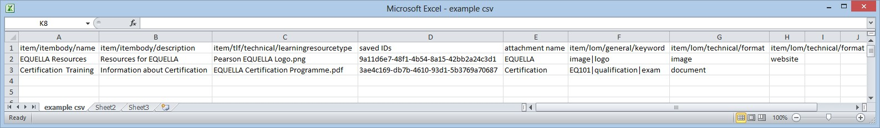Based on the data from each row in your CSV, it forms XML metadata and locates files for uploading. An example is shown in Figure 25. The EBI then creates a corresponding item with the metadata and file attachments.

###### Figure 24 Example CSV file

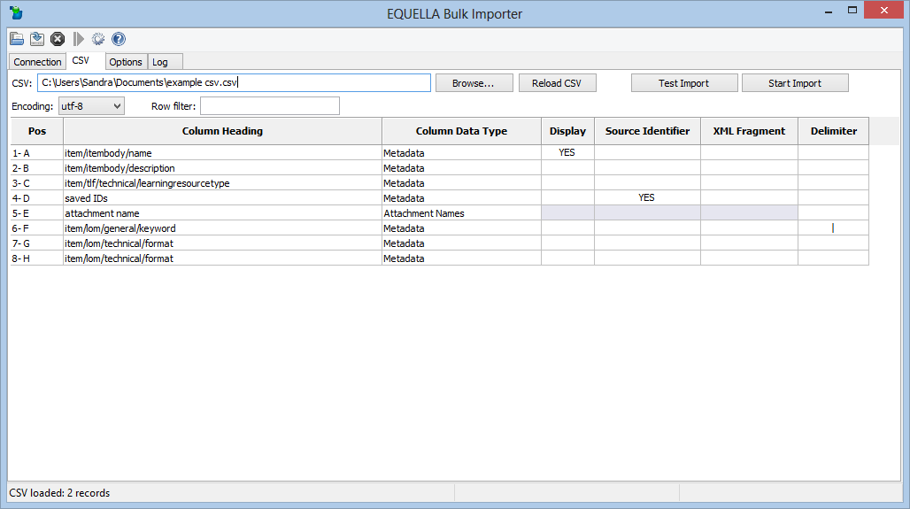

**Figure 25 EBI with loaded CSV file**

The EQUELLA Bulk Importer is designed to import content into EQUELLA 4.1 and higher.

### EBI exercise

Install the EBI, create a CSV file and upload content to your EQUELLA Digital Repository.

1. Search for the *User Community* resource in your repository.
2. Login or join the EQUELLA User Community.
3. Search for the EBI information and follow the links to download the EBI. There is a manual provided with the download.
4. Follow the instructions to create a CSV file or use the *example.csv* using the xpaths from you schema. *Note: Use resource/resourcebody/name instead of*

*/xml/resource/resourcebody/name.*

1. Use your training institution URL, Username and Password.