CHRISTIAN A. NEMENO   
OCTOBER 18, 2024  
COURSE: Computer Organization and Architecture   
Intstructor: Mr. Roden J. Ugang  
CS243 Week 10 Lab Exercises

1. ; Filename: EXER33.ASM

; Programmer Name: Christian A. Nemeno

; Date: OCTOBER 18, 2024

; Description: This assembly language program will input

; two single-digit numbers, add the two numbers,

; and display the sum of the two numbers.

.MODEL SMALL

.STACK 100H

.DATA

num1 DB ?

num2 DB ?

sum DB ?

msg1 DB 'Enter first number (0-9): $'

msg2 DB 13, 10, 'Enter second number (0-9): $'

msg3 DB 13, 10, 'The sum is: $'

.CODE

MAIN PROC

; Initialize data segment

MOV AX, @DATA

MOV DS, AX

; Input first number

LEA DX, msg1

MOV AH, 09H

INT 21H

; Read character input

MOV AH, 01H

INT 21H

SUB AL, '0' ; Convert ASCII to number

MOV num1, AL

; Input second number

LEA DX, msg2

MOV AH, 09H

INT 21H

MOV AH, 01H

INT 21H

SUB AL, '0' ; Convert ASCII to number

MOV num2, AL

; Calculate sum

MOV AL, num1

ADD AL, num2

MOV sum, AL

; Display result

LEA DX, msg3

MOV AH, 09H

INT 21H

; Convert sum to ASCII

ADD sum, '0'

MOV DL, sum

MOV AH, 02H

INT 21H

; Exit program

MOV AX, 4C00H

INT 21H

MAIN ENDP

END MAIN

Screen shot run:  
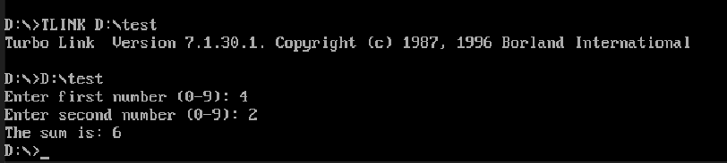

2. ; Filename: EXER34.ASM

; Programmer Name: CHRISTIAN A. NEMENO

; Date: OCTOBER 18, 2024

; Description: This assembly language program will input two

;single-digit numbers, subtract the two numbers,

; and display the difference of the two numbers.

.model small

.stack 100h

.data

msg1 db 'Enter first number: $'

msg2 db 13,10,'Enter second number: $'

resultMsg db 13,10,'The result is: $'

num1 db ?

num2 db ?

result db ?

.code

start:

; Set up the data segment

mov ax, @data

mov ds, ax

; Prompt for the first number

mov ah, 09h

lea dx, msg1

int 21h

; Read first number

call read_number

mov num1, al

; Prompt for the second number

mov ah, 09h

lea dx, msg2

int 21h

; Read second number

call read_number

mov num2, al

; Subtract the second number from the first

mov al, num1

sub al, num2

mov result, al

; Display the result

mov ah, 09h

lea dx, resultMsg

int 21h

; Convert result to ASCII and print

call print_result

; Exit program

mov ax, 4C00h

int 21h

; Read a number from keyboard (assumes single digit input)

read_number proc

mov ah, 01h ; Function to read a character

int 21h

sub al, '0' ; Convert ASCII to integer

ret

read_number endp

; Print the result (single digit)

print_result proc

add result, '0' ; Convert result to ASCII

mov ah, 0Eh ; BIOS teletype output function

mov al, result

int 10h

ret

print_result endp

end start

Screenshot run:  
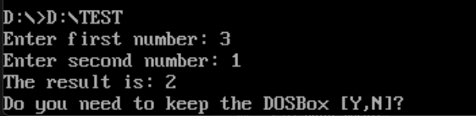

3. ; Filename: EXER35.ASM

; Programmer Name: CHRISTIAN A. NEMENO

; Date: OCTOBER 18, 2024

; Description: This assembly language program will input two

;single-digit numbers, multiply the two numbers,

; and display the product of the two numbers.

.model small

.stack 100h

.data

msg1 db 'Enter first number (0-9): $'

msg2 db 13,10,'Enter second number (0-9): $'

resultMsg db 13,10,'The result is: $'

num1 db ?

num2 db ?

result db ?

.code

start:

; Set up the data segment

mov ax, @data

mov ds, ax

; Prompt for the first number

mov ah, 09h

lea dx, msg1

int 21h

; Read first number

call read_number

mov num1, al

; Prompt for the second number

mov ah, 09h

lea dx, msg2

int 21h

; Read second number

call read_number

mov num2, al

; Multiply the two numbers

mov al, num1

mov bl, num2

mul bl ; AL = AL * BL, result in AX

mov result, al ; Store the lower byte of the result

; Display the result

mov ah, 09h

lea dx, resultMsg

int 21h

; Convert result to ASCII and print

call print_result

; Exit program

mov ax, 4C00h

int 21h

; Read a number from keyboard (assumes single digit input)

read_number proc

mov ah, 01h ; Function to read a character

int 21h

sub al, '0' ; Convert ASCII to integer

ret

read_number endp

; Print the result (single digit)

print_result proc

add result, '0' ; Convert result to ASCII

mov ah, 0Eh ; BIOS teletype output function

mov al, result

int 10h

ret

print_result endp

end start

Screenshot run:

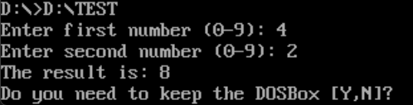

4. ; Filename: EXER36.ASM

; Programmer Name: CHRISTIAN A. NEMENO

; Date: OCTOBER 18, 2024

; Description: This assembly language program will input two

;single-digit numbers, divide the two numbers,

; and display the quotient of the two numbers.

.model small

.stack 100h

.data

msg1 db 'Enter first number (0-9): $'

msg2 db 13,10,'Enter second number (1-9): $' ; Second number

;cannot be zero

resultMsg db 13,10,'The result is: $'

num1 db ?

num2 db ?

result db ?

.code

start:

; Set up the data segment

mov ax, @data

mov ds, ax

; Prompt for the first number

mov ah, 09h

lea dx, msg1

int 21h

; Read first number

call read_number

mov num1, al

; Prompt for the second number

mov ah, 09h

lea dx, msg2

int 21h

; Read second number

call read_number

mov num2, al

; Check for division by zero

cmp num2, 0

je div_by_zero

; Divide the two numbers

mov al, num1

xor ah, ah ; Clear AH for the division

mov bl, num2

div bl ; AL = AL / BL, quotient in AL, remainder in AH

mov result, al ; Store the quotient

; Display the result

mov ah, 09h

lea dx, resultMsg

int 21h

; Convert result to ASCII and print

call print_result

; Exit program

mov ax, 4C00h

int 21h

div_by_zero:

; Handle division by zero (optional: you can display a

;message)

mov ah, 09h

lea dx, msg2 ; Reuse msg2 for simplicity

int 21h

; Exit program

mov ax, 4C00h

int 21h

; Read a number from keyboard (assumes single digit input)

read_number proc

mov ah, 01h ; Function to read a character

int 21h

sub al, '0' ; Convert ASCII to integer

ret

read_number endp

; Print the result (single digit)

print_result proc

add result, '0' ; Convert result to ASCII

mov ah, 0Eh ; BIOS teletype output function

mov al, result

int 10h

ret

print_result endp

end start

Screenshot run:

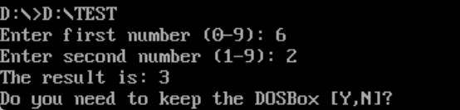

5. ; Filename: EXER37.ASM

; Programmer Name: CHRISTIAN A. NEMENO

; Date: October 18, 2024

; Description: Create a program that inputs a character. If the character

; is the capital letter A, display message “You entered A.”,

; else display “You entered not A.”

.model small

.stack 100h

.data

    prompt      db      'Enter a character: $'

    msgA        db      13, 10,'You entered A.$'

    msgNotA     db      13, 10,'You entered not A.$'

    inputChar   db ?

.code

main:

    ; Set up the data segment

    mov ax, @data

    mov ds, ax

    ; Display prompt

    mov dx, offset prompt

    mov ah, 09h

    int 21h

    ; Read a character from the keyboard

    mov ah, 01h

    int 21h

    mov inputChar, al  ; Store the character in inputChar

    ; Compare the character with 'A'

    cmp inputChar, 'A'

    je isA             ; If equal, jump to isA

notA:

    ; Display "You entered not A."

    mov dx, offset msgNotA

    mov ah, 09h

    int 21h

    jmp endProgram

isA:

    ; Display "You entered A."

    mov dx, offset msgA

    mov ah, 09h

    int 21h

endProgram:

    ; Exit the program

    mov ax, 4C00h

    int 21h

end main

Screenshot run:

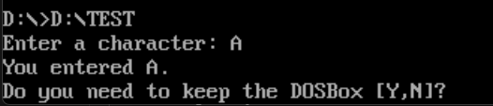

6. ; Filename: EXER38.ASM

; Programmer Name: CHRISTIAN A. NEMENO

; Date: October 18, 2024

; Description: Create a program that inputs a number. Display the following messages depending on the value of the number entered

.model small

.stack 100h

.data

    prompt      db 'Enter a number: $'

    msgEqual    db 13, 10,'The number is equal to 5.$'

    msgLess     db 13, 10,'The number is less than 5.$'

    msgGreater  db 13, 10,'The number is greater than 5.$'

    num    db ?

.code

main:

    ; Set up the data segment

    mov ax, @data

    mov ds, ax

    ; Display prompt

    mov dx, offset prompt

    mov ah, 09h

    int 21h

    ; Read a number from the keyboard

    mov ah, 01h

    int 21h           ; Read a character

    sub al, '0'       ; Convert ASCII to integer

    mov num, al  ; Store the number

    ; Compare the number with 5

    cmp num, 5

    je isEqual        ; Jump if equal to 5

    jl isLess         ; Jump if less than 5

isGreater:

    ; Display "The number is greater than 5."

    mov dx, offset msgGreater

    mov ah, 09h

    int 21h

    jmp endProgram

isEqual:

    ; Display "The number is equal to 5."

    mov dx, offset msgEqual

    mov ah, 09h

    int 21h

    jmp endProgram

isLess:

    ; Display "The number is less than 5."

    mov dx, offset msgLess

    mov ah, 09h

    int 21h

endProgram:

    ; Exit the program

    mov ax, 4C00h

    int 21h

end main

Screenshot run:  
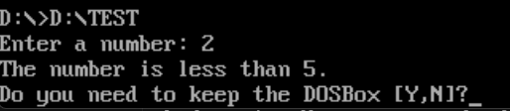

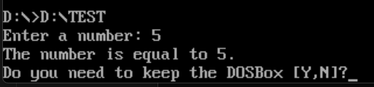

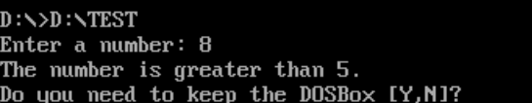

7. ;Filename: EXER39.ASM

;Programmer name: Christian A Nemeno

;Date: OCTOBER 18, 2024

;Description: Create a program that displays a menu for Addition, Subtraction, Multiplication, and Division.

.model small

.stack 500h

.data

    menu        db 'MATH OPERATIONS'  ,13,10

                db '1. Addition'      ,13,10

                db '2. Subtraction'   ,13,10

                db '3. Multiplication',13,10

                db '4. Division'      ,13,10,'$'

    choice      db 'Enter your choice: $'

    aPrompt     db 'Addition$'

    aPrompt1    db 13,10,'Enter first number: $'

    aPrompt2    db 13,10,'Enter second number: $'

    aDisplay3   db 13,10,'Sum: $'

    sPrompt     db 'Subtraction$'

    sPrompt1    db 13,10,'Enter first number: $'

    sPrompt2    db 13,10,'Enter second number: $'

    sDisplay3   db 13,10,'Difference: $'

    mPrompt     db 'Multiplication$'

    mPrompt1    db 13,10,'Enter first number: $'

    mPrompt2    db 13,10,'Enter second number: $'

    mDisplay3   db 13,10,'Product: $'

    dPrompt     db 'Division$'

    dPrompt1    db 13,10,'Enter first number: $'

    dPrompt2    db 13,10,'Enter second number: $'

    dDisplay3   db 13,10,'Quotient: $'

    eDisplay    db 'Exit Program$'

    invalid     db 'INVALID CHOICE!$'

    ending      db 13,10,'Press Enter to continue.$'

    negSign     db '-$'

    divZero     db 'Error: Division by zero is not allowed.$', 13, 10

    input1   dw ?

    input2   dw ?

    sum      dw ?

    diff     dw ?

    prod     dw ?

    quo      dw ?

.code

print proc

    mov ah, 09h

    int 21h

    ret

print endp

getNum PROC

    ; Read a single digit from keyboard and store in AX

    mov ah, 01h

    int 21h

    sub al, '0'          ; Convert from ASCII to integer

    mov ah, 0

    ret

getNum ENDP

getChar PROC

    mov ah,01h

    int 21h

    ret

getChar ENDP

converter proc

    push ax

    push bx

    push cx

    push dx

    mov cx, 0            ; Counter for digits

    mov bx, 10           ; Base for decimal conversion

    converter_loop1:

        xor dx, dx           ; Clear DX before dividing

        div bx               ; AX / BX, result in AX, remainder in DX

        push dx              ; Push remainder onto stack

        inc cx               ; Count the number of digits

        cmp ax, 0            ; Check if quotient is zero

        jne converter_loop1       ; Repeat if not

    converter_loop2:

        pop dx               ; Pop the last remainder

        add dl, '0'          ; Convert to ASCII

        mov ah, 02h          ; Print character function

        int 21h              ; Interrupt to print character

        dec cx               ; Decrease the digit counter

        cmp cx, 0            ; Check if finished printing all digits

        jne converter_loop2       ; Continue if not

    pop dx

    pop cx

    pop bx

    pop ax

    ret

converter endp

newLine PROC

    mov ah, 02h

    mov dl, 13

    int 21h

    mov ah, 02h

    mov dl, 10

    int 21h

    ret

newLine ENDP

addition proc

    call newLine

    call newLine

    mov ah,09h

    lea dx, aPrompt

    call print

    lea dx, aPrompt1

    call print

    call getNum

    mov input1, ax

    lea dx, aPrompt2

    call print

    call getNum

    mov input2, ax

    mov dx, input1

    add dx, input2

    mov sum, dx

    lea dx, aDisplay3

    call print

    mov ax, sum

    call converter

    call newLine

    ret

addition endp

subtraction proc

    call newLine

    call newLine

    mov ah,09h

    lea dx, sPrompt

    call print

    lea dx, sPrompt1

    call print

    call getNum

    mov input1, ax

    lea dx, sPrompt2

    call print

    call getNum

    mov input2, ax

    mov ax, input1

    sub ax, input2

    mov diff, ax

    cmp ax, 0

    lea dx, sDisplay3

    call print

    jge display_result

    neg ax

    mov diff, ax

    lea dx, negSign

    call print

    display_result:

        mov ax, diff

        call converter

    call newLine

    ret

subtraction endp

multiplication proc

    call newLine

    call newLine

    mov ah,09h

    lea dx, mPrompt

    call print

    lea dx, mPrompt1

    call print

    call getNum

    mov input1, ax

    lea dx, mPrompt2

    call print

    call getNum

    mov input2, ax

    mov ax, input1

    mov dx, input2

    mul dx

    mov prod, ax

    lea dx, mDisplay3

    call print

    mov ax, prod

    call converter

    call newLine

    ret

multiplication endp

checkAndHandleZero PROC

    cmp bx, 0

    jne continueDivision

    lea dx, divZero

    call print

    continueDivision:

        ret

checkAndHandleZero ENDP

division proc

    call newLine

    call newLine

    mov ah,09h

    lea dx, dPrompt

    call print

    lea dx, dPrompt1

    call print

    call getNum

    mov input1, ax

    lea dx, dPrompt2

    call print

    call getNum

    mov input2, ax

    mov ax, input1

    mov bx, input2

    call checkAndHandleZero

    xor dx, dx

    div bx

    mov quo, ax

    lea dx, dDisplay3

    call print

    mov ax, quo

    call converter

    call newLine

    ret

division endp

invalidChoice proc

    call newLine

    call newLine

    mov ah,09h

    mov bl,0CEh ;red bg and blinking yellow text

    mov cx,15

    int 10h

    lea dx, invalid

    mov ah, 09h

    int 21h

    call newLine

    ret

invalidChoice endp

endingDisplay proc

    lea dx, ending

    call print

    call getChar

    ret

endingDisplay endp

terminate proc

    lea dx, ending

    call print

    call getChar

    mov ax, 4C00h

    int 21h

terminate endp

start:

    mov  ax, @data

    mov  ds, ax

    startLoop:

        mov ax, 3

        int 10h

        mov ah,09h

        lea dx, menu

        call print

        call newLine

        lea dx, choice

        call print

        mov ah, 01h

        int 21h

        cmp al,'1'

        je doAdd

        cmp al,'2'

        je doSub

        cmp al,'3'

        je doMult

        cmp al,'4'

        je doDiv

        jne doInvalid

        doAdd:

            call addition

            call endingDisplay

            jmp startLoop

        doSub:

            call subtraction

            call endingDisplay

            jmp startLoop

        doMult:

            call multiplication

            call endingDisplay

            jmp startLoop

        doDiv:

            call division

            call endingDisplay

            jmp startLoop

        doInvalid:

            call invalidChoice

            call endingDisplay

            jmp startLoop

end start

Screenshot run:  
