DIPLOMA THESIS
Documentation

Author(s) | Christian Radlingmaier
Form, academic year | 5BHWIN, 2025/26
Topic | Conception and implementation of a modular smart home system in a model house using FHEM, Node-RED, MQTT, Docker and Arduino
Co-operation partners | HTL Leoben, Department of Information Technology (internal school project without an external industry partner).

Assignment of tasks | Planning and implementation of the central smart home control system on a Raspberry Pi.  Setup of container-based services such as FHEM, MQTT and Portainer.  Documentation and testing of automation processes within the smart home system.

Realisation | Step-by-step implementation using Docker Compose on the Raspberry Pi.  Definition of a three-layer architecture consisting of a field layer, a processing layer and a management layer.  Implementation of lighting and sensor automations, creation of dashboards in FHEM and continuous error analysis using serial communication and MQTT.

Results | A functional and modular smart home model with reproducible setup and deployment.  Stable communication between Arduino, Node-RED, MQTT and FHEM.  Successful collection of sensor data and manual control of the smart home components.

Illustrative graph, photo  (incl. explanation) | 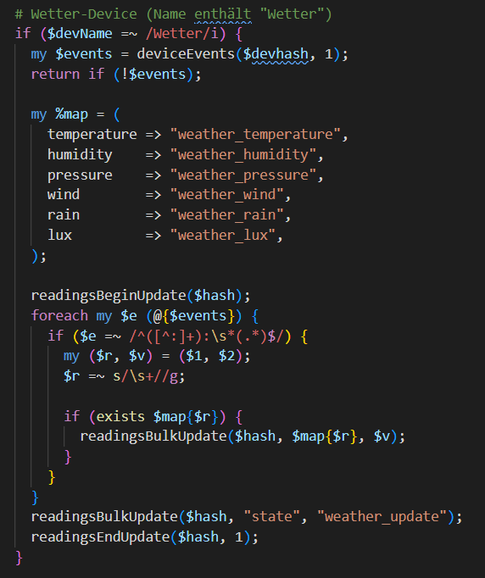

Participation in competitions  Awards | Currently no participation in competitions or awards is planned.

Accessibility of the  Diploma Thesis | The diploma thesis documentation and project files are available at HTL Leoben for educational and demonstration purposes.

Approval  (Date / Signature) | Examiner | Head of College

