DIPLOMA THESIS
Documentation

Author | Christian Beichtbuchner
Form, academic year | 5AHWIN, 2025/26
Topic | Design and implementation of a modular smart home system in a model house using FHEM, Node-RED, MQTT, Docker, and Arduino
Co-operation partners | HTL Leoben, Information Technology Department (internal school project without external industry partners)

Assignment of tasks | Modeling and printing of the model house, wiring of the electronic components, and design of the model to ensure the most realistic representation possible.

Realisation | Remodeling of an original construction plan in Fusion 360, 3D printing of components with a Bambu Lab printer, wiring of individual LEDs, crimping and insulation of cables, and design of the base plate.

Results | Completed model house based on a remodeled construction plan in Fusion 360; successfully implemented 3D printing of components with a Bambu Lab printer; stable assembly of the house on a base plate with frame construction; functional wiring of the LEDs, including professional crimping and insulation of the cables, as well as realistic design of the base plate.

Illustrative graph, photo  (incl. explanation) | 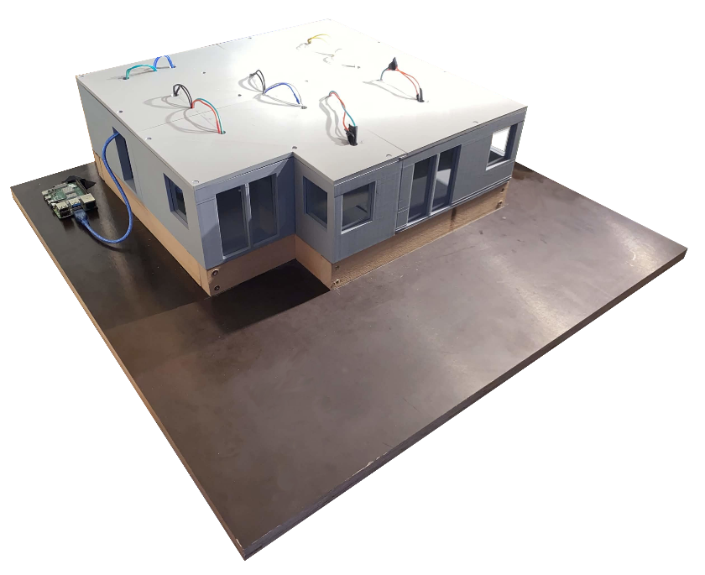

Participation in competitions  Awards | No participation in competitions or awards currently planned.

Accessibility of the  Diploma Thesis | Accessible via the HTL Leoben thesis portal, internal project documentation (Git repository), and printed version in the school archive.

Approval  (Date / Signature) | Examiner | Head of College

