**Student Application Report**

Here will be displayed the results of the report, each graph represents the grade distribution for each class in the form of a histogram. In addition, there is also a short explanation of the graph revealing the class average and the standard deviation of that classes marks. As can be seen in this report the class with the highest average was CP 212 where the lowest was PC 120.In terms of standard deviation the class with the highest was tied with PC 120 & CP 411 while the lowest was AS 101.

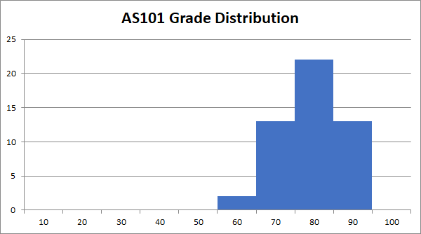Displayed is the grade distribution for the class AS101 in addition to this the class average was 74.11 and the standard deviation was 7.59

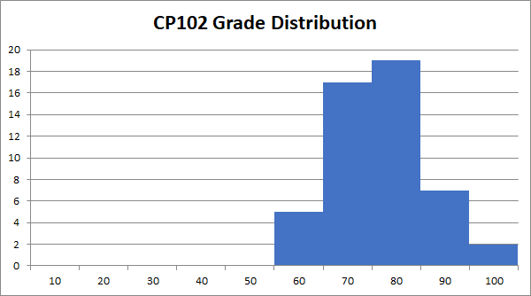Displayed is the grade distribution for the class CP102 in addition to this the class average was 71.34 and the standard deviation was 8.71

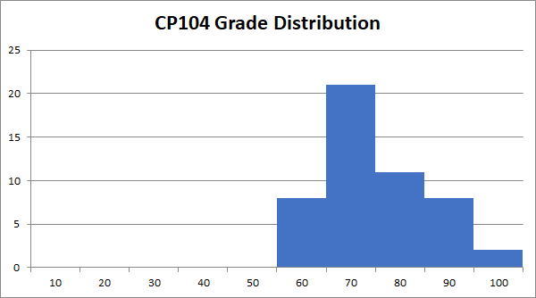Displayed is the grade distribution for the class CP104 in addition to this the class average was 69.99 and the standard deviation was 9.91

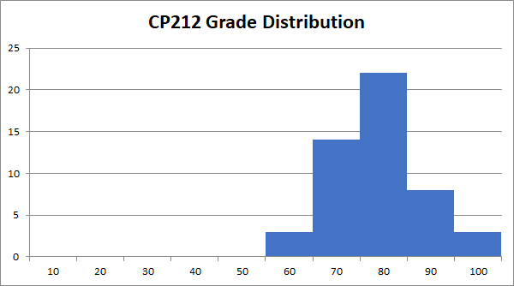Displayed is the grade distribution for the class CP212 in addition to this the class average was 73.49 and the standard deviation was 8.95

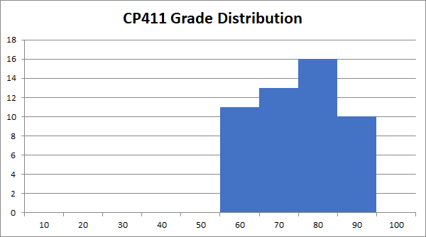Displayed is the grade distribution for the class CP411 in addition to this the class average was 70.5 and the standard deviation was 10.52

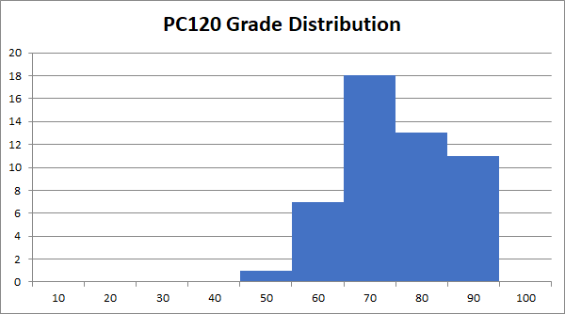Displayed is the grade distribution for the class PC120 in addition to this the class average was 69.78 and the standard deviation was 10.52

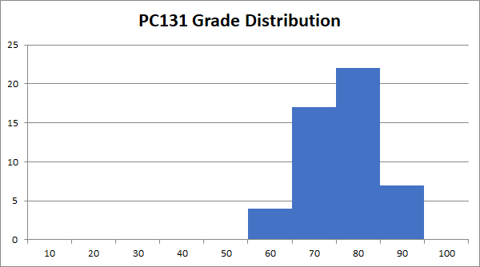Displayed is the grade distribution for the class PC131 in addition to this the class average was 71.51 and the standard deviation was 7.86

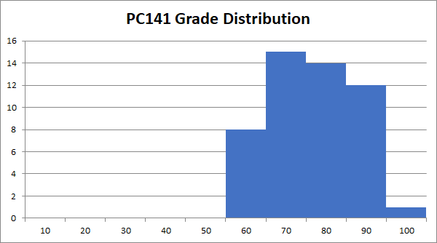Displayed is the grade distribution for the class PC141 in addition to this the class average was 71.24 and the standard deviation was 10.01