Module 2:R Markdown Document 1

Christian Ruiz

1/5/2022

# This is a level 1 header

## R Markdown

### This is a level 3 header

Here is a link to [GOOGLE](www.google.com)

Here is word in **bold** and another word in **bold**

Here is a word in *italics* and another word in *italics*

When we compile documents, we use the rmarkdown package

To higlight r code (that is not executable) but the put 3 back ticks at the beginning and end of text.

mean()

Here is an example of a non numbered list: (NOTE: always indent 4 spaces between points)

* Breakfast
  + food
    - eggs
    - toast
    - bacon
  + drink
    - apple juice

Here is an example of a numbered list

1. Breakfast
   1. food
      1. eggs
      2. toast
      3. bacon
   2. drink
      1. apple juice

This is an example of a block quote This is a list inside a block quote

1. item 1
2. item 2

#use this idea for footnotes or caveats to protocols

This is an example of a nested block quote

This line is nested

To put code in block quotes, add 5 spaces after the greater than symbol followed by r code

mean(x)

This is an R Markdown document. Markdown is a simple formatting syntax for authoring HTML, PDF, and MS Word documents. For more details on using R Markdown see <http://rmarkdown.rstudio.com>.

When you click the **Knit** button a document will be generated that includes both content as well as the output of any embedded R code chunks within the document. You can embed an R code chunk like this:

summary(cars)

## speed dist   
## Min. : 4.0 Min. : 2.00   
## 1st Qu.:12.0 1st Qu.: 26.00   
## Median :15.0 Median : 36.00   
## Mean :15.4 Mean : 42.98   
## 3rd Qu.:19.0 3rd Qu.: 56.00   
## Max. :25.0 Max. :120.00

## Including Plots

You can also embed plots, for example:

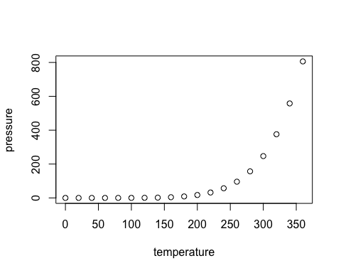

Note that the echo = FALSE parameter was added to the code chunk to prevent printing of the R code that generated the plot.

plot(pressure)

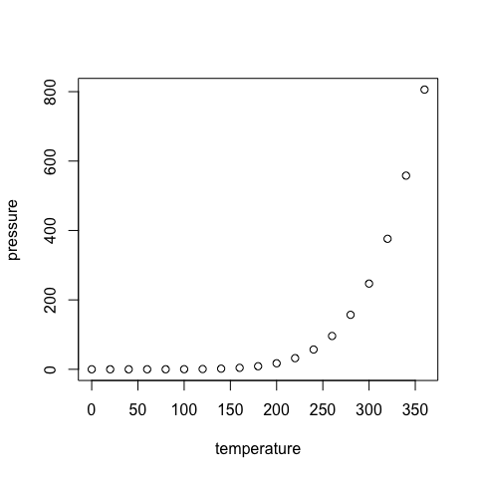

## Insert tables

knitr::kable(head(cars))

|  |  |
| --- | --- |
| speed | dist |
| 4 | 2 |
| 4 | 10 |
| 7 | 4 |
| 7 | 22 |
| 8 | 16 |
| 9 | 10 |