

<http://www.gosugamers.net/rankings>

Detailed Description of Game Tracker

We will be Tracking various esports teams with the above link. Some of the things we will be tracking are wins and losses, the team they competed against, and their current ranking during the game. The games will be League of Legends, Counter Strike: Global Offensive, Heroes of The Storm, and Overwatch.

Links to Project Files

Azure link doesn’t have anything yet, but here it is to show we have an Azure site ready to go

<http://cr-assignment1.azurewebsites.net/>

Github link

https://github.com/ChristianS25/COMP2007_Assignment1

Main Page

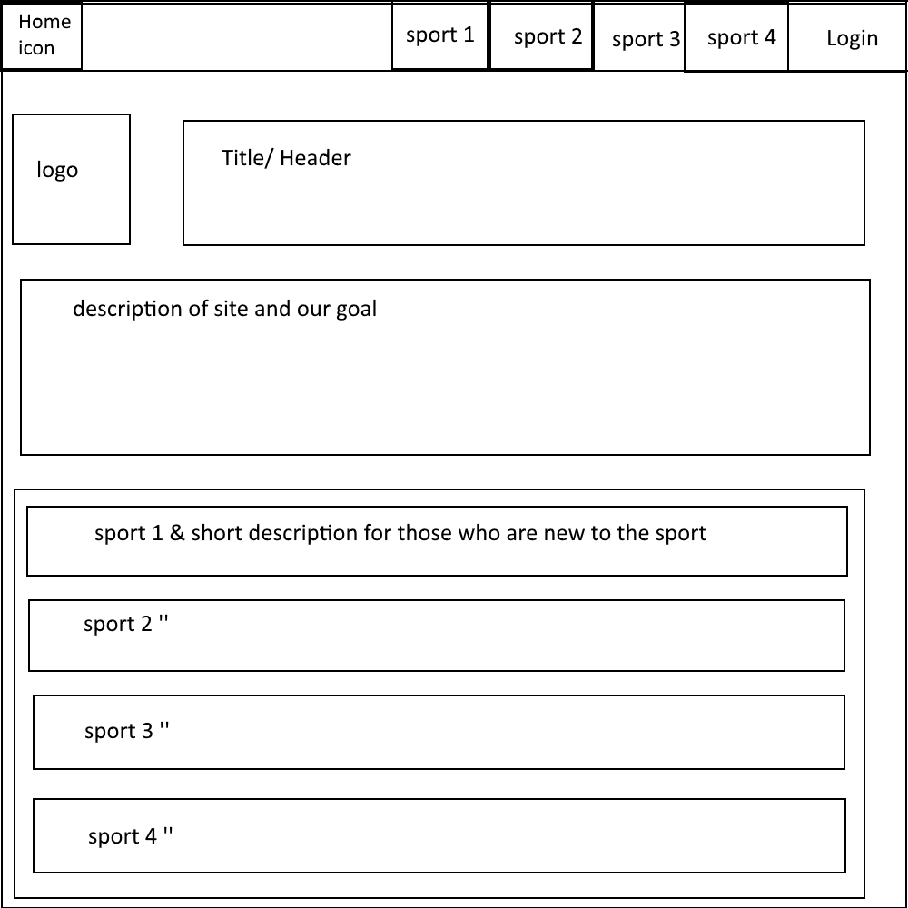

Sport view

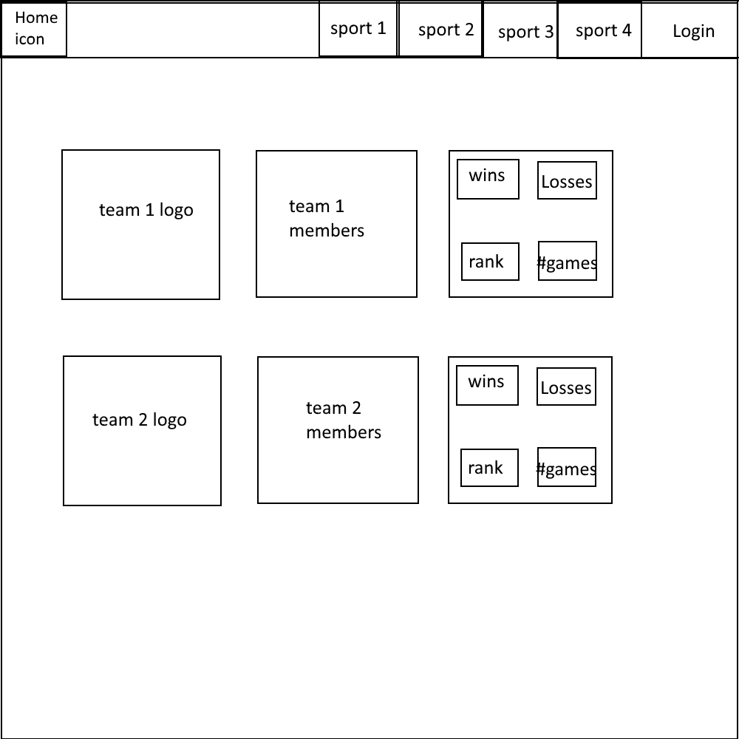

Team page

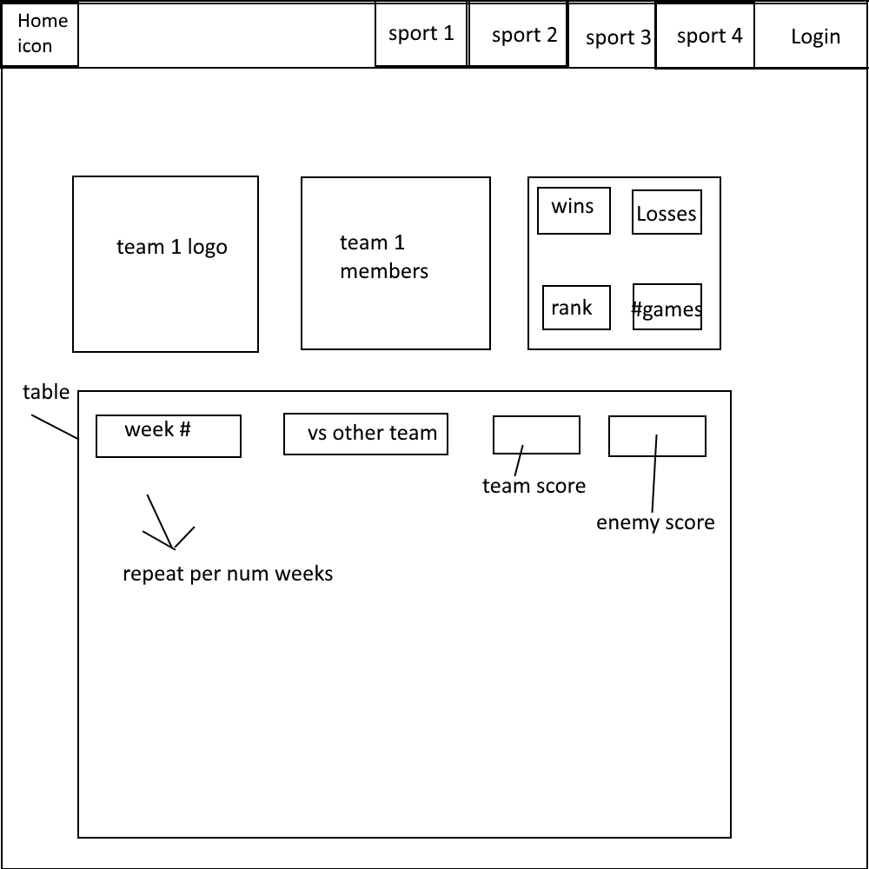

Login Page

